Pharmacy Product Systems (PPS)-N V3.0.3

User Guide



August 2018

Department of Veterans Affairs

Office of Information and Technology (OI&T)

Revision History

| **Date** | **Revision** | **Description** | **Author** |
| --- | --- | --- | --- |
| August 2018 | 1.0 | Updated version number and date for the PPS-N v3.0.3 Sustainment Release (PREN\*3.0\*4). | Pavani Mukthipudi  HPS Sustainment |

**Artifact Rationale**

Per the Veteran-focused Integrated Process (VIP) Guide, the User’s Guide is required to be completed prior to Critical Decision Point #2 (CD2), with the expectation that it will be updated as needed. A User Guide is a technical communication document intended to give assistance to people using a particular system, such as VistA end users. It is usually written by a technical writer, although it can also be written by programmers, product or project managers, or other technical staff. Most user guides contain both a written guide and the associated images. In the case of computer applications, it is usual to include screenshots of the human-machine interfaces, and hardware manuals often include clear, simplified diagrams. The language used is matched to the intended audience, with jargon kept to a minimum or explained thoroughly. The User Guide is a mandatory, build-level document, and should be updated to reflect the contents of the most recently deployed build. The sections documented herein are required if applicable to your product.

**Table of Contents**

[1. Introduction 1](#_Toc520793591)

[1.1. Purpose 1](#_Toc520793592)

[1.2. Overview 1](#_Toc520793593)

[1.2.1. Background 1](#_Toc520793594)

[1.3. PPS-N Advantage 2](#_Toc520793595)

[1.4. Security Roles 2](#_Toc520793596)

[1.4.1. Identity Management 2](#_Toc520793597)

[1.5. Application Interaction Flow 4](#_Toc520793598)

[1.6. Login Page 6](#_Toc520793599)

[2. Home Page Tab 7](#_Toc520793600)

[2.1. Home Page Tab 7](#_Toc520793601)

[2.1.1. Top of the Page 7](#_Toc520793602)

[2.1.1.1. Header 7](#_Toc520793603)

[2.1.1.2. Navigation Bar 7](#_Toc520793604)

[2.1.1.3. Information Bar 8](#_Toc520793605)

[2.1.2. Body of Page 8](#_Toc520793606)

[2.1.2.1. Left Side 8](#_Toc520793607)

[2.1.2.2. Right Side 8](#_Toc520793608)

[2.1.3. Bottom of Page 8](#_Toc520793609)

[2.2. Home Page Tab 9](#_Toc520793610)

[2.2.1. Top of the Page 9](#_Toc520793611)

[2.2.1.1. Header 9](#_Toc520793612)

[2.2.1.2. Navigation Bar 9](#_Toc520793613)

[2.2.1.3. Information Bar 10](#_Toc520793614)

[2.2.2. Body of Page 10](#_Toc520793615)

[2.2.2.1. Left Side 10](#_Toc520793616)

[2.2.2.2. Right Side 10](#_Toc520793617)

[2.2.3. Bottom of Page 10](#_Toc520793618)

[3. Manage PPS Tab 11](#_Toc520793619)

[3.1. Enter Edit Tab 11](#_Toc520793620)

[3.1.1. Perform Simple Search 11](#_Toc520793621)

[3.1.1.1. Text in Search for Field 12](#_Toc520793622)

[3.1.2. Select Search Field 12](#_Toc520793623)

[3.1.2.1. Item Types and Search Fields 12](#_Toc520793624)

[3.1.3. View Search Results 13](#_Toc520793625)

[3.1.4. Export Search Results 13](#_Toc520793626)

[3.1.5. Edit Product 14](#_Toc520793627)

[3.1.6. Edit Orderable Item 15](#_Toc520793628)

[3.1.7. Edit NDC 16](#_Toc520793629)

[3.1.8. Copy NDCs to New Product 17](#_Toc520793630)

[3.1.9. Remove Product from Orderable Item 17](#_Toc520793631)

[3.1.10. Remove NDCs from Product 18](#_Toc520793632)

[3.1.10.1. Use Existing to Create New 19](#_Toc520793633)

[3.1.10.2. Use Template to Create New 19](#_Toc520793634)

[3.1.11. Add Product 20](#_Toc520793635)

[3.1.12. Add Orderable Item 28](#_Toc520793636)

[3.1.13. Add NDC 30](#_Toc520793637)

[3.1.14. Perform Advanced Search 33](#_Toc520793638)

[3.1.15. Retrieve Saved Search Template 36](#_Toc520793639)

[3.1.16. Complete Advanced Search 37](#_Toc520793640)

[3.1.17. Save Search Template 38](#_Toc520793641)

[3.1.18. Change Search Results Template 38](#_Toc520793642)

[3.1.19. Requests Tab 39](#_Toc520793643)

[3.1.19.1. Search Requests 40](#_Toc520793644)

[3.1.19.2. Approve Request 41](#_Toc520793645)

[3.2. Saved Work in Progress Tab 44](#_Toc520793646)

[3.3. PPS Data Elements Tab 45](#_Toc520793647)

[3.3.1. Search for Domains 45](#_Toc520793648)

[3.3.2. View and Edit Domain Fields 46](#_Toc520793649)

[3.3.3. Handle Domain Item Modification Errors 48](#_Toc520793650)

[3.3.4. Create New Domain Item 48](#_Toc520793651)

[3.4. PPS Data Requests Tab 48](#_Toc520793652)

[3.4.1. View Pending Domain Item Requests 48](#_Toc520793653)

[3.4.2. Approve Pending Domain Item Addition Request 50](#_Toc520793654)

[3.5. Manage Update Files Tab 53](#_Toc520793655)

[3.5.1. Update File Messages 57](#_Toc520793656)

[3.5.1.1. Unable to Install Update 57](#_Toc520793657)

[3.5.2. Failure Scenarios 62](#_Toc520793658)

[3.5.2.1. Introduction 62](#_Toc520793659)

[3.5.2.2. Failure Scenario 1 – User Attempts to Create an Update File while an Update File is in Process 62](#_Toc520793660)

[3.5.2.3. Failure Scenario 2 – The Process Fails during File Creation or Transmission to sFTP Server 63](#_Toc520793661)

[3.5.2.4. Failure Scenario 3 – Process Fails during Approval 64](#_Toc520793662)

[3.5.2.5. Failure Scenario 4 – Process Fails during Rejection 64](#_Toc520793663)

[3.6. Rematch 65](#_Toc520793664)

[4. Reports Tab 68](#_Toc520793665)

[4.1. Select Report 69](#_Toc520793666)

[4.2. Open or Save Report 70](#_Toc520793667)

[4.3. Types of Reports 71](#_Toc520793668)

[4.3.1. Capture NDF Data Report 71](#_Toc520793669)

[4.3.2. Ingredients List Report 72](#_Toc520793670)

[4.3.3. Products and Warning Labels Report 73](#_Toc520793671)

[4.3.4. Data Update Compliance Report 73](#_Toc520793672)

[4.3.4.1. Data Update Compliance Report Content 74](#_Toc520793673)

[4.3.5. VA Drug Classifications Report 75](#_Toc520793674)

[4.3.6. Products with Exclusions from Drug-Drug Interactions Report 76](#_Toc520793675)

[4.3.7. Active Products with No Active NDCs Report 76](#_Toc520793676)

[4.3.8. Active Products with Proposed Inactive Date Report 77](#_Toc520793677)

[4.3.9. VUID Approvals Report 78](#_Toc520793678)

[4.3.10. Preview Update File Report 78](#_Toc520793679)

[5. COTS Services Tab 79](#_Toc520793680)

[5.1. FDB Search Tab 79](#_Toc520793681)

[5.2. FDB Add Tab 85](#_Toc520793682)

[5.3. FDB Update Tab 86](#_Toc520793683)

[5.4. Added Report Tab 87](#_Toc520793684)

[5.5. Updated Report Tab 89](#_Toc520793685)

[6. User Preferences Tab 91](#_Toc520793686)

[6.1.1. Search Preferences Tab 92](#_Toc520793687)

[7. Help Tab 94](#_Toc520793688)

[7.1. Accessing Help 95](#_Toc520793689)

[8. Manage Application Tab 95](#_Toc520793690)

[8.1. Domain Mapping Tab 95](#_Toc520793691)

[8.2. Domain Mapping Tab 97](#_Toc520793692)

[8.3. System Data Tab 98](#_Toc520793693)

[8.3.1. Job Types 101](#_Toc520793694)

[8.4. User Roles Tab 102](#_Toc520793695)

[8.5. Edit Home Page Tab 102](#_Toc520793696)

[9. Migration Tab 104](#_Toc520793697)

[9.1. Migrate Package Size Tab 104](#_Toc520793698)

[9.2. Migrate Copay Tier Data 105](#_Toc520793699)

[9.3. Migrate DDI Tab 105](#_Toc520793700)

[9.4. Migrate Formulary Designator Data 105](#_Toc520793701)

[9.5. Migrate Hazardous Waste Data 106](#_Toc520793702)

[10. Additional Help 107](#_Toc520793703)

[11. Appendix 107](#_Toc520793704)

[11.1. A–Z Tab 108](#_Toc520793705)

[11.2. History Tab 111](#_Toc520793706)

[11.3. Icon and Button List 114](#_Toc520793707)

[11.4. Add Domain Pages 119](#_Toc520793708)

[11.4.1. Add VA Drug Class 119](#_Toc520793709)

[11.4.2. Add Dispense Unit Name 120](#_Toc520793710)

[11.4.3. Add Dosage Form Name 121](#_Toc520793711)

[11.4.4. Add Dose Unit Name 122](#_Toc520793712)

[11.4.5. Add Drug Text Name 124](#_Toc520793713)

[11.4.6. Add Drug Unit Name 125](#_Toc520793714)

[11.4.7. Add Generic Name 125](#_Toc520793715)

[11.4.8. Add Ingredient Name 126](#_Toc520793716)

[11.4.9. Add Manufacturer Name 126](#_Toc520793717)

[11.4.10. Add Order Unit Abbreviation 127](#_Toc520793718)

[11.4.11. Add Package Type Name 127](#_Toc520793719)

[11.4.12. Add Special Handling Code 128](#_Toc520793720)

[11.4.13. Add Standard Med Route Name 128](#_Toc520793721)

[11.5. Edit Domain Pages 129](#_Toc520793722)

[11.5.1. Edit VA Drug Class 129](#_Toc520793723)

[11.5.2. Edit VA Dispense Unit Request 130](#_Toc520793724)

[11.5.3. Edit Dosage Form Name 131](#_Toc520793725)

[11.5.4. Edit Dose Unit Name 134](#_Toc520793726)

[11.5.5. Edit Drug Text Name 135](#_Toc520793727)

[11.5.6. Edit Drug Unit Name 136](#_Toc520793728)

[11.5.7. Edit Generic Name 137](#_Toc520793729)

[11.5.8. Edit Ingredient Name 139](#_Toc520793730)

[11.5.9. Edit Manufacturer Name 140](#_Toc520793731)

[11.5.10. Edit Order Unit Abbreviation 141](#_Toc520793732)

[11.5.11. Edit Package Type Name 142](#_Toc520793733)

[11.5.12. Edit Special Handling Code 143](#_Toc520793734)

[11.5.13. Edit Standard Med Route Name 144](#_Toc520793735)

[11.6. NDC Edit Tabs 145](#_Toc520793736)

[11.6.1. NDC Header 145](#_Toc520793737)

[11.6.2. NDC Main Tab 146](#_Toc520793738)

[11.6.3. NDC Price Tab 150](#_Toc520793739)

[11.7. Orderable Item Edit Tabs 153](#_Toc520793740)

[11.7.1. OI Header 153](#_Toc520793741)

[11.7.2. OI Details Tab 153](#_Toc520793742)

[11.7.3. OI Safety Tab 156](#_Toc520793743)

[11.7.4. OI Labs & Vitals Tab 158](#_Toc520793744)

[11.7.5. OI Products Tab 159](#_Toc520793745)

[11.8. Product Edit Tabs 161](#_Toc520793746)

[11.8.1. Product Header 161](#_Toc520793747)

[11.8.2. Product National Data Tab 162](#_Toc520793748)

[11.8.3. Product Drug Data Tab 167](#_Toc520793749)

[11.8.4. Product Quick Actions Tab: CMOP Mark / Unmark 173](#_Toc520793750)

[11.8.5. Product Quick Actions Tab: Enter / Edit Dosages 175](#_Toc520793751)

[11.8.6. Product Quick Actions Tab: Print PMI 176](#_Toc520793752)

[11.8.7. Product Quick Actions Tab: Print Warning Labels 178](#_Toc520793753)

[11.8.8. Product Quick Actions Tab: Coding System 179](#_Toc520793754)

[11.8.9. Product Application Data Tab: Outpatient 181](#_Toc520793755)

[11.8.10. Product Application Data Tab: Inpatient - Unit Dose 183](#_Toc520793756)

[11.8.11. Product Application Data Tab: IV 184](#_Toc520793757)

[11.8.12. Product Application Data Tab: Surgery 185](#_Toc520793758)

[11.8.13. Product Application Data Tab: Ward Stock 186](#_Toc520793759)

[11.8.14. Product Application Data Tab: Drug Accountability 187](#_Toc520793760)

[11.8.15. Product Application Data Tab: Controlled Substance 189](#_Toc520793761)

[11.8.16. Product Application Data Tab: Non-VA Med 190](#_Toc520793762)

[11.8.17. Product Dispense Data Tab 191](#_Toc520793763)

[11.8.18. Product Administration Data Tab 194](#_Toc520793764)

[11.8.19. Product NDCs Tab 197](#_Toc520793765)

[11.9. Product Change Request Tab 199](#_Toc520793766)

[11.10. Product Pending Modification Tab 201](#_Toc520793767)

[11.11. Rematch 202](#_Toc520793768)

[12. Product National Data Tab 205](#_Toc520793769)

[12.1.1. Ingredients List Report 211](#_Toc520793770)

[12.1.2. Edit Product Request 212](#_Toc520793771)

[12.1.3. Edit Orderable Item Request 213](#_Toc520793772)

[12.1.4. Request Summary 213](#_Toc520793773)

[12.1.5. Comment 213](#_Toc520793774)

[12.2. Associate a Product from Rematch 214](#_Toc520793775)

[12.2.1. Edit 215](#_Toc520793776)

[13. Glossary 1](#_Toc520793777)

# Introduction

## Purpose

The Pharmacy Product System-National (PPS-N) is a web-based application that allows select members of the Department of Veterans Affairs (VA) Pharmacy Benefits Management (PBM) Services to create and revise pharmacy drug information.

The purpose of this user guide is to provide a general overview of the PPS-N application as well as more detailed working information. The guide also provides reference material and task-based instructions for performing the various tasks within PPS-N.

## Overview

The Veteran’s Health Administration (VHA) is undertaking a Pharmacy Reengineering (PRE) initiative. The objective of the PRE project is to facilitate the improvement of pharmacy operations, customer service, and patient safety for the VHA. The PRE project will help address the identified goals and vision for the VHA Pharmacy System.

The goal for the overall PRE project is a seamless and integrated nationally supported system that is an integral part of the new VA service-oriented architecture (SOA) environment. To meet this goal, the PRE project will enhance pharmacy data exchange, as well as clinical documentation capabilities, in a truly integrated fashion to improve operating efficiency and patient safety. Additionally, it will provide a flexible technical environment to adjust to future business conditions and to meet patient needs in the clinical environment. Achieving this goal will enable resolution of current pharmacy issues, improve patient safety, and facilitate long-term process stability.

The PRE project has been broken down in multiple projects. Previous phases of PRE have concentrated on order checks (Medication Order Check Healthcare Application (MOCHA)), automated updates (Data Update (DATUP)), and customizing the FDB (First Databank) data used in order check. The PPS-N and the PPS-N Migration projects provide two distinct capabilities that are included in the same application. However, the focus of this User Guide is on the PPS-N application.

### Background

The Pharmacy Product System (PPS) is intended to improve the VA’s current formulary processes. The current VA National Formulary consists of items such as medications and supplies that have been identified by VA organizations for inclusion. The status change of all items with regard to the VA National Formulary is governed by a process that is already in place. Upon approval, the item status is changed in the VA National Formulary, and updates are issued to the local drug files via software patches.

PPS is envisioned as two distinct processes. The first process covers PPS at the National level (called PPS-N). The PPS-N environment provides for the ability to manage pharmacy-specific data across the enterprise, ensuring that all facilities are using the same base data for their operations. The second process encompasses PPS processes at the Local level (called PPS-L). The PPS-L application environment will provide services that enact business logic for the daily operations of pharmacy users at the VA’s medical centers and clinics.

The focus of the current PPS software development efforts and this User Guide is on the PPS-N system. The PPS-N application is used to manage the VA National Formulary.

## PPS-N Advantage

The PPS-N application allows national VA personnel to easily, quickly, and safely manage the VA National Formulary that determines the products, such as medications and supplies that are to be purchased and used by the VA hospital system. The key capabilities are listed below.

With PPS-N, users can:

1. Manage the National VA Formulary items. This ability includes being able to request the addition and update of items, and then approve these requests

* Synchronize the National and Local versions of the VA Formulary Items

PPS-N enables an interface with a third-party Commercial-Off-The-Shelf (COTS) drug data source. With this interface, users can:

* Manage additions and changes made in the COTS drug data source, including synchronization of this data with the PPS-N Enterprise Product List (EPL)
* Search for data within the COTS drug data source
* Manage the mapping of VA concepts to COTS concepts
* Perform reports on items added by the COTS drug data source

With PPS-N, users are able to:

1. Perform simple and advanced searches for item data contained within PPS-N

* Report on the item data contained within PPS-N
* Retrieve pricing information from the Federal Supply Schedule (FSS) system, and then to display this information to the PPS-N users
* Retrieve Standard Medication Route information from the VA Enterprise Terminology Services (VETS), and then to manage this data within PPS-N

## Security Roles

The PPS-N application is accessible only by users signed directly into the VA network, or by users signed into the VA network via the remote client. User authentication into the VA network is a precondition of PPS-N application access. To log into the PPS-N application, users will use Single Sign On (SSOi).

### Identity Management

PPS-N uses the assignment of roles to grant access to the system. Users will log onto the system using Single Sign On (SSOi) and the roles are assigned under the PPS-N Manage Applications User Roles Tab.

##### National Viewer (PSS\_PPSN\_VIEWER)

This role is designed for a user who needs access to PPS-N to view drugs and their attributes. This user can:

* Search for and view drug details but cannot modify drugs nor add new drugs to the system
* Use advanced search and create personal search template
* Search the COTS drug information database, presently First Databank (FDB)
* Submit a change request for a drug
* View all the data screens in PPS-N (not migration)
* View and create reports

This role is the default role assigned to all users when VistA access is granted.

##### National Second Approver (PSS\_PPSN\_ SECOND\_APPROVER)

This role includes all the functionality of a National Viewer. This role allows a user to:

* Provide a second approval on items that are in the Pending second approval state
* Search for all requests, and select and view any request
* Approve or disapprove requests that the National Managers marked as available for second approval. The Request Status column includes the status Pending Second Approval.

This role is assigned on the User Roles tab.

##### National Manager (PSS\_PPSN\_ MANAGER)

This role controls the normal processing of drug items. This role includes all the functionality of the National Second Approver. In addition, users assigned this role can:

* Add, edit, and approve all items such as products and NDCs, the National Council for Pharmacy Drug Programs (NCPDPs)
* Add, edit, and approve new domains such as generic names, ingredients, and so forth
* Search for new items in FDB and add them to PPS-N
* Add, edit, and save partially modified items
* Control sending update files to VistA

This role is assigned on the User Roles tab.

##### 2nd National Manager (PSS\_PPSN\_ MANAGER)

This role controls the normal processing of drug items. This role includes all the functionality of the National Second Approver and a National Manager. In addition, users assigned this role can:

* Add, edit, and approve all items such as products and NDCs, the National Council for Pharmacy Drug Programs (NCPDPs)
* Add, edit, and approve new domains such as generic names, ingredients, and so forth
* Search for new items in FDB and add them to PPS-N
* Add, edit, and save partially modified items
* Approve or disapprove requests that the National Managers marked as available for second approval. (The Request Status column includes the status Pending Second Approval.)

This role is not shown on the User Roles tab. Role access is derived by granting permissions for both the National Second Approver and National Manager roles to the user.

##### National Supervisor (PSS\_PPSN\_ SUPERVISOR)

This role includes all of the permissions of a National Manager. In addition, the role provides users with the ability to:

* Configure the auto-update processes from Standards and Terminology Service (STS) and FSS or to manually start the processes
* Create system-level advanced search templates and delete templates
* Delete partially saved items that other users have created

The Manage Application tab appears only for users with this role assigned. This role is assigned on the User Roles tab.

##### National Migrator User (PPS\_PPSN\_MIGRATOR)

This role includes all the permissions of the National Viewer. In addition, this role provides users with the ability to perform all migration tasks.

The Migration tab appears only for users with this role assigned. This role is assigned on the User Roles tab.

## Application Interaction Flow

The figure below provides a high-level interaction flow diagram for the PPS-N system. The circles within the PPS-N oval represent the major capabilities provided by the application. The squares with inclusive circles represent the main external applications with which PPS-N interacts. Additional details on the process flows for each of the PPS-N capabilities can be found in the System Design Document.

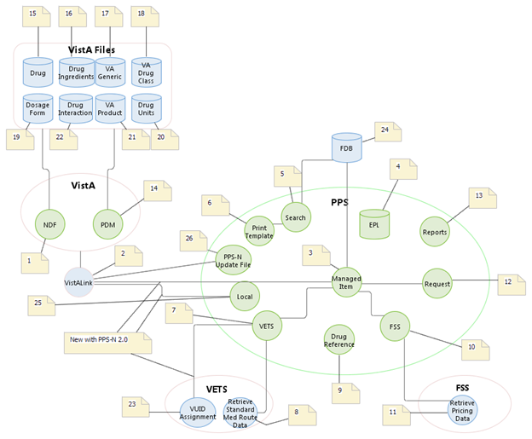

Figure 1: PPS-N Interaction Flow

The table below provides amplifying information for the interaction flow presented above.

Table 1: Interaction Flow Descriptions

| Name | ID | Description | External Interface Name |
| --- | --- | --- | --- |
| VistA Link | 2 | The service is used to send messages between PPS-N and VistA. VistALink is utilized for KAAJEE login purposes and for sending update files. | VistALink, the interface mechanism between VistA and PPS-N |
| Managed Item | 3 | This service handles validation and create, read, update, and delete (CRUD) operations with the PPS-N data entities. | N/A |
| PPS-N EPL Database | 4 | This database is used to persist all entities and information needed by the PPS-N application. | N/A |
| Search | 5 | This service handles all simple and advanced search functionality for the PPS-N application. | N/A |
| Print Template | 6 | This service handles CRUD operations for the print template entity, which is used to persist advanced search criteria and result columns. | N/A |
| VETS | 7 | This service is used to send web service requests to the VETS system for the Standard Med Route data that it contains. | Web services, which is the interface mechanism between VETS and PPS-N. |
| Retrieve Standard Med Route Data | 8 | This process (not developed as part of PPS-N) is invoked by the PPS-N application’s VETS service to request Standard Med Route data. | Web services, which allows external systems (such as PPS-N) to request data contained in the VETS data store. |
| Drug Reference | 9 | This service interfaces with the COTS drug information database (also located within PPS-N). | N/A |
| FSS | 10 | This service is used to send JDBC queries to the FSS system for the pricing data contained in its database tables. | JDBC, which is the interface mechanism between FSS and PPS-N. |
| Retrieve Pricing Data | 11 | This process (not developed as part of PPS-N) is invoked by the PPS-N application’s FSS service to request pricing data. | JDBC, which allows external systems (such as PPS-N) to query for data contained in the FSS database. |
| Request | 12 | This service implements the item request management functionality for the PPS-N application. | N/A |
| Reports | 13 | This service is used to manage reports. | N/A |
| NDF | 1 | The VistA National Drug File Module | TBD |
| PDM | 14 | The VistA Pharmacy Data Management Module | TBD |
| VUID Assignment | 23 | Interface to VETS for the assignment of VUIDs | TBD |
| FDB | 24 | FDB is the COTS Drug Information database being utilized | JDBC (via FDB DIF APIs) |
| PPS-N Update File | 26 | File containing Product updates | VistALink |

## Login Page

The purpose of this page is to provide an authorized user access to the system. Each individual will access the system using Single Sign On (SSOi).

See Security Roles and Identity Management for more information on roles and permissions.

To Log In:

1. Open Internet Explorer.
2. In the Address Bar, enter the URL (Universal Resource Locator) provided to you by the VA. The login page opens.
3. The user will log-in using single sign on.

# Home Page Tab

## Home Page Tab

The Home tab is the first page you see after logging in to PPS-N. You can use the User Preferences option to change the default login page to the Search page.

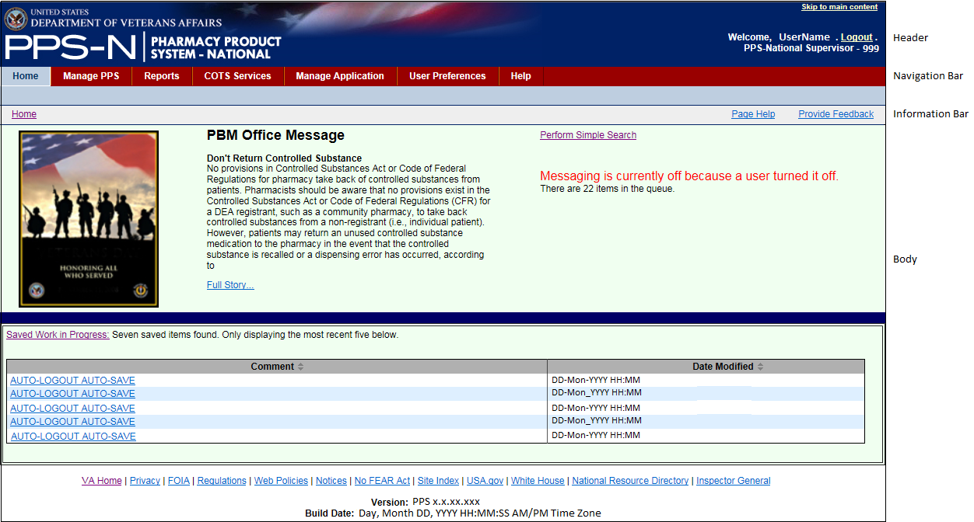

Figure 2: Home Page Tab

### Top of the Page

All PPS-N pages share a common header, main navigation bar, and information bar.

#### Header

* The left side of the header includes the standard VA logo, application abbreviation, and application name.
* The right side shows the user name, the Logout link, and below, the user’s assigned role and location.

#### Navigation Bar

The main navigation bar includes primary tabs: Home, Manage PPS, Rematch, Reports, COTS Services, User Preferences, and Help. Click a tab to open secondary tabs or pages. Additional tabs can display based on permissions: Manage Application, Migration Tab.



Figure 3: Navigation Bar

* Image First Row: This row is the primary menu. Click a tab to open a secondary menu or a page.
* Image Second Row: This row is the secondary menu. In this example, it's the secondary menu for Manage PPS. Click a secondary tab to open a page.
* Image Third Row: This row contains bread crumbs, which shows selections you've made to arrive at the current page. After you have several links displaying, you can click a link in the bread crumbs to return to an earlier page.

#### Information Bar

* The left side of the bar includes bread crumbs (on the left side), which shows selections you've made to arrive at the current page. Click a link in the bread crumbs to return to an earlier page.
* The right side includes a link to context-sensitive help (Page Help) for the displayed application page.
* The right side also includes a Provide Feedback link, which generates an e-mail that you can use to contact PBM staff.

### Body of Page

The body of the Home page displays the content described below.

#### Left Side

* A PBM Office optional image and message  
  The image and message can be edited; see Edit Home Page tab for more information.
* The Saved Work in Progress link  
  Click the link to open the Save Work in Progress tab.
* The Saved Work in Progress table  
  Click a link in the Comment column of the table to open the Edit Drug Information page and continue working.

#### Right Side

* A link to the Perform Simple Search page
* The application status message when appropriate  
  For example, to perform maintenance tasks, a system administrator might turn off communication with the NDFMS server. When this event occurs, the system posts a status message below the Perform Simple Search link.

### Bottom of Page

The bottom of the page displays the following elements:

* A few helpful links
* The application version information (below the helpful links)

## Home Page Tab

The Home tab is the first page you see after logging in to PPS-N. You can use the User Preferences option to change the default login page to the Search page.

Home Page Tab



### Top of the Page

All PPS-N pages share a common header, main navigation bar, and information bar.

#### Header

* The left side of the header includes the standard VA logo, application abbreviation, and application name.
* The right side shows the user name, the Logout link, and below, the user’s assigned role and location.

#### Navigation Bar

The main navigation bar includes primary tabs: Home, Manage PPS, Rematch, Reports, COTS Services, User Preferences, and Help. Click a tab to open secondary tabs or pages. Additional tabs can display based on permissions: Manage Application, Migration Tab.



Figure 4: Navigation Bar

* Image First Row: This row is the primary menu. Click a tab to open a secondary menu or a page.
* Image Second Row: This row is the secondary menu. In this example, it's the secondary menu for Manage PPS. Click a secondary tab to open a page.
* Image Third Row: This row contains bread crumbs, which shows selections you've made to arrive at the current page. After you have several links displaying, you can click a link in the bread crumbs to return to an earlier page.

#### Information Bar

* The left side of the bar includes bread crumbs (on the left side), which shows selections you've made to arrive at the current page. Click a link in the bread crumbs to return to an earlier page.
* The right side includes a link to context-sensitive help (Page Help) for the displayed application page.
* The right side also includes a Provide Feedback link, which generates an e-mail that you can use to contact PBM staff.

### Body of Page

The body of the Home page displays the content described below.

#### Left Side

* A PBM Office optional image and message  
  The image and message can be edited; see Edit Home Page tab for more information.
* The Saved Work in Progress link  
  Click the link to open the Save Work in Progress tab.
* The Saved Work in Progress table  
  Click a link in the Comment column of the table to open the Edit Drug Information page and continue working.

#### Right Side

* A link to the Perform Simple Search page
* The application status message when appropriate  
  For example, to perform maintenance tasks, a system administrator might turn off communication with the NDFMS server. When this event occurs, the system posts a status message below the Perform Simple Search link.

### Bottom of Page

The bottom of the page displays the following elements:

* A few helpful links
* The application version information (below the helpful links)

# Manage PPS Tab

## Enter Edit Tab

The Enter/Edit Items tab allows you to search the system for drug information. After result items display, you can select an item to review or edit. In addition, you can create new items.

Complete a search.

* Perform Simple Search
* Perform Advanced Search

After you have search results, complete any of these tasks:

* View Search Results
* Export Search Results
* Edit Product
* Edit Orderable Item
* Edit NDC
* Add New Items

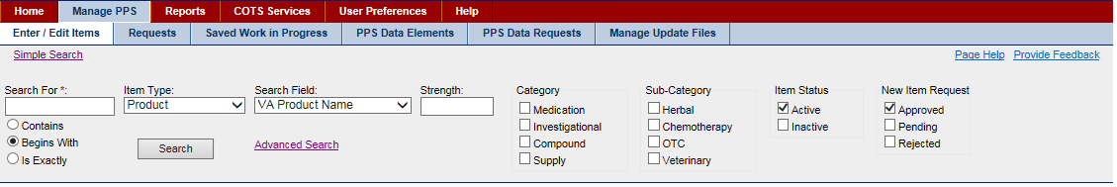

Figure 5: Enter/Edit Items Page

### Perform Simple Search

This search allows you to search for any item within PPS. You select an item type (Product, Orderable Item, or NDC) and apply filters to narrow the list of results.

To Search:

1. Click the Enter / Edit Items tab to display the search page.
2. In Search for, enter text. See Text in Search For Field for more information.
3. In Item Type, select a type from the drop-down list: Product, Orderable Item, or NDC. See Select Search Field for more information.
4. In Search Field, select a field from the drop-down list. See Select Search Field for more information.
5. For Product, in Strength, enter strength.
6. For Orderable Item, in Dosage Form, enter a form.
7. Select filters to further restrict search results. Select options from lists: Category, Sub-Category, Item Status, and New Item Request. For all filter types, you can choose any combination of items, including multiple choices in each filter type.
8. Click the **Search** button. The system displays results in a table list below.

After you have search results, complete any of these tasks:

* View Search Results
* Export Search Results
* Edit Product
* Edit Orderable Item
* Edit NDC
* Add New Items
* Perform Advanced Search

#### Text in Search for Field

Enter a string of text in the required Search For field. The text string can include the following wildcards.

* \_ (underscore for any single character)
* % (percent for any number of characters)

In addition, you can select one of the following options to further restrict search results.

* Contains -Select this option to return search results where the search string appears anywhere in the searchable fields.
* Begins With -Select this option to return search results where the search string appears at the beginning of the searchable fields.
* Is Exactly -Select this option to return search results where the search string matches exactly the searchable field.

### Select Search Field

Selections appearing in the Search field drop-down list depend upon the selected Item Type. For example, if you select NDC as the item type, the drop-down list shows searchable NDC fields. The actual searchable fields for each item type are shown in the list below.

#### Item Types and Search Fields

**Product**

When you accept the default of Product, the system includes an additional Strength field. Enter strength in this field to restrict the search base on strength.

The following search fields are available: All Fields; VA Product Name; VA Print Name; Generic Name; VA Product ID; VA Drug Class; Active Ingredient; Synonym Name, Copay Tier, Formulary Designator.

**Orderable Item**

When you select Orderable Items, the system opens an additional Dosage Form field. Enter a dosage form in this field to restrict the search based on the dosage form.

The following search fields are available: All Fields; PPS OI Name; OI Synonym, Formulary Designator.

**NDC**

The following search fields are available: All Fields; NDC; UPC/UPN; Trade Name.

### View Search Results

After you Perform a Simple Search, search results appear in a table list below the search filters. The table list columns vary, depending on the selected item type and search field you selected for the search.

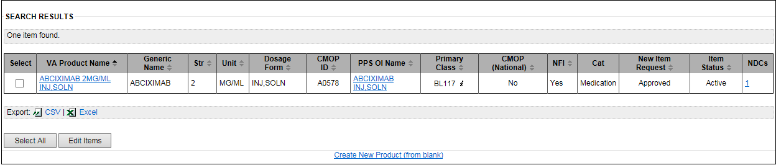

Figure 6: Simple Search Results

For example, in the figure above, search results are specific to Product searches based on VA Product Name. Selecting a different option in the Item Type and Search Field results in different drug information being displayed in the table. Likewise, if you enter different Search Field data, different columns of information appear in results.

On this page, you can:

* Click links in the results to display additional information. For example, in the figure above, the VA Product Name and PPS OI Name columns include links you can click.
* Click the check box beside one or more entries in the results and Export Search Results.
* Click the check box beside one or more entries in the results, click the Edit Item button, and edit a Product, Orderable Item, or NDC. You can edit multiple items at a time.
* Click the Create New (Item) (from blank) link to display a template that you can use to create a new Product, Orderable Item, or NDC.

### Export Search Results

Below the search results table, you can select an option to export the search results in either CSV or Excel format.

**Export Bar**

Export Bar Below Search Results Table

**To Export:**

1. In the Select column of the table list, click the check box to add a check mark beside each result that you want to include in the export.
2. Below the table, click a format check box (CSV or Excel) in the export results.
3. Use the buttons in the resulting dialog box to open or save the results.

**Results**

Based on your selections, results appear as comma separated value (CSV) or as values in an Excel spreadsheet.

### Edit Product

This page allows you to view, modify, approve, or reject existing or newly created product items.

**To Edit:**

1. In a search results list, click a link in the VA Product Name column. The system opens the National Data tab.
2. Click the Show All Tabs link to display additional tabs. The system opens the additional tabs and changes the link to Hide All Tabs.
3. Update data on tabs as necessary. For more information on an individual tab, see Product-Related Edit Tabs list below.
4. Click the Submit button. The system opens the Modification Summary for Product page.
5. Review changes.
6. If you need to make corrections, click the Cancel button to return to the previous page. Otherwise, complete the summary page.
7. In PSR Name, enter the name of the Pharmacy Product System Second Reviewer.
8. In Reason, enter a reason for the change.
9. In Accept Change, click the check box to add or remove a check mark to include or exclude the change.
10. Click the Accept Changes button. A confirmation message appears: Your changes have been committed.
11. Click the OK button to acknowledge the message. The system displays the Request Tab.

**Product-Related Edit Tabs**

|  |  |  |
| --- | --- | --- |
| National Data Tab  Drug Data Tab  **Quick Actions Tab**  CMOP Mark / Unmark  Enter / Edit Dosages  Print PMI  Print Warning Labels  RxNorm | **Application Data Tab**  Controlled Substance  Drug Accountability  Inpatient - Unit Dose  IV  Non-VA Med  Outpatient  Surgery  Ward Stock | Dispense Data Tab  Administration Data Tab  NDCs Tab  History Tab  A - Z Tab  Example of Edit Item in A-Z Tab  Edit Copay Tier A - Z Tab  Multi-Edit\_for\_Copay\_Tiers.htm |

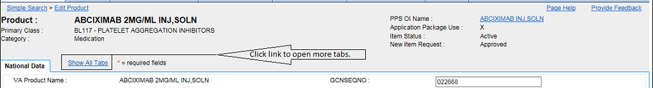

Figure 7: Show All Tabs Link

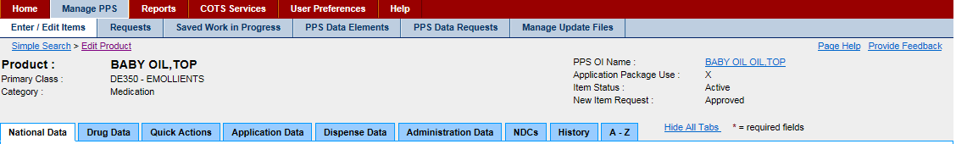

Figure 8: All Tab Links Shown

When the user edits a product and makes a change, the Modification Summary page displays when you hit the submit button.

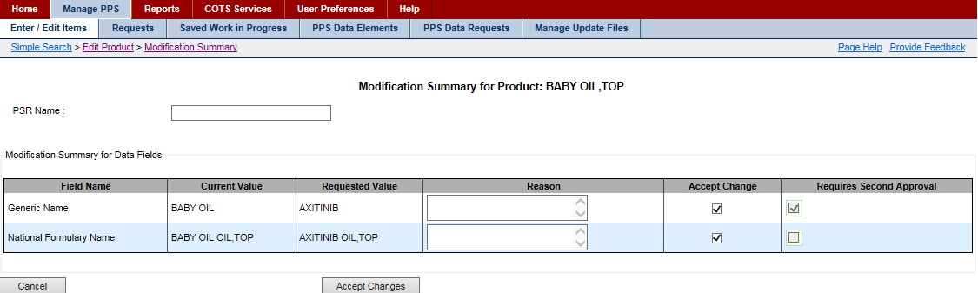

Figure 9: Modification Summary for Edit Product Page

### Edit Orderable Item

This page allows you to view, modify, approve, or reject existing or newly created orderable items.

**To Edit:**

1. In the search results list, click a link in the PPS OI Name column. The system opens the Details tab.
2. Update data on tabs as necessary. For more information on an individual tab, see the Orderable-Item-Related Edit Tabs list below.
3. Click the Submit button. The system opens the Modification Summary for Orderable Item page.
4. Review changes.
5. If you need to make corrections, click the Cancel button to return to the previous page. Otherwise, complete the summary page.
6. In Reason, enter a reason for the change.
7. In Accept Change, click the check box to add or remove a check mark to include or exclude the change.
8. Click the Accept Changes button. A confirmation message appears: Your changes have been committed.
9. Click the OK button to acknowledge the message. The system displays the Request Tab.

**Orderable-Item-Related Edit Tabs**

|  |  |  |
| --- | --- | --- |
| Details Tab | Labs & Vitals Tab | History Tab |
| Safety Tab | Products Tab | A - Z Tab |

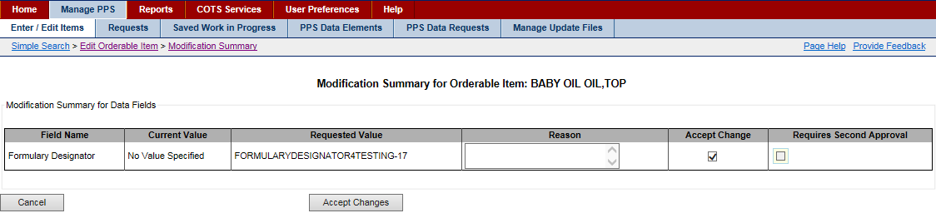

Figure 10: Modification Summary for Orderable Item Page

### Edit NDC

This page allows you to view, modify, approve, or reject existing or newly created NDC items.

**To Edit:**

1. In the search results list, click a link in the NDC column. The system opens the Main tab.
2. Update data on tabs as necessary. For more information on an individual tab, see the NDC-Related Edit Tabs list below.
3. Click the Submit button. The system opens the Modification Summary for NDC page.
4. Review changes.
5. If you need to make corrections, click the Cancel button to return to the previous page. Otherwise, complete the summary page.
6. In Reason, enter a reason for the change.
7. In Accept Change, click the check box to add or remove a check mark to include or exclude the change.
8. Click the Accept Changes button. A confirmation message appears: Your changes have been committed.
9. Click the OK button to acknowledge the message. The system displays the Request Tab.

**NDC-Related Edit Tabs**

|  |  |  |  |
| --- | --- | --- | --- |
| Main Tab | Price Tab | History Tab | A - Z Tab |

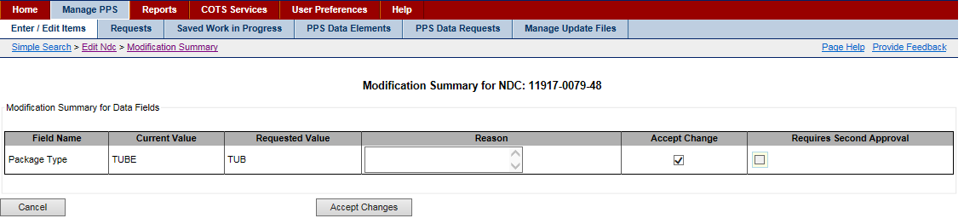

Figure 11: Modification Summary for NDC Page

### Copy NDCs to New Product

**To Copy:**

1. In a product search results list, click the link in the VA Product Name column of the product with the NDCs you want to copy. The system opens the National Data tab.
2. Click the Show All Tabs link to display additional tabs. The system opens the additional tabs.
3. Click the NDC tab. The system displays a table with the NDCs associated with the product.
4. In the Select column, click the check box beside one or more NDCs in the table. Or, click the Select All button below to select all NDCs in the table.
5. Click the Copy NDCs to New Product button. The system displays the Add New National Product page.

**To Add New National Product:**

1. Make appropriate changes on the page. See Add Product for more information.
2. Click the Submit button. The system displays a Confirmation page.
3. Review the information on the Confirmation page, and then click the Accept Changes to Product & Edit NDCs button. The system displays the Add New NDC page.
4. Make appropriate changes on the page, and then click the Submit button. The system displays a Confirmation page.
5. Review the information on the Confirmation page, and then click the Save NDC button. If you selected more than one NDC, the system displays the next NDC you selected in the Add New NDC page.
6. Repeat steps 4 and 5 for each additional NDC.
7. On the final NDC Confirmation page, click the Save Final NDC button. A confirmation message appears: Your changes have been committed.
8. Click the OK button to acknowledge the message.

### Remove Product from Orderable Item

Completing these steps removes product(s) from an orderable item; however, the product is not deleted.

**To Remove Product:**

1. In an Orderable Item search results list, click the link in the PPS OI Name column of the Orderable Item with the product you want to remove.
2. Click the Products tab. The system displays a table with the products associated with the Orderable Item.
3. In the Select column, click the check box beside one or more products in the table. Or, click the Select All button below to select all products in the table.
4. Click the Move Products button. The system displays the Enter/Edit Items tab.
5. Use the Enter/Edit Items tab to search for the same orderable item again and confirm the removal.

**To Confirm:**

1. In Search For, enter search text.
2. In Item Type, select Orderable Item from the drop-down list.
3. In Search Field, select a field from the drop-down list: PPS OI Name, OI Synonym, and All Fields.
4. In Dosage Form, enter a form.
5. Select filters in the filter fields: Category, Sub-Category, Item Status, and New Item Request.
6. Click the Search button. The system displays results in a table list.
7. In the PPS OI Name column, select a link for the orderable item from which you removed product(s).
8. Click the Products tab. The system displays a table with the products associated with the Orderable Item.
9. Verify that the product(s) has been removed.

### Remove NDCs from Product

Completing these steps removes NDC(s) from a product; however, the NDC is not deleted.

**To Remove:**

1. In a product search results list, click the link in the VA Product Name column of the product with the NDCs you want to remove. The system opens the National Data tab.
2. Click the Show All Tabs link to display additional tabs. The system opens the additional tabs.
3. Click the NDC tab. The system displays a table with the NDCs associated with the product.
4. In the Select column, click the check box beside one or more NDCs in the table. Or, click the Select All button below to select all NDCs in the table.
5. Click the Move NDCs button. The system displays the Enter/Edit Items tab.
6. Use the Enter/Edit Items tab to search for the same product again and confirm the removal.

**To Confirm:**

1. In Search For, enter search text.
2. In Item Type, select Product from the drop-down list.
3. In Search Field, select a field from the drop-down list.
4. In Strength, enter strength.
5. Select filters in the filter fields: Category, Sub-Category, Item Status, and New Item Request.
6. Click the Search button. The system displays results in a table list.
7. In the VA Product Name column, select a link for the product from which you removed NDC(s).
8. Click the NDC tab. The system displays a table with the NDCs associated with the product.
9. Verify that the NDC(s) has been removed.

After performing the search for an item type (Product, Orderable Item or NDC), you might determine that the appropriate drug does not exist in PPS-N and needs to be created. You can:

* Use an existing item as a template
* Use a blank template to create a new item

#### Use Existing to Create New

When you review an existing item, you can click a link at the bottom of the page to create a new item, using the currently selected item as a template.

**To Create:**

1. Display an item type (Product, Orderable Item, or NDC).
2. Click the Create New [item type] (from existing) link at the bottom of the page. The form for the existing item opens.
3. Update item-related fields and click the Submit button to save the new item.

See the following sections for detailed information on completing item-related fields:

* Add Product
* Add Orderable Item
* Add NDC

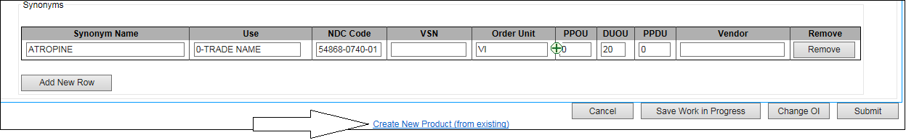

Figure 12: Create New from Existing Link

#### Use Template to Create New

If you cannot find an item closely related to the item for which you are searching, you can create a new item, using a blank template. The blank template includes only a few pre-populated fields.

To Create:

1. At the bottom of the Search Results page, click the Create New [item type] (from blank) link. The new template opens.
2. Complete item-related fields and click the Submit button to save the new item.

See the following sections for detailed information on completing item-related fields:

* Add Product
* Add Orderable Item
* Add NDC

Create New from Blank Link

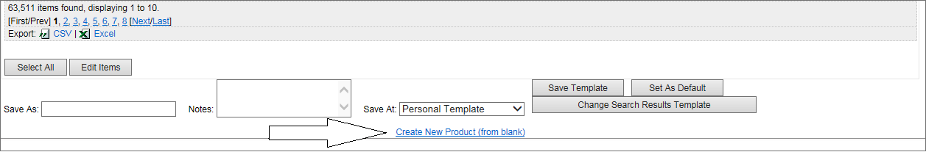

### Add Product

Whether you used a blank template or an existing product as a template, the system starts the Add New National Product wizard. The wizard contains a number of areas organized into field sets, that is, sections that are logical groupings. The field sets include:

* Define VA Product
* Define VA Drug Classes
* Define Schedule and Handling
* Define Copay Tier
* Define Miscellaneous

Each of these field sets contains fields that you might or might not complete. Fields with a red asterisk are required fields that you must complete.

The template header consists of a few empty fields just below the title Add New National Product. As you complete the template, the system updates these view-only fields.

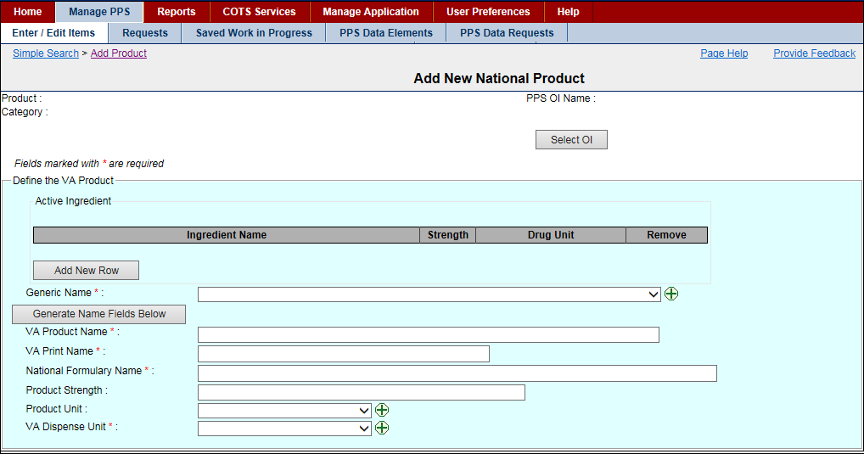

Figure 13: New Product Template - Define VA Product

**Field List Header**

Fields with a red asterisk are required fields that you must complete.

**Product**

The view-only name of the Product. This field is completed when you click the Generate Name Fields Below button to complete product-related data fields.

**Category**

The view-only Category for the product: Compound; Investigational; Medication; Supply. This field is completed when you Select a Parent for the product.

**PPS OI Name**

The Pharmacy Product System Orderable Item Name for the product and the parent of the product. This field is completed when you Select a Parent for the product.

**Field List Define the VA Product**

**Active Ingredient Table**

Click the Add New Row button to add a new row of enabled fields to the Active Ingredient table.

**Ingredient Name**

Select an Ingredient Name from the drop-down list.

If you don't find the ingredient name you need, click add_button.png. The system opens the Add Ingredient Name page that you can use to add the ingredient.

**Drug Unit**

Select a Drug Unit from the drop-down list.

If you don't find the unit you need, click add_button.png. The system opens the Add Drug Unit Name page that you can use to add the ingredient.

**Remove**

Click the Remove button to remove the active ingredient from the table.

Generic Name \*

Select a Generic Name from the drop-down list.

If you don't find the name you need, click add_button.png. The system opens the Add Generic Name page that you can use to add the name.

**Generate Name Fields Below Button**

Click this button to complete fields below automatically. To use this shortcut, you must have already, selected a parent, added active ingredients, and selected a generic name.

VA Product Name \*

Enter the VA Product Name.

VA Print Name \*

Enter the VA Print Name.

National Formulary Name \*

Enter the National Formulary Name.

Product Strength \*

Enter the Product Strength.

**Product Unit**

Select a Product Unit from the drop-down list.

If you don't find the unit you need, click add_button.png. The system opens the Add Drug Unit Name page that you can use to add the ingredient.

VA Dispense Unit \*

Select a VA Dispense Unit from the drop-down list.

If you don't find the unit you need, click add_button.png. The system opens the Add Dispense Unit Name page that you can use to add the ingredient.

**To Define VA Product:**

1. In the header, click the Select OI button to select a parent for the new product.
2. In Active Ingredient, click the Add New Row button to add active ingredients.
3. For product, add product-related data.
4. Define VA Drug Classes.

**To Select a Parent:**

1. Click the Select OI button. The Orderable Item Search page opens.
2. In Search For, enter search text.
3. In Dosage Form, enter a dosage form.
4. In Item Status, click one or more statuses.
5. In New Item Request, click one or more states.
6. Click the Search button. The system displays results in a list below.
7. Locate the orderable item you want to add as the parent to the new product you are creating.
8. Click the link in the PPS OI Name column. The system re-displays the template with completed fields based on the parent you selected.
9. Notice that the header includes the parent name and category, and the system updated the button name to Change OI.
10. Add Active Ingredients.

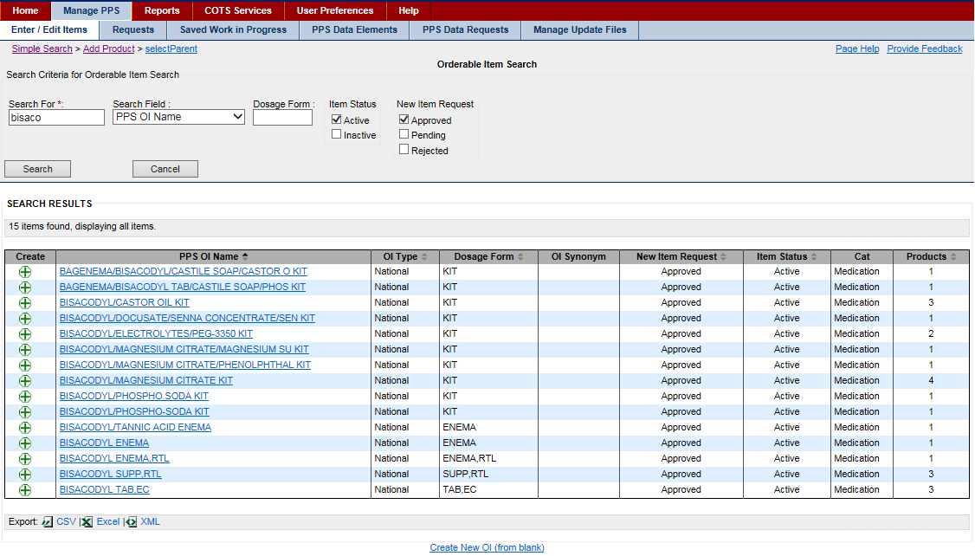

Figure 14: Select Parent Page

**Field List Select Parent Page**

**Create**

Click the add icon add_button.pngto open the Add New Orderable Item template. See Add Orderable Item for more information on completing this task.

**PPS OI Name**

Click the link in this column to select the orderable item as the parent of the new product you are adding.

**OI Type**

The view-only Orderable Item Type

**Dosage Form**

The view-only Dosage Form

**OI Synonym**

The view-only Orderable Item Synonym

**New Item Request**

The view-only state of the New Item Request: Approved, Pending, Rejected

**Item Status**

The view-only status of the Item Status: Active or Inactive

**Cat**

The view-only Category: Compound; Investigational; Medication; Supply

**Products**

The view-only number of Products associated with the PPS OI Name

**Buttons and Links**

**Search**

Update search fields and click this button again to continue searching for a parent.

**Cancel**

Click this button discard changes and return to the previous page.

**CSV or Excel**

Click the CSV or Excel link to export search results.

**To Add Active Ingredients:**

1. Click the Add New Row button to add the new row to the Active Ingredient table.
2. In Ingredient Name, select a name from the drop-down list. Or, click the add icon add_button.pngto add an ingredient. See Add Ingredient Name for more information.
3. In Strength, enter strength.
4. In Drug Unit, select a drug unit from the drop-down list. Or, click the add icon add_button.pngto add a drug unit name. See Add Drug Unit Name for more information.
5. Click the Add New Row button to add additional rows if you need to add additional active ingredients.
6. Click the Remove button beside any ingredients you want to remove from the list.
7. Add Product-Related Data.

**To Complete Fields Automatically:**

If you want to use the Generate Name Fields Below button to complete fields automatically, you must:

* Select a parent so that the field PPS OI Name is complete in the header.
* Add active Ingredients.
* Enter a Generic Name.

Otherwise, you can use the field list to add product-related data.

**To Add Product-Related Data:**

1. Select a generic name from the drop-down list.
2. Click the Generate Name Fields Below button to have the system complete fields automatically based on the active ingredient(s) and generic name.
3. Define VA Drug Classes.

**To Define VA Drug Classes:**

1. Click the Add New Row button to add a new drug class line to the table.
2. Select a VA drug class from the drop-down list.
3. Repeat steps 1–2 if you need to add additional drug classes.
4. Click the Primary check box beside the primary class.
5. Define Schedule and Handling.

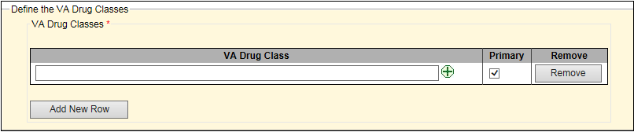

Figure 15: New Product Template - Define VA Drug Classes

**Field List Define VA Drug Classes**

**Add New Row Button**

Click the Add New Row button to add a new row of enabled fields to the VA Drug Class table.

**VA Drug Class**

Select a VA Drug Class from the drop-down list.

If you don't find the class you need, click add_button.png. The system opens the Add VA Drug Class page that you can use to add the class.

**Primary**

Click the check box beside the class that is primary to add a check mark to the box.

**Remove Button**

Click the Remove button to remove the drug class from the table.

**To Define Schedule and Handling:**

1. Complete this field set using the field list below.
2. Define Copay Tier.

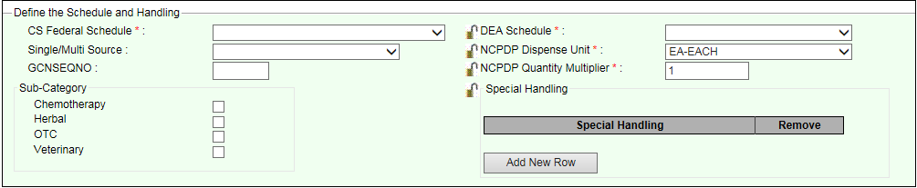

Figure 16: New Product Template - Define Schedule and Handling

**Field List Define Schedule and Handling**

Fields with a red asterisk are required fields that you must complete.

CS Federal Schedule \*

Select a Controlled Substance Federal Schedule from the drop-down list. When you make a selection in this field, the system completes the DEA Schedule field.

**Single/Multi Source**

Select a source from the drop-down list: M - Multi Source; S - Single Source; B -Both; N - Neither.

**GCNSEQNO**

Enter a Generic Code Number Sequence Number that represents a generic formulation, specific non generic ingredient(s), drug strength, dose form, and route of administration.

**Sub-Category Box**

Click one or more of the check boxes to indicate a Sub-Category for the product: Chemotherapy; Herbal; OTC; Veterinary.

DEA Schedule \*

This field is automatically completed when you select a CS Federal Schedule. You can select another option from the drop-down list: 0 - Unscheduled; 1 - Schedule 1 Item; 2 - Schedule 2 Item; 3 - Schedule 3 Item; 4 - Schedule 4 Item; 5 - Schedule 5 Item; 6 - Legend Item; 9 - Over the Counter.

Click the lock icon Graphic Open Lock to lock the field so that it cannot be changed. The system changes the icon Graphic Closed Lock. The lock is a toggle, which can be clicked to lock or unlock the field.

NCPDP Dispense Unit \*

This field defaults to EA-EACH. Select a National Council for Prescription Drug Programs (NCPDP) Dispense Unit from the drop-down list.

Click the lock icon Graphic Open Lock to lock the field so that it cannot be changed. The system changes the icon Graphic Closed Lock. The lock is a toggle, which can be clicked to lock or unlock the field.

NCPDP Quantity Multiplier \*

This field defaults to 1. Enter a National Council for Prescription Drug Programs Quantity Multiplier.

Click the lock icon Graphic Open Lock to lock the field so that it cannot be changed. The system changes the icon Graphic Closed Lock. The lock is a toggle, which can be clicked to lock or unlock the field.

**Special Handling**

Click the Add New Row button add a new row to the Special Handling table.

Click the lock icon Graphic Open Lock to lock the field so that it cannot be changed. The system changes the icon Graphic Closed Lock. The lock is a toggle, which can be clicked to lock or unlock the field.

**Special Handling**

Select a Special Handling option from the drop-down list. See Add Special Handling Code for more information on the source of this list.

**Remove Button**

Click the Remove button beside a special handling code to remove it from the table.

**To Define Miscellaneous:**

1. Use the field list below to complete the miscellaneous fields.
2. Submit Product-Related Data.

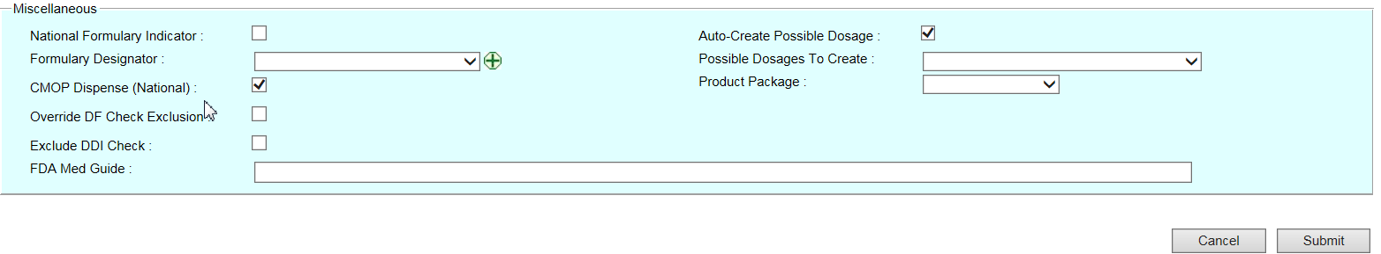

Figure 17: New Product Template - Define Miscellaneous

**Field List Define Miscellaneous**

**National Formulary Indicator**

Click the check box to add a check mark to turn on the National Formulary Indicator.

**Formulary Designator**

Click the drop down menu to select the pre-defined formulary designator, or click add_button.png to open text box to enter a different formulary designator and description.

**CMOP Dispense (Nation)**

Click the check box to add a check mark to turn on the Consolidated Mail Outpatient Pharmacy Dispense indicator.

**Override DF Check Exclusion**

Click the check box to add a check mark to turn on the Override Drug File Check Exclusion indicator.

**Exclude DDI Check**

Click the check box to add a check mark to turn on the exclude Drug-Drug Interaction Check indicator.

**FDA Med Guide**

Enter the name of the Food and Drug Administration Medication Guide.

**Auto-Create Possible Dosage**

Click the check box to add a check mark to turn on the Auto-Create Possible Dosage indicator.

**Possible Dosages To Create**

Select a Possible Dosage To Create option from the drop-down list.

**Product Package**

Select a Product Package from the drop-down list.

**To Submit Product-Related Data:**

1. After completing all field sets, click the Submit button. The system audits the page and displays the Confirmation page.
2. Review the information on the confirmation page. Any warning messages appear at the top of the Confirmation page. Warnings are for informational purposes only, meaning that the data in the page has been saved to the system.
3. If you need to make changes, click the Return button to return to the previous page and make changes.
4. Click the Submit button. The system audits the page and displays the Confirmation page again.

Complete any of these actions:

* Click the Accept Changes button to save the item to the database. The system saves the item and re-displays the Search Results page.
* Click the Add More Details button to save the item to the database. The system saves the item and opens the Edit tabs where you can add additional information about this item.
* Click the Accept Changes to Product & Create Blank NDC button save the item to the database. The system saves the item, and opens a blank child template that you can use to create a child using this item as its parent.

### Add Orderable Item

Whether you used a blank template or an existing product as a template, the system starts the Add New Orderable Item wizard. The wizard contains a set of fields that defines the uniqueness of the orderable item.

The template header consists of a few empty fields just below the title Add New Orderable Item. As you complete the template, the system updates these view-only fields. Header fields include: PPS OI Name; New Item Request (Status).

**To Add New Orderable Item:**

1. Complete fields using the field list below.
2. Click the Submit button to have the system audit the page and display the confirmation page. Any warning messages appear at the top of the confirmation screen. Warnings are for informational purposes only, meaning that the data in the page has been saved to the system.
3. If you need to make changes, click the Return button to return to the previous page and make changes.
4. Click the Submit button to have the system audit the page and display the Confirmation page again.

Complete any of these actions:

* Click the Accept Changes button. The system saves the orderable item to the database and opens the Search Results page.
* Click the Add More Details button. The system saves the orderable item to the database and opens the Edit tabs (Details, Safety, Labs & Vitals, Product, History, and A–Z) where you can add additional information about this orderable item.
* Click the Accept Changes to Product & Create New Product (from blank) button. The system saves the orderable item to the database and opens a blank child template that you can use to create a child using this orderable item as its parent.

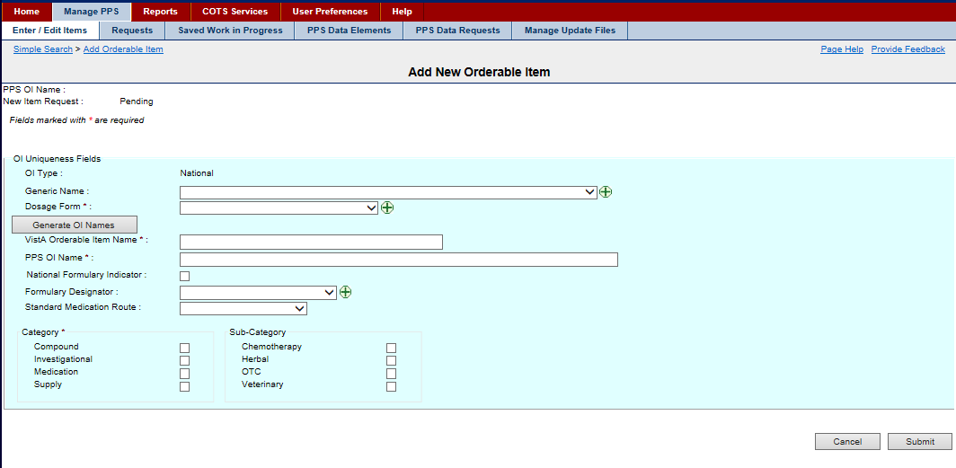

Figure 18: New Orderable Item Template

**Field List Header**

The system completes header fields.

**PPS OI Name**

The view-only name of the orderable item

**New Item Request**

The view-only status of the request

**Field List OI Uniqueness Fields**

Fields with a red asterisk are required fields that you must complete.

**OI Type**

The view-only Orderable Item Type; for example, National

**Generic Name**

Select a Generic Name from the drop-down list. Click the add icon add_button.pngto add a new generic name. See Add Generic Name for more information.

Dosage Form \*

Select a Dosage Form from the drop-down list. Click the add icon add_button.pngto add a new dosage form. See Add Dosage Form Name for more information.

**Generate OI Names Button**

Click this button to generate entries for the remaining fields automatically.

VistA Orderable Item Name \*

Enter a VistA Orderable Item Name.

PPS OI Name \*

Enter a Pharmacy Product System Orderable Item Name.

**National Formulary Indicator**

Click this check box to add a check mark for orderable items that have a national formulary.

**Formulary Designator**

Select the Formulary Designator from the drop-down list. Click the add icon add_button.pngto add a new formulary designator.

Note: After the National Formulary Indicator and Formulary Designator fields are entered, that these two fields are independent of each other.

**Standard Medication Route**

Select a Standard Medication Route from the drop-down list. See Edit Standard Med Route Name for more information on entries in this list.

Category Box \*

Click the check box beside the appropriate Category Box: Compound; Investigational; Medication; Supply.

**Sub-Category Box**

Click one or more of the check boxes to indicate a Sub-Category for the orderable item: Chemotherapy; Herbal; OTC; Veterinary.

### Add NDC

Whether you used a blank template or an existing product as a template, the system starts the Add New NDC wizard. The wizard contains a number of areas organized into field sets, that is, sections that are logical groupings. The field sets include:

* NDC Information
* Pill Information

The template header consists of a few empty fields just below the title Add New NDC. As you complete the template, the system updates these view-only fields. Header fields include: NDC; Request Status; Product; Generic Name.

**To Add NDC:**

1. Click the Select Product button. The system opens the Product Search page.
2. Search for and select a product as the parent for the NDC. The system re-displays the template with completed fields based on the parent you selected.
3. Complete fields for NDC and Pill Information using the field lists below.
4. Click the Submit button. The system displays the Confirmation page. Any warning messages appear at the top of the confirmation screen. Warnings are for informational purposes only, meaning that the data in the page has been saved to the system.
5. If you need to make changes, click the Return button to return to the previous page and make changes.
6. Click the Submit button to have the system audit the page and display the Confirmation page again.

Complete any of these actions:

* Click the Accept Changes button. The system saves the NDC to the database and opens the Search Results page.
* Click the Add More Details button. The system saves the NDC to the database and opens the Edit tabs (Main, Price, History, and A–Z) where you can add additional information about this NDC.

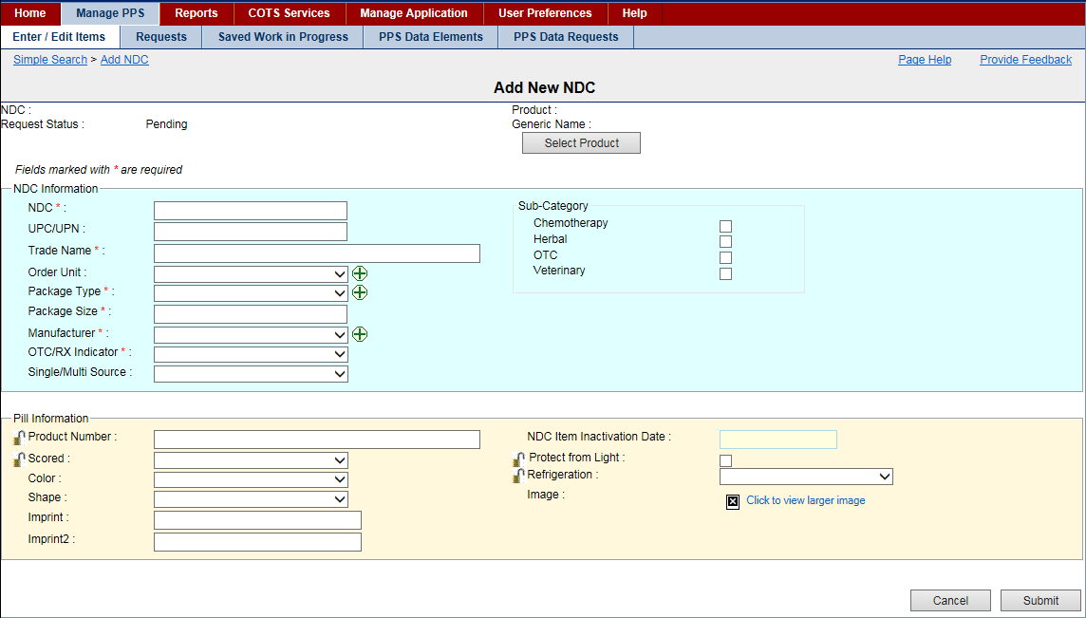

Figure 19: New NDC Template

Field List Header

The system completes header fields.

NDC

The view-only National Drug Code

Request Status

The view-only status of the request

Product

The view-only name of the parent Product

Generic Name

The view-only Generic Name for the drug

Select Product

Click this button to open Product Search page, which you can use to search for and select a parent for the NDC.

Field List NDC Information

Fields with a red asterisk are required fields that you must complete.

NDC \*

Enter a National Drug Code.

UPC/UPN

Enter a Universal Product Code or Universal Product Number.

Trade Name \*

Enter a Trade Name.

Order Unit

Select an Order Unit from the drop-down list. Click the add icon add_button.pngto add a new order unit. See Add Order Unit Abbreviation for more information.

Package Type \*

Select a Package Type from the drop-down list. Click the add icon add_button.pngto add a new package type. See Add Package Type Name for more information.

Package Size \*

Enter a Package Size.

Manufacturer \*

Select a Manufacturer name from the drop-down list. Click the add icon add_button.pngto add a new manufacturer name. See Add Manufacturer Name for more information.

OTX/RX Indicator \*

Select a type from the drop-down list: Over the Counter (OTX) or Prescription (Rx).

Single/Multi Source

Select a source from the drop-down list: M - Multi Source; S - Single Source; B -Both; N - Neither.

Sub-Category Box

Click one or more of the check boxes to indicate a Sub-Category for the NDC: Chemotherapy; Herbal; OTC; Veterinary.

Field List Pill Information

Product Number

Enter a Product Number.

Click the lock icon Graphic Open Lock to lock the field so that it cannot be changed. The system changes the icon Graphic Closed Lock. The lock is a toggle, which can be clicked to lock or unlock the field.

Scored

Select a fraction that the drug can be scored by from the drop-down list: 0.25, 0.33, and 0.5.

Click the lock icon Graphic Open Lock to lock the field so that it cannot be changed. The system changes the icon Graphic Closed Lock. The lock is a toggle, which can be clicked to lock or unlock the field.

Color

Select a Color for the drug from the drop-down list.

Shape

Select a Shape for the drug from the drop-down list.

Imprint

Enter the Primary imprint for the drug.

Imprint 2

Enter the Secondary imprint for the drug.

NDC Item Inactivation Date

Enter an Inactivation Date using the format DD-Mon-YYYY.

Product from Light

Click this check box if the NDC should be protected from light.

Click the lock icon Graphic Open Lock to lock the field so that it cannot be changed. The system changes the icon Graphic Closed Lock. The lock is a toggle, which can be clicked to lock or unlock the field.

Refrigeration

Select an option for the drug from the drop-down list: Do Not Refrigerate; Refrigerate.

Click the lock icon Graphic Open Lock to lock the field so that it cannot be changed. The system changes the icon Graphic Closed Lock. The lock is a toggle, which can be clicked to lock or unlock the field.

Image

The uploaded Image of the NDC. Click the Click to view larger image link to open a larger image of the label.

### Perform Advanced Search

This function allows you to search using customized and multiple search criteria.

To Search:

1. Click the Enter/Edit Items tab. The system opens the Simple Search page.
2. Click the Advanced Search link. The Advanced Search page opens.

Complete any of these actions:

* Retrieve Saved Search Template
* Complete an Advanced Search

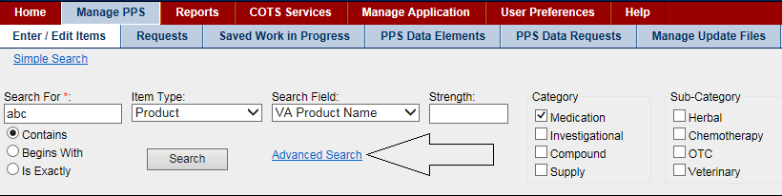

Figure 20: Advanced Search Link

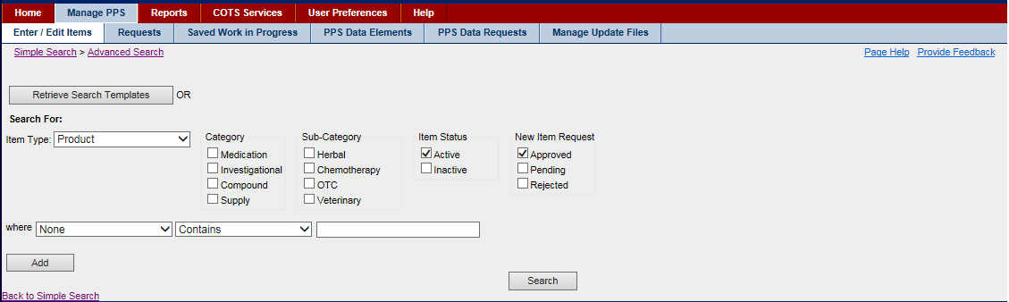

Figure 21: Advanced Search Page

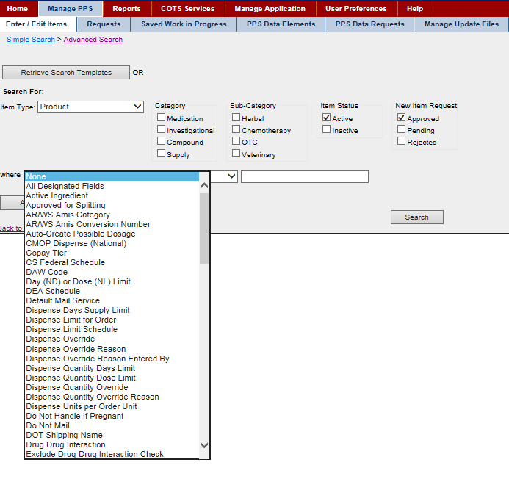

Figure 22: Advanced Search Product Drop Down Menu

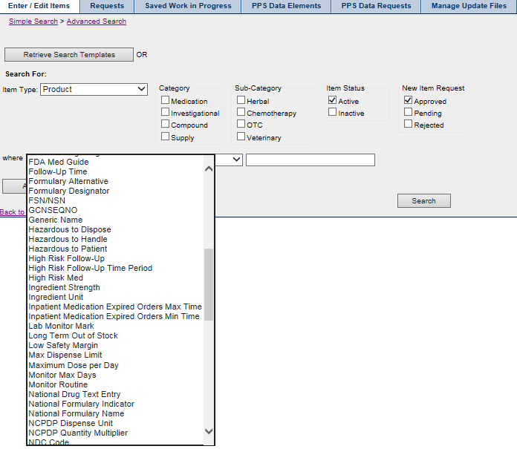

Figure 23: Advanced Search Product Drop Down Menu

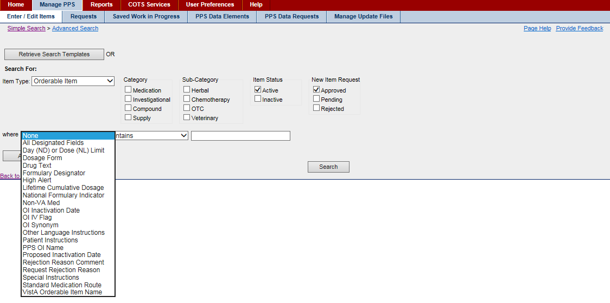

### Retrieve Saved Search Template

If a personal or national search template has been added to the system, you can complete your search using the save search template.

To Retrieve Saved Search Template:

1. On the Advance Search page, click the Retrieve Search Templates button. The system opens the Search Templates page and displays the available search templates in a table.
2. To open a template and perform the search, click the hyper linked template name in Change Search Results Template the Template Name column. The system opens the template.
3. Click the Search button. The system displays results in a table list below.

After you have search results, complete any of these tasks:

* View Search Results
* Export Search Results
* Edit Product
* Edit Orderable Item
* Edit NDC
* Add New Items
* Save Search Template (if this search is one that you will do repeatedly)
* Change Search Results Template

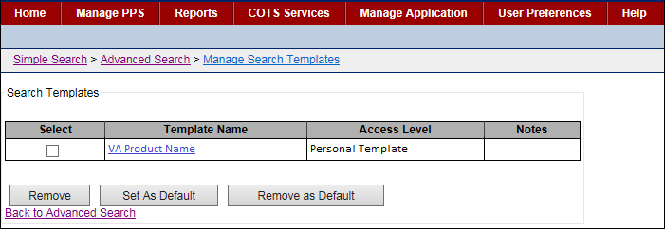

Figure 24: Search Template Page

Field List Template Page

Select

Click this check box to add a check mark beside a template and use a button below to complete a task. For example, click the Remove button to delete the template.

Template Name

Click the hyper linked Template Name to open the search results template. When adding a template, be sure to use a descriptive name that enables you to find the template again easily.

(Default) displays after the template name when the template has been selected as the default. The default template displays automatically when you open the Advanced Search page.

Access Level

This view-only field describes the type of template.

* Personal Template - A user-created template, which is available only to the user who created the template.
* National System Template - A supervisor-created template, which is available to all users.

Notes

This view-only field show notes that further describe the template.

Buttons

Remove

Click the check box beside a template in the Select column, and then click the Remove button to remove a personal template.

Set As Default

Click the check box beside a template in the Select column, and then click the Set as Default button. The system adds (Default) to the template name and opens the template automatically when you open the Advanced Search page. You are able to make changes after the default template opens.

Remove as Default

Click the check box beside the default template in the Select column, and then click the Remove as Default button. The system disables the automatic display of the default template. The Advance Search page opens. This action does not delete the template.

### Complete Advanced Search

If you do not have a saved search template, you can perform an advanced search. If the search is one that you will do repeatedly, you can save the search as a template.

To Complete a Search:

1. On the Advance Search page, select an Item Type from the drop-down list: Product, Orderable Item, or NDC.
2. Select filters to further restrict search results. Select options from lists: Category, Sub-Category, Item Status, and New Item Request.
3. Select search parameters. Make selections in the Item-Type-based fields displaying below the filters.
4. Click the Search button. They system displays the search results in a table below.

If the system returns too many results, add parameters to refine the search.

1. Click the Add button. The system adds a set of parameter fields.
2. Select AND or OR from the drop-down list at the end of the first set of parameter fields.
3. Set the additional search parameters in the second set of parameter fields.
4. Click the Search button. The system displays the search results in a table below.

After you have search results, complete any of these tasks:

* View Search Results
* Export Search Results
* Edit Product
* Edit Orderable Item
* Edit NDC
* Add New Items
* Save Search Template (if this search is one that you will do repeatedly)
* Change Search Results Template



Figure 25: Advanced Search Page

### Save Search Template

Look for additional buttons and fields at the bottom of the results page. You can use the buttons and fields to save the advanced search as a search template.

* Users with the role of Supervisor can save National Templates.
* Users with other roles can save Personal Templates.

To Save:

1. In Save As, enter a name for the search template. Be descriptive.
2. In Notes, enter additional text related to the template.
3. In Save At, select a template type from the drop-down list: Personal Template or National Template. To save a National Template, you must have the PPS-N Supervisor role assigned to you.
4. Click the Save Template button to save the template or click the Set As Default button to save the template and set it as the default template to open when you select the Advanced Search link.
5. In addition, you can click the Change Search Results Template to pick the columns you want to display in the search results table.

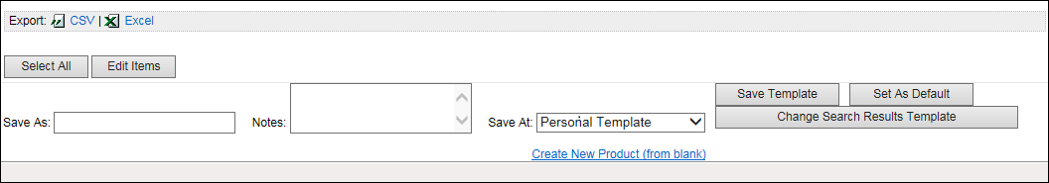

Figure 26: Save Search Template Buttons and Fields

### Change Search Results Template

You can pick the columns you want to display in the search results table for the associated search template.

To Pick Columns:

1. On the Save Search Template page, click the Change Search Results Template button. The system opens the Manage Print Templates page.
2. To add fields to the results template, select an entry in the Available Fields list, and click the Right move button to move the entry to the Selected Fields list.  
   Graphic Right Arrow Button
3. To remove fields from the results template, select an entry in the Selected Fields list, and click the Left move button to move the entry to the Available Fields list.  
   Graphic Left Arrow Button
4. To reposition columns in the Selected Field list, select the item in the Selected Fields list, and click the Up or Down button to move the item up or down in the list.
5. Click the Submit button. The system updates the results template with changes.
6. Be sure to note that changes to the Print Template associated with the Search Template are not permanently saved until the Search Template is saved.

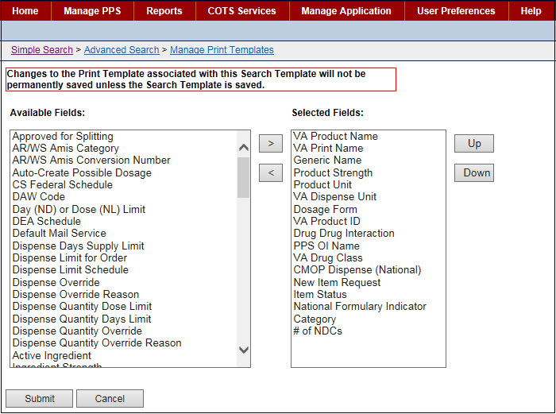

Figure 27: Change Search Results Template Page

### Requests Tab

After a new item, such as a Product, has been created and saved to the database, its approval state is Pending, indicating that it needs to be reviewed and approved. This status also applies when you make item modifications to an existing item and that change requires review and approval. These items are now considered approval requests and are made available to users with appropriate permissions to approve such requests.

#### Search Requests

To Search for Pending Requests:

1. Select the Requests tab. The system displays a page with various filters that you can use when you perform a search for pending requests. See Request Type Filters for more information.
2. Click a check box beside one or more filters.
3. Click the Search button. The system displays a table below with the requests that match the filter(s). If the system returns no results, select filters again and click the Search button.

After you have search results, complete any of these tasks:

* Approve Request
* Reject Modification Request
* Place Request Under Review
* Place Request in Pending State

To complete requests tasks, you must have the appropriate role assigned. See Identity Management for more information.

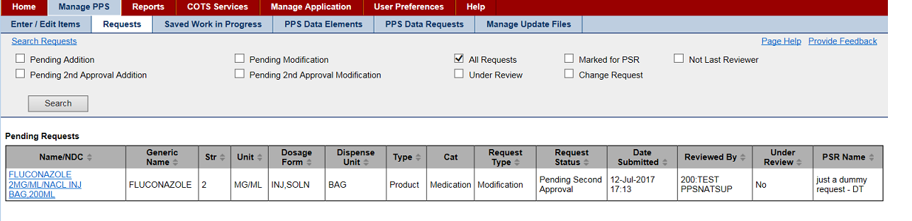

Figure 28: Pending Requests Results Page

Request Type Filters

All Requests

This filter is the default check box selection, and it displays all requests that are pending action. If you want to apply other filters, click this check box to remove the check mark.

Pending Action

Choose this filter to display those pending requests with a Request Type of Addition and a Request Status of Pending Approval.

Pending 2nd Approval Addition

Choose this filter to display those pending requests with a Request Type of Addition and a Request Status of Pending Second Approval.

Pending Modification

Choose this filter to display those pending requests with a Request Type of Modification and a Request Status of Pending Approval.

Pending 2nd Approval Modification

Choose this filter to display those pending requests with a Request Type of Modification (an existing item was changed) and a Request Status of Pending Second Approval.

Under Review

Choose this filter to display those requests that were placed Under Review.

Marked for PSR

Choose this filter to display those requests that were marked for PSR (PPS Second Reviewer).

Change Request

Choose this filter to display those requests that were marked as a Change Request.

Not Last Reviewer

Choose this filter to display those requests for which you were not the last reviewer, meaning you can approve any of those that are displayed.

#### Approve Request

To Approve Request:

1. In the Name/NDC column of the Pending Request Results page, click a link to display a request. The system opens an edit page that includes additional tab(s) and buttons.
2. Review the information. Be sure to notice the additional tabs that display. In addition, you can click the Show All Tabs link to open all tabs.
3. In the Action column, select Approved.
4. In Comment, add comments as necessary.
5. Click the Accept Actions button. The system opens the Confirmation page.
6. In New Comments, enter any comments you may have.
7. In PSR Name, enter the name of the Pharmacy Product System Second Reviewer.
8. Click the Accept Actions button. The system updates the status.

Status Update

* If the request has no second review fields, the system sets the status to Approved.
* If the add request includes any second review fields, the system sets the status to Pending so that the item can be reviewed by a second reviewer.

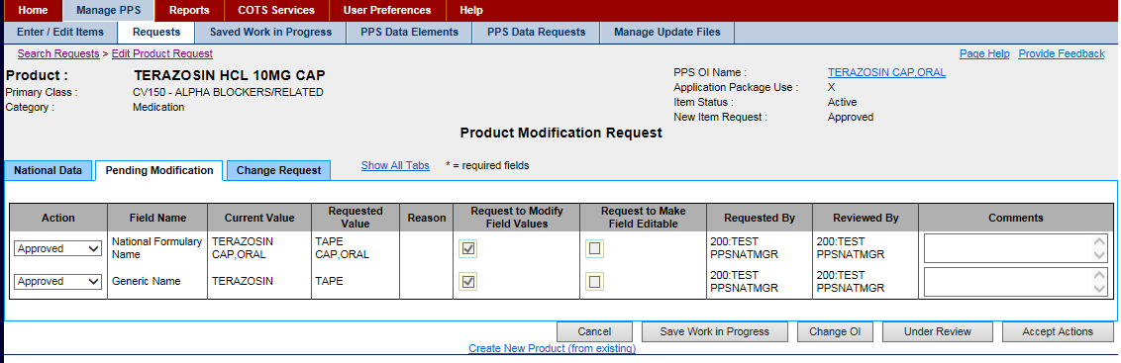

Figure 29: Product Pending Modification Tab

The page can have multiple entries in the table. You can select different actions in the Action drop-down list for each entry on the page. When you click the Accept Actions button, the system cycles through each action.

Field List Product Addition Request Confirmation Page

Action

Select a state from the drop-down list: Approved, Rejected, Pending.

Field Name

The view-only name of the field where the change was made.

Current Value

The view-only original value of the field

Requested Value

The view-only modified value of the field

Reason

The view-only reason that the change is being submitted

Request to Modify Field Values

If the box is checked, the field can be edited.

If the box is unchecked, the field is view-only.

This field is completed by a local manager and it will not be useful until PPS-L is released.

Request to Make Field Editable

If the box is checked, the request is to enable the field so that it can be edited.

If the box is unchecked, the request is to disable the field so that it cannot be edited.

This field is completed by a local manager and it will not be useful until PPS-L is released.

Requested By

The view-only role name of the user who made the request

Requires Second Approval

This field is checked if a change to this row requires a second review of the change.

Reviewed By

The view-only role name of the user who reviewed the request

Comments

Enter additional information as necessary.

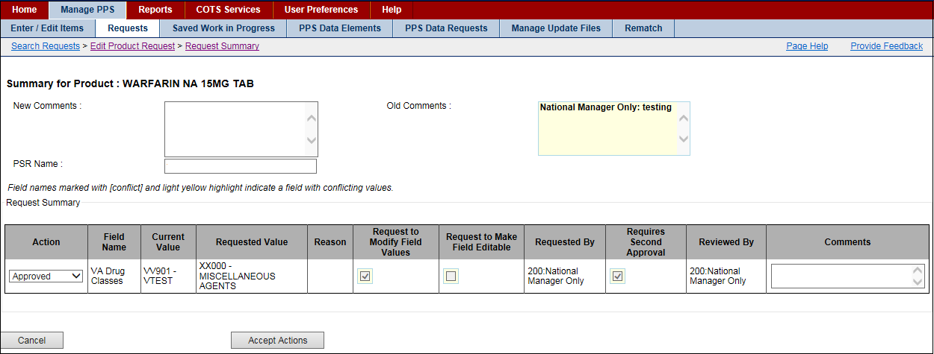

Figure 30: Product Addition Request Confirmation Page

To Reject Request:

1. In the Name/NDC column of the Pending Request Results page, click a link to display a request. The system opens an edit page that includes additional tab(s) and buttons.
2. Review the information.
3. Click the Reject Product button. The system opens the rejection details page.
4. In Request Rejection Reason, select a reason from the drop-down list.
5. In Rejection Reason Comment, enter a reason.
6. In Enter any optional comments here, enter any comments you may have.
7. Click the Submit button. The system updates the database.

To Reject a Few Entries in a Request:

1. In the Name column on the Pending Request Results page, click a link to display a request. The system opens an edit page with several entries and includes additional tab(s) and buttons.
2. Review the information.
3. In the Action column, select Reject from the drop-down list beside the entries you want to reject.
4. Click the Accept Actions button. The system opens a rejection details page.
5. In Request Rejection Reason, select a reason from the drop-down list.
6. In Rejection Reason Comment, enter a reason.
7. In Enter any optional comments here, enter any comments you may have.
8. Click the Submit button. The system updates the database.

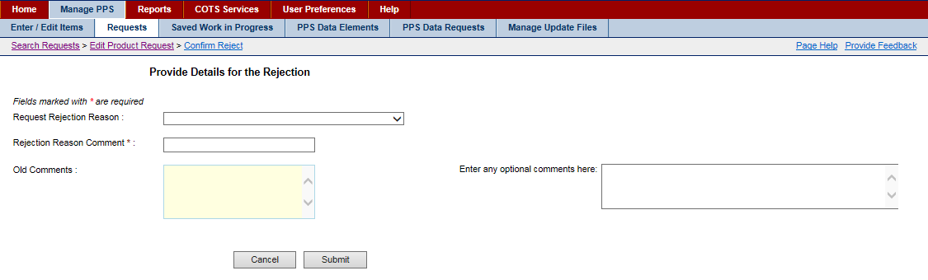

Figure 31: Product Rejection Detail Page

To Place Request Under Review:

1. In the Name/NDC column of the Pending Request Results page, click a link to display a request. The system opens an edit page that includes additional tab(s) and buttons.
2. Click the Under Review button to take no action at this time other than to place the item in the Under Review status. You can return to the Requests tab later and use the Under Review filter to locate the item.

To Place Request in Pending State:

1. In the Name/NDC column of the Pending Request Results page, click a link to display a request. The system opens an edit page that includes additional tab(s) and buttons.
2. In the Action column, select Pending to leave the request in the pending state.
3. In Comments, add a comment if necessary.
4. Click the Accept Actions button. The system updates the status to Pending.

## Saved Work in Progress Tab

When you are modifying an item, you can be interrupted and need to save your work by clicking the **Saved Work in Progress** button during various processes. Later, you can use this tab to retrieve saved work in progress.

In addition, the system automatically saves work in progress upon system time-out. The system adds the name AUTO-LOGOUT AUTO-SAVE and includes a date-time stamp for the work in progress.

Saved work in progress appears in two locations in the system and can be retrieved from either location.

* The body of the Home page
* The Saved Work in Progress tab

To Save Work:

1. On a page with a **Save Work in Progress** button, click the button. The system opens a comments page.
2. In the comment field, enter a comment to reference your work in progress. Be descriptive.
3. Click the Submit button. The system adds an entry to the Saved Work in Progress table. No changes are made to the item in the database and no request is generated.

**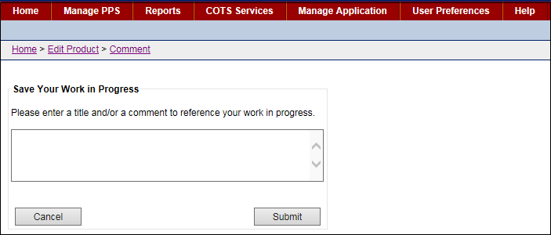**

Figure 32: Saved Work in Progress Comment Page

To Retrieve Work:

1. Click the Saved Work in Progress tab. The system opens the tab.
2. To open a work in progress item, click the link In the Comment Column. The system opens the appropriate edit page and you can continue to make more changes.

To Delete Work:

1. To delete a few items, click the check box beside one or more items in the Select column, and then click the Delete button.
2. To delete all items, click the Select All button, and then click the Delete button.

**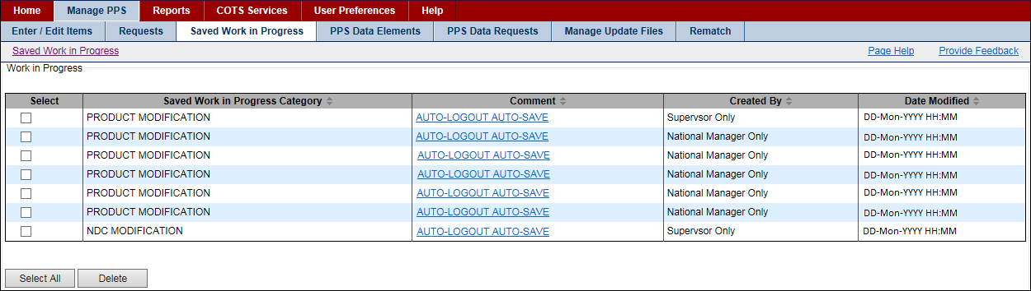**

Figure 33: Saved Work in Progress Tab

## PPS Data Elements Tab

Rather than enter text for every data field in PPS-N, the system includes a number of drop-down lists that make it easier for users to select the appropriate entry while ensuring consistency from user to user and drug to drug. These drop-down lists involve what PPS-N terms drug domains, which are lists of related data elements. These drug domains are available in the PPS Data Elements tab.

Data elements that are added or edited have a status of Pending and must be approved, edited, or rejected. See PPS Data Requests Tab for more information.

### Search for Domains

This page allows you to search for domains in the system. The results table provides a link for editing the returned items. In addition, the page includes an Open Blank Template link that you can use to add a new item.

To Search:

1. Select the PPS Data Elements tab. The system opens the PPS Search Domains page.
2. In Search Field, select a domain from the drop-down list. You can manage multiple domain lists within PPS-N. The Search Field drop-down list shows the types of domains that can be viewed and edited. Of note, Standard Med Route Name items are view-only; you cannot edit them.
3. In For, enter search criteria text. For example, enter amino.
4. Make selections in the following filter list: Item Status and New Item Request.
5. Click the Search button. The system displays results in a table list below.

After you have search results, complete any of these tasks:

* View and Edit Domain Fields
* Delete Domain
* Inactivate Domain
* Handle Domain Item Modification Errors
* Create New Domain Items

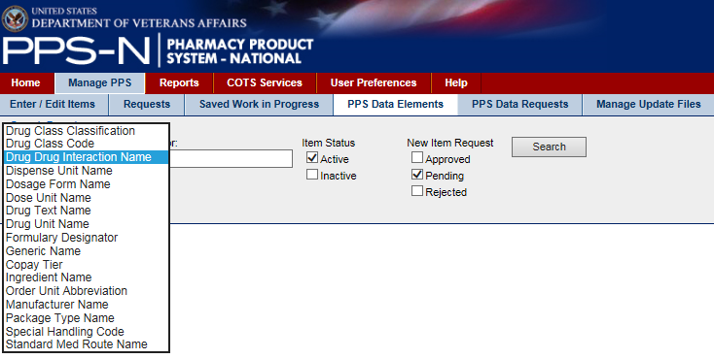

Figure 34: PPS Data Elements Search Field

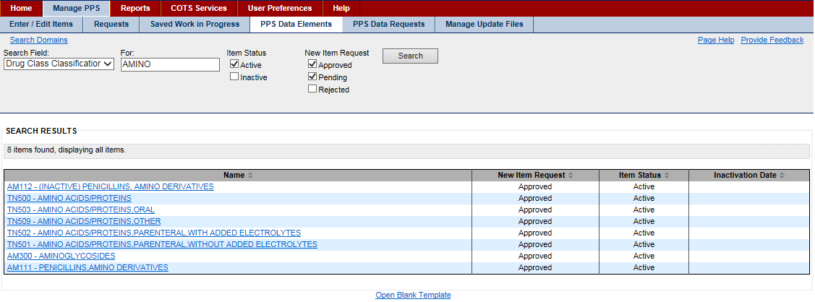

Figure 35: PPS Data Elements Search Results

### View and Edit Domain Fields

To View and Edit Domain Fields:

1. In the Search for Domains results page, click the item link in the Name column. The system displays the A–Z tab, which lists all the related data fields with current values.
2. To edit a data field, click the link in the Field Name column. The system displays a pop-up window with current values for that field. The system displays a pop-up window with current values for that field. See the List of Domains below for links to pages that provide field details for each domain item.
3. In the pop-up window, make changes in the editable value fields, and then click the Save Changes button. The system closes the pop-up window and updates the Current Value for the field in the A–Z tab.
4. Continue making and saving changes as necessary.
5. After you are finished making changes to fields, click the Submit button on the A–Z tab. The system displays a Confirmation page that includes a table with a summary of the changes you made.
6. Review the changes in the table.
7. If the changes are correct, click the Accept Changes button to save changes to the database. The status of the item is Pending and it must be approved, edited, or rejected. See PPS Data Requests for more information.
8. If the changes need to be undone or edited, click the Cancel button. The system displays the A–Z tab, where you can continue making changes.

Reference

See the following topics for more information on tabs:

* A–Z tab
* History tab

List of Domains

|  |  |
| --- | --- |
| Edit Drug Class | Edit Generic Name |
| Edit Dispense Unit Name | Edit Ingredient Name |
| Edit Dosage Form Name | Edit Manufacturer Name |
| Edit Dose Unit Name | Edit Order Unit Abbreviation |
| Edit Drug Text Name | Edit Package Type Name |
| Edit Drug Unit Name | Edit Special Handling Code |
| Edit Formulary Designator | Edit Standard Med Route Name |
| Edit Copay Tier |  |

To Delete Domain:

1. In the Search for Domains results page, click the item link in the Name column. The system displays the A–Z tab, which lists all the related data fields with current values.
2. Click the Delete button below the current value table. The system deletes the domain.

You cannot delete a domain that has already been synchronized with the National Drug File.

To Inactive Domain:

1. In the Search for Domains results page, click the item link in the Name column. The system displays the A–Z tab, which lists all the related data fields with current values.
2. Click the Inactivate button below the current value table. The system updates the domain status to Inactive with the current date.
3. If you need the change the inactivation date, click the Inactivation Date link. The system opens a pop-up.
4. Enter a date, and then click the Save Changes button. The system closes the pop-up and updates the inactivation date.
5. Click the Submit button. The system displays the modification summary.
6. If the changes are correct, click the Accept Changes button to save changes to the database. The status of the item is Pending and it must be approved, edited, or rejected. See PPS Data Requests for more information.
7. If the changes need to be undone or edited, click the Cancel button. The system displays the A–Z tab, where you can continue making changes.

### Handle Domain Item Modification Errors

When the PPS Domain Confirmation page display, it can display with an error message that prevents the modification. For example, if you attempted to inactivate a Dosage Form that has other orderable items dependent on it, the system displays the following error:

The system is unable to inactivate this Dosage Form because 10 Orderable Items(s) including ACETAMINOPHEN-N TAB depend on it being active.

Click Cancel to cancel the modification. Before the domain item can be inactivated, you must revise the affected items. In the case of the example, you would edit the 10 Orderable Items(s) that include ACETAMINOPHEN-N TAB.

### Create New Domain Item

If the system does not return the domain item you are searching for, you can create a new domain item using a template. Each of the domain templates is different. Some templates are short, while others, like the Dosage Form Name template, have many fields. When the page appears, complete the relevant fields, and as a minimum, complete all required fields.

To Create New Domain Item:

1. In the Search for Domains results page, click the Open Blank Template link at the bottom of the page. The system opens a domain template based on the Search Field selection.
2. Complete the domain template. Click a link in the List of Domains below to see a field list for the domain.
3. Click the Submit button. The system saves the domain item to the database with a Pending status and it must be approved, edited, or rejected. See PPS Data Requests for more information.

List of Domains

|  |  |
| --- | --- |
| Add Drug Class | Add Generic Name |
| Add Dispense Unit Name | Add Ingredient Name |
| Add Dosage Form Name | Add Manufacturer Name |
| Add Dose Unit Name | Add Order Unit Abbreviation |
| Add Drug Text Name | Add Package Type Name |
| Add Drug Unit Name | Add Special Handling Code |
| Add Formulary Designator |  |

The additional domain menu option Standard Med Route Name has no add function. Standard Medication Routes are added through the STS web services. See the System Data tab for more information.

## PPS Data Requests Tab

### View Pending Domain Item Requests

To Search for Requests:

1. Select the PPS Data Requests tab. The system displays a page with various filters that you can use when you perform a search for pending requests. See Request Type Filters for more information.
2. Click a check box beside one or more filters.
3. Click the Search button. The system displays a table below with the requests that match the filter(s). If the system returns no results, select filters again and click the Search button.

After you have search results, complete any of these tasks:

* Approve Addition Request
* Approve Modification Request
* Reject Addition or Modification Request
* Place Request Under Review
* Place Request in Pending State
* Inactivate Request

To complete requests tasks, you must have the appropriate role assigned. See Identity Management for more information.

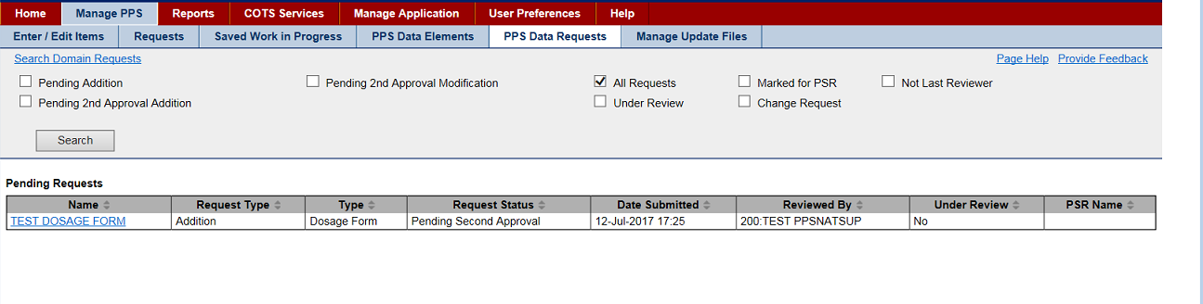

Figure 36: Pending Domain Item Requests Results Page

Request Type Filters

All Requests

This filter is the default check box selection, and it displays all requests that are pending action. If you want to apply other filters, click this check box to remove the check mark.

Pending Action

Choose this filter to display those pending requests with a Request Type of Addition and a Request Status of Pending Approval.

Pending 2nd Approval Addition

Choose this filter to display those pending requests with a Request Type of Addition and a Request Status of Pending Second Approval.

Pending 2nd Approval Modification

Choose this filter to display those pending requests with a Request Type of Modification (an existing item was changed) and a Request Status of Pending Second Approval.

Under Review

Choose this filter to display those requests that were placed Under Review.

Marked for PSR

Choose this filter to display those requests that were marked for PSR (PPS Second Reviewer).

Change Request

Choose this filter to display those requests that were marked as a Change Request.

Not Last Reviewer

Choose this filter to display those requests for which you were not the last reviewer, meaning you can approve any of those that are displayed.

### Approve Pending Domain Item Addition Request

To Approve Addition:

1. In the Name column on the Pending Domain Item Requests Results page, click a link to display a request. The system opens a domain item page.
2. Review the information. Be sure to notice the additional tabs that display.
3. To edit a data field, click the link in the Field Name column. The system displays a pop-up window with current values for that field. See the List of Domains below for links to pages that provide field details for each domain item.
4. In the pop-up window, make changes in the editable value fields, and then click the Save Changes button. The system closes the pop-up window and updates the Current Value for the field in the A–Z tab.
5. Click the Approve button. The system updates the status.

Status Update

* If the request has no second review fields, the system sets the status to Approved.
* If the add request includes any second review fields, the system sets the status to Pending so that the item can be reviewed by a second reviewer.

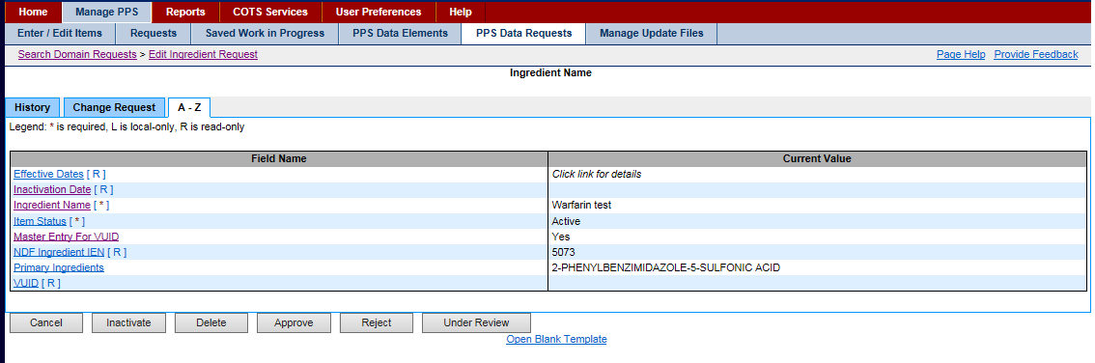

Figure 37: Domain Item Page

Reference

See the following topics for more information on tabs:

* A–Z tab
* History tab

List of Domains

|  |  |
| --- | --- |
| Edit Drug Class | Edit Generic Name |
| Edit Dispense Unit Name | Edit Ingredient Name |
| Edit Dosage Form Name | Edit Manufacturer Name |
| Edit Dose Unit Name | Edit Order Unit Abbreviation |
| Edit Drug Text Name | Edit Package Type Name |
| Edit Drug Unit Name | Edit Special Handling Code |
| Edit Formulary Designator | Edit Standard Med Route Name |
| Edit Copay Tier |  |

To Approve Modification:

1. In the Name column of the Pending Domain Item Requests page, click the link for a request type of Modification. The system opens the Pending Modification Request page or the A–Z Tab.
2. Review the information and make edits as necessary. Be sure to notice the additional tabs that display.
3. In the Action column, select Approved from the drop-down list.
4. In Comments, add a comment if necessary.
5. Click the Accept Actions button to save the changes. The system updates the status.

Status Update

* If the request has no second review fields, the system sets the status to Approved.
* If the add request includes any second review fields, the system sets the status to Pending so that the item can be reviewed by a second reviewer.

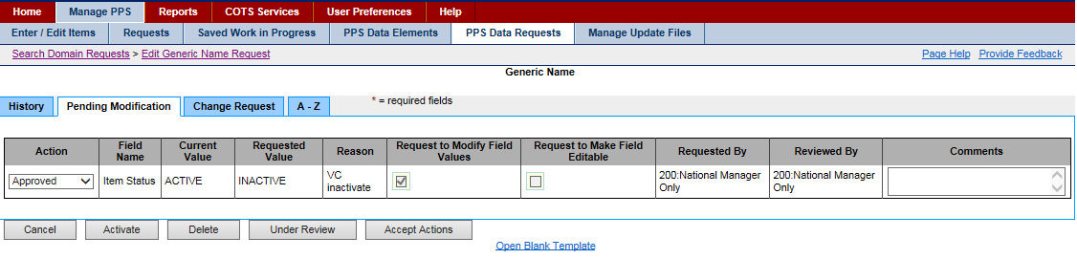

Figure 38: Pending Modification Request Page

The page can have multiple entries in the table. You can select different actions in the Action drop-down list for each entry on the page. When you click the Accept Actions button, the system cycles through each action.

Reference

See the following topics for more information on tabs:

* A–Z tab
* History tab

To Reject Request:

1. In the Name column on the Pending Domain Item Requests Results page, click a link to display a request. The system opens a domain item page.
2. Review the information.
3. Click the Reject button. The system opens a rejection details page.
4. In Request Rejection Reason, select a reason from the drop-down list.
5. In Rejection Reason Comment, enter a reason.
6. In Enter any optional comments here, enter any comments you may have.
7. Click the Submit button. The system updates the database.

To Reject a Few Entries in a Request:

1. In the Name column on the Pending Domain Item Requests Results page, click a link to display a request. The system opens an edit page with several entries and includes additional tab(s) and buttons.
2. Review the information.
3. In the Action column, select Reject from the drop-down list beside the entries you want to reject.
4. Click the Accept Actions button. The system opens a rejection details page.
5. In Request Rejection Reason, select a reason from the drop-down list.
6. In Rejection Reason Comment, enter a reason.
7. In Enter any optional comments here, enter any comments you may have.
8. Click the Submit button. The system updates the database.

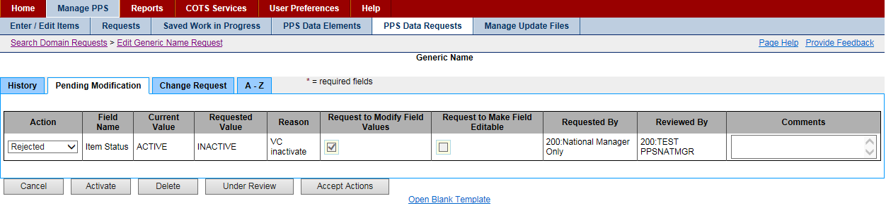

Figure 39: Domain Item Rejection Detail Page

To Place Request Under Review:

1. In the Name column on the Pending Domain Item Requests Results page, click a link to display a request. The system opens a domain item page.
2. Click the Under Review button to take no action at this time other than to place the item in the Under Review status. You can return to the Requests tab later and use the Under Review filter to locate the item.

To Place Request in Pending State:

1. In the Name column on the Pending Domain Item Requests Results page, click a link to display a request. The system opens a domain item page. See Note below.
2. In the Action column, select Pending to leave the request in the pending state.
3. In Comments, add a comment if necessary.
4. Click the Accept Actions button. The system opens a Summary page.
5. In PSR Name, enter the name of the Pharmacy Product System Second Reviewer.
6. Click the Accept Actions button. The system updates the status to Pending.

The page can have multiple entries in the table. You can select different actions in the Action drop-down list for each entry on the page. When you click the Accept Actions button, the system cycles through each action.

To Inactivate Request:

1. In the Name column on the Pending Domain Item Requests Results page, click a link to display a request. The system opens a domain item page.
2. Click the Inactivate button. The system adds the current date as the inactivation date and changes the status to Inactive. The system places the inactivation request in a Pending status and the inactivation must be approved.

## Manage Update Files Tab

Use this tab to transfer and verify any updated files. Using this tab you can see both the successful and unsuccessful PPS/NDF Update Test File statuses in the Manage Update Files History section. Updates can be done manually or automatically by scheduled process.

To use this tab, you must have the role of National Manager or National Supervisor assigned to you.

To Create Update File Manually:

1. Run the Preview Update File Report to see a list of what will be included in the update file.
2. Make any edits to PPS-N files as needed.
3. Click the Create Update File button. The system displays a status message, disables the Create Update File button, and starts the update file process. Processing can take several minutes. You can complete other tasks while processing is occurring.

As the system processes an update request, it automatically sends details of changes to the Update File to PBM designated PPS-N users and Local VistA users via Microsoft Outlook.See Update File messages for more information.

After the creation process is complete, the file is in a Pending Status. The system opens the Pending File box automatically and you can complete any of these tasks:

* Accept or Reject File
* 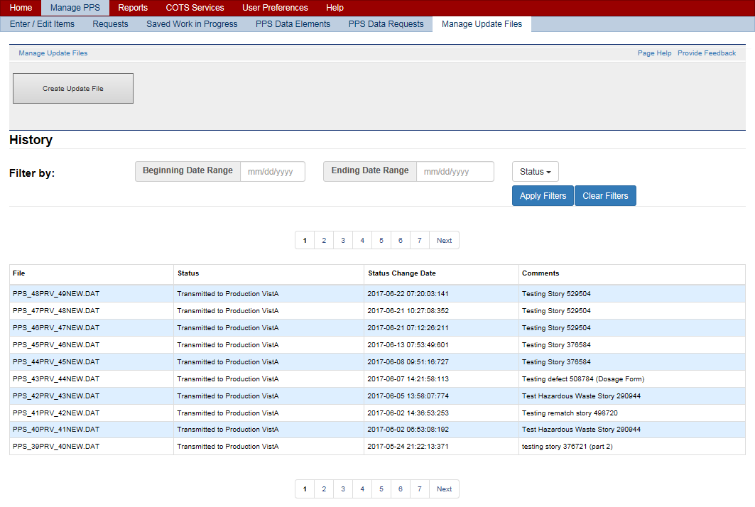Search for File in History

Figure 40: Manage Update Files Tab

**Failure Scenarios**

* Scenario 1 - User attempts to create an update file while an update file is in process
* Scenario 2 - The process fails during file creation or transmission to sFTP server
* Scenario 3 - Process fails during approval
* Scenario 4 - Process fails during rejection

To Accept or Reject File:

1. In the Pending File area of the page, select a status from the Action drop-down list: Accept or Reject.
2. In Comments, add any necessary comments.
3. Click the Submit button. The system updates the file status. For rejected files, the system renames the file and moves it to a rejected folder on the FTP server.

To Search for File in History:

1. In Beginning Date Range, enter a beginning date using the format mm/dd/yyyy.
2. In Ending Date Range, enter an ending date using the format mm/dd/yyyy.
3. In Status, select a status from the drop-down list.
4. Click the Apply Filters button. The system updates the list below based on your filter criteria.
5. After you are finished, click the Clear Filters button to restore all entries in the History list below.

Filter fields work independently of each other. Therefore, you can select a status and search based on the status alone.

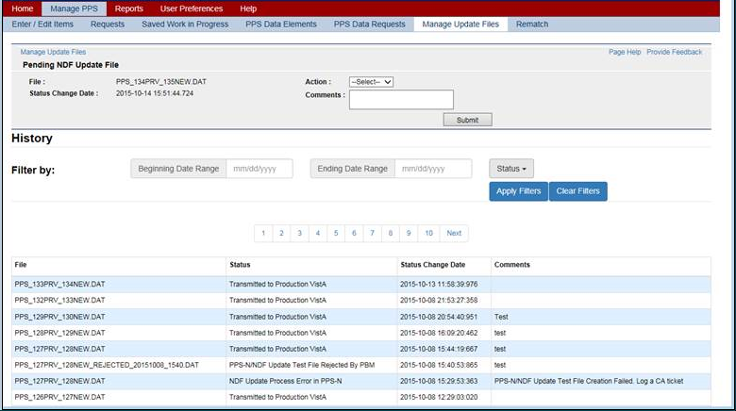

Figure 41: Manage Update Files History Tab

**Field List Pending NDF Update File**

File

The view-only name of the file.

Status Change Date

The view-only date of the change in status

Action

Select an action from the drop-down list for a test file: Approve or Reject.

Comments

Enter any comments necessary in reference to the update file.

Submit Button

Click this button to submit the action and comments.

**Field List History**

Filter By

Use these fields to narrow the list of results.

Beginning Date Range

Enter a beginning date for a search using the format mm/dd/yyyy

Ending Date Range

Enter an ending date for a search using the format mm/dd/yyyy

Status

Select a Status from the drop-down list.

Initiated   
Update processing has started.

Created   
Processing is complete and the update file has been created.

PPS-N/NDF Update Test File Transmitted to the test sFTP   
The update file has been placed in QA test directory.

Start of National VistA Processing   
The update file installation process has started manually or by scheduled process.

PPS-N/NDF Update Test File Install Successful   
The update file has been installed in the National Test account.

PPS-N/NDF Update Test File Approved by PBM  
The update file has been approved on the PPS-N Mange Update Files page.

PPS-N/NDF Update Test File Rejected by PBM  
The update file has been rejected on the PPS-N Mange Update Files page.

Transmitted to Production VistA  
The approved update file has been moved to the Production directory.

NDF Update Process Error in VistA   
The update file cannot be installed in the National Test account. In addition, if the current file status is not PPS-N/NDF Update Test File Transmitted to the test sFTP or Start of National VistA Processing, PPS-N ignores the status update sent from VistA.

NDF Update Process Error in PPS-N   
The update file cannot be transmitted to QA test directory. Or, the Approved Update File cannot be moved to the approved directory in the FTP Server.

Apply Filters

Click this button to narrow the list of results based on a date range and/or status.

Clear Filters

Click this button to clear filter fields and restore all entries in the results list.

**Manage Update Files Library**

Numbered Buttons (Files Library)

The ten most recent files appear in the results list sorted by the year and month they were generated. To see older files, use the number buttons above the result list to display older Data Update Files in descending order; that is, current to oldest file. You cannot open and view the data in the Update File on this tab. As the system processes an update request, it automatically sends details of changes to the Update File to PBM designated PPS-N users and Local VistA users via Microsoft Outlook. See Update File messages for more information.

**Field List Results List**

File

The view-only name of the File

Status

The view-only Status of the file. Statuses can have associated comments, which are generated by the system automatically.

Status Change Date

The view-only date and time of the status change for the file in the format YYYY-MM-DD HH:MM:SS.Tenths

Comments

The view-only Comments associated with the file. Some statuses generate comments automatically.

Status: NDF Update Process Error in VistA   
Comment: Automatically Rejected: Unable to Install Update File in the Test Account.

Status: NDF Update Process Error in PPS-N   
Comment: PPS-N/NDF Update Test File Creation Failed. Log a CA ticket.  
Comment: PPS-N/NDF Update Test File Transmission Failed. Log a CA ticket.  
Comment: PPS-N/NDF Update Production File Transmission Failed. Log a CA ticket.

The system generates messages associated with a successful or unsuccessful file update. See Update File messages for more information.

### Update File Messages

As the system processes an update request, it automatically sends details of changes to the Update File to PBM designated PPS-N users and Local VistA users via Microsoft Outlook.

When an update starts, the system sends messages to coordinate and ensure that local VistA systems are paused until updates are processed so that updates are completely and accurately added to local systems consistent with the PPS-N database. In addition, the system pauses the following menu options automatically (disable at the start of an update file installation and enabled after update file installation is complete):

* Print a PMI Sheet
* Patient Prescription Processing
* Release Medication
* Reprint an Outpatient Rx label

In addition, a Local VistA user can use the CONF option to add Scheduled Options, Menu Options, or Protocols that need to be paused during the update file install. A Local VistA user can only add or delete options. The pre-defined menu options noted above cannot be deleted.

When the system is paused, the system sends the following message to local site users:

The NDF Update file [File Name & File Size] is ready for Local VistA installation via the scheduled or manual process utilized at your site. The following VistA options will be placed out of order while the NDF Update file is installed: Print PMI Sheet, Patient Prescription Processing, Release Medication, and Reprint an Outpatient Rx label.

When the update is complete, the system sends the following message to local site users:

The NDF Data Update file [File Name & File Size] has been installed successfully. All VistA options placed out of order are now available.

#### Unable to Install Update

When the system is unable to install the update, the system sends the local system Automated Data Processing Applications Coordinators (ADPAC), and other designated users a message via the current VistA Mailman Message functionality and Outlook so that all relevant stakeholders are informed when there are problems with the installation of updates.

Error condition messages contain the following information about the error (if available):

* .DAT file name being processed
* Error Date/Time
* Global (VistA file being processed when the error occurred) IEN – (IEN being processed when the error occurred)
* Update File Section (.DAT file section being processed when the error occurred)
* Error Message
* Steps to Correct the Error

Messages are sent in the following instances:

* Unable to Download Update File
* Missing or Incomplete Data
* National Email Report Issue
* Local Email Report Issue
* Unknown Error
* Restart

In addition, VistA identifies update file process errors in the PPS-N Update Control File (GLOBAL MAP DATA DICTIONARY #57.23). The file will contain the following fields:

* Name
* Directory Path
* Version
* Email Group Name
* Install in Progress – Flag indicating install is in progress.
* Current Global – Vista file currently being updated (i.e. 50.416, 50.68)
* Current IEN – The current IEN being processed
* Current Update File Section – The section of the .DAT currently being processed (i.e. PMIDATA, DATANT, DATAN, MESSAGE)
* DAT file Name – The name of the .DAT being processed.
* Install Begin Date/Time – Date/Time the .DAT file processing began
* Restart Date/Time – Date/Time a restart began. (if restarted)
* Restart Completion Date/Time – Date/Time restart completed (if restarted)
* Beginning IEN – initial IEN to install
* Beginning Update File Section – initial .DAT file section to install
* Error Date/Time – Date/Time of error
* Global – Vista file being processed when error occurred
* IEN – IEN being processed when error occurred
* Update File Section - .DAT file section processing when error occurred
* Error Message – Descriptive text of the error condition
* File Number – NDF File Number (50.68, 50.605, etc.)
* Completion Date/Time – Date/Time update completed

##### Unable to Download Update File

VistA processes files in sequential order only. When a site needs to retrieve multiple files and the next file to be processed is not retrieved, VistA will be unable to install until the correct file is retrieved. In this instance, the site might have been unable to connect to the SFTP Server. The system sends the following message:

Subj: PPSN NDF UPDATE ERROR - PPS\_12PRV\_14NEW.DAT [#163063] 07/27/15@11:00 157 lines

From: NDF\_MANAGER In 'IN' basket. Page 1

-----------------------------------------------------------------------------

\*\*\*\*\*\*\*\*\*\*\*\*\*\*\*\*\*\*\*\*\*\*\*\*\*\*\*\*\*\*\*\*\*\*\*\*\*\*\*\*\*\*\*\*\*\*\*\*\*\*\*\*\*\*\*\*\*\*\*\*\*\*\*\*\*\*\*\*\*\*\*\*\*

\*\*\* An error occurred during install of the following Update file(s): \*\*\*

\*\*\*\*\*\*\*\*\*\*\*\*\*\*\*\*\*\*\*\*\*\*\*\*\*\*\*\*\*\*\*\*\*\*\*\*\*\*\*\*\*\*\*\*\*\*\*\*\*\*\*\*\*\*\*\*\*\*\*\*\*\*\*\*\*\*\*\*\*\*\*\*\*

The following file(s) could not be installed:

Update file Name

-------------------

PPS\_12PRV\_14NEW.DAT

An error occurred for:

File:

IEN:

Entry Name:

Update file section:

Error Message: Unable to download and install the update file.

How to correct your error:

1. Validate that the CONF settings are correct.

2. Validate that the update file name PRV version matches the last installed version in the Update Control File (57.23).

3. Rerun the UPDT option to re-attempt retrieval.

4. Contact the National Help Desk (self-server CA Ticket)

##### Missing or Incomplete Data

The system sends a message when it encounters missing or invalid data; for example, an assigned drug does not have a drug class in the file. The system sends the following message:

Subj: PPSN NDF UPDATE ERROR - PPS\_12PRV\_14NEW.DAT [#163063] 07/27/15@11:00 157 lines

From: NDF\_MANAGER In 'IN' basket. Page 1

-----------------------------------------------------------------------------

\*\*\*\*\*\*\*\*\*\*\*\*\*\*\*\*\*\*\*\*\*\*\*\*\*\*\*\*\*\*\*\*\*\*\*\*\*\*\*\*\*\*\*\*\*\*\*\*\*\*\*\*\*\*\*\*\*\*\*\*\*\*\*\*\*\*\*\*\*\*\*\*\*

\*\*\* An error occurred during install of the following Update file(s): \*\*\*

\*\*\*\*\*\*\*\*\*\*\*\*\*\*\*\*\*\*\*\*\*\*\*\*\*\*\*\*\*\*\*\*\*\*\*\*\*\*\*\*\*\*\*\*\*\*\*\*\*\*\*\*\*\*\*\*\*\*\*\*\*\*\*\*\*\*\*\*\*\*\*\*\*

The following file(s) could not be installed:

Update file Name

-------------------

PPS\_12PRV\_14NEW.DAT

An error occurred for:

File: 50.68

IEN: 21210

Entry Name: WARFARIN NA (GOLDEN STATE) 2.5MG TAB

Update file section: DATAO

Error Message: Missing or Incomplete data in the Update file.

How to correct your error:

1. Contact the National Help Desk (self-server CA Ticket)

Further details can be found on the Update Control File (57.23) by selecting the UCF option in the National Drug File Menu Inquiry Options.

##### National Email Report Issue

The system sends a message when it cannot generate the national email reports (Update for NDF Report or Updated Interactions and FDA Med Guides Report). In this instance, the processed .DAT file does not contain the message section for one or both reports. The system sends the following message:

Subj: PPSN NDF UPDATE ERROR - PPS\_12PRV\_14NEW.DAT [#163063] 07/27/15@11:00 157 lines

From: NDF\_MANAGER In 'IN' basket. Page 1

-----------------------------------------------------------------------------

\*\*\*\*\*\*\*\*\*\*\*\*\*\*\*\*\*\*\*\*\*\*\*\*\*\*\*\*\*\*\*\*\*\*\*\*\*\*\*\*\*\*\*\*\*\*\*\*\*\*\*\*\*\*\*\*\*\*\*\*\*\*\*\*\*\*\*\*\*\*\*\*\*

\*\*\* An error occurred during install of the following Update file(s): \*\*\*

\*\*\*\*\*\*\*\*\*\*\*\*\*\*\*\*\*\*\*\*\*\*\*\*\*\*\*\*\*\*\*\*\*\*\*\*\*\*\*\*\*\*\*\*\*\*\*\*\*\*\*\*\*\*\*\*\*\*\*\*\*\*\*\*\*\*\*\*\*\*\*\*\*

The following file(s) were installed but one or messages did not generate:

Update file Name

-------------------

PPS\_12PRV\_14NEW.DAT

Error Message: The system was unable to read or create a national report.

1. UPDATE FOR NDF REPORT or

2. UPDATED INTERACTIONS AND FDA MED GUIDES REPORT

How to correct your error:

1. Contact the National Help Desk (self-server CA Ticket)

Further details can be found on the Update Control File (57.23) by selecting the UCF option in the National Drug File Menu Inquiry Options.

##### Local Email Report Issue

The system sends a message when it cannot generate local email reports (Interactions and Allergies, Drugs Unmatched from NDF, or Local Drugs Rematched to NDF). In this instance, no data was received in the .DAT that would populate the report or the report encounters an error during generation. The system sends the following message:

Subj: PPSN NDF UPDATE ERROR - PPS\_12PRV\_14NEW.DAT [#163063] 07/27/15@11:00 157 lines

From: NDF\_MANAGER In 'IN' basket. Page 1

-----------------------------------------------------------------------------

\*\*\*\*\*\*\*\*\*\*\*\*\*\*\*\*\*\*\*\*\*\*\*\*\*\*\*\*\*\*\*\*\*\*\*\*\*\*\*\*\*\*\*\*\*\*\*\*\*\*\*\*\*\*\*\*\*\*\*\*\*\*\*\*\*\*\*\*\*\*\*\*\*

\*\*\* An error occurred during install of the following Update file(s): \*\*\*

\*\*\*\*\*\*\*\*\*\*\*\*\*\*\*\*\*\*\*\*\*\*\*\*\*\*\*\*\*\*\*\*\*\*\*\*\*\*\*\*\*\*\*\*\*\*\*\*\*\*\*\*\*\*\*\*\*\*\*\*\*\*\*\*\*\*\*\*\*\*\*\*\*

The following file(s) were installed but one or messages did not generate:

Update file Name

-------------------

PPS\_12PRV\_14NEW.DAT

Error Message: The system was unable to create local reports.

1. INTERACTIONS AND ALLERGIES or

2. DRUGS UNMATCHED FROM NDF or

3. LOCAL DRUGS REMATCHED TO NDF

How to correct your error:

1. Contact the National Help Desk (self-server CA Ticket)

Further details can be found on the Update Control File (57.23) by selecting the UCF option in the National Drug File Menu Inquiry Options.

##### Unknown Error

The system sends a message when the system has encountered an unknown error. Error conditions might occur that do not fit into one of the above pre-defined error messages. In that instance, the system sends the following message:

Subj: PPSN NDF UPDATE ERROR - PPS\_12PRV\_14NEW.DAT [#163063] 07/27/15@11:00 157 lines

From: NDF\_MANAGER In 'IN' basket. Page 1

-----------------------------------------------------------------------------

\*\*\*\*\*\*\*\*\*\*\*\*\*\*\*\*\*\*\*\*\*\*\*\*\*\*\*\*\*\*\*\*\*\*\*\*\*\*\*\*\*\*\*\*\*\*\*\*\*\*\*\*\*\*\*\*\*\*\*\*\*\*\*\*\*\*\*\*\*\*\*\*\*

\*\*\* An error occurred during install of the following Update file(s): \*\*\*

\*\*\*\*\*\*\*\*\*\*\*\*\*\*\*\*\*\*\*\*\*\*\*\*\*\*\*\*\*\*\*\*\*\*\*\*\*\*\*\*\*\*\*\*\*\*\*\*\*\*\*\*\*\*\*\*\*\*\*\*\*\*\*\*\*\*\*\*\*\*\*\*\*

The following file(s) could not be installed:

Update file Name

-------------------

PPS\_12PRV\_14NEW.DAT

An error occurred for:

File:

IEN:

Entry Name:

Update file section: PMI DATA 50.621

Error Message: Unknown Error. The update file stopped processing in the above listed section.

How to correct your error:

1. Contact the National Help Desk (self-server CA Ticket)

Further details can be found on the Update Control File (57.23) by selecting the UCF option in the National Drug File Menu Inquiry Options.

##### Restart

The system sends a message when a stopped installation is restarted. The message contains restart information in addition to the error file details:

* .DAT file name being processed
* Restart IEN
* Restart VistA File
* Restart Date/Time
* Restart Completion Date/Time

The system sends the following message:

Subj: PPSN NDF UPDATE RESTART - PPS\_12PRV\_14NEW.DAT [#163063] 07/27/15@11:00 157 lines

From: NDF\_MANAGER In 'IN' basket. Page 1

-----------------------------------------------------------------------------

\*\*\*\*\*\*\*\*\*\*\*\*\*\*\*\*\*\*\*\*\*\*\*\*\*\*\*\*\*\*\*\*\*\*\*\*\*\*\*\*\*\*\*\*\*\*\*\*\*\*\*\*\*\*\*\*\*\*\*\*\*\*\*\*\*\*\*\*\*\*\*\*\*

\*\*\* An update file stopped processing and was restarted \*\*\*

\*\*\*\*\*\*\*\*\*\*\*\*\*\*\*\*\*\*\*\*\*\*\*\*\*\*\*\*\*\*\*\*\*\*\*\*\*\*\*\*\*\*\*\*\*\*\*\*\*\*\*\*\*\*\*\*\*\*\*\*\*\*\*\*\*\*\*\*\*\*\*\*\*

The following file Installation was stopped and restarted:

Update file Name

-------------------

PPS\_12PRV\_14NEW.DAT

An error occurred for:

File: 50.68

IEN: 21210

Entry Name: WARFARIN NA (GOLDEN STATE) 2.5MG TAB

Update file section: DATAO

Restart Information:

Restart IEN: 21210

File: 50.68

Restart Date/Time: 07/27/15@10:30

Restart Completion Date/Time: 07/27/15@10:59

Further details can be found on the Update Control File (57.23) by selecting the UCF option in the National Drug File Menu Inquiry Options.

### Failure Scenarios

#### Introduction

This document describes the testing of five PPS-N error scenarios that could occur during the Update File Process. It includes descriptions of each error scenario, and screen shots that were taken when the error scenario was executed.

#### Failure Scenario 1 – User Attempts to Create an Update File while an Update File is in Process

In this scenario, a user initiates the Update File Process while the process is already running. Typically, when the Update Process is running, the “Create Update File” button is disabled so this won’t happen. However, it can happen in the following scenario:

* Two users are on the Manage Update File screen at the same time
* User A clicks the Create Update File button
* If User B hasn’t refreshed his screen, the button will still be enabled, allowing him to attempt to create another update file.

Or in this scenario

* The user is on the Manage Update File screen at the moment when the scheduled job kicks off. If the user hasn’t refreshed the screen, the Create Update File button will still be enabled, allowing him to attempt to create another update file.

In either case, the system did not allow the creation of an update file while an update file is in progress. The user was presented with the following error message:

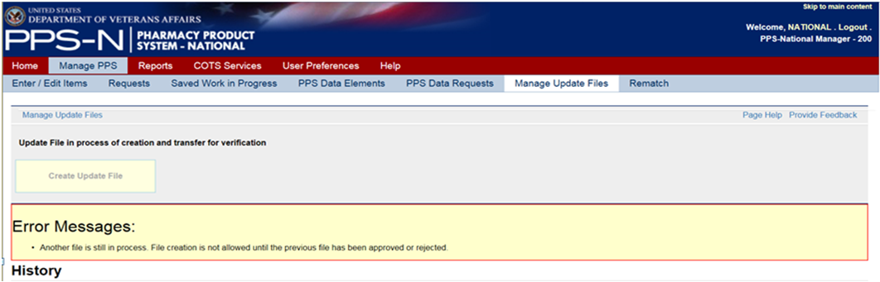

Figure 42: Failure Scenario 1 - Error Message

#### Failure Scenario 2 – The Process Fails during File Creation or Transmission to sFTP Server

In this case, the user was presented with the following:

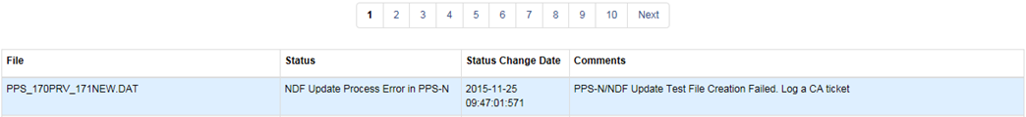

Figure 43: Failure Scenario 2 - Process Failure

The “Create Update File” button was automatically re-enabled, which eliminates the need for the support team to manually manipulate the status of the update file once the problem is corrected. At that point, the user can simply create another update file.

##### File was Successfully Created and Transmitted to sFTP Server, but the Email Notifications Fail

In this case, the user was presented with the following:

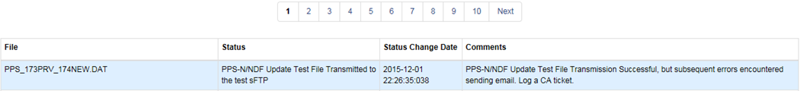

Figure 44: Failure Scenario 2 - Created & Transmitted, but Email Notification Failed

Note: This is not an error status. The process moves along as usual but the user is informed that the emails did not go out.

#### Failure Scenario 3 – Process Fails during Approval

This failure occurs while moving the file from the pending directory to the approved directory. In this case, the user was presented with the following:

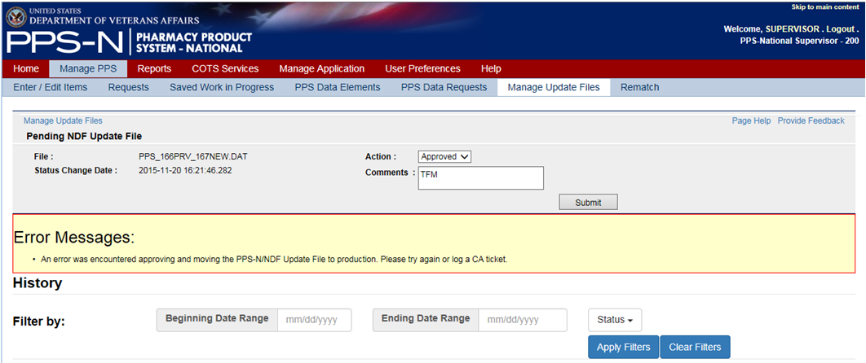

Figure 45: Failure Scenario 3 - Failure Moving Directory

The ability to approve or reject remained enabled, so the user could try again or log a CA ticket.

##### File was Successfully Approved and Moved to the Approved Directory, but the Email Notifications Fail

In this case, the user was presented with the following:

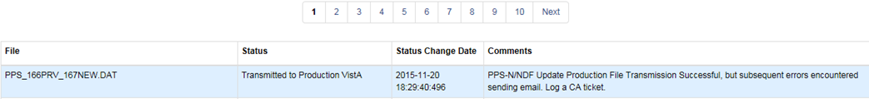

Figure 46: Failure Scenario 3 - Approved & Moved, but Email Notification Failed

Note: This is not an error status. The process moves along as usual but the user is informed that the emails did not go out.

#### Failure Scenario 4 – Process Fails during Rejection

This failure occurs while renaming the file and moving it to the archive directory.

In this case, the user was presented with the following:

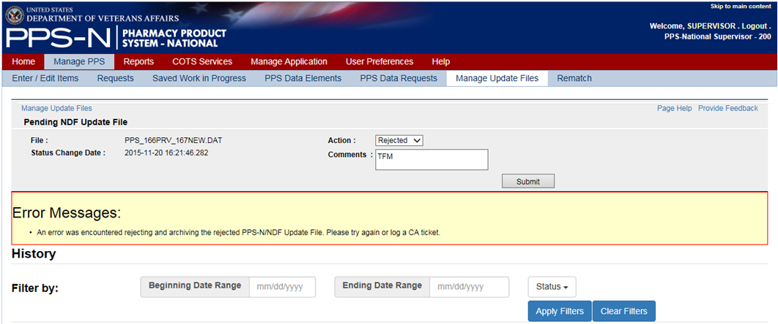

Figure 47: Failure Scenario 4 - Failure Renaming & Moving Directory

The ability to approve or reject remained enabled, so the user could try again or log a CA ticket.

##### File was Successfully Rejected, Renamed, and Moved to the Archived Directory, but the Email Notifications Fail

In this case, the user was presented with the following:

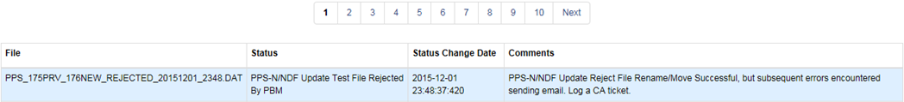

Figure 48: Failure Scenario 4 - Rejected, Renamed, & Moved, but Email Notification Failed

Note: This is not an error status. The process moves along as usual but the user is informed that the emails did not go out.

## Rematch

When the user edits a product in PPS-N it causes a potential un-match at the local level due to an Inactivation, Proposed Inactivation or “Other” modification such as changing the VA Print Name. The PPS system then provides the user the ability to select products as suggestions or automatic rematches to replace the edited product.

The Data NDF update Report will display to the user the products whose edits cause the potential un-match along with products that are suggested for rematch, products that will be automatically rematched, or an indicator that there are no alternatives.

From the edit product page the user can select the **Rematch** button to navigate to the Rematch page. See image below.

To Access Rematch Page:

1. Navigate to the **Manage PPS page.**
2. Under **Enter/Edit Items tab** search for an active product, and select that product for editing.
3. Change any of the above-listed item attributes that cause an un-match (e.g., changing **Item Status** to Inactive).
4. Click the **Submit** button**.**
5. The Rematch page displays with possible matches, the user can either mark possible matches as suggested or automatic.
6. The user can then either click **Cancel, Skip, or Submit** the changes.

If I click Skip, the current Modification Summary for Product page displays.

If I click Submit, the Modification Summary for Product page that includes the product(s) I selected for rematch displays.

If I click Cancel, I am able to edit the product again.

If I click Accept Changes, the confirmation page displays.

To Define an Automatic Rematch:

1. In Automatic, click the radio button beside a VA product name that matches the unmatched product.
2. Click the Submit button. The system re-displays the Unmatched Products list and updates the Rematch Type to Automatic.

To Define One or More Suggested Rematch:

1. In Suggestion, click the radio button beside a VA product(s) name that is a possible match to the unmatched product.
2. Click the Submit button. The system re-displays the Unmatched Products list and updates the Rematch Type to Suggest.

To Search for Product:

1. If none of the suggestions is a good match, click the Product Search button. They system opens the Associate Product search page.
2. In Search for, enter text.
3. In Search Field, select a field from the drop-down list.
4. In Strength, enter strength.
5. Click the Search button. The system displays a list of possible matches.
6. In VA Product Name, click the link of a possible match. The system closes the search page and re-displays the Possible Matches with the product you selected added to the list.
7. To add more products, click the Internet Explorer Back button and click the link of another possible match in the VA Product Name.
8. Complete the match process by selecting Automatic or Suggestion radio button.

Field List Rematch

VA Product Name

The name of the VA product. Click the link to open the Possible Rematches page.

VA Product ID

The view-only VA Product Identification

Rematched VA Product Name

The view-only name of the Rematched VA product

Rematched Status

The view-only Rematched Status: Active or Inactive

Rematched VA Product ID

Rematch Type

The view-only Rematch Type for the product: Suggest or Automatic.

Screenshot of Rematch  button

Figure 49: Rematch Button

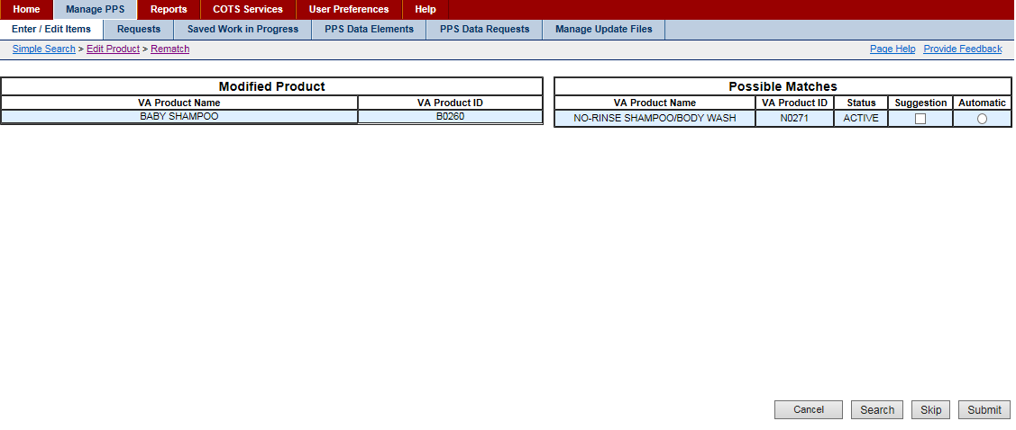

Figure 50: Rematch Page with Possible Matches

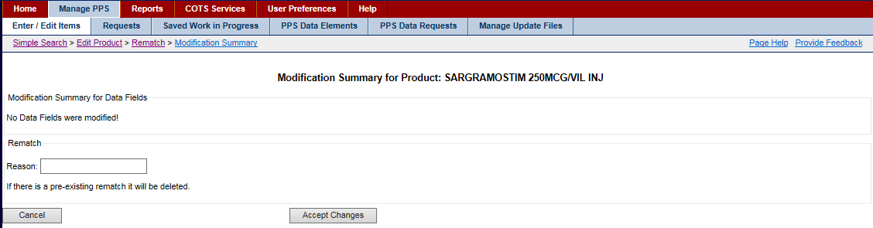

Figure 51: Figure: Rematch Modification Screen

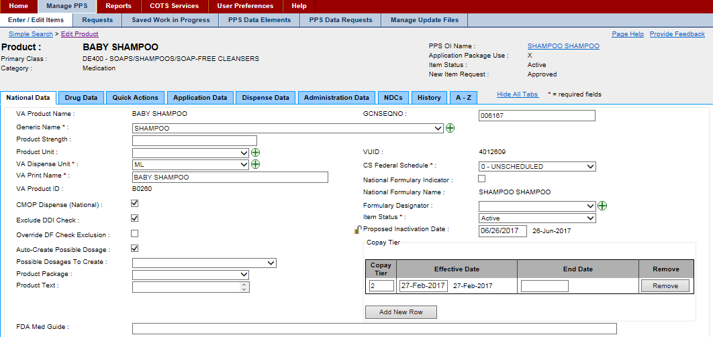

Figure 52: Proposed Inactivation for Product for Rematch

# Reports Tab

This tab allows you to generate reports. Two types of reports are possible:

* Download Only Reports, which are reports that can only be downloaded based on the size of the report.
* Non-Download Reports, which can be run immediately

The system uses the comma-separated value (.CSV) format and you can view reports using a third-party tool such as Microsoft Excel.

To convert a download only report to display without the delimiters, go to the Control Panel. Select Clock, Language and Region, then select Change the date, time, or number format. Click the Additional settings button and enter ^ for the List Separator option.

You can request reports and continue working while the system processes your request.

On this tab, you can complete any of these tasks:

* Select Report
* Open or Save Report

## Select Report

To Select Report:

1. Click the Reports tab. The system opens the tab.
2. From the Select a Report drop-down list, select a report type. Depending on the type of report you select, additional field may open and different buttons may appear.
3. Complete any additional fields.
4. Click buttons to download the current version of the report or create or run a new version of the report.

Download Only Reports

Use these instructions for reports that include (download only) after the report name.

To Download Current Version:

1. Click the Get Status button. The system displays the current report status below and enables buttons.
2. Review the status, and if the report is recent enough for your needs and is not running, click the Download Current button to download the current version of the report. The system opens a dialog at the bottom of the page.
3. To continue, see Open or Save a Report.

To Create New Version:

1. Click the Get Status button. The system displays the current report status below and enables buttons.
2. Click the Generate New button to generate a new report. The system opens a pop-up window with a message indicating how long the process will take.
3. Click the OK button to start the process. The system generates a new report. While the system generates the new report, it disables buttons and shows a status of running. After generation is complete, the system re-enables the button.
4. Click the Download Current button. The system opens a dialog at the bottom of the page.
5. To continue, see Open or Save a Report.

When you click the Get Status button, the system displays the status (Running, Not Running) and indicates when the process was started and completed.

Run Reports

Use these instructions for reports that do not include (download only) after the report name.

To Download Current Version:

1. Click the Download Current button to download the current version of the report. The system opens a dialog at the bottom of the page.
2. To continue, see Open or Save a Report.

To Run New Report:

1. Click the Run Report button to generate a new report below.
2. Click the Download Current button to download the report. The system opens a dialog.
3. To continue, see Open or Save Report.

Available Reports

See the following topics for more information on report access pages:

* Capture NDF Data (download only)
* Ingredients List (download only)
* Products and Warning Labels (download only)
* Data Update Compliance (download only)
* VA Drug Classifications
* Products with Exclusion from Drug-Drug Interactions
* Active Products with No Active NDCs
* Active Products with Proposed Inactive Date
* VUID Approvals
* Products with Copay Tier Level Changes (download only)
* FDB Copay Change
* Preview Update File

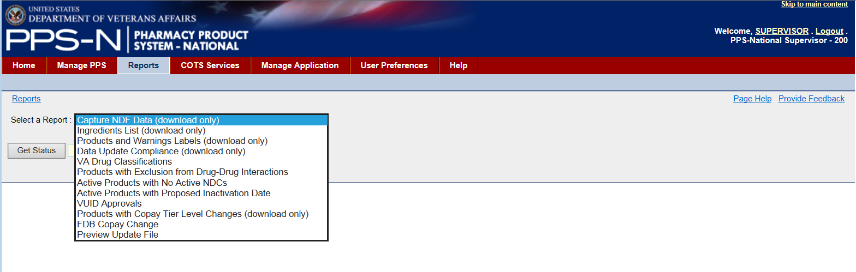

Figure 53: Reports Tab

## Open or Save Report

All report pages include a Download Current button that allows you to open or save the report, or cancel the request. For reports, the system uses the CSV format and you can view reports using a third party tool such as Microsoft Excel.

To Open or Save Current Version of Report:

1. Click the Download Current button. The system opens a dialog.
2. Click a button.

**Buttons**

* Click the Open button to view the CSV report.
* Click the Save button to save the file. They system displays a Save As dialog. Navigate to a location on your system and save the file.
* Click Cancel to cancel the report.

Open or Save Report Dialog Box

Figure 54: Open or Save Report Dialog

## Types of Reports

The following types of reports are available:

* Capture NDF Data (download only)
* Ingredients List (download only)
* Products and Warning Labels (download only)
* Data Update Compliance (download only)
* VA Drug Classifications
* Products with Exclusion from Drug-Drug Interactions
* Active Products with No Active NDCs
* Active Products with Proposed Inactive Date
* VUID Approvals
* Products with Copay Tier Level Changes (download only)
* FDB Copay Change
* Preview Update File

Reports that include the notation (download only) after the name are too large to be viewed online and must be downloaded to a file to view.

### Capture NDF Data Report

The report provides a complete listing of the Active NDCs in PPS-N EPL as well as a large number of their attributes.

**Buttons**

* Click the Get Status button to open the current status of the report and enable buttons.
* Click the Download Current button to download the current report. To continue, see Open or Save a Report.
* Click the Generate New button. The system opens a pop-up window with a message indicating how long the process will take. Click the OK button to start the process. The system generates a new report. After generation is complete, click the Download Current button. To continue, see Open or Save a Report.

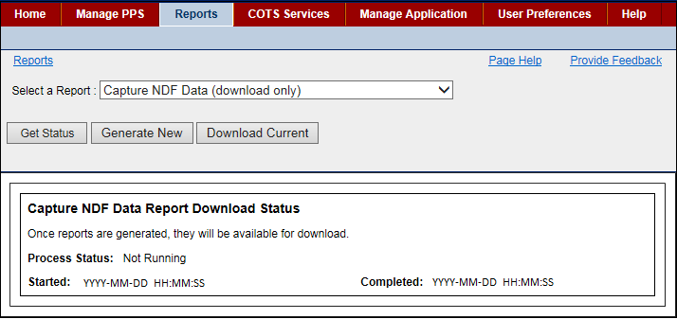

Figure 55: Access Page for Capture NDF Data Report

### Ingredients List Report

This report provides a complete list of the Active products in PPS-N EPL with each of their ingredients.

**Buttons**

* Click the Get Status button to open the current status of the report and enable buttons.
* Click the Download Current button to download the current report. To continue, see Open or Save a Report.
* Click the Generate New button. The system opens a pop-up window with a message indicating how long the process will take. Click the OK button to start the process. The system generates a new report. After generation is complete, click the Download Current button. To continue, see Open or Save a Report.

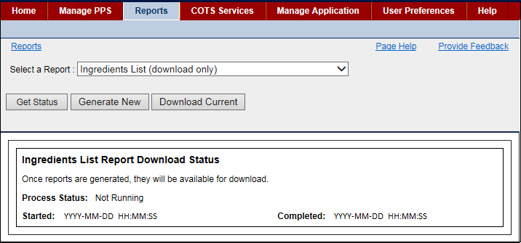

Figure 56: Access Page for Ingredients List Report

### Products and Warning Labels Report

This report provides a complete list of the Active products in PPS-N with the warning labels for each product that is retrieved from the FDB MedKnowledge.

Buttons

* Click the Get Status button to open the current status of the report and enable buttons.
* Click the Download Current button to download the current report. To continue, see Open or Save a Report.
* Click the Generate New button. The system opens a pop-up window with a message indicating how long the process will take. Click the OK button to start the process. The system generates a new report. After generation is complete, click the Download Current button. To continue, see Open or Save a Report.

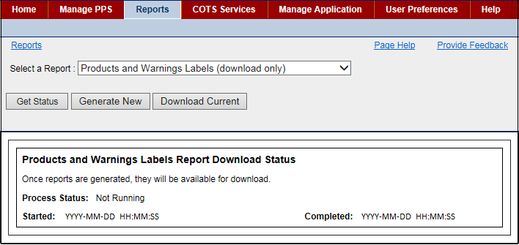

Figure 57: Access Page for Products and Warning Labels Report

### Data Update Compliance Report

Data Update Compliance Report

This report provides a list of all sites with the most current update file from PPS-N.

Sites statuses are listed in the sections below.

**Buttons**

Click the Get Status button to open the current status of the report and enable buttons.

Click the Download Current button to download the current report. To continue, see

Open or Save a Report.

Click the Generate New button. The system opens a pop-up window with a message indicating

how long the process will take. Click the OK button to start the process. The system generates a new report. After generation is complete, click the Download Current button. To continue, see Open or Save a Report.

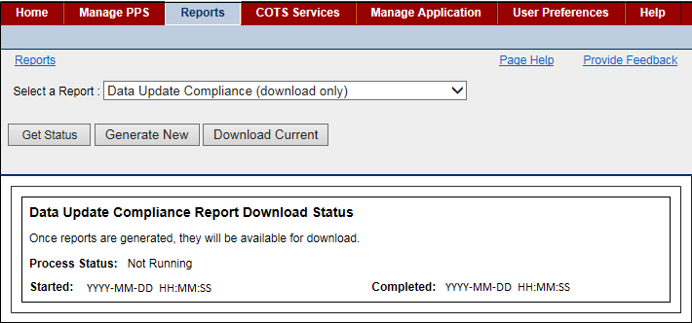

Figure 58: Access Page for Data Update Compliance Report

#### Data Update Compliance Report Content

**Sites Up to Date**

A site will be listed in the Up to Date section of the Data Update Compliance report if it has installed the latest update file.

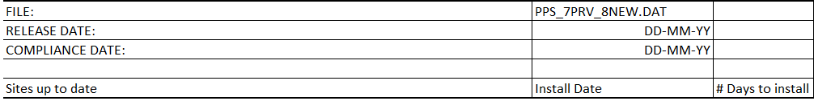

Figure 59: Data Update Compliance Report - Sites Up to Date

Field List Up to Date:

**File**

The name of the latest report

**Release Date**

The date the file became available to the local sites

**Compliance Date**

The date updates need to be applied to the local file(s) to be in compliance (compliance

date)

**Sites up to Date**

The list of sites that have installed the latest update file

**Install Date**

The date sites installed the update

**# of Days to Install**

The given number of days to install to be considered in compliance

**Sites out of Date**

A site will be listed in the Out of Date section of the Data Update Compliance report if the site has not installed the latest update file.



Figure 60: Data Update Compliance Report - Not Up to Date

Field List Not Up to Date

**Sites out of Date**

The list of sites that have not installed the update

**Last  file successfully installed**

The name of the last update file successfully installed

**Install Date**

The date sites installed the update

**Installed previous file?**

Populated by Y if the previous update file was installed successfully or N if the previous update has not yet been installed.

### VA Drug Classifications Report

This report provides a complete list of the VA Drug Classes displayed in a hierarchical format with the option of including the Description field by clicking the check box with Description.

**Buttons**

* Click the Run Report button to generate a new version of the report. To continue, see Open or Save a Report.
* Click the Download Current button to download the current report. To continue, see Open or Save a Report.

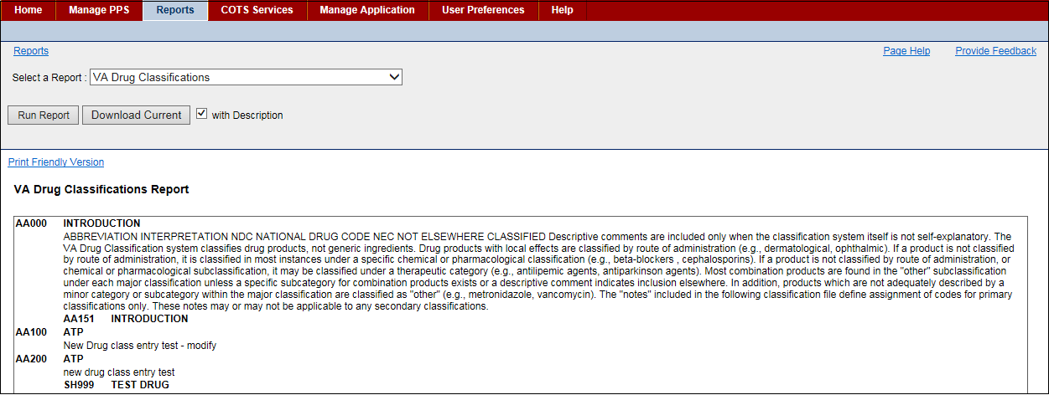

Figure 61: Access Page for VA Drug Classifications Report with Sample Report

### Products with Exclusions from Drug-Drug Interactions Report

This report provides a list of the products that have been created in PPS-N (during the start and stop dates time period) and shows VA Product Names and a letter indicating whether or not the product is marked for exclusion -N for No and Y for Yes.

**Buttons**

* Click the Run Report button to generate a new version of the report. To continue, see Open or Save a Report.
* Click the Download Current button to download the current report. To continue, see Open or Save a Report.

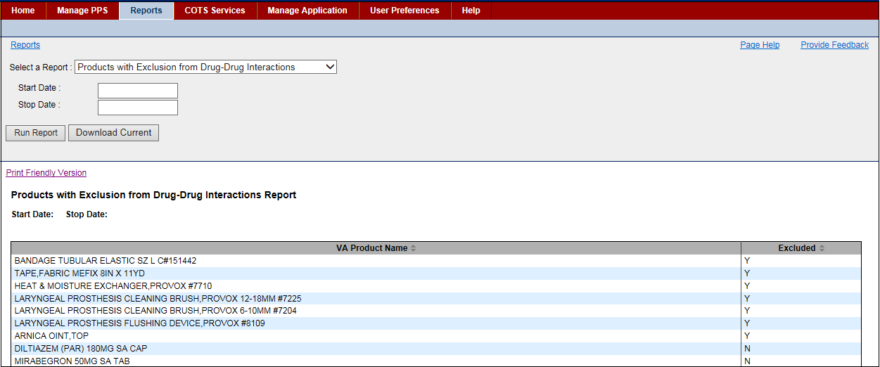

Figure 62: Access Page for Products with Exclusions from Drug-Drug Interactions Report with Sample Report

### Active Products with No Active NDCs Report

This report provides a list of all the Active Products in PPS-N that do not have any active NDCs. To view a product, select the hyperlinked VA Product Name.

Click the Print Friendly Version link to open a file. Right-click the file and select the Print option. The system opens a print dialog that you can use to print the report.

Buttons

* Click the Run Report button to generate a new version of the report. To continue, see Open or Save a Report.
* Click the Download Current button to download the current report. To continue, see Open or Save a Report.

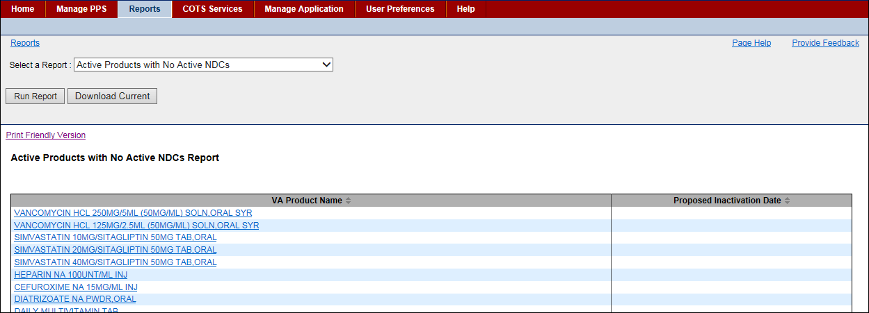

Figure 63: Access Page for Active Products with No Active NDCs Report with Sample Report

### Active Products with Proposed Inactive Date Report

This report provides a list of all the active products in PPS-N that have a Proposed Inactivation Date. Optionally, you can enter a Start Date to filter the results from the start date to the current date.

Entries for this report come from the system Inactivation job. See System Data tab for more information.

**Buttons**

* Click the Run Report button to generate a new version of the report. To continue, see Open or Save a Report.
* Click the Download Current button to download the current report. To continue, see Open or Save a Report.

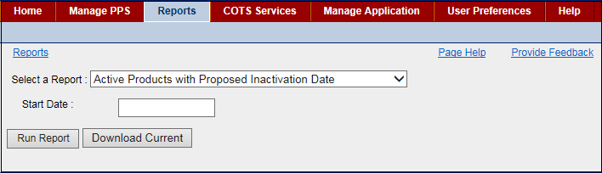

Figure 64: Access Page for Active Products with Proposed Inactive Date Report

### VUID Approvals Report

This report provides a list of all products, ingredients, generic names, and drug classes with VA Unique Identifiers (VUIDs) that have been approved, inactivated, or reactivated in PPS-N. Before running this report, you must enter a Start Date. Without a date, no results appear.

**Buttons**

* Click the Run Report button to generate a new version of the report. To continue, see Open or Save a Report.
* Click the Download Current button to download the current report. To continue, see Open or Save a Report.

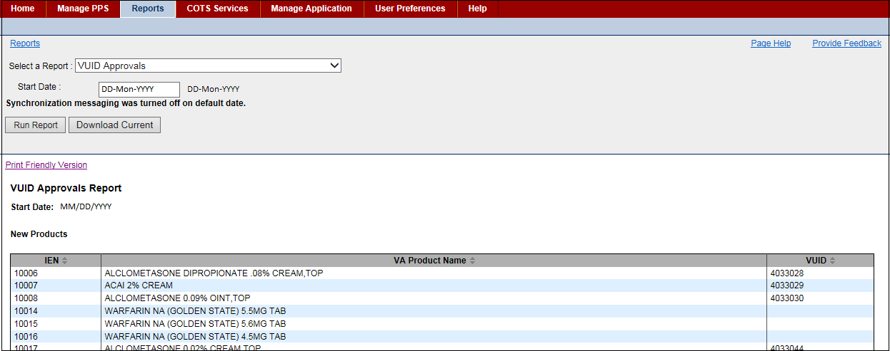

Figure 65: Access Page for VUID Approvals Report with Sample Report

### Preview Update File Report

This report provides a list of what will be included in the update file. Use this report to see if there are any edits that need to be made in PPS-N before the update file is generated. When you download the report, it opens in Microsoft Word. The report format includes the messages that make up the Data Update for NDF Report and show the changes that have been made since the update file was last generated.

**Buttons**

* Click the Run Report button to generate a new version of the report. To continue, see Open or Save a Report.
* Click the Download Current button to download the current report. To continue, see Open or Save a Report.

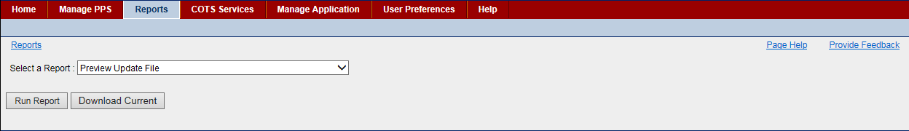

Figure 66: Access Page for Preview Update File Report Page

# COTS Services Tab

This tab allows you to use COTS services to perform a number of operations dealing with the FDB MedKnowledge. When you select the COTS Services tab, the system opens the following secondary tabs:

* FDB Search Tab -Use this tab to search the FDB database for drug information.
* FDB Add Tab -Use this tab to see the FDB packaged drugs that were added to FDB but not automatically added to PPS-N during the last scheduled FDB Add process.
* FDB Update Tab -Use this tab to see the FDB items that were updated in FDB but not updated in PPS-N during the last scheduled FDB Update process.
* Added Report Tab -Use this tab to see a list of FDB items that were automatically added to PPS-N during the last scheduled FDB Add process.
* Updated Report Tab -Use this tab to see a list of FDB items that were automatically updated in PPS-N during the last scheduled FDB Update process.

## FDB Search Tab

Use this tab to search the FDB Information Framework database for drug information. Each search returns a list of FDB packaged drugs even if the search criteria is for another drug concept. For example, a generic-based search searches the FDB Generic Drug concept for matches and returns a list of all packaged drugs associated with the matched generic drugs.

FDB search options are controlled on the User Preferences page. Altering preferences can cause any particular search to return different results.

To Search:

1. Click the COTS Services tab. The system opens the FDB Search tab.
2. In FDB Search Option Type, select an option from the drop-down list. See the list below for information on each type.
3. In FDB Search String, enter search text.
4. Click the Perform FDB Search button. The system displays first 501 items that match the query in a results table below.
5. Click the Hide Existing PPS button below the results table to compare all of the NDCs in the search results and remove those that match NDCs that are already present in PPS-N.

After you have search results, complete any of these tasks:

* Print FDB Search Results to print NDC search results  
  (or export to CSV or Excel spreadsheet)
* Review NDC Details to see NDC details
* Match Results to match selected NDCs to existing items in PPS-N

FDB Search Option Type List

All

Select this option to search all FDB entries.

NDC

Enter at least five digits to search based on the NDC number. The system searches the first five digits of the 11-digit NDC number of the FDB Packaged Drug. The normal PPS-N data entry validation rules apply (numeric and correct format). The system displays an error message if your entry does not comply with the rules.

Label

Select this option to search based on the FDB Label Name Field.

Generic

Select this option to search based on the FDB Generic Drug Name Field.

GCNSEQNO

Select this option to search based on the Generic Code Number Sequence Number, which is a numeric value that corresponds to the Generic Code Number Sequence Number of an FDB generic drug. The normal PPS-N data entry validation rules apply (numeric only). The system displays an error message if your entry does not comply with the rules.

Drug Class

Select this option to search based on the FDB Drug Class.

The grouping of drug products is based on various criteria, which can include similarity of chemical structure, clinical indications, pharmacology, and therapeutic activity. Drug class includes fields for both the FDB Generic and the FDB Dispensable Drug.

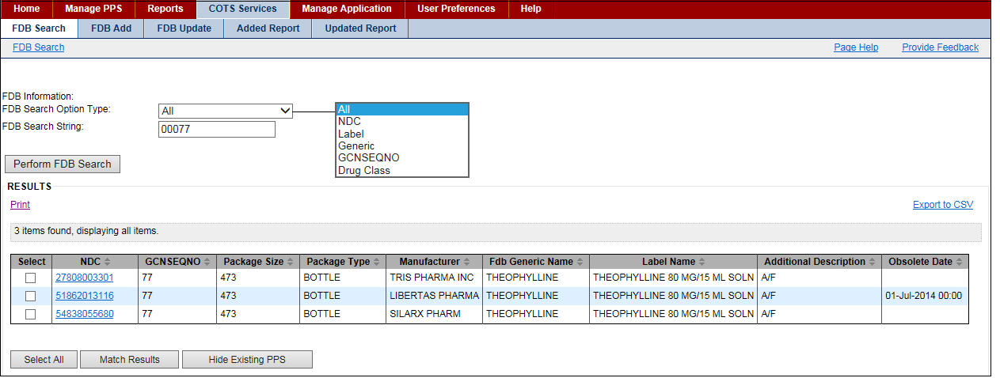

Figure 67: FDB Search Tab with Results

To Print Search Results:

1. Above the table in the FDB Search results table, click the Print link. The system opens a selection page.
2. Click the check box beside entries to select a few entries. Or, click the Select All button to select all entries in the report.
3. Click the Print button. The system prints selected records.

To Export Search Results:

1. Above the table in the FDB Search results table, click the Export to CSV link. The system opens a selection page.
2. Click the check box beside entries to select a few entries. Or, click the Select All button to select all entries in the report.
3. Click the Export to CSV button. The system exports the results to CSV or Excel format.
4. Use the buttons in the resulting dialog box to open or save the results.

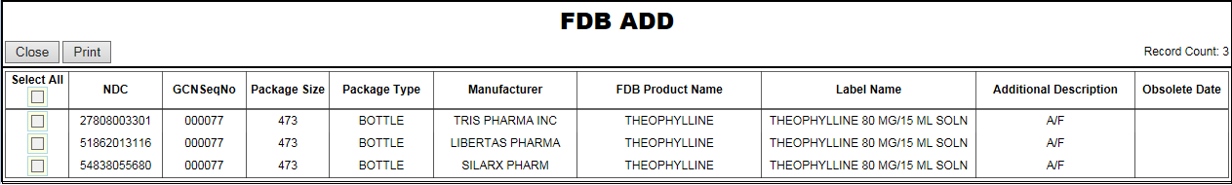

Figure 68: Print FDB Selection Page Sample for Print

To Review NDC Details:

1. With the FDB Search results table displaying, click a hyperlink in the NDC column. The system opens a Details pop-up.
2. Click the Print button to print the Details pop-up page.
3. Click the Close button to close the pop-up.

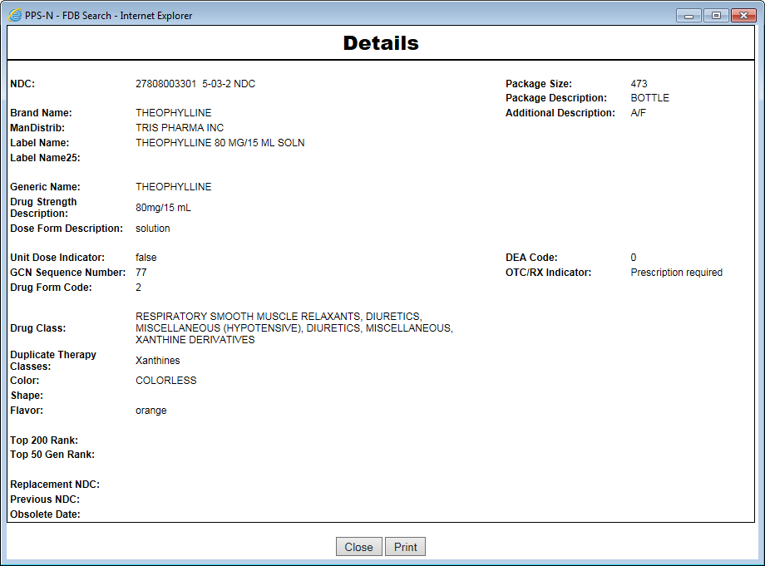

Figure 69: NDC Details Pop-Up

Match Results

The system matches selected NDCs to existing items in PPS-N. The matches must have the same Generic Code Number Sequence Number (GCNSEQNO column) or the system generates an error.

To Match Results:

1. With the FDB Search results table displaying, locate the NDCs you want to match.
2. In the Select column, click the check box beside a few of the NDCs that you want to match. Or, click the Select All button to select all entries in the results table.
3. Confirm that all of your selections have the same Generic Code Number Sequence Number in the GCNSEQNO column. If the numbers are not the same, the system generates an error.
4. Click the Match Results button below the table. The system starts a process that matches selected NDCs to existing items in PPS-N. The system opens the matching page, copies the selected NDC items into the FDB NDCs table on the left of the page, and on the right, and displays any products in PPS-N that matches the GCNSEQNO.
5. Select a parent.

To Select Parent:

1. In FDB NDCs results, click a few NDCs to be used as children. Or, click the Select All button to select all NDCs.
2. In VA Products results, click the Use radio button beside any matching VA product to use that product as the parent to select FDB NDCs.
3. Click the Add to Product button to add the product to serve as the parent for the selected NDCs.

If you find no suitable product to select as a parent, use the following buttons to create a parent or complete additional actions:

* Blank Template -If no products are suitable as a parent for the selected NDCs
* Use Existing -To use the product as a template to create a new product to serve as the parent for the selected NDCs
* Complete Product Search -If no products matched the selected NDCs. The system displays the product (parent).
* Click the Cancel button to return to the FDB Search Results page.

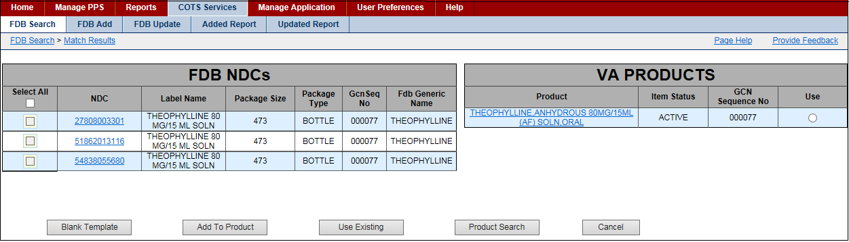

Figure 70: NDC Match Results Page

Field List FDB NDCs

Select All

Click the check box beside an entry to select it for matching. Or click the Select All check box at the top to select all entries.

NDC

The National Drug Code for the FDB packaged drug. Click a hyperlinked entry to open a page with additional information about the FDB packaged drug.

Label Name

The view-only FDB name on the label

Package Size

The view-only FDB size of the package

Package Type

The view-only FDB type of package

GcnSeq No

The view-only Generic Code Sequence Number

Fdb Generic Name

The view-only FDB Generic Name

Field List VA Products

Product

Click a hyperlinked entry to open a page with additional information about the VA product.

Item Status

The view-only status of the product: Approved, Pending, Rejected

GcnSeq No

The view-only Generic Code Sequence Number

Use Button

Click this button to use the product as the parent for matching.

To Use Blank Template:

1. On the Match Results page, click the Blank Template button if no products are suitable as a parent for the selected NDCs. The system opens a blank product template.
2. Complete the form. See Add Product for more information.
3. Submit the product.
4. Associate the NDCs with the product.
5. Save the NDCs to the PPS-N database.

To Add Product as Parent:

1. On the Match Results page, select products in the FDB NDC list.
2. Click the Add to Product button.
3. Associate the selected NDCs to the product and save them to the PPS-N database.

To Use Existing as Template:

1. On the Match Results page, after you have selected products in the FDB NDCs list, click the Use Existing button to use the product as a template to create a new product that will serve as the parent for the selected NDCs.
2. Create a template using the selected product.
3. Make changes. See Edit Product for more information.
4. Save the product to the database.
5. Associate the NDCs to the new product.
6. Save the NDCs to the database.

To Complete Product Search:

1. On the Match Results page, click the Product Search button if no products matched the selected NDCs. The system displays the product (parent) search page.
2. Search for an appropriate product.
3. Select the product from the search results. The system displays the previous matching page, and the VA Products table now shows the selected product.
4. Select the product in the result table.

After you select a product, use these buttons complete tasks:

* Add to Product -To add the product to serve as the parent for the selected NDCs
* Use Existing -To use the product as a template to create a new product to serve as the parent for the selected NDCs

## FDB Add Tab

Use this tab to see the FDB packaged drugs that were added to FDB MedKnowledge since the last update occurred and could not be automatically added to the PPS-N EPL because the packaged drug did not meet specific requirements.

The system updates the FDB on a periodic basis. A background job queries the FDB database to see if any new products have been added to the FDB since the last running of the background job. For more information, see System Data tab.

To Display:

1. Click the COTS Services tab. The system opens the FDB Search tab.
2. Click the FDB Update tab. The system displays the report.

To Match Results:

1. Click the check box beside entries to select a few entries. Or, click the Select All button to select all entries in the report.
2. Click the Match Results button. The system opens a Match Results page that you can use to match results.

To Print:

1. Click the check box beside entries to select a few entries. Or, click the Select All button to select all entries in the report.
2. Click the Print link to open search results page. The system opens a file. Right-click the file and select the Print option. The system prints the page.

To See Details:

Click a hyperlink in the NDC column to display the NDC item in the PPS-N EPL. The system displays the Main tab along with the Price, History, and A–Z tabs.

To Export Entries to CSV:

1. Click the check box beside entries to select a few entries. Or, click the Select All button to select all entries in the report.
2. Click the Export to CSV link to export the entries in either CSV or Excel format, and then use the buttons in the resulting dialog box to open or save the results.

To Delete Entries:

1. Click the check box beside entries to select a few entries. Or, click the Select All button to select all entries in the report.
2. Click the Delete button. The system removes any selected entries.

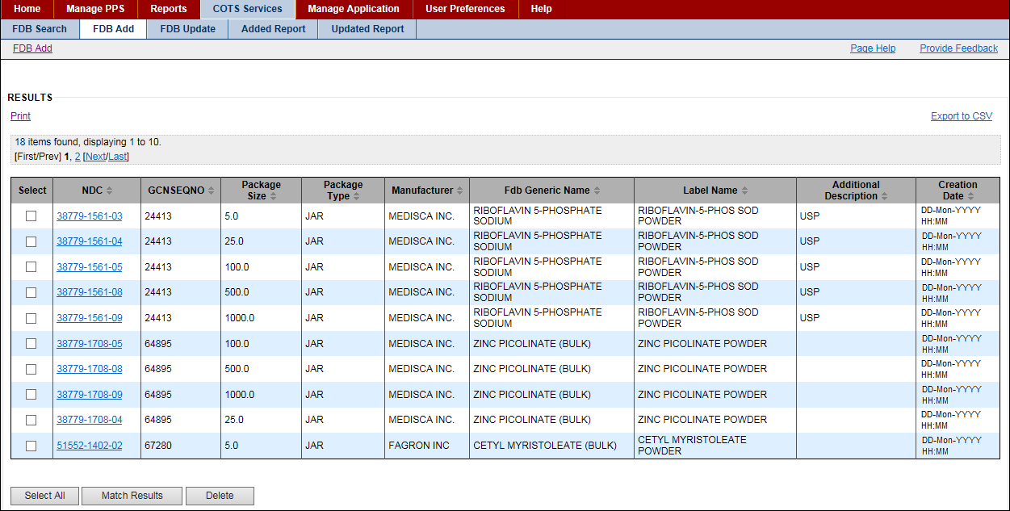

Figure 71: FDB Add Tab with Results

## FDB Update Tab

Use this tab to see the FDB packaged drugs that were updated in FDB MedKnowledge since the last update occurred and could not be automatically updated in the PPS-N EPL because the packaged drug did not meet specific requirements.

The system updates the FDB on a periodic basis. A background job queries the FDB database to see if any products were updated in the FDB since the last running of the background job. For more information, see System Data tab.

**To Display:**

Click the COTS Services tab. The system opens the FDB Search tab.

Click the FDB Update tab. The system displays the report.

**To See Details:**

Click a hyperlink in the NDC column to display the NDC item in the PPS-N EPL. The system displays the Main tab along with the Price, History, and A–Z tabs.

**To Export Entries to CSV:**

Click the check box beside entries to select a few entries. Or, click the Select All button to select all entries in the report.

Click the Export to CSV link to export the entries in either CSV or Excel format, and then use the buttons in the resulting dialog box to open or save the results.

**To Delete Entries:**

Click the check box beside entries to select a few entries. Or, click the Select All button to select all entries in the report.

Click the Delete button. The system removes any selected entries.

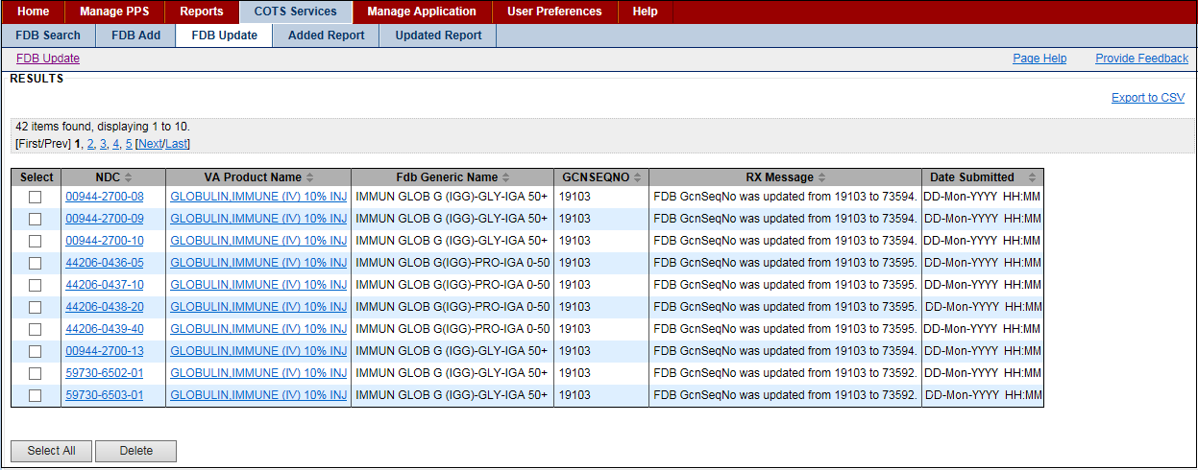

Figure 72: FDB Updated Tab with Results

## Added Report Tab

Use this tab to see the report for the FDB packaged drugs that were added to FDB MedKnowledge since the last update occurred and were automatically added to the PPS-N EPL because the packaged drug met specific requirements.

Managers need not take any additional actions. Entries remain in the list for 90 days unless deleted. Entries on this list were added by a user and have met the criteria for automatic update.

The system updates the FDB on a periodic basis. A background job queries the FDB database to see if any new products have been added to the FDB since the last running of the background job. For more information, see System Data tab.

**To Display:**

Click the COTS Services tab. The system opens the FDB Search tab.

Click the Added Report tab. The system displays the report.

Be sure to note the record count above the table.

**To See Details:**

Click a hyperlink in the NDC column to display the NDC item in the PPS-N EPL. The system displays the Main tab along with the Price, History, and A–Z tabs.

**To Export Entries to CSV:**

Click the check box beside entries to select a few entries. Or, click the Select All button to select all entries in the report.

Click the Export to CSV link to export the entries in either CSV or Excel format, and then use the buttons in the resulting dialog box to open or save the results.

**To Delete Entries:**

Click the check box beside entries to select a few entries. Or, click the Select All button to select all entries in the report.

Click the Delete button. The system removes any selected entries.

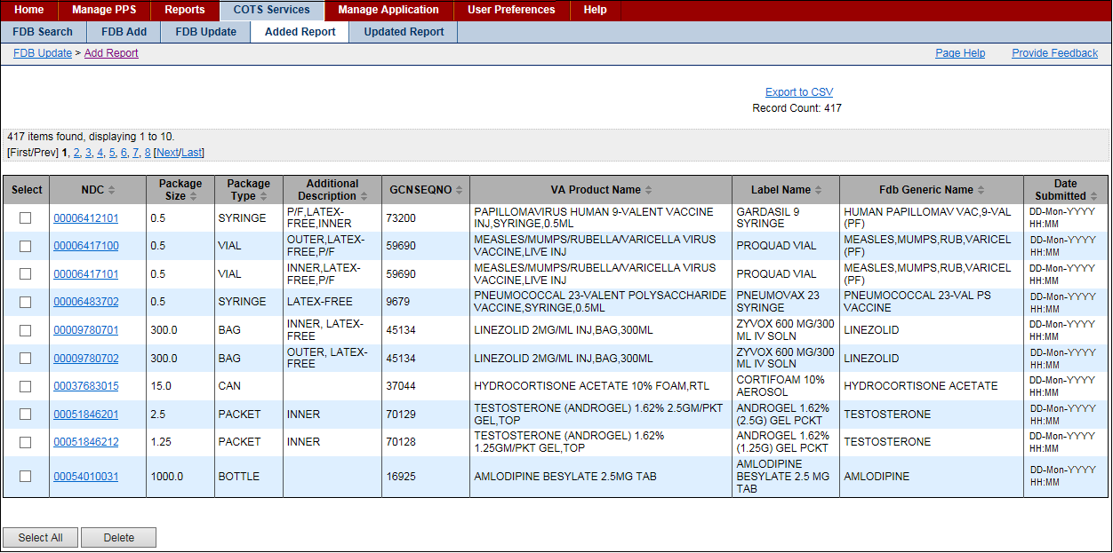

Figure 73: FDB Added Report Tab with Results

**Field List FDB Added Report Tab with Results**

**Select**

Click the check box beside entries to select it. Selected entries can be exported to CSV or deleted.

**NDC**

Click the link to open the NDC item in the PPS-N EPL.

**Package Size**

The view-only size of the package

**Package Type**

The view-only type of package

**Additional Description**

Any additional information that needs to be known about the drug.

**GcnSeqNo**

The view-only Generic Code Number Sequence Number, which is a numeric value that corresponds to the Generic Code Number Sequence Number of an FDB generic drug

**Label Name**

The view-only name of the drug that appears on the label

**Fdb Generic Name**

The view-only Generic Name used in the FDB.

**Date Submitted**

The view-only date and time the item was added to the PPS-N EPL

## Updated Report Tab

Use this tab to see the report for the FDB packaged drugs that were updated in the FDB MedKnowledge since the last update occurred and were automatically updated in the PPS-N EPL because the packaged drug met specific requirements.

Managers need not take any additional actions. Entries remain in the list for 90 days unless deleted. Entries on this list were updated by a user and have met the criteria for automatic update. Not all FDB changes are logged in this file. The report includes only those changes that the NDF Managers have determined could have a potential impact on VA operations.

The system updates the FDB on a periodic basis. A background job queries the FDB database to see if any new products have been added to the FDB since the last running of the background job. For more information, see System Data tab.

**To Display:**

Click the COTS Services tab. The system opens the FDB Search tab.

Click the Updated Report tab. The system displays the report.

**To See Details:**

Click a hyperlink in the NDC column to display the NDC item in the PPS-N EPL. The system displays the Main tab along with the Price, History, and A–Z tabs.

**To Export Entries to CSV:**

Click the check box beside entries to select a few entries. Or, click the Select All button to select all entries in the report.

Click the Export to CSV link to export the entries in either CSV or Excel format, and then use the buttons in the resulting dialog box to open or save the results.

**To Delete Entries:**

Click the check box beside entries to select a few entries. Or, click the Select All button to select all entries in the report.

Click the Delete button. The system removes any selected entries.

**Field List Updated Report Tab**

**Select**

Click the check box beside entries to select it. Selected entries can be exported to CSV or deleted.

**NDC**

Hyperlinked field that shows the NDC item in the PPS-N EPL. This field may be blank if the update affects an FDB Dispensable Drug but not a specific FDB Packaged Drug.

**VA Product Name**

Hyperlinked name of the VA Product item in the PPS-N EPL

**FDB Generic Name**

The Generic Name used in the FDB

**GcnSeqNo**

The Generic Code Number Sequence Number, which is a numeric value that corresponds to the Generic Code Number Sequence Number of an FDB generic drug

**Rx Message**

Message containing the attribute that updated and the value to which it has been updated. To see the old value, click the NDC hyperlink and then look at the audit history record.

**Date Submitted**

Date and time the item was added to the PPS-N EPL

# User Preferences Tab

This tab allows you to specify individual settings for your user experience within the application.

**To Update User Preferences:**

1. Click the User Preferences tab. The system opens the User Preferences page.
2. In the Date/Time Format box, click an option to select a date format and a time format.
3. In the Default Login Page box, click an option: Home Page or Search Page.
4. In the Table Display Format box, enter the number of lines you want to display in search result table: 10 to 100.
5. In the FDB Filter box, make selections. Note that if you make changes to FDB preferences, you can affect search results that appear when you search the FDB database.
6. Click the Set Preferences button.

User Preferences Tab

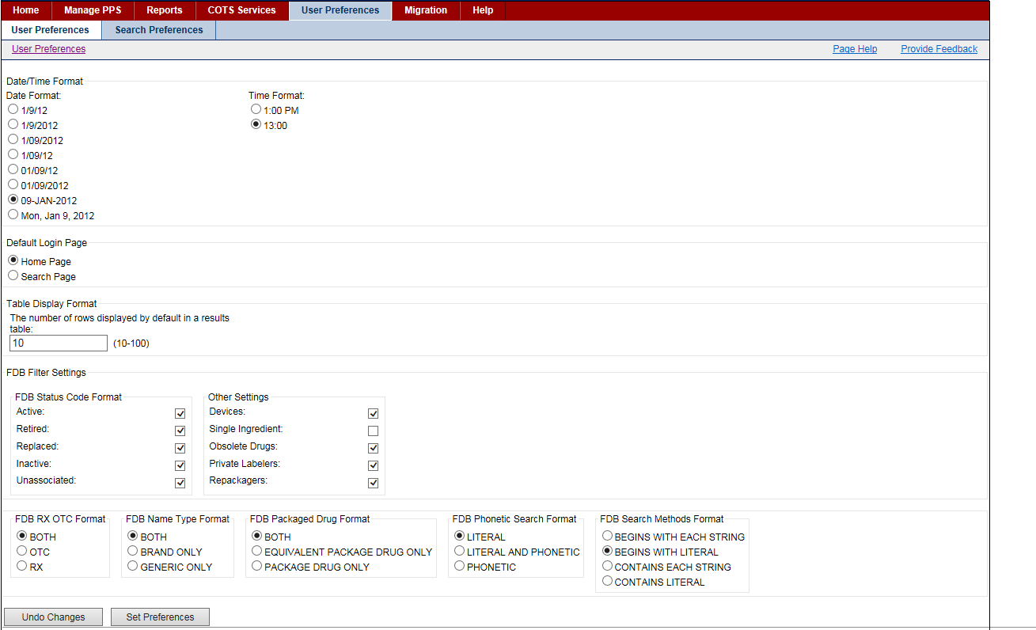

Date and Time Formats

|  |  |
| --- | --- |
| 1/9/12 | Non-zero-padded month and day with two-digit year |
| 1/9/2012 | Non-zero-padded month and day with four-digit year |
| 1/09/2012 | Non-zero-padded month, zero-padded day with four-digit year |
| 1/09/12 | Non-zero-padded month, zero-padded day with two-digit year |
| 01/09/12 | Zero-padded month and day with two-digit year |
| 01/09/2012 | Zero-padded month and day with four-digit year |
| 09-Jan-2012 | Zero padded day, three-letter short form of month spelled out with four-digit year |
| Mon, Jan 9, 2012 | Three-letter short form of day of week and month spelled out, non-zero-padded day with four-digit year |

**Within Time Formats**

|  |  |
| --- | --- |
| 1:00 PM | Standard U.S. time designation with AM or PM (before or after noon) |
| 13:00 | 24 hour time designation |

### Search Preferences Tab

This page allows you to specify how search results are displayed for each search type. Each search type is set to a default, but you can alter the column that display and their order for each search. Search Preferences are only used when All Fields is the selected search field.

**To Update Search Preferences:**

1. Click the User Preferences tab. The system opens the User Preferences page.
2. Click the Search Preferences tab. The system opens the Search Preferences page.
3. Select Appropriate Search Template using the drop down menu, the options are: Personal Product Search, Personal Orderable Item Search, and Personal NDC Search.
4. To add fields to the results template, select an entry in the Available Fields list, and click the Right move button to move the entry to the Selected Fields list.  
   Right Arrow Button
5. To remove fields from the results template, select an entry in the Selected Fields list, and click Left the move button to move the entry to the Available Fields list.  
   Left Arrow Button
6. To reposition columns in the Selected Field list, select the item in the Selected Fields list, and click the Up or Down button to move the item up or down in the list.
7. Click the Submit button. The system updates the results template with changes.

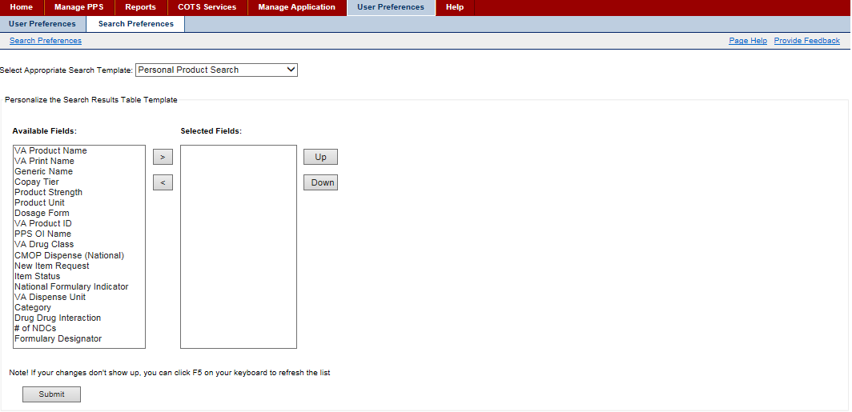

Figure 74: Search Preferences Tab- Product

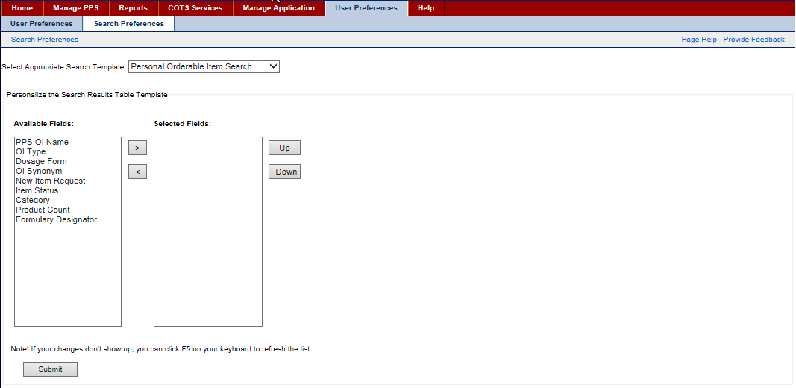

Figure 75: Search Preferences Tab- Orderable Item

# Help Tab

Click the Help tab to open the Help file. The topic Home Page Tab opens. In addition, the following navigational elements are available: Table of Contents, Search, and Glossary.

Table of Contents

The Table of Contents includes books with related topics. Be sure to notice that the books and topics follow the flow of the application. If the table does not open automatically, click the Show link in the upper left of a topic page to open it.

**To Display Topics:**

1. Click the Help tab to open the Help file.
2. Click a book to see related sub-books and topics.
3. Click a topic to display related information.

Search

The search element enables you to search for words or strings of text. The search is literal so that if you include a common word like the in your search text, the system will return every instance of the word the in results.

**To Search:**

1. Click the Help tab to open the Help file.
2. Click the Search button.
3. In Type in the word(s) to search for, enter a word or text string.
4. Click Go. Search results appear in the column below.
5. Click an entry in the results to open a topic page.

Glossary

The Glossary includes definitions for words, abbreviations, and terms used throughout the Help file.

**To Search:**

1. Click the Help tab to open the Help file.
2. Click the Glossary button.
3. Scroll through the alphabetized list to the word, abbreviation, or term you need, and click it. The definition displays in the Definition column below.

Conventions Used in Help File

* Links -Links to other topics appear as blue underlined text. Click the link and a new topic opens. Here is an example: Home Page Tab.
* Bread Crumbs -Links to where you are in the Help file appear in the upper right of each topic page. Click a link and you will return to that page.
* Glossary Pop-ups -Pop-ups appear a blue italic text. Click the link and a pop-up with the definition of a word, abbreviation, or term opens.

## Accessing Help

If you are having difficulties with opening the Help file using an Internet Explorer 11 browser, complete the following steps to resolve the problem.

**To Reset Compatibility:**

1. Open an instance of an Internet Explorer 11 browser.
2. Click the wheel shaped Tools icon in the upper-right of the page. A pop-up menu opens.  
   Graphic Wheel Tool for Internet Explorer
3. Click Compatibility View settings. The system opens the Compatibility View Settings dialog.
4. In Add this website, enter adobe.com, and then click the Add button. The system adds adobe.com to the website list below that allows a compatibility view.
5. Click the Close button.
6. Open PPS-N, and click the Help tab. The Help file opens.

# Manage Application Tab

This tab allows you to manage the application. Using this tab, you can manage:

* Domain Mapping
* System Data
* User Roles
* Home Page

To see this tab, you must be assigned the role of National Supervisor. See Identity Management for more information on roles.

## Domain Mapping Tab

This tab allows you to match FDB concepts to VA Drug Concepts. The system uses these matches to create better auto matching and updating algorithms.

To see this tab, you must be assigned the role of National Supervisor. See Identity Management for more information on roles.

**To Match:**

1. Click the Domain Mapping tab. The system opens the page.
2. In Domain, select a domain from the drop-down list. See the Drug Concept Type list below for more information.
3. In Entry Date, enter a date using the format DD-Mon-YYYY. Only terms added after this date appear in results.
4. Click the Search button. The system displays results below.
5. In the FDB Term List, click an Associated PPS-N Term to select that term to match the FDB term. The system highlights the selected term.
6. In the PPS-N Term List, click a term to match. The system adds the selected term to the Associated PPS-N Term field.
7. Repeat steps 5 and 6 to match additional terms.
8. Click the Submit button. The system saves changes to the database.
9. To make corrections, click the Clear button to reload the page from the database. Any changes you have made since the Submit button was pressed are lost.

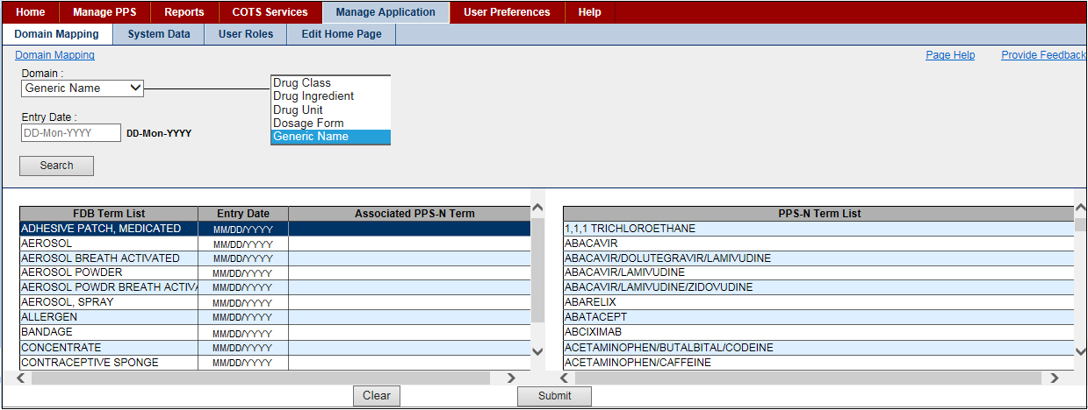

Figure 76: Domain Mapping Tab

**Drug Concept Types**

**Drug Class**

A Drug Class is a group of medications that may work in the same way, have a similar chemical structure, or are used to treat the same health condition.

**Drug Ingredient**

The Drug Ingredient is the substance in a pharmaceutical drug that is biologically active. Some medications may contain more than one active ingredient.

**Drug Unit**

The unit of measure of a drug.

**Dosage Form**

The Dosage Form is the physical form of a dose of a chemical compound used as a drug or medication intended for administration or consumption. The route of administration for drug delivery is dependents on the dosage form of the substance.

**Generic Name**

The term Generic Name has several meanings.

* The chemical name of the drug
* A term referring to the chemical makeup of a drug rather than the advertised brand name under which the drug is sold
* A term referring to any drug marketed under its chemical name without advertising

## Domain Mapping Tab

This tab allows you to match FDB concepts to VA Drug Concepts. The system uses these matches to create better auto matching and updating algorithms.

To see this tab, you must be assigned the role of National Supervisor. See Identity Management for more information on roles.

**To Match:**

1. Click the Domain Mapping tab. The system opens the page.
2. In Domain, select a domain from the drop-down list. See the Drug Concept Type list below for more information.
3. In Entry Date, enter a date using the format DD-Mon-YYYY. Only terms added after this date appear in results.
4. Click the Search button. The system displays results below.
5. In the FDB Term List, click an Associated PPS-N Term to select that term to match the FDB term. The system highlights the selected term.
6. In the PPS-N Term List, click a term to match. The system adds the selected term to the Associated PPS-N Term field.
7. Repeat steps 5 and 6 to match additional terms.
8. Click the Submit button. The system saves changes to the database.
9. To make corrections, click the Clear button to reload the page from the database. Any changes you have made since the Submit button was pressed are lost.



Figure 77: Domain Mapping Tab

**Drug Concept Types**

**Drug Class**

A Drug Class is a group of medications that may work in the same way, have a similar chemical structure, or are used to treat the same health condition.

**Drug Ingredient**

The Drug Ingredient is the substance in a pharmaceutical drug that is biologically active. Some medications may contain more than one active ingredient.

**Drug Unit**

The unit of measure of a drug.

**Dosage Form**

The Dosage Form is the physical form of a dose of a chemical compound used as a drug or medication intended for administration or consumption. The route of administration for drug delivery is dependents on the dosage form of the substance.

**Generic Name**

The term Generic Name has several meanings.

* The chemical name of the drug
* A term referring to the chemical makeup of a drug rather than the advertised brand name under which the drug is sold
* A term referring to any drug marketed under its chemical name without advertising

## System Data Tab

This tab allows you to schedule when background tasks run. Each of these tasks runs independently. For performance reasons, the tasks should be scheduled to run during the systems down time. In addition, they should be spaced out so that they do not run at the same time. Generally, each task runs in less than five minutes. Therefore, they do not need to be spread out significantly.

To see this tab, you must be assigned the role of National Supervisor. See Identity Management for more information on roles.

**To Refresh Data or Pause/Resume:**

1. To refresh data, click the Refresh button in the upper right of the page.
2. To stop job processing, click the Pause button in the Controls column beside a job.
3. To start job processing, click the Resume button in the Controls column beside a job.

**To Schedule Job:**

1. Locate the job you want to schedule. See Job Types for more information on jobs.
2. Click the Pause button in the Controls column. The system enables buttons and fields.
3. In Hrs, select an hour from the drop-down list: 1–23.
4. In Mins, select a minute from the drop-down list: 1–59.
5. Click the Schedule button to save changes.

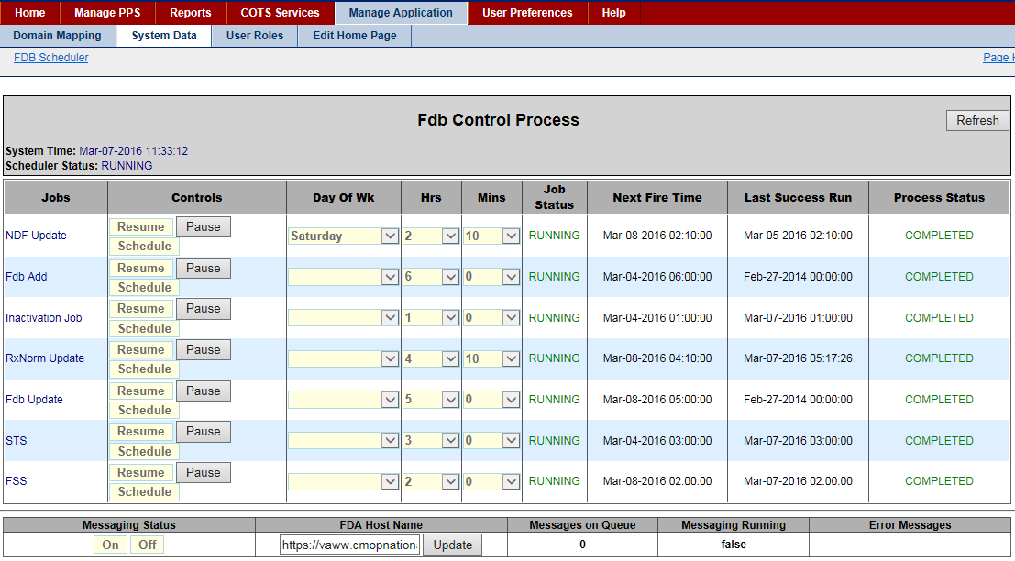

Figure 78: System Data Tab

**Field List System Data Tab**

**System Time**

Current date and time of the application server that will be processing the request. The application server can be in a different time zone than the client machine on which you are working.

**Scheduler Status**

The status should always be Running. If this field is set to anything other than running, a serious error has occurred. Notify System Administrators immediately.

**Jobs**

The name of the job. For more information on each type of job, see Job Types.

**Controls**

Click the Pause button to stop the job from running at the specified time and put the job in a hold mode. The system enables the Resume and Schedule buttons.

Click the Resume button to restart job processing if it was paused for some reason.

Click the Schedule button to schedule a job to run once they have set the hours and minutes.

**Hrs**

The server time hours for the job to run. For example, selecting 1 would have the job run in the 1 a.m. hour. This field is used in conjunction with the Mins column.

**Mins**

The server time minutes for the job to run. For example, selecting 30 would have the job run at the bottom of the hour. This field is used in conjunction with the Hrs column.

**Job Status**

The status of the job

PAUSED indicates that the job is not currently scheduled to run.

RUNNING indicates that the job will run at the time in the Next Fire Time field.

**Next Fire Time**

The next scheduled time for the job to run

**Last Successful Run**

For the Inactivation, FSS, and STS jobs, this field shows the date and time the job finished on its last run.

For the FDB Add and Update jobs, this field shows the latest value in the AddDate or UpdateDate field in the FDB Packaged Drug table.

**Process Status**

The status of processing

STOPPED indicates the job has not been executed since the code was deployed.

COMPLETED indicates that the job has executed and the Last success Run holds the date and time the job last completed.

RUNNING indicates the job is currently running.

**Field List Messaging**

Messaging Status

The button indicates the current status of messaging. Click a button to change the status.

A status of Off indicates that messages are being queued as they are generated. Click Off to turn on system messaging.

A status of On indicates that messages are being sent to NDF as they are generated. Click On to turn off system messaging.

**FDA Host Name**

The host name of the FDA Server that holds the FDB Med guides. The host name is used in conjunction with the name of the medical guide in the product attribute to display the appropriate medical guide.

**Messages on Queue**

The integer count of the number of message in the NDF message queue.

**Messages Running**

Used in conjunction with the Massage Status button, this field indicates status.

If True, messaging in turned on.

If False, messaging is turned off.

**Error Messages**

If errors occur during processing of the NDF Messages from the queue, the error displays in this field. When errors occur, the system automatically turns off messaging.

### Job Types

**Inactivation Job**

This job looks at the Product and NDC proposed inactivation date.

If there are any NDCs that are Active and have a proposed Inactivation date earlier than the current date, the system inactivates the NDC.

If there are any Products that are Active and have a proposed Inactivation date earlier than the current date, the system adds a Request to Inactivate the product to the request list.

**FDB Update**

This job searches the FDB Packaged Drugs Update Date field for all entries greater that the Last Successful Run date. When a match is found, the system checks the FDB Drug against its VA equivalent to see if any fields that are currently monitored by the VA were updated.

If yes, the job adds an entry to the FDB Update list (if the system could not automatically process the update) or the Update Report (if the system automatically processed the update),

**FDB Add**

This job searches the FDB Packaged Drugs Add Date field for all entries greater that the Last Successful Run date. When a match is found, the system adds the Packaged Drug to the PPS-N EPL (if criteria for auto add are met) and places the Packaged Drug on the FDB Add list for NDF Managers to process,

**NDF Update Job**

This job automatically creates the file of updates to the National Data File that will be distributed to the local VistA sites. This file may also be created manually using the Create Update File button found on the Manage Update Files page.

**FSS**

This job searches the FSS database for any updates that have occurred since the Last Success Run time. The system automatically updates any PPS-N EPL NDCs that have corresponding updates in FSS.

**STS**

This job calls the Standard Terminology Web Service (STS) to retrieve the up-to-date list of Standard Medication Routes. The system adds any newly added routes to the PPS-N EPL. You can view Standard Med Route Names to see detailed information.

**RxNorm**

This job searches the National Library of Medicine (NLM) for the RxCUID file, which includes product-related normal prescription data. If the job finds the file or returns data, the process updates the product(s) in PPS-N.

The update of normal prescription data can be suppressed using the RxNorm Suppress and/or the Exclude from AutoUpdate fields on the Product Quick Actions Tab RxNorm.

## User Roles Tab

This tab allows you to assign roles to users, which enables them to do more than view system data.

To see this tab, you must be assigned the role of National Supervisor. See Identity Management for more information on roles.

**To Grant Permissions:**

1. Click the User Roles tab. The system opens the page.
2. Find the user in the Username list. Users with roles that have additional permissions have check boxes available for selection based on their assigned role. To see more information on user roles, see Identity Management.
3. Click a check box to grant the associated set of permissions.
4. Click the Submit button. The system processes changes and updates permissions for the user.

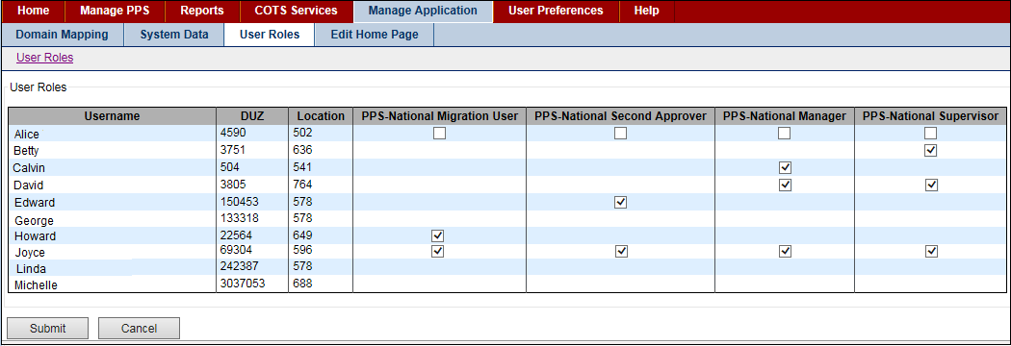

Figure 79: User Roles Tab

## Edit Home Page Tab

You can use this tab to change the image and text on the Home page of the application.

To see this tab, you must be assigned the role of National Supervisor. See Identity Management for more information on roles.

**To Change Image:**

1. Click the Edit Home Page tab. The system opens the page.
2. Select an option from the image drop-down list: Default System Image or Current Custom Image. They system updates the image.
3. Click the Save Changes button. The system processes the request and displays the image on the Home page.

**To Upload New Image:**

1. Click the Edit Home Page tab. The system opens the page.
2. In the image drop-down list, select Upload New Image. The system opens the Upload Image field with a Browse button.
3. Click the Browse button to open a navigational dialog, and select an image to upload. The system adds the image name in the Upload Image field.
4. Click the Save Changes button. The system processes the request and displays the image on the Home page.

Image Options

**Default System Image**

The default image that comes bundled with the application. To change the default image, the application must be updated and reinstalled.

**Current Custom Image**

A custom image that a Supervisor uploaded. If a custom image has not been uploaded, the default image displays. After you select an image and click the Save Changes button, the system submits the form. After the system processes the submission, the custom image field automatically changes to the Current Custom Image and a preview of the image displays below.

**Upload New Image**

This option allows a Supervisor to upload a custom image to the server. This action over-writes the previous custom image. A form field allowing file selection appears below when this option is selected. Images are restricted to a maximum height or width of 500 pixels. Larger images can become scaled.

To Update Message:

1. Click the Edit Home Page tab. The system opens the page.
2. In Title, update the page title.
3. In Body, update the text in the body of the Home page.
4. In Link Title, enter text for the link a user presses to see the remainder of the body.
5. In Link, enter the link page address (URL -Uniform Resource Locator). Or, enter a value of # and the link does not display another page.
6. Click the Save Changes button. The system processes the request and displays the message on the Home page.

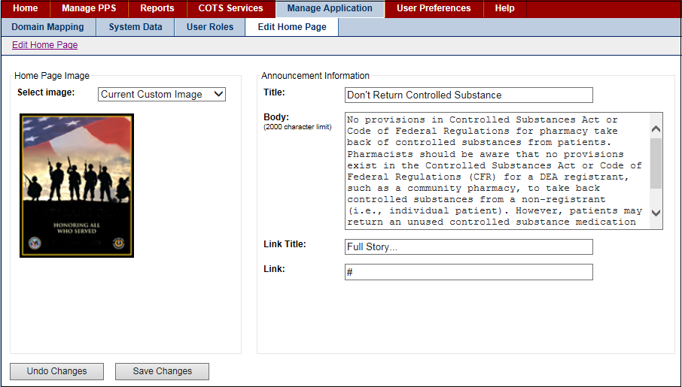

Figure 80: Home Page Message (Editing)

# Migration Tab

This tab allows you to complete the migration tasks. Using this tab, you can:

* Migrate DDI (Drug-Drug Interaction file)
* Migrate Package Size
* Migrate Copay Tier Data
* Migrate Formulary Designator Data
* Migrate Hazardous Waste Data

To see this tab, you must be assigned the role of National Migrator. See Identity Management for more information on roles.

## Migrate Package Size Tab

Use this tab to migrate the package size file.

**To Migrate:**

1. Click the Migration tab, and then click the Migrate Package Size tab.
2. Click the Browse button. The system opens a navigation dialog.
3. Navigate to and select the package size file you want to migrate.
4. Click the Open button. The system adds the file name to the Package Size file field.
5. Click the Upload button. The system uploads the file.

## Migrate Copay Tier Data

Migrate Copay Tier Data - this allows the user to import a file to populate the Copay Tier Level Fields for associated PPS-N Files.

The structure of the file should be in the following format:

* VUID
* VA\_Product\_Name
* Tier
* Effective Date
* Migrate Copay Tier Data

Use this tab to migrate the copay tier level fields.

**To Migrate:**

1. Click the Migration tab, and then click the Migrate Copay Tier Data tab.
2. Click the Browse button. The system opens a navigation dialog.
3. Navigate to and select the file you want to migrate.
4. Click the Open button. The system adds the file name to the Copay Tier Data file field.
5. Click the Upload button. The system uploads the file.
6. Once the migration process has completed, click the Download button to view the migration
7. results.

## Migrate DDI Tab

Use this tab to migrate the Drug-Drug Interaction file.

**To Migrate:**

1. Click the Migration tab, and then click the Migrate DDI tab.
2. Click the Browse button. The system opens a navigation dialog.
3. Navigate to and select the drug-drug interaction file you want to migrate.
4. Click the Open button. The system adds the file name to the Drug Drug Interaction file field.
5. Click the Upload button. The system uploads the file.

## Migrate Formulary Designator Data

Use this tab to migrate formulary designator data.

If the user tries to import a file and a required field is left blank, the user will see this error message: "The import file data is formatted incorrectly: for input string 'xx'".

If the user exports the file from the database, please the instructions below:

1. Export the file into a comma separated file (CSV).
2. Open an Excel file that will be the import spreadsheet and go to the Data tab and select From Text.
3. Pick the CSV file in the Import Text File popup window.
4. After the file has been selected, it will ask for a delimiter (comma) and then another page will let the user select each column and specify the data type.

Note: The EPL\_ID column in the import spreadsheet must be formatted as "text" in Excel, not as a number, to ensure that the correct values are imported (Excel rounds any number longer than 15 digits to zero in right-most digits, which makes the EPL IDs invalid).

The structure of the file should be in the following format:

* Column A = EPL ID
* Column B = Orderable Item Name
* Column C = Formulary Designator
* Column D = Orderable Item Text

**To Migrate:**

1. Click the Migration tab, and then click the Migrate Formulary Designator Data tab.
2. Click the Browse button. The system opens a navigation dialog.
3. Navigate to and select the file you want to migrate.
4. Click the Open button. The system adds the file name to the Formulary Designator Data  file field.
5. Click the Upload button. The system uploads the file.
6. Once the migration process has completed, click the Download button to view migration results.

## Migrate Hazardous Waste Data

Use this tab to migrate hazardous waste data.

If the user tries to import a file and a required field is left blank, the user will see this error message: "The import file data is formatted incorrectly: for input string 'xx'".

If the user exports the file from the database, please the instructions below:

1. Export the file into a comma separated file (CSV).
2. Open an Excel file that will be the import spreadsheet and go to the Data tab and select From Text.
3. Pick the CSV file in the Import Text File popup window.
4. After the file has been selected, it will ask for a delimiter (comma) and then another page will let the user select each column and specify the data type.

Note: The EPL\_ID column in the import spreadsheet must be formatted as "text" in Excel, not as a number, to ensure that the correct values are imported (Excel rounds any number longer than 15 digits to zero in right-most digits, which makes the EPL IDs invalid).

The structure of the file should be in the following format:

* VUID
* EPL\_ID
* CMOP\_ID
* NDF\_Product\_IEN
* VA\_Product\_Name
* Generic\_Name
* Schedule\_Name
* DF\_Name
* Hazardous\_To\_Handle
* Hazardous\_To\_Dispose
* Primary\_EPA
* Waste\_Sort\_Code
* DOT\_Shipping\_Name

To Migrate:

1. Click the Migration tab, and then click the Migrate Hazardous Waste Data tab.
2. Click the Browse button. The system opens a navigation dialog.
3. Navigate to and select the file you want to migrate.
4. Click the Open button. The system adds the file name to the Hazardous Waste Data file field.
5. Click the Upload button. The system uploads the file.
6. Once the migration process has completed, click the Download button to view the migration results.

To run the query to dump the products from the database to generate the input file for hazardous waste is below.  After creating the file, the user will have to modify the values in the hazardous waste columns of the file to reflect what the products should have and then they can feed it into the migration.

* select p.VUID as VUID, p.EPL\_ID as EPL\_ID, CMOP\_ID, NDF\_PRODUCT\_IEN, VA\_PRODUCT\_NAME,
* gn.GENERIC\_NAME as GENERIC\_NAME, fs.SCHEDULE\_NAME as SCHEDULE\_NAME, DF.DF\_NAME as
* DF\_NAME, HAZARDOUS\_TO\_HANDLE, HAZARDOUS\_TO\_DISPOSE, PRIMARY\_EPA, WASTE\_SORT\_CODE,
* DOT\_SHIPPING\_NAME from ppsnepl.epl\_products p, ppsnepl.epl\_orderable\_items oi, ppsnepl.epl\_dosage\_forms
* df, ppsnepl.EPL\_CS\_FED\_SCHEDULES fs, ppsnepl.EPL\_VA\_GEN\_NAMES gn where oi.epl\_id
* =P.EPL\_ID\_OI\_FK AND df.epl\_id =OI.DOSAGE\_FORM\_ID\_FK AND fs.epl\_id =P.CS\_FED\_SCHED\_ID\_FK
* AND gn.epl\_id = P.VA\_GEN\_NAME\_ID\_FK;

# Additional Help

# Appendix

This section includes some helpful information that is referenced from many topics.

|  |  |
| --- | --- |
| A-Z Tab  History Tab  Icon and Button List  Add Domain Pages   * Add Drug Class * Add Dispense Unit Name * Add Dosage Form Name * Add Dose Unit Name * Add Drug Text Name * Add Drug Unit Name * Add Generic Name * Add Copay Tier * Add Ingredient Name * Add Manufacturer Name * Add Order Unit Abbreviation * Add Package Type Name * Add Special Handling Code * Add Standard Med Route Name   Edit Domain Pages   * Edit Drug Class * Edit Dispense Unit Name * Edit Dosage Form Name * Edit Dose Unit Name * Edit Drug Text Name * Edit Drug Unit Name * Edit Generic Name * Edit Copay Tier * Edit Ingredient Name * Edit Manufacturer Name * Edit Order Unit Abbreviation * Edit Package Type Name * Edit Special Handling Code * Edit Standard Med Route Name | NDC Edit Tabs   * Header * Main Tab * Price Tab   Orderable Item Edit Tabs   * Header * Details Tab * Labs & Vitals Tab * Products Tab * Safety Tab   Product Edit Tabs   * Header * National Data Tab * Drug Data Tab   Product Quick Actions Tab   * CMOP Mark / Unmark * Enter / Edit Dosages * Print PMI * Print Warning Labels * RxNorm   Product Application Data Tab   * Controlled Substance * Drug Accountability * Inpatient - Unit Dose * IV * Non-VA Med * Outpatient * Surgery * Ward Stock * Dispense Data Tab * Administration Data Tab * NDCs Tab   Product Change Request Tab  Product Pending Modification Tab |

## A–Z Tab

This tab appears frequently. The tab includes a list of all attributes for the applicable Product, Orderable Item, or NDC in a table format. Many fields are editable.

The following restrictions can appear beside field labels:

|  |  |  |
| --- | --- | --- |
| L | - | This label indicates the field is Local Only and cannot be modified by National Users. |
| \* | - | This label indicates a mandatory field; that is, a field you must complete. |
| R | - | This label indicates a read-only field. Read-only fields are fields that can be entered when an Orderable Item is created but cannot be modified after the creation. |

**To Edit Fields**

1. Click the link in the Field Name column. The system displays a pop-up window with current values for that field.
2. In the pop-up window, make changes in the editable value fields, and then click the Save Changes button. The system closes the pop-up window and updates the Current Value for the field in the A–Z tab.
3. After making all changes, click the Submit button to save all changes made to the Product, Orderable Item, or NDC. The system opens a Modification Summary.
4. Click Accept Changes. A confirmation message appears: Your changes have been committed.
5. Click OK to acknowledge the message. The system displays the Request Tab.

**Field List A–Z Tab Headers**

See the following topics for information about header fields.

NDC Header

Orderable Item Header

Product Header

**Field List A–Z Tab Table**

**Field Name**

Click the link to open the pop-up for the Field Name. Data in the fields on this page comes from many sources. For more information on a specific field, search for the field label in the Help file.

If the field is editable, the pop-up includes an entry field and buttons. See edit instructions above.

If the field is editable with restrictions, the pop-up includes current data and restrictions. For example, the pop-up might include the following statement: This field is local-only, and cannot be edited by National. Therefore, while the field is editable, only a local user can edit it. A user with a National role has read-only access.

If the field cannot be edited, the pop-up includes current data and restrictions. The pop-up will include the following statement: This field is read-only, and cannot be edited.

**Current Value**

The view-only Current Value for the associated field name

**Buttons and Links**

**Cancel**

Click this button discard changes and return to the previous page.

**Save Work in Progress**

Click this button to save your work. See Saved Work in Progress tab for more information.

**Submit**

Click this button to submit the additions or changes you have made.

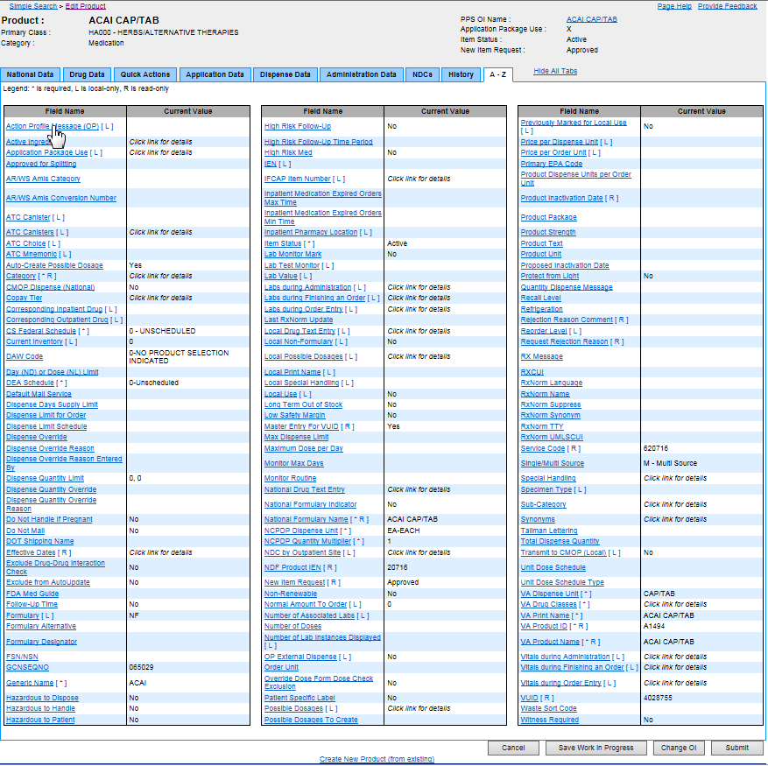

Figure 81: Edit Product A-Z Tab

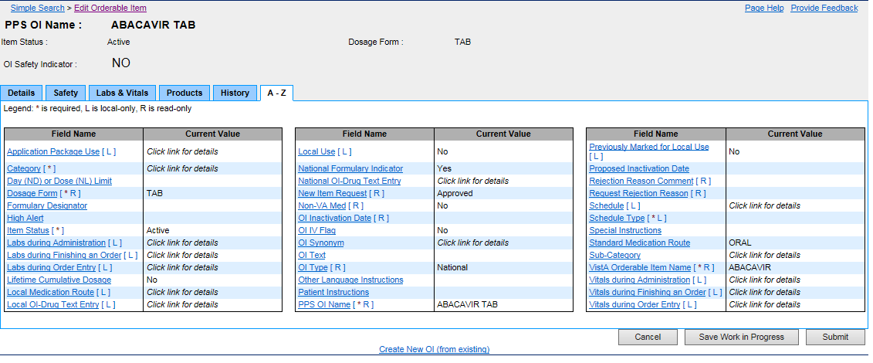

Figure 82: A–Z Tab

## History Tab

This tab appears in many instances. The History tab contains information about changes that were made since the product, orderable item, or NDC was updated or approved. This tab contains several attributes, and then a table listing the changes that were made. There are several different history tabs, see examples below. The history tab will display item/product modifications including copay tier changes, VA Drug class changes, formulary designator modifications, and product units.

**Field List History Tab Headers**

See the following topics for information about header fields.

**NDC Header**

Orderable Item Header

**Product Header**

Field List Request Details

**New Item Request**

The view-only status of a new item: Approved, Pending, or Rejected.

A request is a user action that a PPS (Pharmacy Product System) Item (OI, Product Item, or NDC Item) addition or modification be considered by the PNM for updates within the PPS enterprise database. See Select Search Field for more information.

**Request Rejection Reason**

The view-only reason a domain was rejected

**Rejection Reason Comment**

The view-only additional comments that were made for a rejected domain

**Field List Audit History**

**Event Category**

The view-only major category for why the change occurred. For example, a System Event occurs based on an automated action of the system while a National Modification occurs based on a user action.

An event is an occurrence that can be synchronous or asynchronous and to which an application must respond in some manner.

**Detail Event Category**

The view-only details. When multiple attributes are changed at the same time, there is a single event that captures the change but each change is listed separately in this field.

**Field Name**

The view-only Field Name of the attribute that was modified

**Reason**

The view-only Reason for the change. In most cases, this is optional free text that is entered by the user.

**Old Value**

The view-only original value

**New Value**

The view-only modified value

**Date/Time Modified**

The view-only date and time the change was made

**Username**

The view-only role of the user who modified or approved the request. See Identity Management for more information.

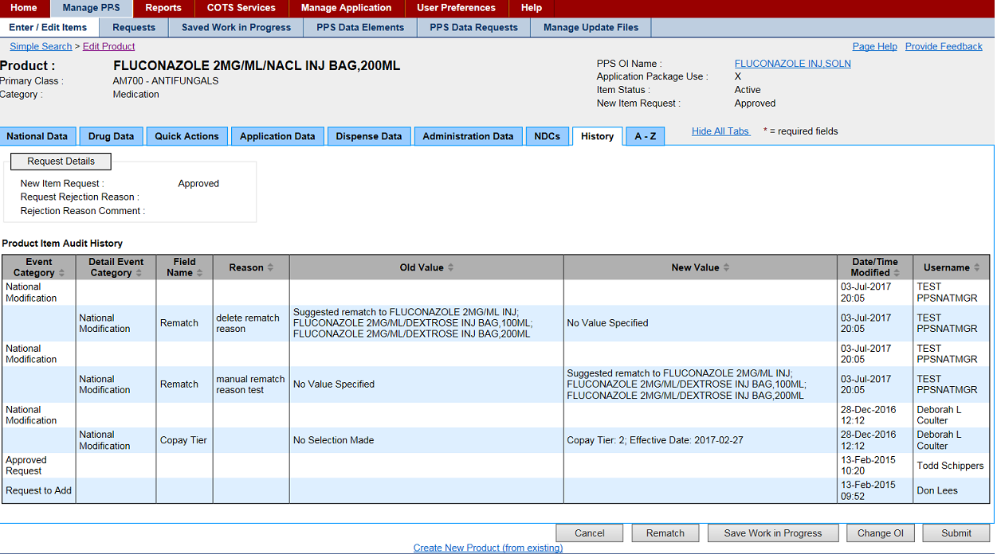

Figure 83: Figure: History Tab- Edit Product

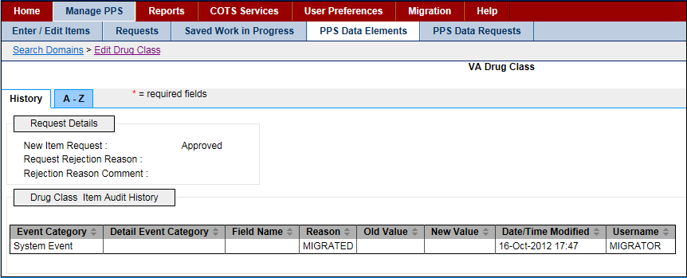

Figure 84: History Tab for PPS Data Elements- Edit Drug Class

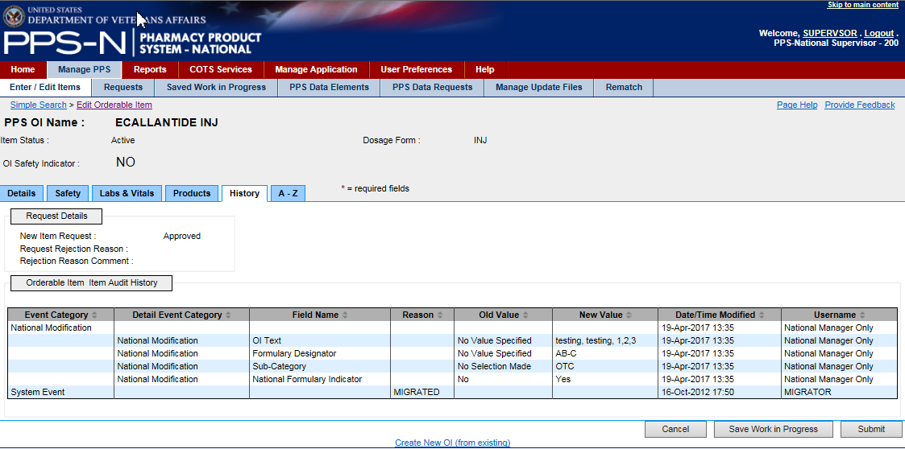

Figure 85: Edit OI- History Tab

## Icon and Button List

The PPS-N application contains many buttons and links. The table below shows the buttons used in PPS-N and their meanings. This list is alphabetical, not by window or function, as the buttons can display on many different windows and it depends upon user authority whether a button is visible.

**List of Icons and Buttons**

|  |  |
| --- | --- |
| Graphic Left Arrow Button | Click this button to move an entry from the right-side list to the left-side list. |
| Graphic Right Arrow Button | Click this button to move an entry from the left-side list to the right-side list. |
| Graphic Plus Button | Click this icon to add a new item to a list. |
| Graphic Open Lock | Click this icon to lock a field. The system changes the icon Graphic Closed Lock.For example, when you click this icon beside the Proposed Inactivation Date field, the system disables the field so that it cannot be changed. The lock is a toggle, which can be clicked to lock or unlock the field. |
| Graphic PDF Button | Click this icon to display data in the Medication Guide. |

**- A -**

Accept Changes

When a user makes changes to an item, those changes are displayed in a modification summary table so they can review and confirm the changes. This button provides that confirmation.

Accept Changes to Product & Create Blank NDC

After a user creates a new product and views the changes on the confirmation page, the user has the option to accept those changes and also launch a blank NDC template form for creating a new NDC to be associated with the product they just created.

Activate

Activate an item that was previously inactive.

Add

Add a new search filter in Advanced Search.

Add More Details

After a user creates a new item using a template (which only contains the primary information fields), the user has an option to proceed to the edit table, which provides access to all available data fields for that type item.

Add New Row

Add a new row in one of the multiple select boxes.

Apply Changes to All Items

When editing multiple items at the same time, as part of a single process, the user can apply changes to all items in the process.

Apply Changes to Just This Item

When editing multiple items at the same time, as part of a single process, the user can apply changes to a single item.

Approve

Approve any or all changes made to an item.

**- C -**

Cancel

Cancels the current action or process and returns to the previous page.

Change OI

Each product has an associated OI. When the OI for a product already exists, the user can search for and select a different OI.

Change Product

Each NDC has an associated Product. When the Product for an NDC already exists, the user can search for and select a different Product.

Change Search Results Template

Select the current advanced search template for editing or to create a new template.

Create New NDC (from blank)

Create a new NDC from scratch by using a blank NDC template form.

Create New NDC (from existing)

Use an existing NDC and its details as a template for creating a new NDC.

Create New OI (from blank)

Create a new OI from scratch by using a blank OI template form.

Create New OI (from existing)

Use an existing OI and its details as a template for creating a new OI.

Create New Product (from blank)

Create a new product from scratch by using a blank product template form.

Create New Product (from existing)

Use an existing product and its details as a template for creating a new product.

**- D -**

Delete

Delete an item, typically by removing it from a list.

Delete Change Request

Delete a change request.

Down

Move an item down in the list.

Download

Download a file, typically in a CSV format.

**- E -**

Edit Items

Select to edit multiple items as part of a single process.

**- G -**

Generate Name Fields Below

When creating a new product, the user can automatically generate the VA Product Name, VA Print Name, and National Formulary Name.

Generate New

When viewing some report types, the user can create a new CSV file, which can then be downloaded for viewing and/or saving.

Generate OI Names

When creating a new OI, this permits the user to automatically generate the PPS OI Name and VistA Orderable Item Name.

Get Status

Permits the user to view the status of a report generation process.

**- I -**

Ignore

In certain instances, the user will receive a warning about the item they have just submitted. This warning is for information purposes only.

Inactivate

Choose to inactivate an item that is currently active.

**- L -**

Load Print Template

Search preferences permit a user to personalize All Fields search templates for each Item Type. This action loads the appropriate fields for selection, based on the Item Type, and also loads an existing template when a template exists.

Login

Log in to PPS-N

**- M -**

Match Results

After performing an FDB search, select to match the NDCs with an existing PPS-N product.

**- N -**

Next Item

Advance to the next item in the process, typically when performing edits on more than one item at a time.

**- O -**

OK

Final confirmation that an item has been saved to the database.

Open Blank Template

Create a new domain item using a blank form template.

Overwrite

Replace an existing item with a new item.

**- P -**

Perform FDB Search

Send a search query to FDB.

Previous Item

Back up to the previous item in the process, typically when performing edits on more than one item at a time.

**- R -**

Reject

Reject any or all changes made to an item.

Remove

Remove an item.

Remove As Default

Unmark the existing default advanced search template.

Remove Row

Some data fields can have multiple entries and these are displayed as rows within a table. This action allows the user to remove an item (row) from the table.

Retrieve Search Templates

Change the current advanced search template by selecting another one from the list of available saved templates.

Return

Return to the previous page, typically so the user can make more changes.

Run Report

When viewing some report types, the user can create a new report.

**- S -**

Save Changes

Save all changes.

Save Template

After a user has created a new advanced search template or changed an existing template, they will assign a name for that template, and then use this button to save the template to the database.

Save Work in Progress

When a user is not done editing, the user can use this button to save their work and return to it later.

Search

Perform a search using the defined search criteria.

Select All

When viewing a table, you can use this button to select all of the items displaying in the table; that is, add a check mark to the check boxes in the table (usually in a Select column).

Select OI

When creating a new product using a blank product template form, this action is used to search for and select an OI.

Select Product

When creating a new NDC using a blank NDC template form, this action is used to search for and select a Product.

Set As Default

Define one advanced search template as the default template.

Set Preferences

After a user has set or changed their user preferences, this action will save those preferences to the database.

Submit

Start the confirmation process for a new item or revisions to an existing item. In some cases, this also saves the item to the database.

**- U -**

Under Review

Place an item under review.

Undo Changes

Undo all changes made since the last time this item was saved.

Up

Move an item up in a list.

**- V -**

View PMI

View the Patient Medication Instructions for a specific drug.

## Add Domain Pages

### Add VA Drug Class

Use this template to add drug class classifications or drug class codes. A drug class is a grouping of drug products based on various criteria that can include similarity of chemical structure, clinical indications, pharmacology, and therapeutic activity.

**Field List Template**

Fields with a red asterisk are required fields that you must complete.

**Drug Class Code** \*

Enter a Drug Class Code.

**Drug Class Classification** \*

Enter a Drug Class Classification.

**Drug Class Type** \*

Select a Drug Class Type from the drop-down list.

**Drug Class Description**

Enter a Drug Class Description.

**Drug Class Parent**

Select a Drug Class Parent from the drop-down list.

If the parent you need is not on the list, click the add button add_button.pngto add a parent. Complete the fields, and then click the Submit button.

Check box if excluded.

**Excluded**

Drug classes marked as excluded will default to tier 0 when a copay tier record is added to the associated product, to change a product to be excluded check the excluded box and click the Save Changes button.

**PSR Name**

Enter the name of the Pharmacy Product System Second Reviewer. See PPS Data Requests Tab for more information on second reviewers.

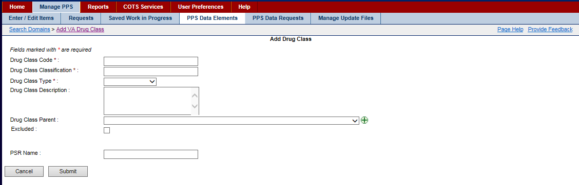

Figure 86: Add Drug Class Template

### Add Dispense Unit Name

Use this template to add dispense units. A dispense unit is a unit of measure for dispensing. For example, GM, EA, CANNISTER, and so forth.

**Field List Template**

Fields with a red asterisk are required fields that you must complete.

**Dispense Unit Name** \*

Enter a name for the dispense unit.

**PSR Name**

Enter the name of the Pharmacy Product System Second Reviewer.

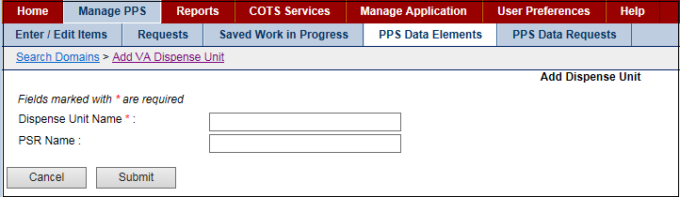

Figure 87: Add Dispense Unit Template

### Add Dosage Form Name

Use this template to add a dosage form. A dosage form is the medium used to administer the active ingredient(s) in health products. Dosage forms include, but are not limited to capsules, tablets, injectables, oral solutions, drops, creams, ointments, and patches.

**Field List Template**

Fields with a red asterisk are required fields that you must complete.

**Dosage Form Name** \*

Enter a Dosage Form Name.

Exclude from Dosage Checks

Accept the default of No or select Yes from the drop-down list.

**Verb**

Enter a Verb. This field is local-only and cannot be edited by National.

Other Language Verb

Enter a verb for another language. This field is local-only and cannot be edited by National.

**Preposition**

Enter a Preposition. This field is local-only and cannot be edited by National.

**Other Language Preposition**

Enter a preposition for another language. This field is local-only and cannot be edited by National.

**Conjunction**

Enter a Conjunction. This field is local-only and cannot be edited by National.

**Med Route for Dosage Form**

Enter a standard medical route. This field is local-only and cannot be edited by National.

**Dosage Form Nouns**

Enter a Dosage Form Noun. This field is local-only and cannot be edited by National.

**Dosage Form Units Box**

To add, click the Add New Row button and the system adds a new row.

* In Drug Unit, enter the unit.
* In Possible Dosages Package, select an option: I-Inpatient or Outpatient.
* Click the Save Changes button.

To remove, click the Remove button beside a unit that is not valid.

**Dispense Units per Dose Box**

To add, click the Add New Row button and the system adds a new row.

* In Dispense Unit per Dose, enter the dispensing unit.
* In Possible Dosages Package, select an option: I-Inpatient or Outpatient.
* Click the Save Changes button.

To remove, click the Remove button beside a unit that is not valid.

**PSN Name**

Enter the name of the Pharmacy Product System Second Reviewer.

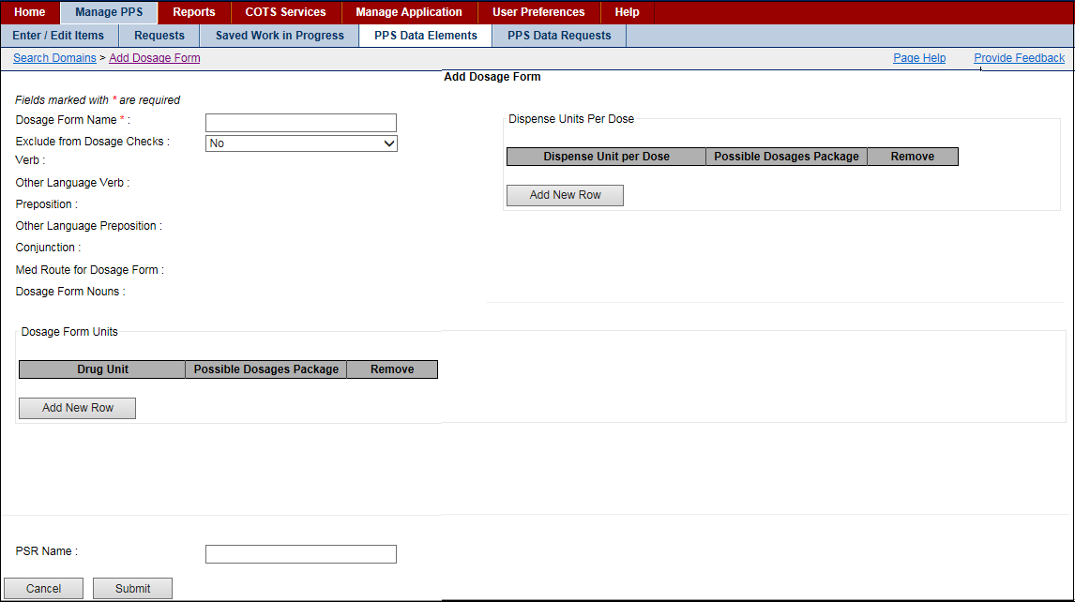

Figure 88: Add Dosage Form Template

### Add Dose Unit Name

Use this template to add dose units.

**Field List Template**

Fields with a red asterisk are required fields that you must complete.

**Dose Unit Synonym Box**  
Synonym Name

Click the Add New Row button. The system adds a new line to the Dose Unit Synonyms field group. In Synonym Name, enter a synonym for the dose unit.

**COTS Dose Unit** \*

Enter a Commercial-Off-the-Shelf (COTS) Dose Unit.

**Replaced by VHA Standard Terms**

Select a term from the drop-down list.

**Dose Indicator**

Click this box to add a check mark if you want the system to allow for different dosages for different disease states as well as for different Patient conditions. For example, the dose for Megestrol used for anorexia is 800mg daily, whereas the dose for Megestrol used for breast cancer is 40mg four times daily. Additionally, doses for Patients with impaired renal or hepatic clearances may have to be adjusted.

**Dose Unit Name** \*

Enter a Dose Unit Name.

**PSR Name**

Enter the name of the Pharmacy Product System Second Reviewer.

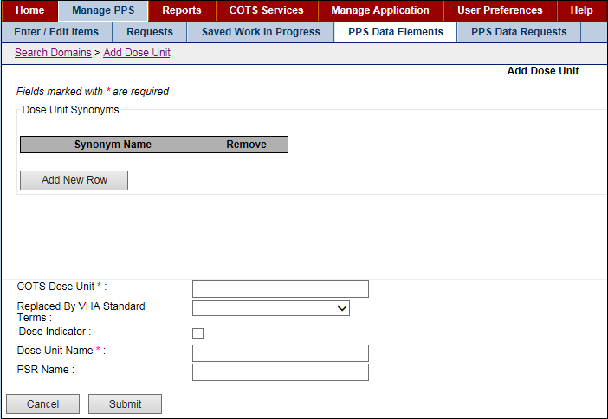

Figure 89: Add Dose Unit Template

### Add Drug Text Name

Use this template to add drug text.

**Field List Template**

Fields with a red asterisk are required fields that you must complete.

**Drug Text Name** \*

Enter a text name for the drug.

**National Text** \*

Enter a National Text name for the drug. National text name is associated with information on drug restrictions, guidelines, and protocols to help assure medications are being used according to formulary specifications.

**Synonyms Box**

**Drug Text Synonym**

To add, click the Add New Row button and the system adds a new row.

* In Drug Text Synonym, enter the Synonym.
* Click the Save Changes button.

To remove, click the Remove button beside a synonym that is not valid.

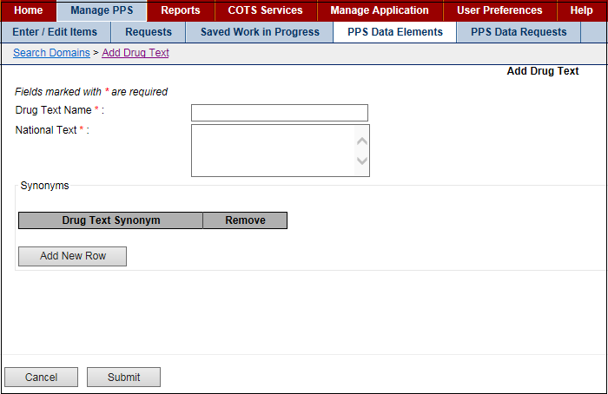

Figure 90: Add Drug Text Template

### Add Drug Unit Name

Use this template to add drug units.

**Field List Template**

Fields with a red asterisk are required fields that you must complete.

**Drug Unit Name** \*

Enter a name for the drug unit.

**PSR Name**

Enter the name of the Pharmacy Product System Second Reviewer.

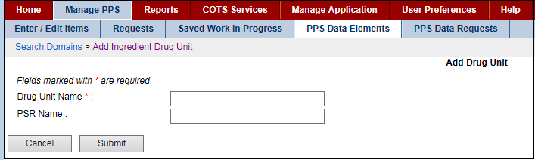

Figure 91: Add Drug Unit Template

### Add Generic Name

Use this template to add generic names for drugs.

**Field List Template**

Fields with a red asterisk are required fields that you must complete.

**Generic Name** \*

Enter a Generic Name for the drug.

**PSR Name**

Enter the name of the Pharmacy Product System Second Reviewer.

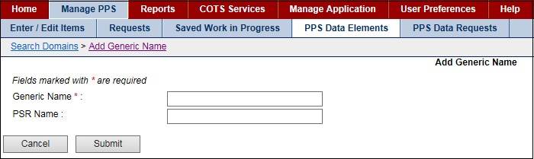

Figure 92: Add Generic Name Template

### Add Ingredient Name

Use this template to add ingredients.

**Field List Template**

Fields with a red asterisk are required fields that you must complete.

**Ingredient Name** \*

Enter an Ingredient Name.

**Primary Ingredients**

Select a Primary Ingredient from the drop-down list. Or, click the add icon add_button.png to add a new primary ingredient. In Ingredient Name, enter the new primary ingredient, and then click the Submit button.

**PSR Name**

Enter the name of the Pharmacy Product System Second Reviewer.

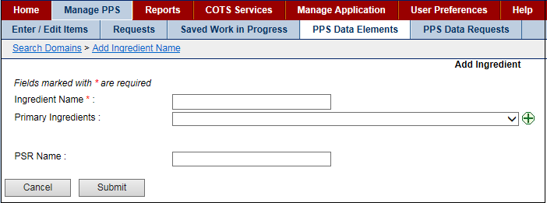

Figure 93: Add Ingredient Template

### Add Manufacturer Name

Use this template to add manufacturer names for drugs.

**Field List Template**

Fields with a red asterisk are required fields that you must complete.

**Manufacturer Name** \*

Enter the name of a manufacturer.

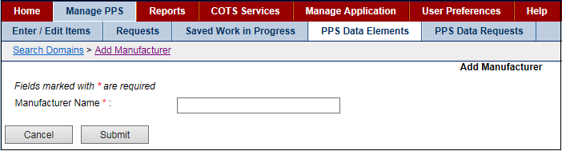

Figure 94: Add Manufacturer Name Template

### Add Order Unit Abbreviation

Use this template to add order units.

**Field List Template**

Fields with a red asterisk are required fields that you must complete.

**Order Unit Abbreviation** \*

Enter an abbreviation for the order unit. For example, enter AM for ampul.

**Order Unit Expansion**

Enter the full text for the abbreviation for the order unit. For example, enter AMPUL.

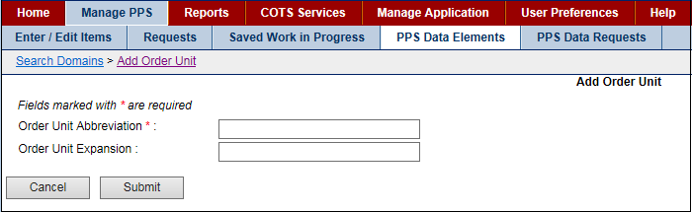

Figure 95: Add Order Unit Template

### Add Package Type Name

Use this template to add package types.

**Field List Template**

Fields with a red asterisk are required fields that you must complete.

**Package Type Name** \*

Enter a name for the package type.

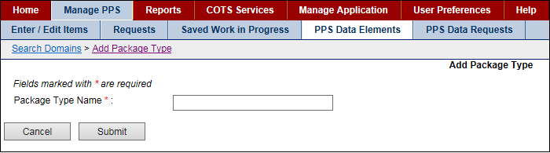

Figure 96: Add Package Type Template

### Add Special Handling Code

Use this template to add special handling instructions.

**Field List Template**

Fields with a red asterisk are required fields that you must complete.

**Description** \*

Enter a Description of the special handling instructions. For example, enter NARCOTICS AND ALCOHOL.

**Special Handling Code** \*

Enter a code for the special handling. For example, enter A.

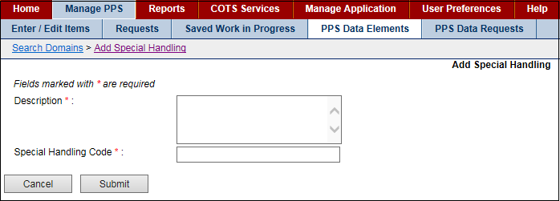

Figure 97: Add Special Handling Template

### Add Standard Med Route Name

The additional domain menu option Standard Med Route Name has no add function. Standard Medication Routes are added through the STS web services.

* To see details for a med route, see Edit Standard Med Route Name.
* To see more information on STS web services, see the System Data tab.

## Edit Domain Pages

### Edit VA Drug Class

Use this form to edit a drug class classifications or drug class code domain. A drug class is a grouping of drug products based on various criteria that can include similarity of chemical structure, clinical indications, pharmacology, and therapeutic activity.

**Field List Current Values**

Fields with a red asterisk are required fields that you must complete.

**Classification** [\* R]

 The drug class Classification. Read-only field.

**Code** [\* R]

 The drug class Code .Read-only field.

**Description**

 Enter a drug class Description and click the Save Changes button.

**Parent Class**

 Enter a drug class parent and click the Save Changes button.

**Type** \*

Select a drug class Type from the drop-down list and click the Save Changes button.

**VUID** [R]

 Enter a VA Unique Identifier. Read-only field.

**Effective Dates** [R]

The Effective Date related to the status in the Status file. Read-only field.

**Excluded**

Drug classes marked as excluded will default to tier 0 when a copay tier record is added to the associated product, to change a product to be excluded check the excluded box and click the Save Changes button.

**Item Status** [\* R]

The status of the item. Read-only field.

**Master Entry for VUID** [R]

The Master Entry for the VA Unique Identifier. Read-only field.

**NDF IEN** [R]

The National Drug File (NDF) Internal Entry Number (IEN). Read-only field.

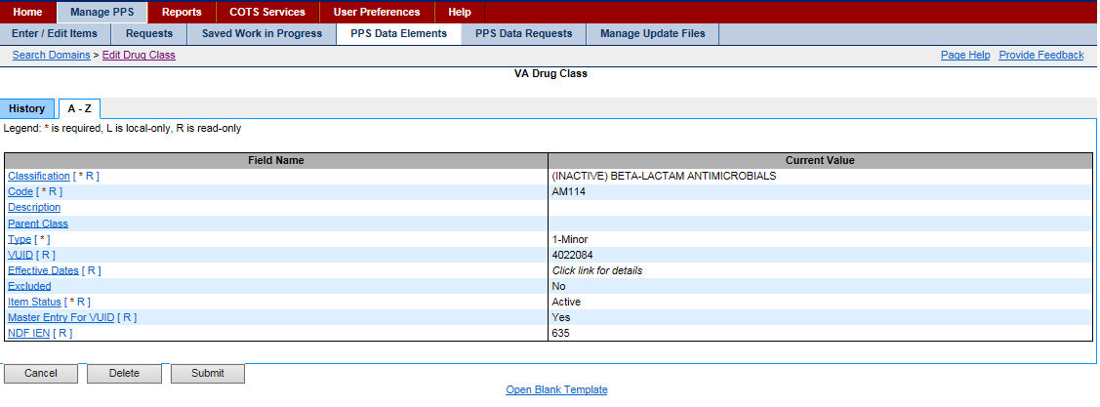

Figure 98: Edit VA Drug Class Sample

**Reference**

See the following topics for more information on tabs:

* A–Z tab
* History tab

### Edit VA Dispense Unit Request

Use this form to manage a dispense unit request that another user has entered. This same page is used to manage Addition Requests as well as Modification Requests and the screen is altered a little differently depending on which type of request is being handled.

The Edit Dispense Form Request page will allow the user to view the history of the ingredient, the change request, and the A-Z Tab. The user can cancel, inactivate, delete, approve, reject or place the ingredient under review.

Complete the steps to Search for Requests.

After you have search results, complete any of these tasks:

* Approve Request
* Reject Modification Request
* Place Request Under Review
* Place Request in Pending State

**Field List Current Values**

Fields with a red asterisk are required fields that you must complete.

**Dispense Unit Name** [\*]

Enter he name of the dispense unit. For example, canister.

**Inactivation Date** [R]

The inactivation date. This is a read only field.

**Item Status** [\*]

The status of the item: Active or Inactive. If you select Inactive from the drop-down list, the system updates the status and changes the Inactivate button below to Activate.

This field requires a second approval. See Section 3.4 for more information.

**NDF Dispense Unit IEN** [R]

The National Drug File (NDF) dispense unit Internal Entry Number (IEN). Read-only field.

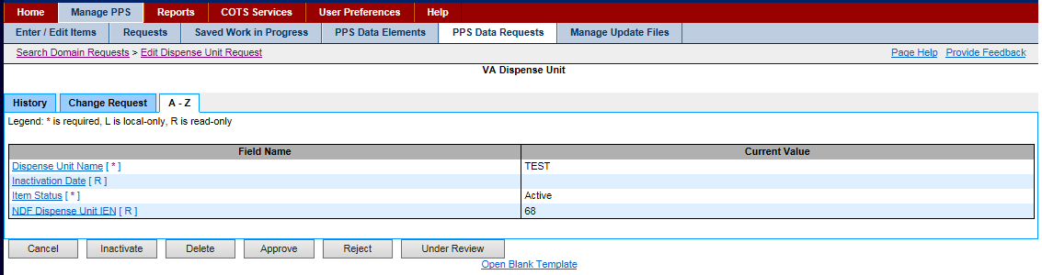

Figure 99: Edit VA Dispense Unit Request

Reference

See the following topics for more information on tabs:

* A–Z tab
* History tab

### Edit Dosage Form Name

Use this form to edit a dosage form domain. A dosage form is the medium used to administer the active ingredient(s) in health products. Dosage forms include, but are not limited to capsules, tablets, injectables, oral solutions, drops, creams, ointments, and patches.

**Field List Current Values**

Fields with a red asterisk are required fields that you must complete.

**Conjunction** [L]

Enter a Conjunction and click the Save Changes button.

This field is local-only and cannot be edited by National.

**Dispense Units Per Dose**

To add, click the Add New Row button and the system adds a new row.

* In Dispense Unit per Dose, enter the dispensing unit.
* In Possible Dosages Package, select an option: I-Inpatient or Outpatient.
* Click the Save Changes button.

To remove, click the Remove button beside a unit that is not valid and click the Save Changes button.

**Dosage Form Name** [\* R]

The name of the dosage form. Read-only field.

This field requires a second approval. See PPS Data Requests Tab for more information.

**Dosage Form Nouns** [L]

Enter a noun that describes the medium used to administer the active ingredient(s) in health products.

This field is local-only and cannot be edited by National.

**Dosage Form Units**

To add, click the Add New Row button and the system adds a new row.

* In Drug Unit, enter the unit.
* In Possible Dosages Package, select an option: I-Inpatient or Outpatient.
* Click the Save Changes button.

To remove, click the Remove button beside a unit that is not valid and click the Save Changes button.

**Exclude from Dosage Checks**

Select an option from the drop-down list (Yes, No) and click the Save Changes button.

**Inactivation Date** [R]

The date the item was inactivated. After you change the Item Status to Inactive, the system inserts the current date. You can edit the date. In Inactivation Date, enter a date using the format DD-Mon-YYYY and click the Save Changes button. See the Job Types for more information.

This field requires a second approval. See PPS Data Requests Tab for more information.

**Item Status** [\*]

The status of the item: Active or Inactive. If you select Inactive from the drop-down list, the system updates the status and changes the Inactivate button below to Activate.

Read-only field.

This field requires a second approval. See PPS Data Requests Tab for more information.

**Med Route for Dosage Form** [L]

Enter the method in which the product is to be administered (e.g., oral, injection).

This field is local-only and cannot be edited by National.

**NDF Dosage Form IEN** [R]

The National Drug File (NDF) dosage form Internal Entry Number (IEN). Read-only field.

**Other Language Preposition** [L]

Enter a preposition for another language and click the Save Changes button.

This field is local-only and cannot be edited by National.

**Other Language Verb** [L]

Enter a verb for another language and click the Save Changes button.

This field is local-only and cannot be edited by National.

**Preposition** [L]

Enter a Preposition and click the Save Changes button.

This field is local-only and cannot be edited by National.

**Verb** [L]

Enter a Verb and click the Save Changes button.

This field is local-only and cannot be edited by National.

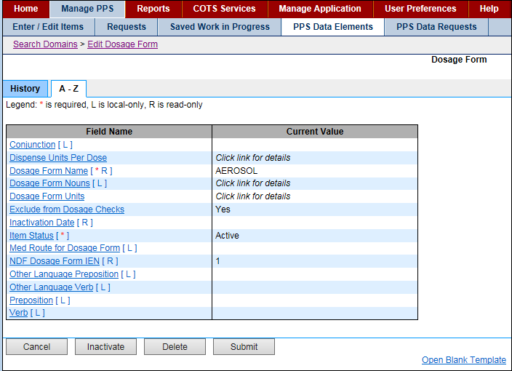

Figure 100: Edit Dosage Form Sample

**Reference**

See the following topics for more information on tabs:

* A–Z tab
* History tab

### Edit Dose Unit Name

Use this form to edit the dose unit domain.

**Field List Current Values**

Fields with a red asterisk are required fields that you must complete.

**COTS Dose Unit** [\* R]

Enter a Commercial-Off-the-Shelf (COTS) Dose Unit and click the Save Changes button.

**Dose Indicator**

For Yes, click the Dose Indicator check box to add a check mark and click the Save Changes button.

For No, click the check box to remove a check mark and click the Save Changes button.

**Dose Unit Name** [\* R]

The name of the dose unit. Read-only field.

This field requires a second approval. See PPS Data Requests Tab for more information.

**Dose Unit Synonyms**

To add, click the Add New Row button and the system adds a new row. In Synonym Name, enter a name and click the Save Changes button.

To remove, click the Remove button beside a synonym that is no longer valid and click the Save Changes button.

**Inactivation Date** [R]

The date the item was inactivated. After you change the Item Status to Inactive, the system inserts the current date. You can edit the date. In Inactivation Date, enter a date using the format DD-Mon-YYYY and click the Save Changes button. See the Job Types for more information.

This field requires a second approval. See PPS Data Requests Tab for more information.

**Item Status** [\*]

The status of the item: Active or Inactive. If you select Inactive from the drop-down list, the system updates the status and changes the Inactivate button below to Activate.

This field requires a second approval. See Section 3.4 for more information.

**Replaced by VHA Standard Terms**

Select a term from the drop-down list and click the Save Changes button.

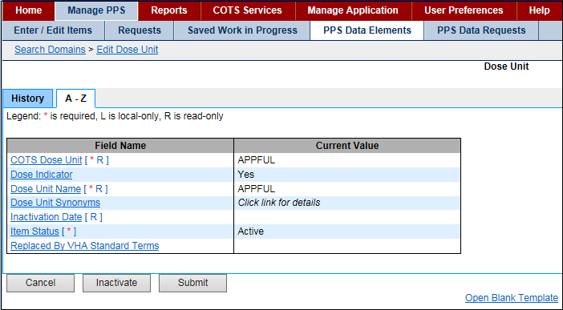

Figure 101: Edit Dose Unit Sample

**Reference**

See the following topics for more information on tabs:

* A–Z tab
* History tab

### Edit Drug Text Name

Use this form to edit a drug text domain.

**Field List Current Values**

Fields with a red asterisk are required fields that you must complete.

**Drug Text Name** [\* R]

The text name of the drug. Read-only field.

**Drug Text Type** [R]

They text type of the drug. Read-only field.

**Inactivation Date** [R]

The date the item was inactivated. After you change the Item Status to Inactive, the system inserts the current date. You can edit the date. In Inactivation Date, enter a date using the format DD-Mon-YYYY and click the Save Changes button. See the Job Types for more information.

**Item Status** [\*]

The status of the item: Active or Inactive. If you select Inactive from the drop-down list, the system updates the status and changes the Inactivate button below to Activate.

**Local Text** [L]

The Local Text for the drug.

This field is local-only and cannot be edited by National.

**National Text** [\*]

The National Text for the drug.

**Synonyms**

To add, click the Add New Row button and the system adds a new row.

* In Drug Text Synonym, enter the Synonym.
* Click the Save Changes button.

To remove, click the Remove button beside a synonym that is not valid.

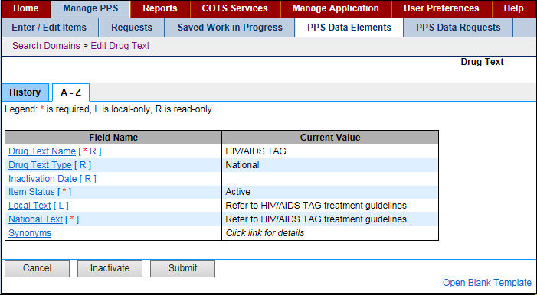

Reference

See the following topics for more information on tabs:

* A–Z tab
* History tab

### Edit Drug Unit Name

Use this form to edit a drug unit domain.

**Field List Current Values**

Fields with a red asterisk are required fields that you must complete.

**Drug Unit Name** [\* R]

The name of the drug unit. Read-only field.

**Inactivation Date** [R]

The date the item was inactivated. After you change the Item Status to Inactive, the system inserts the current date. You can edit the date. In Inactivation Date, enter a date using the format DD-Mon-YYYY and click the Save Changes button. See the Job Types for more information.

This field requires a second approval. See PPS Data Requests Tab for more information.

**Item Status** [\*]

The status of the item: Active or Inactive. If you select Inactive from the drop-down list, the system updates the status and changes the Inactivate button below to Activate.

This field requires a second approval. See PPS Data Requests Tab for more information.

**NDF Drug Unit IEN** [R]

The National Drug File (NDF) dispense unit Internal Entry Number (IEN). Read-only field.

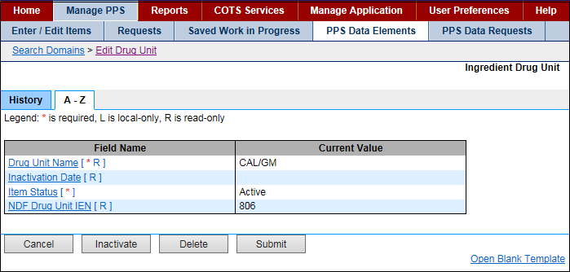

Figure 102: Edit Drug Unit Sample

**Reference**

See the following topics for more information on tabs:

* A–Z tab
* History tab

### Edit Generic Name

Use this form to edit generic name domain.

**Field List Current Values**

Fields with a red asterisk are required fields that you must complete.

**Effective Dates** [R]

The Effective Dates for when the generic name was used. Read-only field.

**Generic Name** [\* R]

The Generic Name for the drug. Read-only field.

**Inactivation Date** [R]

The date the item was inactivated. After you change the Item Status to Inactive, the system inserts the current date. You can edit the date. In Inactivation Date, enter a date using the format DD-Mon-YYYY and click the Save Changes button. See the Job Types for more information.

This field requires a second approval. See PPS Data Requests Tab for more information.

**Item Status** [\*]

The status of the item: Active or Inactive. If you select Inactive from the drop-down list, the system updates the status and changes the Inactivate button below to Activate.

This field requires a second approval. See PPS Data Requests Tab for more information.

**Master Entry For VUID** [R]

The Master Entry For VA Unique Identifier. Read-only field.

**NDF Generic IEN** [R]

The National Drug File (NDF) Generic name Internal Entry Number (IEN). Read-only field.

**VUID** [R]

The VA Unique Identifier. Read-only field.

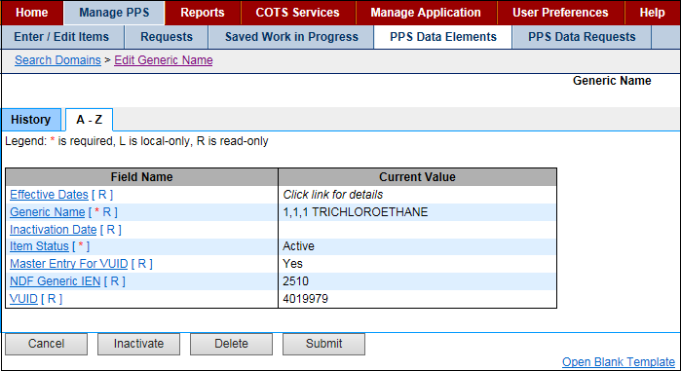

Figure 103: Edit Generic Name Sample

**Reference**

See the following topics for more information on tabs:

* A–Z tab
* History tab

### Edit Ingredient Name

Use this form to edit an ingredient domain.

**Field List Current Values**

Fields with a red asterisk are required fields that you must complete.

**Effective Dates** [R]

The Effective Dates for when the ingredient name was used. Read-only field.

**Inactivation Date** [R]

The date the item was inactivated. After you change the Item Status to Inactive, the system inserts the current date. You can edit the date. In Inactivation Date, enter a date using the format DD-Mon-YYYY and click the Save Changes button. See the Job Types for more information.

This field requires a second approval. See PPS Data Requests Tab for more information.

**Ingredient Name** [\* R]

The name of the ingredient. Read-only field.

**Item Status** [\*]

The status of the item: Active or Inactive. If you select Inactive from the drop-down list, the system updates the status and changes the Inactivate button below to Activate.

This field requires a second approval. See PPS Data Requests Tab for more information.

**Master Entry For VUID** [R]

The Master Entry For VA Unique Identifier. Read-only field.

**NDF Generic IEN** [R]

The National Drug File (NDF) Generic ingredient name Internal Entry Number (IEN). Read-only field.

**Primary Ingredients**

Enter the name of the primary ingredients and click the Save Changes button.

**VUID** [R]

The VA Unique Identifier. Read-only field.

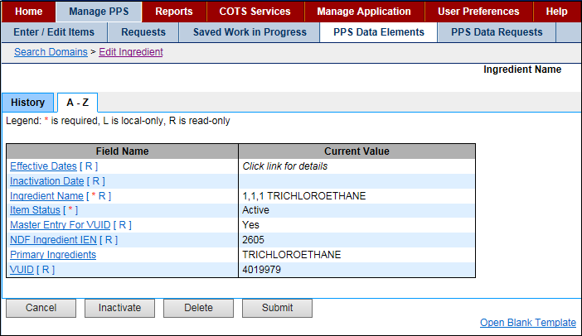

Figure 104: Edit Ingredient Sample

**Reference**

See the following topics for more information on tabs:

* A–Z tab
* History tab

### Edit Manufacturer Name

Use this form to edit a manufacturer domain.

**Field List Current Values**

Fields with a red asterisk are required fields that you must complete.

**Inactivation Date** [R]

The date the item was inactivated. After you change the Item Status to Inactive, the system inserts the current date. You can edit the date. In Inactivation Date, enter a date using the format DD-Mon-YYYY and click the Save Changes button. See the Job Types for more information.

This field requires a second approval. See PPS Data Requests Tab for more information.

**Item Status** [\*]

The status of the item: Active or Inactive. If you select Inactive from the drop-down list, the system updates the status and changes the Inactivate button below to Activate.

This field requires a second approval. See PPS Data Requests Tab for more information.

**Manufacturer Name** [\* R]

The name of the manufacturer. Read-only field.

**NDF Generic IEN** [R]

The National Drug File (NDF) Generic manufacturer name Internal Entry Number (IEN). Read-only field.

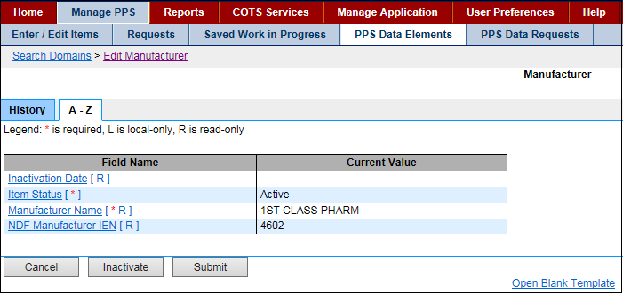

Figure 105: Edit Manufacturer Name Sample

**Reference**

See the following topics for more information on tabs:

* A–Z tab
* History tab

### Edit Order Unit Abbreviation

Use this form to edit order unit abbreviation domain

**Field List Current Values**

Fields with a red asterisk are required fields that you must complete.

**Item Status** [\* R]

The status of the item: Active or Inactive. Read-only field.

**Order Unit Abbreviation** [\* R]

The abbreviation for the order unit. Read-only field.

**Order Unit Expansion**

Enter the full text for the abbreviation of the order unit and click the Save Changes button.

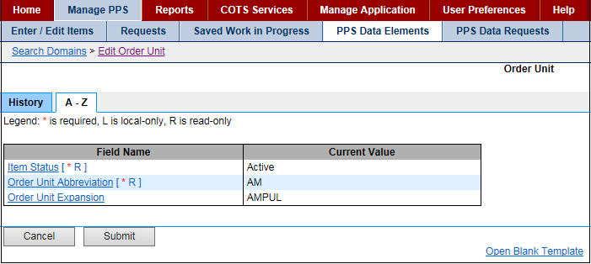

Figure 106: Edit Order Unit Sample

**Reference**

See the following topics for more information on tabs:

* A–Z tab
* History tab

### Edit Package Type Name

Use this form to edit a package type domain.

**Field List Current Values**

Fields with a red asterisk are required fields that you must complete.

**Inactivation Date** [R]

The date the item was inactivated. After you change the Item Status to Inactive, the system inserts the current date. You can edit the date. In Inactivation Date, enter a date using the format DD-Mon-YYYY and click the Save Changes button. See the Job Types for more information.

This field requires a second approval. See Section 3.4 for more information.

**Item Status** [\*]

The status of the item: Active or Inactive. If you select Inactive from the drop-down list, the system updates the status and changes the Inactivate button below to Activate.

This field requires a second approval. See PPS Data Requests Tab for more information.

NDF Package Type IEN [R]

The National Drug File (NDF) Package Type Internal Entry Number (IEN). Read-only field.

Package Type Name [\* R]

The name of the package type. Read-only field.

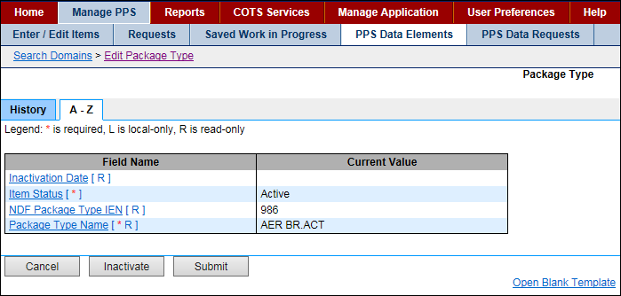

Figure 107: Edit Package Type Sample

**Reference**

See the following topics for more information on tabs:

* A–Z tab
* History tab

### Edit Special Handling Code

Use this form to edit a special handling domain.

**Field List Current Values**

Fields with a red asterisk are required fields that you must complete.

**Description** [\*]

Enter the full Description of the code.

**Item Status** [\* R]

The status of the item: Active or Inactive. Read-only field.

**Special Handling Code** [\* R]

The code associated with the full description. Read-only field.

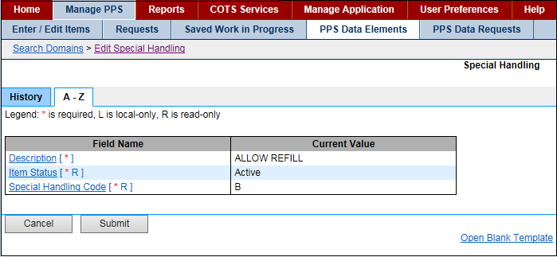

Figure 108: Edit Special Handling Sample

**Reference**

See the following topics for more information on tabs:

* A–Z tab
* History tab

### Edit Standard Med Route Name

Use this view-only form to see data for a standard medication route domain. Standard Medication Routes cannot be added or edited. Instead, they are updated using the Standard Terminology Web Service (STS) job on the System Data tab. The job calls STS to retrieve an up-to-date list of standard medication routes. The system adds any newly added routes to the PPS-N EPL.

**Field List Current Values**

**COTS Med Route** [\* R]

The view-only Commercial-Off-the-Shelf (COTS) Medical Route. Read-only field.

**Effective Dates** [R]

The view-only dates that the medical route were effective. Read-only field.

**Item Status** [\* R]

The view-only status of the item: Active or Inactive. Read-only field.

**Master Entry For VUID** [R]

The view-only Master Entry For VA Unique Identifier. Read-only field.

**Route Replaced By VHA Standard Term** [R]

The view-only VHA standard term for the replacement route. Read-only field.

**Standard Med Route Name** [\* R]

The view-only Standard Medical Route Name. Read-only field.

**VUID** [R]

The view-only VA Unique Identifier. Read-only field.

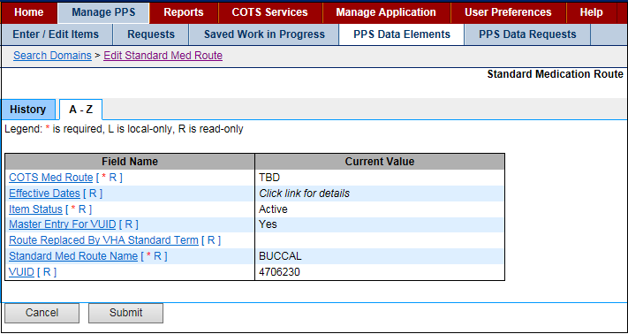

Figure 109: Edit Standard Med Route Sample

**Reference**

See the following topics for more information on tabs:

* A–Z tab
* History tab

## NDC Edit Tabs

### NDC Header

When you edit an NDC, NDC-related tabs appear with a consistent header. This topic provides details for fields appearing in that header.

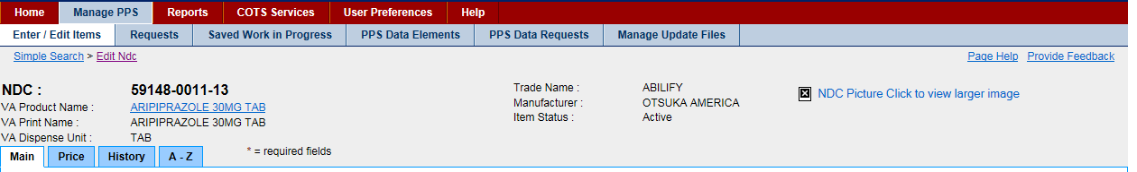

Figure 110: NDC Header

**Field List Header**

**NDC**

The view-only National Drug Code

**VA Product Name**

Click to open a page to view the description and strength of drug to be dispensed.

**VA Print Name**

The view-only VA Print Name

**VA Dispense Unit**

The view-only dispensing unit for the product

**Trade Name**

The view-only Trade Name for the product

**Manufacturer**

The view-only name of the Manufacturer of the product

**Item Status**

The view-only status of the drug: Active or Inactive

**Image**

The view-only uploaded Image of the product

### NDC Main Tab

This tab appears when you edit an NDC and select the Main tab. Use this tab to edit NDC-related main data.

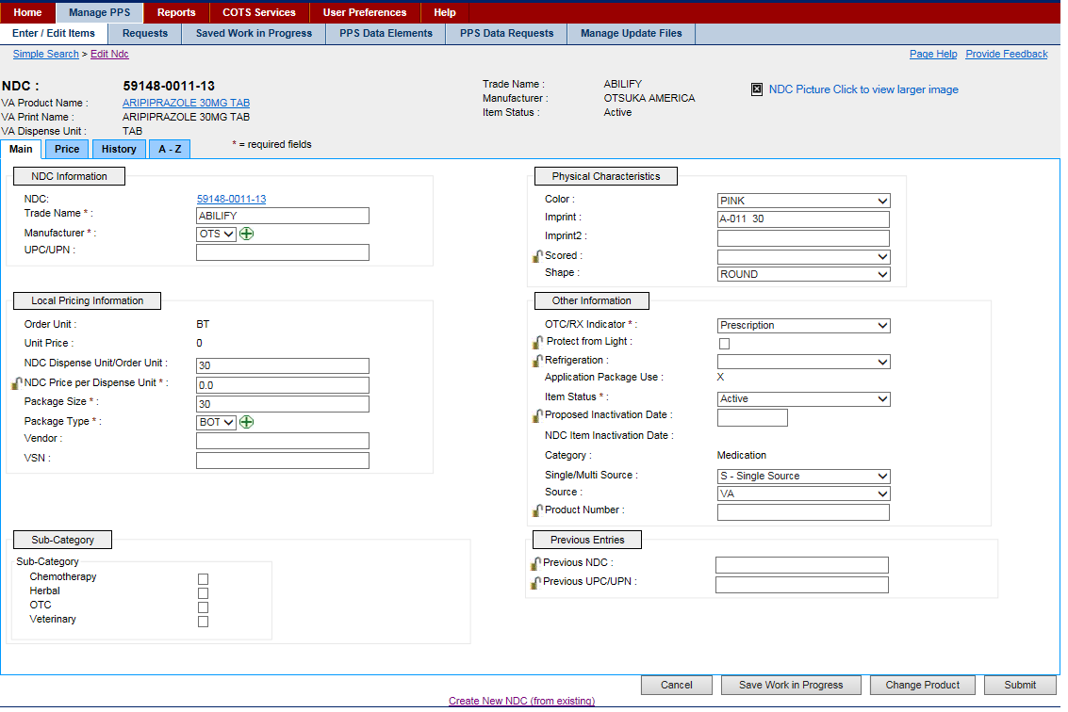

Figure 111: NDC Main Tab

**Field List Header**

**See NDC Header.**

**Field List Main Tab**

Fields with a red asterisk are required fields that you must complete.

NDC Information

**NDC**

Click the link to open a page with National Drug Code details.

**Trade Name** \*

Enter Trade Name for the national drug code.

**Manufacturer** \*

Select a Manufacturer for the national drug code from the drop-down list.

**UPD/UPN**

Enter the Universal Product Code (UPC) or Universal Product Number (UPN) for the national drug code.

**Local Pricing Information**

**Order Unit**

The view-only order unit for the national drug code

**Unit Price**

The view-only unit price for the national drug code

**NDC Dispense Unit/Order Unit**

Enter the Dispense Unit/Order Unit (DUOU) for the national drug code.

**NDC Price per Dispense Unit** \*

Enter the Price per Dispense Unit (PPDU) for the national drug code.

Click the lock icon Graphic Open Lock to lock the field so that it cannot be changed. The system changes the icon Graphic Closed Lock. The lock is a toggle, which can be clicked to lock or unlock the field.

**Package Size** \*

Enter the Package Size for the national drug code.

**Package Type** \*

Select a Package Type for product from the drop-down list for the national drug code.

**Vendor**

Enter Vendor for the national drug code.

**VSN**

Enter the Vendor Stock Number (VSN) for the national drug code.

**Sub-Category Box**

Click one or more of the check boxes to indicate a sub-category for the national drug code: Chemotherapy; Herbal; OTC; Veterinary.

**Physical Characteristics**

**Color**

Select a Color for the product from the drop-down list for the national drug code.

**Imprint**

Enter the Imprint on product for the national drug code.

**Imprint2**

Enter an additional Imprint for the national drug code if applicable.

**Scored**

Select a fraction that the drug can be scored by from the drop-down list: 0.25, 0.33, and 0.5.

Click the lock icon Graphic Open Lock to lock the field so that it cannot be changed. The system changes the icon Graphic Closed Lock. The lock is a toggle, which can be clicked to lock or unlock the field.

Shape

Select a Shape for the drug from the drop-down list.

**Other Information**

**OTC/RX Indicator** \*

Select an indicator for the national drug code from the drop-down list: over the counter (OTC) or requires a prescription (RX).

**Protect from Light**

Click the check box to indicate that the drug is light sensitive.

Click the lock icon Graphic Open Lock to lock the field so that it cannot be changed. The system changes the icon Graphic Closed Lock. The lock is a toggle, which can be clicked to lock or unlock the field.

**Refrigeration**

Select an option for the drug from the drop-down list: Do Not Refrigerate or Refrigerate.

Click the lock icon Graphic Open Lock to lock the field so that it cannot be changed. The system changes the icon Graphic Closed Lock. The lock is a toggle, which can be clicked to lock or unlock the field.

**Application Package Use**

The view-only application package indicator. If marked (X), the drug is part of an application package.

**Item Status** \*

Select an option for the national drug code from the drop-down list: Active and Inactive.

**Proposed Inactivation Date**

Enter the Proposed Inactivation Date for the national drug code.

Click the lock icon Graphic Open Lock to lock the field so that it cannot be changed. The system changes the icon Graphic Closed Lock. The lock is a toggle, which can be clicked to lock or unlock the field.

**NDC Item Inactivation Date**

The view-only inactivation date for the national drug code

**Category**

The view-only Category for the national drug code: Compound; Investigational; Medication; Supply

**Single/Multi Source**

Select an option for the national drug code from the drop-down list: M - Multi Source; S - Single Source; B -Both; N - Neither.

**Source**

Select an option for the type of Source for the national drug code from the drop-down list: COTS; FDA; VA.

**Product Number**

Enter the Product Number for the national drug code.

Click the lock icon Graphic Open Lock to lock the field so that it cannot be changed. The system changes the icon Graphic Closed Lock. The lock is a toggle, which can be clicked to lock or unlock the field.

**Previous Entries**

**Previous NDC**

Enter the Previous National Drug Code(s) if applicable.

Click the lock icon Graphic Open Lock to lock the field so that it cannot be changed. The system changes the icon Graphic Closed Lock. The lock is a toggle, which can be clicked to lock or unlock the field.

**Previous UPC/UPN**

Enter the Previous Universal Product Code (UPC) or Universal Product Number (UPN) for the NDC if applicable.

Click the lock icon Graphic Open Lock to lock the field so that it cannot be changed. The system changes the icon Graphic Closed Lock. The lock is a toggle, which can be clicked to lock or unlock the field.

**Buttons and Links**

**Cancel**

Click this button discard changes and return to the previous page.

**Save Work in Progress**

Click this button to save your work. See Saved Work in Progress tab for more information.

**Change Product**

Click this button to start a new product search and change the product.

**Submit**

Click this button to submit the additions or changes you have made.

**Create New NDC (from existing)**

Click this link to open the Add New NDC page where you can edit the current NDC for the selected product or change product.

### NDC Price Tab

This tab appears when you edit an NDC and select the Price tab. Use this tab to edit NDC-related price data.

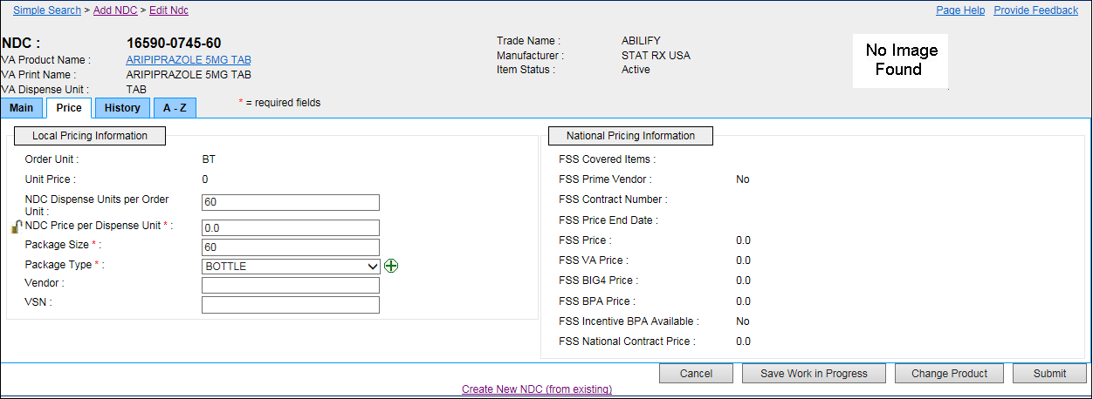

Figure 112: NDC Price Tab

**Field List Header**

**See NDC Header.**

**Field List Price Tab**

Fields with a red asterisk are required fields that you must complete.

Local Pricing Information

**Order Unit**

The view-only Order Unit

**Unit Price**

The view-only Unit Price

**NDC Dispense Units per Order Unit**

Enter the National Drug Code Dispense Units per Order Unit (DUOU).

**NDC Price per Dispense Unit** \*

Enter the National Drug Code Price per Dispense Unit (PPDU).

Click the lock icon Graphic Open Lock to lock the field so that it cannot be changed. The system changes the icon Graphic Closed Lock. The lock is a toggle, which can be clicked to lock or unlock the field.

**Package Size** \*

Enter the Package Size.

**Package Type** \*

Select a Package Type for the national drug code from the drop-down list.

**Vendor**

Enter Vendor for the national drug code.

**VSN**

Enter the Vendor Stock Number (VSN) for the national drug code.

**National Pricing Information**

Data for fields in this section comes from a scheduled background task. See the System Data Tab and Job Types for more information.

**FSS Covered Items**

The view-only Federal Supply Schedule (FSS) Covered Items

**FSS Prime Vendor**

The view-only Federal Supply Schedule (FSS) Prime Vendor

**FSS Contract Number**

The view-only Federal Supply Schedule (FSS) Contract Number

**FSS Price End Date**

The view-only Federal Supply Schedule (FSS) Price End Date

**FSS Price**

The view-only Federal Supply Schedule (FSS) Price

**FSS VA Price**

The view-only Federal Supply Schedule (FSS) VA Price

**FSS BIG4 Price**

The view-only Federal Supply Schedule (FSS) BIG4 Price

**FSS BPA Price**

The view-only Federal Supply Schedule (FSS) Blanket Purchase Agreement (BPA) Price

**FSS Incentive BPA Available**

The view-only Federal Supply Schedule (FSS) Incentive Blanket Purchase Agreement (BPA) Available

**FSS National Contract Price**

The view-only Federal Supply Schedule (FSS) National Contract Price

**Buttons and Links**

**Cancel**

Click this button discard changes and return to the previous page.

**Save Work in Progress**

Click this button to save your work. See Saved Work in Progress tab for more information.

**Change Product**

Click this button to enter new product search

**Submit**

Click this button to submit the additions or changes you have made.

**Create New NDF (from existing)**

Click this link to open the Add New NDC page where you can edit the NDC for selected product or change product.

## Orderable Item Edit Tabs

### OI Header

When you edit an orderable item, orderable-item-related tabs appear with a consistent header. This topic provides details for fields appearing in that header.

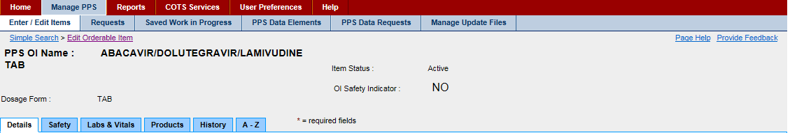

Figure 113: OI Header

**Field List Header**

**PPS OI Name**

The view-only name of the Pharmacy Product System Orderable Item

**Dosage Form**

The view-only form of the dosage

**Item Status**

The view-only status of the drug: Active or Inactive

**OI Safety Indicator**

The view-only status of the Orderable Item Safety Indicator: Yes or No

### OI Details Tab

This tab appears when you edit an orderable item and select the Details tab. Use this tab to edit OI-related details data.

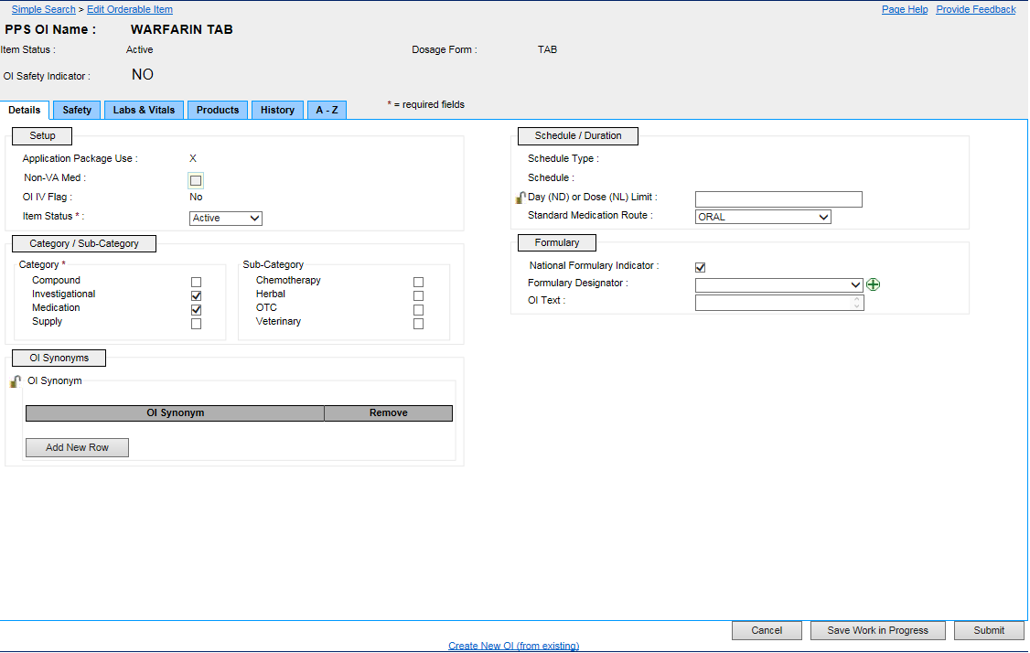

Figure 114: OI Details Tab

**Field List Header**

**See OI Header.**

**Field List Details Tab**

Fields with a red asterisk are required fields that you must complete.

**Setup**

**Application Package Use**

The view-only Application Package Use indicator. If marked (X), the orderable item is part of an application package.

**Non-VA Med**

Click the check box if the orderable item is a non-VA medication.

If a check mark appears (Yes), the orderable item is a non-VA medication.

If no check mark appears (No), the orderable item is a VA medication.

**OI IV Flag**

Click the check box if the orderable item is an IV medication.

If a check mark appears (Yes), the orderable item is an IV medication.

If no check mark appears (No), the orderable item is an IV medication.

**Item Status** \*

The view-only status of the drug: Active or Inactive

Category / Sub-Category

**Category** \*

Click check box to select a Category: Compound; Investigational; Medication; Supply.

**Sub-Category**

Click check box to select a Sub-Category: Chemotherapy; Herbal; OTC; Veterinary.

**OI Synonym**

Click the Add New Row button to add a row to the OI Synonym table.

In OI Synonym, enter a synonym.

Click the Remove button beside an entry to remove it.

Click the lock icon Graphic Open Lock to lock the field so that it cannot be changed. The system changes the icon Graphic Closed Lock. The lock is a toggle, which can be clicked to lock or unlock the field.

**Schedule / Duration**

**Schedule Type**

Enter a unit dose Schedule Type for the orderable item.

**Schedule**

Enter a unit dose Schedule type: OC - On Call; O - One-time; P - PRN; R - Fill on Request

**Day (ND) or Dose (NL) Limit**

Enter a whole number (no decimal) between 0 and 99 followed by a D (Day) or L (Limit) for the Number of Days (ND) or Dose Limit (NL) for the orderable item. For example, enter 5D for a limit of five days for the administration of the orderable item.

Click the lock icon Graphic Open Lock to lock the field so that it cannot be changed. The system changes the icon Graphic Closed Lock. The lock is a toggle, which can be clicked to lock or unlock the field.

**Standard Medication Route**

Select a Standard Medication Route for the orderable item from the drop-down list.

**Formulary**

**National Formulary Indicator**

Click to add a check mark If the orderable item is part of the national formulary.

**Formulary Designator**

Use the drop down menu to select a formulary designator, or use the add icon add_button.png to add a new formulary designator.

**OI Text**

Use the text box to add OI text to an existing orderable item. Note the OI Text field displays only the first 36 characters of the OI Text. The user can navigate into that field, which will expand to show the full text. When the user is finished making edits to this field, click the Save Changes button, which would allow the user to continue making edits to the other orderable item fields.

This field requires a second approval. See Section 3.4 for more information.

**Buttons and Links**

**Cancel**

Click this button discard changes and return to the previous page.

**Save Work in Progress**

Click this button to save your work. See Saved Work in Progress tab for more information.

**Submit**

Click this button to submit the additions or changes you have made.

**Create New OI (from existing)**

Click this link to open the Add Orderable Item page and create a new orderable item from an existing orderable item.

### OI Safety Tab

This tab appears when you edit an orderable item and select the Safety tab. Use this tab to edit OI-related safety data.

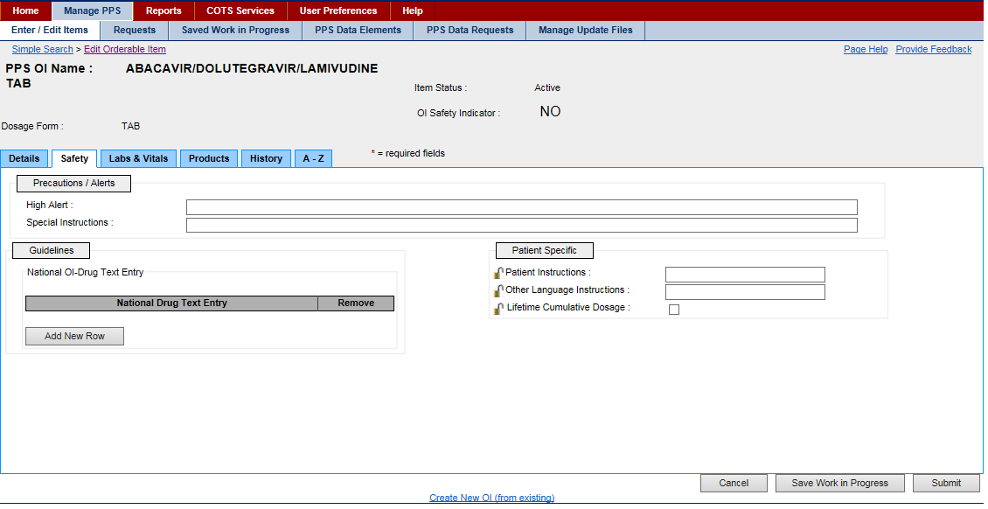

Figure 115: OI Safety Tab

**Field List Header**

See OI Header.

**Field List Safety Tab**

**Precautions / Alerts**

High Alert

Enter medication alert.

**Special Instructions**

Enter Special Instructions for medication.

**Guidelines**

**National OI-Drug Text Entry**

Click the Add New Row button to add a row to the National Drug Text Entry table.

* In National Drug Text Entry, enter National Drug Text.
* Click the Remove button beside an entry to remove it.

**Patient Specific**

**Patient Instructions**

Enter Patient Instructions.

Click the lock icon Graphic Open Lock to lock the field so that it cannot be changed. The system changes the icon Graphic Closed Lock. The lock is a toggle, which can be clicked to lock or unlock the field.

**Other Language Instructions**

Enter patient instructions in preferred language.

Click the lock icon Graphic Open Lock to lock the field so that it cannot be changed. The system changes the icon Graphic Closed Lock. The lock is a toggle, which can be clicked to lock or unlock the field.

**Lifetime Cumulative Dosage**

Click the check box to display the Lifetime Cumulative Dosage of the drug.

Click the lock icon Graphic Open Lock to lock the field so that it cannot be changed. The system changes the icon Graphic Closed Lock. The lock is a toggle, which can be clicked to lock or unlock the field.

**Buttons and Links**

**Cancel**

Click this button discard changes and return to the previous page.

**Save Work in Progress**

Click this button to save your work. See Saved Work in Progress tab for more information.

**Submit**

Click this button to submit the additions or changes you have made.

**Create New OI (from existing)**

Click this link to open the Add Orderable Item page and create a new orderable item from an existing orderable item.

### OI Labs & Vitals Tab

This tab appears when you edit an orderable item and select the Labs & Vitals tab. Use this tab to edit OI-related laboratory and vital readings data.

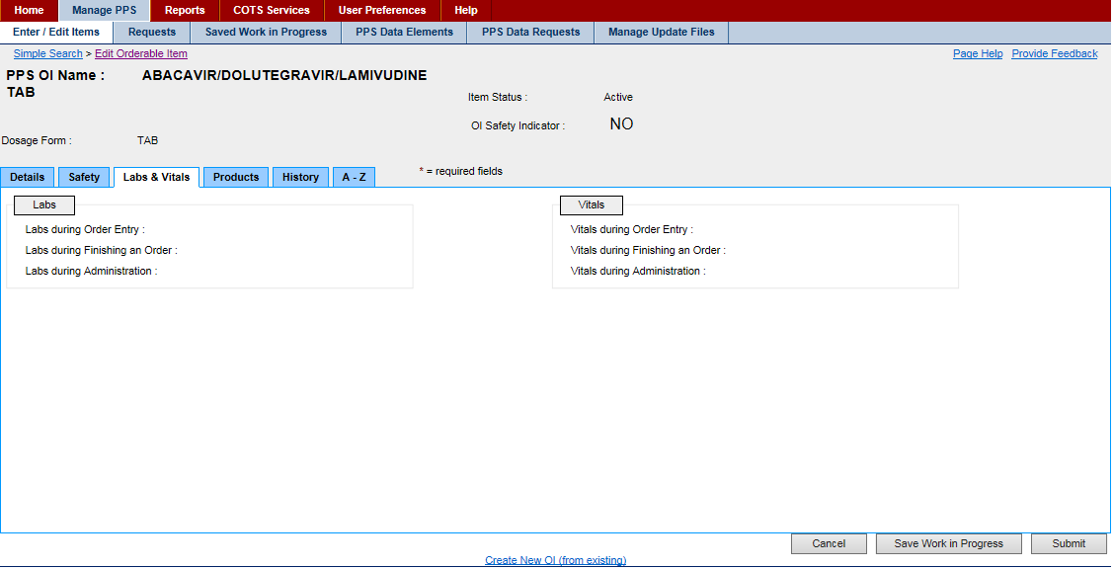

Figure 116: OI Lab Vitals

**Field List Header**

See OI Header.

**Field List Labs & Vitals Tab**

**Labs**

**Labs during Order Entry**

Enter the laboratory tests required during order entry for the orderable item.

**Labs during Finishing an Order**

Enter the laboratory tests required during order entry finishing for the orderable item.

**Labs during Administration**

Enter the laboratory tests required during administration for the orderable item.

**Vitals**

**Vitals during Order Entry**

Enter the vitals monitoring required during order entry for the orderable item.

**Vitals during Finishing an Order**

Enter the vitals monitoring required during order entry finishing for the orderable item.

**Vitals during Administration**

Enter the vitals monitoring required during administration for the orderable item.

**Buttons and Links**

**Cancel**

Click this button discard changes and return to the previous page.

**Save Work in Progress**

Click this button to save your work. See Saved Work in Progress tab for more information.

**Submit**

Click this button to submit the additions or changes you have made.

**Create New OI (from existing)**

Click this link to open the Add Orderable Item page and create a new orderable item from an existing orderable item.

### OI Products Tab

This tab appears when you edit an orderable item and select the Products tab. Use this tab to edit OI-related product data.

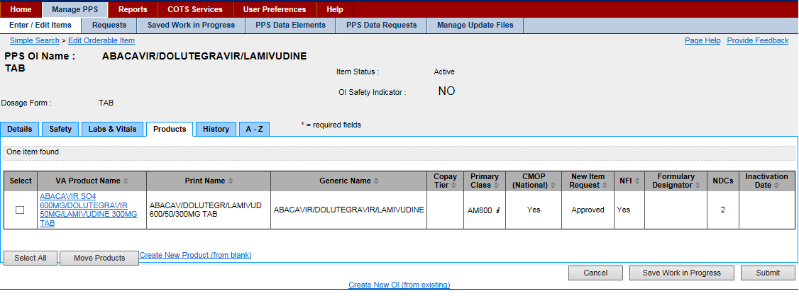

Figure 117: OI Products Tab

**Field List Header**

See OI Header.

**Field List Products Tab**

**Select**

Click the check box beside an orderable item to select it for additional handling.

**VA Product Name**

Click the link to open the National Data Tab for the product.

**Print Name**

The view-only Print Name of the orderable item

**Generic Name**

The view-only Generic Name of the orderable item

**Primary Class**

The view-only Primary Class of the orderable item

**CMOP (National)**

The view-only status of the Consolidated Mail Out Pharmacy National for the orderable item: Yes or No

**New Item Request**

The view-only status of the New Item Request for the orderable item

**NFI**

The view-only status of the Non-formulary Indicator (NFI) for the orderable item: Yes or No

**Formulary Designator**

The view-only formulary designator for each product associated with the orderable item.

**NDCs**

The view-only National Drug Code(s) (NDCs) for the orderable item

**Inactivation Date**

The view-only Inactivation Date for the orderable item in the format DD-MMM-YYYY HH:MM

**Buttons and Links**

**Select All**

Click this button to select all entries in the Select column of the table for further handling.

**Move Products**

Click this button to remove selected products from the orderable item. See Remove Product from Orderable Item for more information.

**Create New Product (from blank)**

Click this link to open the Add Product Item page and create a new product.

**Cancel**

Click this button discard changes and return to the previous page.

**Save Work in Progress**

Click this button to save your work. See Saved Work in Progress tab for more information.

**Submit**

Click this button to submit the additions or changes you have made.

**Create New OI (from existing)**

Click this link to open the Add Orderable Item page and create a new orderable item from an existing orderable item.

## Product Edit Tabs

### Product Header

When you edit a product, product-related tabs appear with a consistent header. This topic provides details for fields appearing in that header.

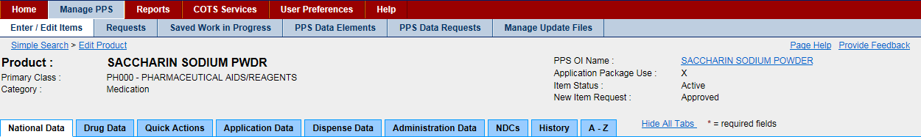

Figure 118: Product Header

**Field List Header**

**Product**

The view-only name of the Product

**Primary Class**

The view-only Primary Class of the product

**Category**

The view-only Category of the product: Compound; Investigational; Medication; Supply

**PPS OI Name**

Click the link to open the Pharmacy Product System Orderable Item information on product.

**Application Package Use**

The view-only Application Package Use indicator. If marked (X), the orderable item is used as part of an application package.

**Item Status**

The view-only status of the drug: Active or Inactive

**New Item Request**

The state of the new item request: Pending, Approved, Rejected

### Product National Data Tab

This tab appears when you edit a product and select the National Data tab. Use this tab to edit product-related national data.

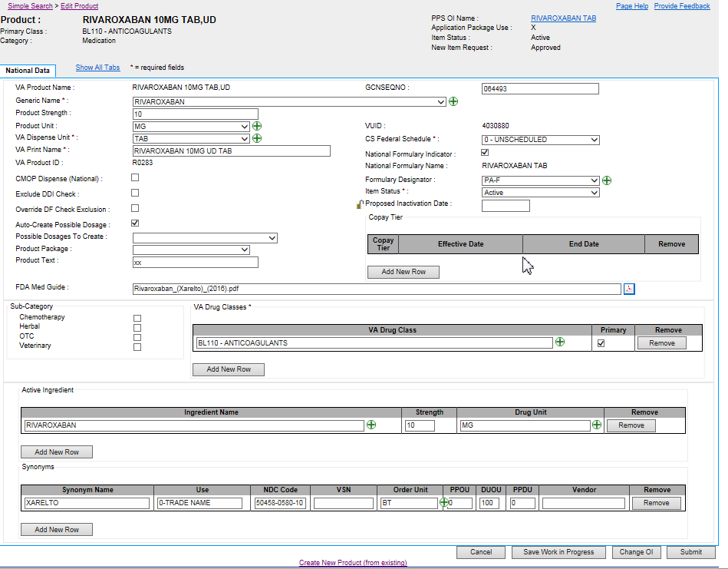

Figure 119: Product National Data Tab

**Field List Header**

See Product Header.

**Field List National Data Tab**

Fields with a red asterisk are required fields that you must complete.

**VA Product Name**

The view-only name of the VA product. The name is derived based on the following criteria.

If the product has more than one Ingredient Name in Ingredients multiple, the system sorts Ingredient Names in alphabetical order. Each Ingredient Name is followed by Ingredient Strength and Ingredient Unit.

If the product has more than one Ingredient Name in Ingredients multiple, the system inserts a slash ( / ) after each Ingredient Unit with the exception of the last Ingredient Unit. Further, the system insert Dosage Form after the last Ingredient Unit. The system truncates the value if it exceeds the max limit of 64 characters.

If Not For Human Use is marked and Category does not equal Investigational, then the system starts the VA Product Name with the prefix AML. For example, a VA Product Name of Tylenol 325 mg Tab, SA becomes AML Tylenol 325 mg SA Tab.

**Generic Name** \*

Select a Generic Name for the product from the drop-down list.

Click the Graphic Plus Buttonto add a new generic name. The system opens the Add Generic Name page, which you can use to add a new generic name for the product.

**Product Strength**

Enter the strength of the product.

**Product Unit**

Select a unit for the product from the drop-down list.

Click the Graphic Plus Buttonto add a new unit for the product. The system opens the Add Dose Unit Name page, which you can use to add a new unit for the product.

**VA Dispense Unit** \*

Select a VA Dispense Unit for the product from the drop-down list.

Click the Graphic Plus Buttonto add a new dispense unit for the product. The system opens the Add Dispense Unit Name page, which you can use to add a new dispense unit for the product.

**VA Print Name** \*

Enter the VA Print Name for the product. The name is derived based on the following criteria.

If the product has more than one Ingredient Name in Ingredients multiple, the system sorts Ingredient Names in alphabetical order. Each Ingredient Name is followed by Ingredient Strength and Ingredient Unit.

If the product has more than one Ingredient Name in Ingredients multiple, the system inserts a slash ( / ) after each Ingredient Unit with the exception of the last Ingredient Unit. Further, the system insert Dosage Form after the last Ingredient Unit. In addition, if the Dosage for value is composed of two parts separated by a comma, the system reverses the two parts and removes the comma. The system truncates the value if it exceeds the max limit of 40 characters.

If Not For Human Use is marked and Category does not equal Investigational, then the system starts the VA Product Name with the prefix AML. For example, a VA Product Name of Tylenol 325 mg Tab, SA becomes AML Tylenol 325 mg SA Tab.

If the product item has more than one Ingredient Name in Ingredients multiple, Ingredient Names must be in alphabetical order.

When edited, this field requires a second review. See PPS Data Requests Tab for more information.

**VA Product ID**

The view-only Consolidated Mail Outpatient Pharmacy (CMOP) identification. This field is required after the product has been approved or after the VA Print Name of an existing product has been edited and approved.

When edited, this field requires a second review. See PPS Data Requests Tab for more information.

**CMOP Dispense (National)**

Click this check box to indicate that the product is to be dispensed via the national Consolidated Mail Outpatient Pharmacy (CMOP).

When edited, this field requires a second review. See PPS Data Requests Tab for more information.

**Exclude DDI Check**

Click this check box to indicate that the product is to be excluded from the system Drug-Drug Interaction (DDI) check.

**Override DF Check Exclusion**

Click this check box to indicate that the product is included in the national Drug File (DF) check.

**Auto-Create Possible Dosage**

Click this check box to indicate that the system should suggest a possible dosage automatically.

**Possible Dosages to Create**

This field is required when Auto-Create Possible Dosage is selected.

Select a possible dosage from the drop-down list to auto-create for the dispense drugs: N - No Possible Dosages; O - Only 1x Possible Dosage; B - Both 1x and 2x Possible Dosages.

**Product Package**

This field is required when Auto-Create Possible Dosage is selected.

Select a possible package description for the product from the drop-down list.

**Product Text**

This field is to enter any text for notes relating to the product.

 Note the Text field displays only the first 36 characters of the OI Text. The user can navigate into that field, which will expand to show the full text.

**FDA Med Guide**

The view-only name of the Federal Drug Administration (FDA) medical guide in which the product is detailed.

Click the PDF icon Graphic PDF Buttonto open the FDA Medical Guide.

**GCNSEQNO**

Enter the Generic Sequence Number (GCNSEQNO) for the product.

When edited, this field requires a second review. See PPS Data Requests Tab for more information.

**VUID**

The view-only VA Unique Identifier.

**CS Federal Schedule** \*

Select a federal controlled substance schedule from the drop-down list: 0 - Unscheduled; 1 - Schedule 1; 2 - Schedule II; 2n - Schedule II Non-Narcotic; 3 - Schedule 3; 3n - Schedule III Non-Narcotics; 4 - Schedule IV; 5 - Schedule 5.

**National Formulary Indicator**

Click this check box to indicate that the product is part of the national formulary.

When edited, this field requires a second review. See PPS Data Requests Tab for more information.

**National Formulary Name**

The view-only name of the product in the national formulary

**Formulary Designator**

This field shows the formulary designator being added to an existing product.

**Item Status** \*

Select a status for the product: Active or Inactive.

**Proposed Inactivation Date**

Enter a Proposed Inactivation Date using the format DD-Mon-YYYY.

Click the lock icon Graphic Open Lock to lock the field so that it cannot be changed. The system changes the icon Graphic Closed Lock. The lock is a toggle, which can be clicked to lock or unlock the field.

**Copay Tier**

Click the Add New Row button to add a row to the Copay Tier.

* Select the Copay Tier from the drop-down menu.
* Effective Date will auto-populate with today's date, the user can also a start date for the start of the copay period.
* For the End Date, the user can enter an end date for the end of the copay period, or if the user adds another row and sets a new copay tier the end date will auto-populate with a day before the new row's effect date.
* Click the Remove button beside an entry to remove the copay range.

**Sub-Category Box**

Click one or more of the check boxes to indicate a Sub-Category for the product: Chemotherapy; Herbal; OTC; Veterinary.

**VA Drug Class** \*

Click the Add New Row button to add a row to the VA Drug Class table.

In VA Drug Class, enter the name of the class for the VA drug. Click the add_button.pngto add a new drug class for the product. The system opens the Add Drug Class page, which you can use to add a new drug class for the product.

In Primary, click the check box to indicate that this drug class is primary. When the product includes more than one VA Drug Class, you must select one as primary. If the product includes only one VA Drug Class, the system automatically selects it as primary.

When edited, this field requires a second review. See PPS Data Requests Tab for more information.

Click the Remove button beside an entry to remove the drug class.

**Active Ingredient**

Click the Add New Row button to add a row to the Ingredient Name table.

In Ingredient Name, enter the name of the active ingredient. Click the add_button.pngto add a new active ingredient for the product. The system opens the Add Ingredient Name page, which you can use to add a new active ingredient for the product.

In Strength, enter a strength for the active ingredient.

In Drug Unit, enter a drug unit for the active ingredient. Click the add_button.pngto add a new drug unit for the active ingredient. The system opens the Add Drug Unit Name page, which you can use to add a new drug unit name for the active ingredient.

Click the Remove button beside an entry to remove it.

**Synonyms**

Click the Add New Row button to add a row to the Synonyms table.

In Synonym, enter a synonym for the product.

In Use, enter medication use: 0 - Trade Name; 1 - Quick Code; D - Drug Accountability; C - Controlled Substance.

In NDC Code, enter a National Drug Code (NDC) for the product synonym.

In VSN, enter the Vendor Stock Number (VSN) for the product synonym.

In Order Unit, enter order unit type for the product synonym. Click the add_button.pngto add a new order unit for the synonym. The system opens the Add Order Unit Abbreviation page, which you can use to add a new order unit abbreviation for the synonym.

In PPOU, enter a Product Price per Order Unit (PPOU) for the product synonym.

In DUOU, enter a Drug Units per Order Unit (DUOU) for product synonym.

In PPDU, enter a Product Price per Dispense Unit (PPDU) for the product synonym.

In Vendor, enter a vendor name for the product synonym.

--Click the Remove button beside an entry to remove the synonym.

When edited, this field requires a second review. See PPS Data Requests Tab for more information.

**Buttons and Links**

**Cancel**

Click this button discard changes and return to the previous page.

**Save Work in Progress**

Click this button to save your work. See Saved Work in Progress tab for more information.

**Change OI**

Click this button to open an Orderable Item Search page, which you can use to search criteria for product, dosage form, item status, and new item request to search for an orderable item. You are selecting a parent for the product.

**Submit**

Click this button to submit the additions or changes you have made.

**Create New Product (from existing)**

Click this link to open the Add Product page, and create a product from an existing product.

### Product Drug Data Tab

This tab appears when you edit a product and select the Drug Data tab. Use this tab to edit product-related drug data.

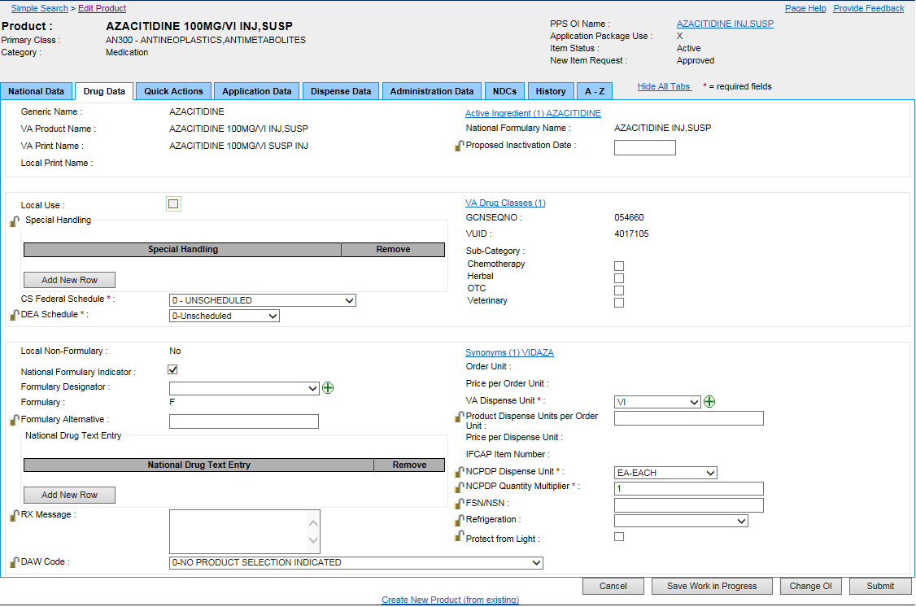

Figure 120: Product Drug Data Tab

**Field List Header**

See Product Header.

**Field List Drug Data Tab**

Fields with a red asterisk are required fields that you must complete.

**Generic Name**

The view-only Generic Name for the product

**VA Product Name**

The view-only VA Product Name for the product

**VA Print Name**

The view-only VA Print Name for the product

**Local Print Name**

The view-only Local Print Name for the product

**Local Use**

Click this check box to restrict the product for local use. When this box is checked, it cannot be edited by National. See A–Z Tab for more information.

**Special Handling**

Click the Add New Row button add a new row to the Special Handling table.

In Special Handling, select a special handling option from the drop-down list. See Add Special Handling Code for more information on the source of this list.

Click the Remove button beside a special handling code to remove it from the table.

Click the lock icon Graphic Open Lock to lock the field so that it cannot be changed. The system changes the icon Graphic Closed Lock. The lock is a toggle, which can be clicked to lock or unlock the field.

**CS Federal Schedule** \*

Select a federal controlled substance schedule from the drop-down list. When you make a selection in this field, the system completes the DEA Schedule field.

**DEA Schedule** \*

This field is automatically completed when you select a CS Federal Schedule. You can select another option from the drop-down list: 0 - Unscheduled; 1 - Schedule 1 Item; 2 - Schedule 2 Item; 3 - Schedule 3 Item; 4 - Schedule 4 Item; 5 - Schedule 5 Item; 6 - Legend Item; 9 - Over the Counter.

Click the lock icon Graphic Open Lock to lock the field so that it cannot be changed. The system changes the icon Graphic Closed Lock. The lock is a toggle, which can be clicked to lock or unlock the field.

**Local Non-Formulary**

The view-only status of the local non-formulary product: Yes or No

**National Formulary Indicator**

Click this check box to indicate that the product is part of the national formulary.

**Formulary Designator**

Select the Formulary Designator for the drug from the drop-down list.

Click the Graphic Plus Buttonto add a new Formulary Designator to the product.

**Formulary**

The view-only status of the Formulary

**Formulary Alternative**

Enter an alternative for the formulary for this product.

Click the lock icon Graphic Open Lock to lock the field so that it cannot be changed. The system changes the icon Graphic Closed Lock. The lock is a toggle, which can be clicked to lock or unlock the field.

**National Drug Text Entry**

Click the Add New Row button add a new row to the National Drug Text Entry table.

In National Drug Text Entry, select a text option from the drop-down list.

Click the Remove button beside a special handling code to remove it from the table.

Click the add icon Graphic Plus Buttonto add new text. See Add Drug Text Name for more information on the source of this list.

**RX Message**

Enter any additional instructions for the pharmacy for this product.

Click the lock icon Graphic Open Lock to lock the field so that it cannot be changed. The system changes the icon Graphic Closed Lock. The lock is a toggle, which can be clicked to lock or unlock the field.

**DAW Code**

Select dispensing substitution directions from the drop-down list for the product.

Click the lock icon Graphic Open Lock to lock the field so that it cannot be changed. The system changes the icon Graphic Closed Lock. The lock is a toggle, which can be clicked to lock or unlock the field.

**Active Ingredient**

Click this link to display the Active Ingredient pop-up to view a list of active ingredients.

* In the pop-up, click the Add New Row button add a new row to the list of active ingredients.
* In Ingredient Name, select an ingredient from the drop-down list.
* In Strength, enter the strength for the active ingredient.
* In Drug Unit, select a unit from the drop-down list.
* Click Save Changes to save the active ingredient.

Click the Remove button beside an active ingredient to remove it from the table.

**National Formulary Name**

The view-only name associated with the national formulary

**Proposed Inactivation Date**

Enter a Proposed Inactivation Date using the format DD-Mon-YYYY.

Click the lock icon Graphic Open Lock to lock the field so that it cannot be changed. The system changes the icon Graphic Closed Lock. The lock is a toggle, which can be clicked to lock or unlock the field.

**VA Drug Classes**

Click this link to open the VA Drug Class pop-up to view a list of classes.

* In the pop-up, click the Add New Row button add a new row to the list of classes.
* In VA Drug Class, select a class from the drop-down list.
* In Primary, click the check box if the class is primary for the product.
* Click Save Changes to save the class.
* Click the Remove button beside a class to remove it from the table.

**GCNESQNO**

The view-only Generic Code Number Sequence Number, which is a numeric value that corresponds to the Generic Code Number Sequence Number of an FDB generic drug.

**VUID**

The view-only VA Unique Identifier

**Sub-Category**

Click one or more of the check boxes to indicate a Sub-Category for the product: Chemotherapy; Herbal; OTC; Veterinary.

**Synonyms**

Click this link to open the Synonyms pop-up to view a list of synonyms for the product.

* In Synonym, enter a synonym for the product.
* In Use, enter medication use: 0 - Trade Name; 1 - Quick Code; D - Drug Accountability; C - Controlled Substance.
* In NDC Code, enter a National Drug Code (NDC) for the product synonym.
* In VSN, enter the Vendor Stock Number (VSN) for the product synonym.
* In Order Unit, enter order unit type for the product synonym.
* In PPOU, enter a Product Price per Order Unit (PPOU) for the product synonym.
* In DUOU, enter a Drug Units per Order Unit (DUOU) for product synonym.
* In PPDU, enter a Product Price per Dispense Unit (PPDU) for the product synonym.
* In Vendor, enter a vendor name for the product synonym.
* Click the Remove button beside an entry to remove the synonym.

**Order Unit**

The view-only Order Unit for the product synonym

**Price per Order Unit**

The view-only Price per Order Unit (PPOU) for the product synonym

**VA Dispense Unit** \*

Select a VA Dispense Unit for the product synonym from the drop-down list.

Click the Graphic Plus Buttonto add a new dispense unit for the product synonym. The system opens the Add Dispense Unit Name page, which you can use to add a new dispense unit for the product synonym.

**Product Dispense Units per Order Unit**

Enter the dispense units per order unit for the product synonym.

Click the lock icon Graphic Open Lock to lock the field so that it cannot be changed. The system changes the icon Graphic Closed Lock. The lock is a toggle, which can be clicked to lock or unlock the field.

**Price per Dispense Unit**

The view-only the Price per Dispense Unit (PPDU) for the product synonym

**IFCAP Item Number**

The view-only Integrated Funds Distribution, Control Point Activity, Accounting, and Procurement number

**NCPDP Dispense Unit** \*

Select National Council for Prescription Drug Program (NCPDP) Dispense Unit for the drug from the drop-down list.

Click the lock icon Graphic Open Lock to lock the field so that it cannot be changed. The system changes the icon Graphic Closed Lock. The lock is a toggle, which can be clicked to lock or unlock the field.

**NCPDP Quantity Multiplier** \*

Enter the National Council for Prescription Drug Program (NCPDP) Quantity Multiplier.

Click the lock icon Graphic Open Lock to lock the field so that it cannot be changed. The system changes the icon Graphic Closed Lock. The lock is a toggle, which can be clicked to lock or unlock the field.

**FSN/NSN**

Enter the Federal Stock Number (FSN) or National Stock Number (NSN) for the product.

Click the lock icon Graphic Open Lock to lock the field so that it cannot be changed. The system changes the icon Graphic Closed Lock. The lock is a toggle, which can be clicked to lock or unlock the field.

**Refrigeration**

Select an option from the drop-down list: Refrigerate or Do Not Refrigerate.

Click the lock icon Graphic Open Lock to lock the field so that it cannot be changed. The system changes the icon Graphic Closed Lock. The lock is a toggle, which can be clicked to lock or unlock the field.

**Protect from Light**

Click this check box if the product should be protected from exposure to light.

Click the lock icon Graphic Open Lock to lock the field so that it cannot be changed. The system changes the icon Graphic Closed Lock. The lock is a toggle, which can be clicked to lock or unlock the field.

**Buttons and Links**

**Cancel**

Click this button discard changes and return to the previous page.

**Save Work in Progress**

Click this button to save your work. See Saved Work in Progress tab for more information.

**Change OI**

Click this button to open an Orderable Item Search page, which you can use to search criteria for product, dosage form, item status, and new item request to search for an orderable item. You are selecting a parent for the product.

**Submit**

Click this button to submit the additions or changes you have made.

**Create New Product (from existing)**

Click this link to open the Add Product page, and create a product from an existing product.

### Product Quick Actions Tab: CMOP Mark / Unmark

This tab appears when you edit a product and select the Quick Actions tab menu option CMOP (Consolidated Mail Outpatient Pharmacy) Mark / Unmark. Use this tab to edit product-related CMOP mark and unmark data.

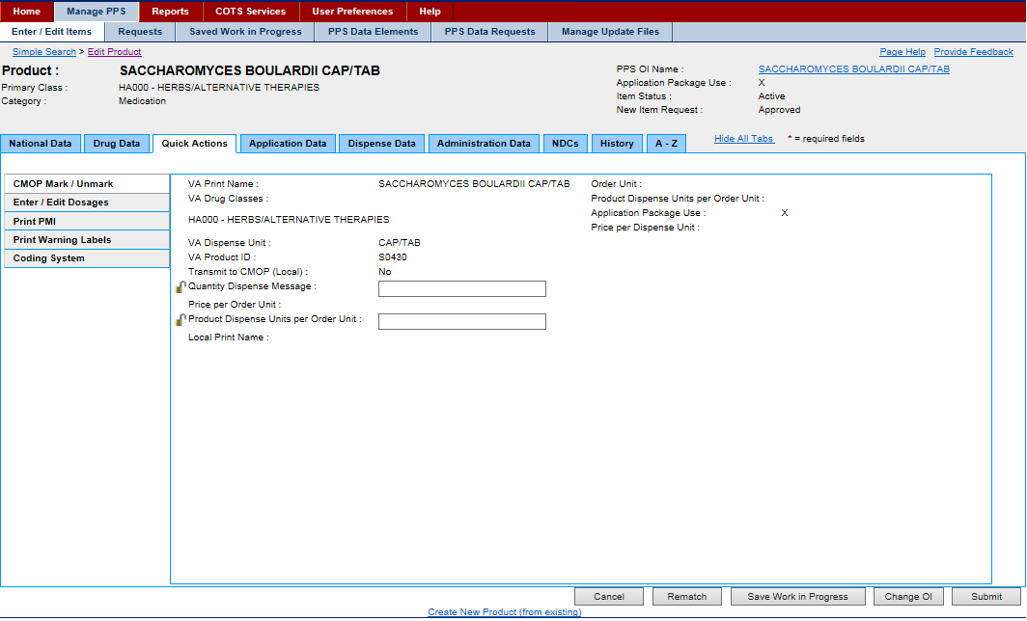

Figure 121: Product Quick Actions Tab-CMOP Mark / Unmark

**Field List Header**

See Product Header.

**Field List CMOP Mark / Unmark**

**VA Print Name**

The view-only VA Print Name. For more information about the field, see the National Data Tab.

**VA Drug Class**

The view-only VA Drug Class. For more information about the field, see the National Data Tab.

**VA Dispense Unit**

The view-only VA Dispense Unit. For more information about the field, see the National Data Tab.

**VA Product ID**

The view-only VA Product Identification. For more information about the field, see the National Data Tab.

**Transmit to CMOP (Local)**

The view-only Transmit to Consolidated Mail Outpatient Pharmacy (CMOP) (Local) indicator when applicable. For more information about the field, see the National Data Tab.

**Quantity Dispense Message**

Enter Quantity Dispense Message for the product.

Click the lock icon Graphic Open Lock to lock the field so that it cannot be changed. The system changes the icon Graphic Closed Lock. The lock is a toggle, which can be clicked to lock or unlock the field.

**Price per Order Unit**

The view-only Price per Order Unit (PPOU).

**Products Dispense Unit per Order Unit**

Enter Products Dispense Unit per Order Unit.

Click the lock icon Graphic Open Lock to lock the field so that it cannot be changed. The system changes the icon Graphic Closed Lock. The lock is a toggle, which can be clicked to lock or unlock the field.

**Local Print Name**

The view-only Local Print Name when applicable.

**Order Limit**

**Products Dispense Unit per Order Unit**

The view-only dispense units per order unit for the product.

**Application Package Use**

The view-only Application Package Use indicator field. If marked (X), the product is part of an application package.

**Price Per Dispense Unit**

The view-only Price Per Dispense Unit (PPDU).

**Buttons and Links**

**Cancel**

Click this button discard changes and return to the previous page.

**Save Work in Progress**

Click this button to save your work. See Saved Work in Progress tab for more information.

**Change OI**

Click this button to open an Orderable Item Search page, which you can use to search criteria for product, dosage form, item status, and new item request to search for an orderable item. You are selecting a parent for the product.

**Submit**

Click this button to submit the additions or changes you have made.

**Create New Product (from existing)**

Click this link to open the Add Product page, and create a product from an existing product.

### Product Quick Actions Tab: Enter / Edit Dosages

This tab appears when you edit a product and select the Quick Actions tab menu option Enter / Edit Dosages. Use this tab to edit product-related dosages data.

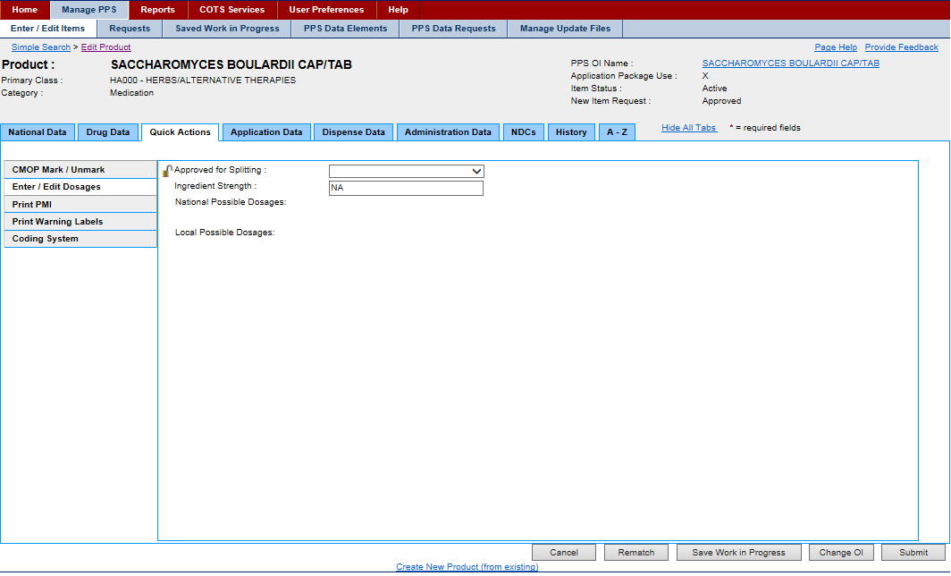

Figure 122: Product Quick Actions Tab-Enter / Edit Dosages

**Field List Header**

See Product Header.

**Field List Enter / Edit Dosages**

**Approved for Spitting**

Select Yes or No from the drop-down list to indicate if product can be split.

**Ingredient Strength**

Enter Ingredient Strength of product.

**National Possible Dosages**

The view-only field displaying the National Possible Dosages available

**Local Possible Dosages**

The view-only field displaying the Local Possible Dosages available

**Buttons and Links**

**Cancel**

Click this button discard changes and return to the previous page.

**Save Work in Progress**

Click this button to save your work. See Saved Work in Progress tab for more information.

**Change OI**

Click this button to open an Orderable Item Search page, which you can use to search criteria for product, dosage form, item status, and new item request to search for an orderable item. You are selecting a parent for the product.

**Submit**

Click this button to submit the additions or changes you have made.

**Create New Product (from existing)**

Click this link to open the Add Product page, and create a product from an existing product.

### Product Quick Actions Tab: Print PMI

This tab appears when you edit a product and select the Quick Actions tab menu option Print PMI (Patient Medication Information). Use this tab to edit product-related patient medication information data.

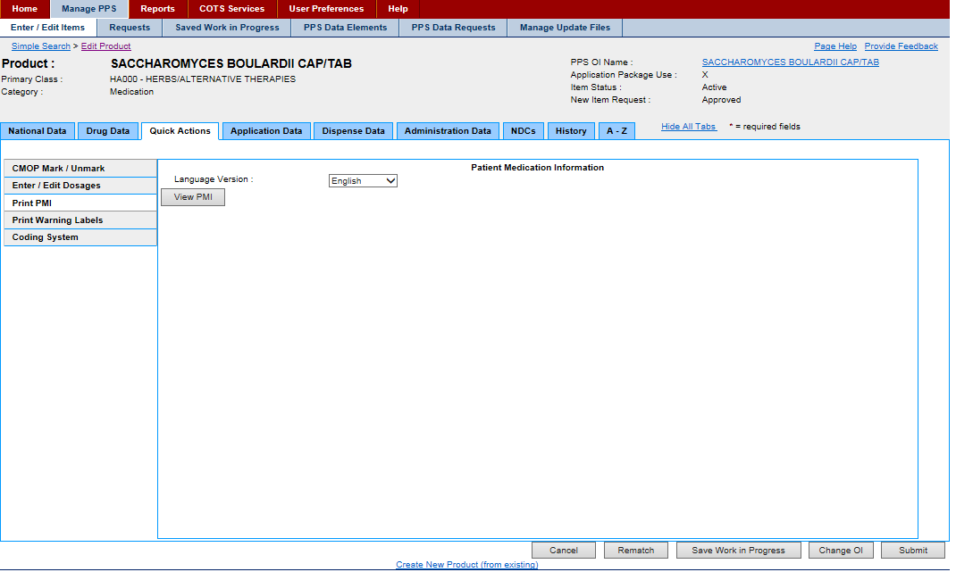

Figure 123: Product Quick Actions Tab-Print PMI

**Field List Header**

See Product Header.

**Field List Print PMI**

**Language Version**

Select a language from the drop-down list: English or Spanish.

**View PMI Button**

Click the PMI button to display Patient Medication Information (PMI) for selected product.

**Buttons and Links**

**Cancel**

Click this button discard changes and return to the previous page.

**Save Work in Progress**

Click this button to save your work. See Saved Work in Progress tab for more information.

**Change OI**

Click this button to open an Orderable Item Search page, which you can use to search criteria for product, dosage form, item status, and new item request to search for an orderable item. You are selecting a parent for the product.

**Submit**

Click this button to submit the additions or changes you have made.

**Create New Product (from existing)**

Click this link to open the Add Product page, and create a product from an existing product.

### Product Quick Actions Tab: Print Warning Labels

This tab appears when you edit a product and select the Quick Actions tab menu option Print Warning Labels. Use this tab to edit product-related printed warning labels data.

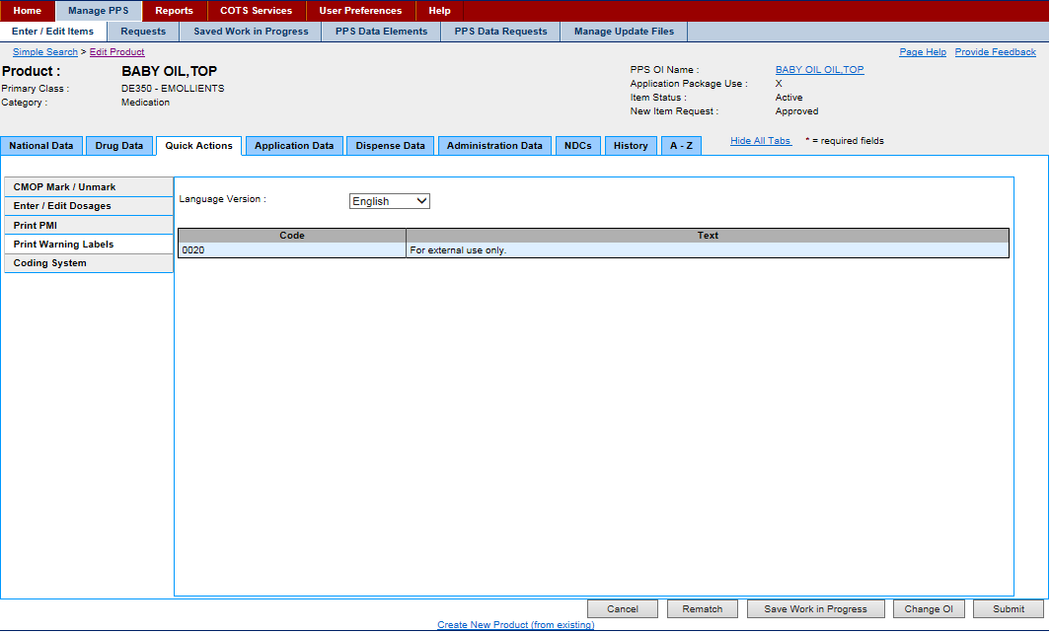

Figure 124: Product Quick Actions Tab-Print Warning Labels

**Field List Header**

See Product Header.

**Field List Print Warning Labels**

**Language Version**

Select a language from the drop-down list: English or Spanish.

**Code**

The view-only a four digit number to print on warning labels

**Text**

The view-only text description to print on warning labels

**Buttons and Links**

**Cancel**

Click this button discard changes and return to the previous page.

**Save Work in Progress**

Click this button to save your work. See Saved Work in Progress tab for more information.

**Change OI**

Click this button to open an Orderable Item Search page, which you can use to search criteria for product, dosage form, item status, and new item request to search for an orderable item. You are selecting a parent for the product.

**Submit**

Click this button to submit the additions or changes you have made.

**Create New Product (from existing)**

Click this link to open the Add Product page, and create a product from an existing product.

### Product Quick Actions Tab: Coding System

This tab appears when you edit a product and select the Quick Actions tab menu option RxNorm. Use this tab to edit product-related normal prescription data.

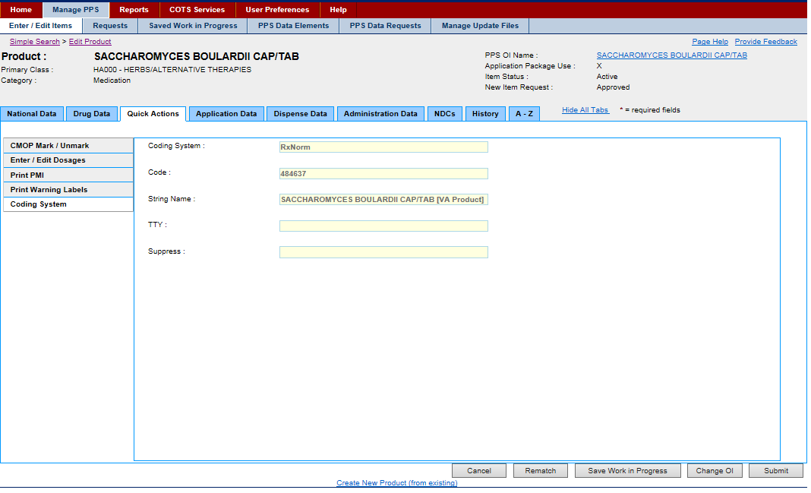

Figure 125: Product Quick Actions Tab-Coding System

**Field List Header**

See Product Header.

**Field List RxNorm**

**RxNorm Name**

Enter the product-related normal prescription name.

**RXCUI**

Enter the product-related normal prescription Concept Unique Identifier (CUI).

**RxNorm TTY**

Enter the product-related normal prescription term type.

**RxNorm Language**

Enter the product-related normal prescription language.

**RxNorm Suppress**

Select a product-related normal prescription type of suppressibility from the drop-down list: O - Obsolete; Y - Suppressed; E - Editor- Assigned Suppressibility; N - Not Suppressible. See FDB Update for more information on the update process, which is affected by this selection.

**RxNorm UMLSCUI**

Enter the product-related normal prescription Unified Medical Language System Concept Unique Identifier (UML SCUI).

**RxNorm Synonym**

Enter the product-related normal prescription synonym.

**Last RxNorm Update**

The view-only last update date for the product-related normal prescription

**Exclude from AutoUpdate**

Click the check box to exclude the product-related normal prescription from the automatic update process. See FDB Update for more information on the update process, which is affected by this selection.

You must be logged in with the role of Manager, Second Approver, or Supervisor to use this field. See Identity Management for more information.

**Buttons and Links**

**Cancel**

Click this button discard changes and return to the previous page.

**Save Work in Progress**

Click this button to save your work. See Saved Work in Progress tab for more information.

**Change OI**

Click this button to open an Orderable Item Search page, which you can use to search criteria for product, dosage form, item status, and new item request to search for an orderable item. You are selecting a parent for the product.

**Submit**

Click this button to submit the additions or changes you have made.

**Create New Product (from existing)**

Click this link to open the Add Product page, and create a product from an existing product.

### Product Application Data Tab: Outpatient

This tab appears when you edit a product and select the Application Data tab menu option Outpatient. Use this tab to edit product-related outpatient data.

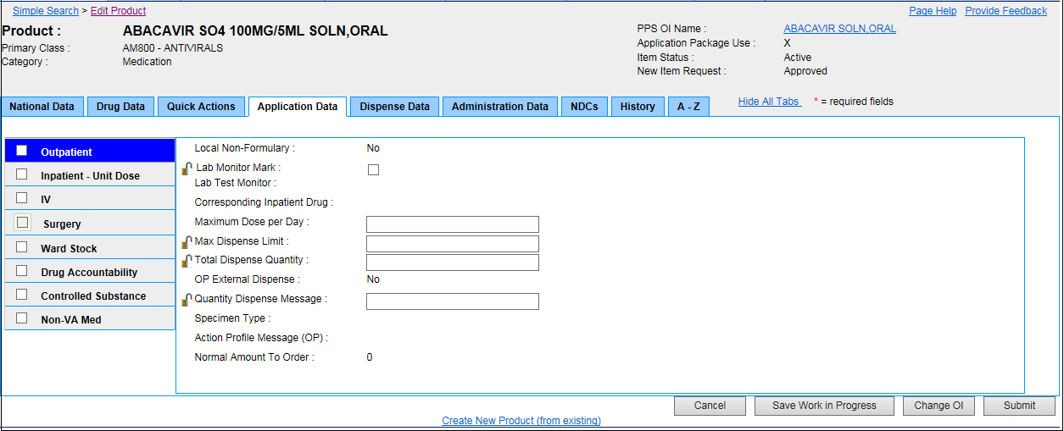

Figure 126: Product Application Data Tab-Outpatient

**Field List Header**

See Product Header.

**Field List Outpatient**

**Local Non-Formulary**

The view-only status of the Local Non-Formulary product: Yes or No. If Yes, the product is non-formulary and administered from the local pharmacy.

**Lab Monitor Mark**

Click this check box to indicate that laboratory monitoring is required when this drug is administered.

Click the lock icon Graphic Open Lock to lock the field so that it cannot be changed. The system changes the icon Graphic Closed Lock. The lock is a toggle, which can be clicked to lock or unlock the field.

**Lab Test Monitor**

Click this check box to indicate that laboratory testing is required when this drug is administered.

**Correspondence Inpatient Drug**

The view-only inpatient pharmacy correspondence indicator: Yes or No. If Yes, the product has inpatient correspondence associated with it.

**Maximum Does per Day**

Enter the maximum dose limit per day from 0 to 999.

**Max Dispense Unit**

Enter the maximum dispense limit for the product.

Click the lock icon Graphic Open Lock to lock the field so that it cannot be changed. The system changes the icon Graphic Closed Lock. The lock is a toggle, which can be clicked to lock or unlock the field.

**Total Dispense Quantity**

Enter the Total Dispense Quantity from 1 to 120.

Click the lock icon Graphic Open Lock to lock the field so that it cannot be changed. The system changes the icon Graphic Closed Lock. The lock is a toggle, which can be clicked to lock or unlock the field.

**OP External Dispense**

The view-only Outpatient Pharmacy (OP) External Dispense indicator: Yes or No. If Yes, the product is eligible for external dispensing.

**Quantity Dispense Message**

Enter quantity dispense message for the product

Click the lock icon Graphic Open Lock to lock the field so that it cannot be changed. The system changes the icon Graphic Closed Lock. The lock is a toggle, which can be clicked to lock or unlock the field.

**Specimen Type**

The view-only Specimen Type

**Action Profile Message (OP)**

The view-only Outpatient Pharmacy (OP) action profile message

**Normal Amount to Order**

The view-only amount to order normally for the selected product

**Buttons and Links**

**Cancel**

Click this button discard changes and return to the previous page.

**Save Work in Progress**

Click this button to save your work. See Saved Work in Progress tab for more information.

**Change OI**

Click this button to open an Orderable Item Search page, which you can use to search criteria for product, dosage form, item status, and new item request to search for an orderable item. You are selecting a parent for the product.

**Submit**

Click this button to submit the additions or changes you have made.

**Create New Product (from existing)**

Click this link to open the Add Product page, and create a product from an existing product.

### Product Application Data Tab: Inpatient - Unit Dose

This tab appears when you edit a product and select the Application Data tab menu option Unit Dose. Use this tab to edit product-related unit dose data.

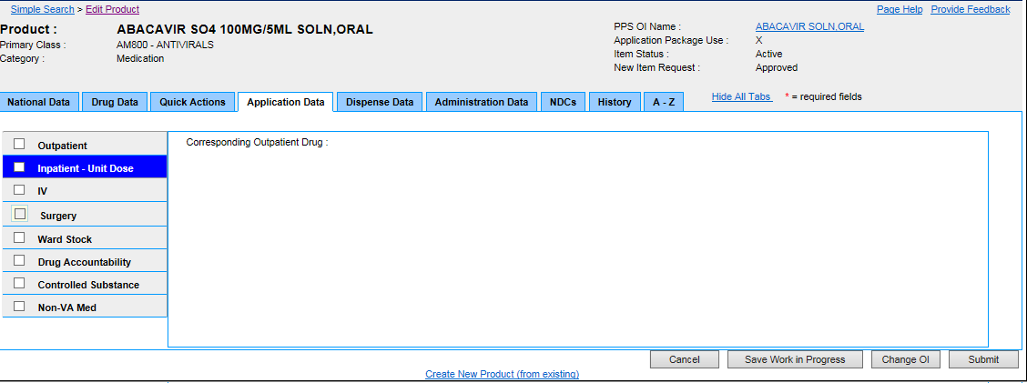

Figure 127: Product Application Data Tab-Inpatient - Unit Dose

**Field List Header**

See Product Header.

**Field List Inpatient - Unit Dose**

**Corresponding Outpatient Drug**

The view-only Corresponding Outpatient Drug if applicable.

**Buttons and Links**

**Cancel**

Click this button discard changes and return to the previous page.

**Save Work in Progress**

Click this button to save your work. See Saved Work in Progress tab for more information.

**Change OI**

Click this button to open an Orderable Item Search page, which you can use to search criteria for product, dosage form, item status, and new item request to search for an orderable item. You are selecting a parent for the product.

**Submit**

Click this button to submit the additions or changes you have made.

**Create New Product (from existing)**

Click this link to open the Add Product page, and create a product from an existing product.

### Product Application Data Tab: IV

This tab appears when you edit a product and select the Application Data tab menu option IV. Use this tab to edit product-related IV data.

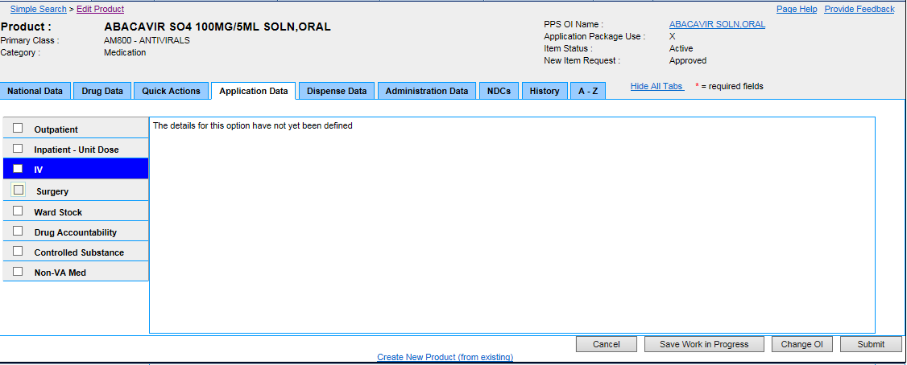

Figure 128: Product Application Data Tab-IV

**Field List Header**

See Product Header.

**Field List IV**

For future development, and not in use at the moment.

**Buttons and Links**

**Cancel**

Click this button discard changes and return to the previous page.

**Save Work in Progress**

Click this button to save your work. See Saved Work in Progress tab for more information.

**Change OI**

Click this button to open an Orderable Item Search page, which you can use to search criteria for product, dosage form, item status, and new item request to search for an orderable item. You are selecting a parent for the product.

**Submit**

Click this button to submit the additions or changes you have made.

**Create New Product (from existing)**

Click this link to open the Add Product page, and create a product from an existing product.

### Product Application Data Tab: Surgery

This tab appears when you edit a product and select the Application Data tab menu option Surgery. Use this tab to edit product-related surgery data.

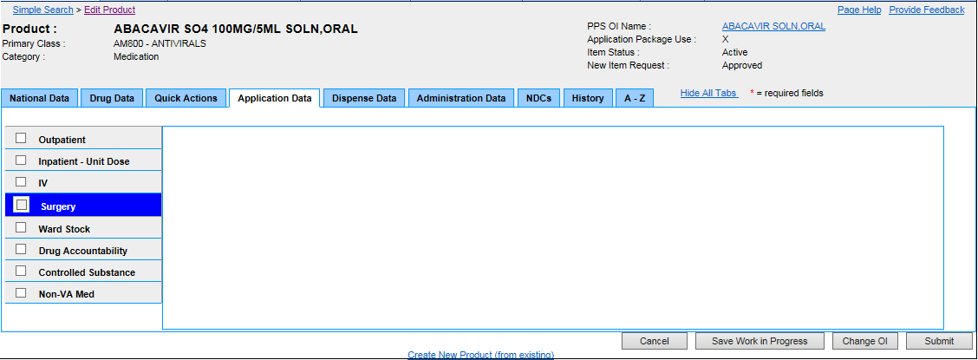

Figure 129: Product Application Data Tab-Surgery

**Field List Header**

See Product Header.

**Field List Surgery**

For future development, and not in use at the moment.

**Buttons and Links**

**Cancel**

Click this button discard changes and return to the previous page.

**Save Work in Progress**

Click this button to save your work. See Saved Work in Progress tab for more information.

**Change OI**

Click this button to open an Orderable Item Search page, which you can use to search criteria for product, dosage form, item status, and new item request to search for an orderable item. You are selecting a parent for the product.

**Submit**

Click this button to submit the additions or changes you have made.

**Create New Product (from existing)**

Click this link to open the Add Product page, and create a product from an existing product.

### Product Application Data Tab: Ward Stock

This tab appears when you edit a product and select the Application Data tab menu option Ward Stock. Use this tab to edit product-related ward stock data.

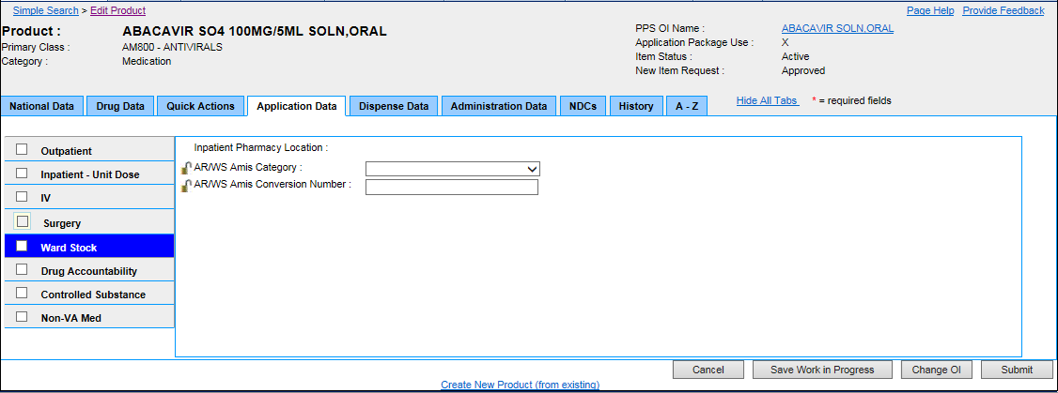

Figure 130: Product Application Data Tab-Ward Stock

**Field List Header**

See Product Header.

**Field List Ward Stock**

**Inpatient Pharmacy Location**

The view-only location of the inpatient pharmacy

**AR/WS Amis Category**

Select an Automatic Replenishment/Ward Stock (AR/WS) Category from the drop-down list: 0-DOSE BY TYPE; 1-UNITS OF ISSUE; 2-FLUIDS AND ADMIN SETS; 3-BLOOD PRODUCT.

Click the lock icon Graphic Open Lock to lock the field so that it cannot be changed. The system changes the icon Graphic Closed Lock. The lock is a toggle, which can be clicked to lock or unlock the field.

**AR/WS Amis Conversion Number**

Enter the Automatic Replenishment/Ward Stock (AR/WS) Amis Conversion Number.

Click the lock icon Graphic Open Lock to lock the field so that it cannot be changed. The system changes the icon Graphic Closed Lock. The lock is a toggle, which can be clicked to lock or unlock the field.

**Buttons and Links**

**Cancel**

Click this button discard changes and return to the previous page.

**Save Work in Progress**

Click this button to save your work. See Saved Work in Progress tab for more information.

**Change OI**

Click this button to open an Orderable Item Search page, which you can use to search criteria for product, dosage form, item status, and new item request to search for an orderable item. You are selecting a parent for the product.

**Submit**

Click this button to submit the additions or changes you have made.

**Create New Product (from existing)**

Click this link to open the Add Product page, and create a product from an existing product.

### Product Application Data Tab: Drug Accountability

This tab appears when you edit a product and select the Application Data tab menu option Drug Accountability. Use this tab to edit product-related drug accountability data.

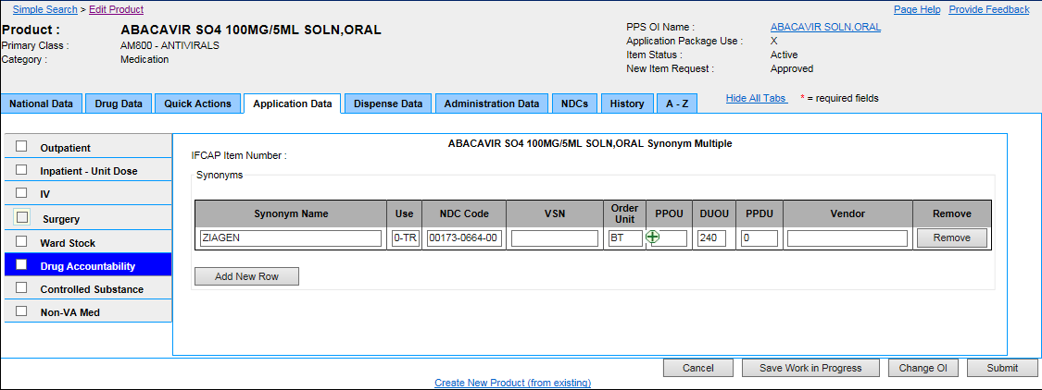

Figure 131: Product Application Data Tab-Drug Accountability

**Field List Header**

See Product Header.

**Field List Drug Accountability**

**IFCAP Item Number**

The view-only Integrated Funds Distribution, Control Point Activity, Accounting, and Procurement (IFCAP) item number.

**Synonym Name**

Enter or edit the product synonym.

**Use**

Select a medication use from the drop-down list: 0 - Trade Name; 1 - Quick Code; D - Drug Accountability; C - Controlled Substance.

**NDC Code**

Enter the National Drug Code (NDC) number.

**VSN**

Enter or edit the Vendor Stock Number (VSN) for the product synonym.

**Order Unit**

Select an Order Unit type from the drop-down list for the product synonym.

Click the add button add_button.png to open the Add Order Unit page and add an order unit abbreviation.

**PPOU**

Enter or edit the Product Price per Order Unit (PPOU) for the product synonym.

**DUOU**

Enter or edit the Drug Units per Order Unit (DUOU) for product synonym.

**PPDU**

Enter or edit the Product Price per Dispense Unit (PPDU) for the product synonym.

**Vendor**

Enter or edit a Vendor name for the product synonym.

**Remove**

Click this button to remove the product synonym.

**Add New Row**

Click this button to add a new row to the list and add another product synonym.

**Buttons and Links**

**Cancel**

Click this button discard changes and return to the previous page.

**Save Work in Progress**

Click this button to save your work. See Saved Work in Progress tab for more information.

**Change OI**

Click this button to open an Orderable Item Search page, which you can use to search criteria for product, dosage form, item status, and new item request to search for an orderable item. You are selecting a parent for the product.

**Submit**

Click this button to submit the additions or changes you have made.

**Create New Product (from existing)**

Click this link to open the Add Product page, and create a product from an existing product.

### Product Application Data Tab: Controlled Substance

This tab appears when you edit a product and select the Application Data tab menu option Controlled Substance. Use this tab to edit product-related controlled substance data.

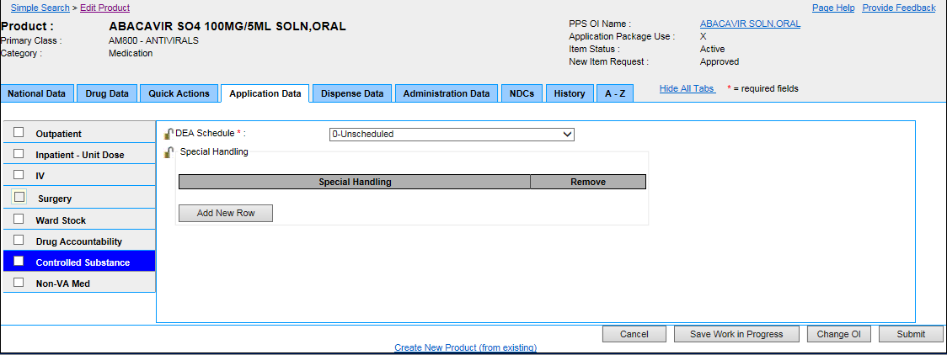

Figure 132: Product Application Data Tab-Controlled Substance

**Field List Header**

**See Product Header.**

**Field List Controlled Substance**

Fields with a red asterisk are required fields that you must complete.

**DEA Schedule** \*

Select a Drug Enforcement Administration (DEA) Schedule from the drop-down list: 0 - Unscheduled; 1 - Schedule 1 Item; 2 - Schedule 2 Item; 3 - Schedule 3 Item; 4 - Schedule 4 Item; 5 - Schedule 5 Item; 6 - Legend Item; 9 - Over the Counter.

Click the lock icon Graphic Open Lock to lock the field so that it cannot be changed. The system changes the icon Graphic Closed Lock. The lock is a toggle, which can be clicked to lock or unlock the field.

**Special Handling**

Click the Add New Row button add a new row to the Special Handling table.

In Special Handling, select a special handling option from the drop-down list. See Add Special Handling Code for more information on the source of this list.

Click the Remove button beside a special handling code to remove it from the table.

Click the lock icon Graphic Open Lock to lock the field so that it cannot be changed. The system changes the icon Graphic Closed Lock. The lock is a toggle, which can be clicked to lock or unlock the field.

**Buttons and Links**

**Cancel**

Click this button discard changes and return to the previous page.

**Save Work in Progress**

Click this button to save your work. See Saved Work in Progress tab for more information.

**Change OI**

Click this button to open an Orderable Item Search page, which you can use to search criteria for product, dosage form, item status, and new item request to search for an orderable item. You are selecting a parent for the product.

**Submit**

Click this button to submit the additions or changes you have made.

**Create New Product (from existing)**

Click this link to open the Add Product page, and create a product from an existing product.

### Product Application Data Tab: Non-VA Med

This tab appears when you edit a product and select the Application Data tab menu option Non-VA Med. Use this tab to edit product-related non-Veterans Administration medication data.

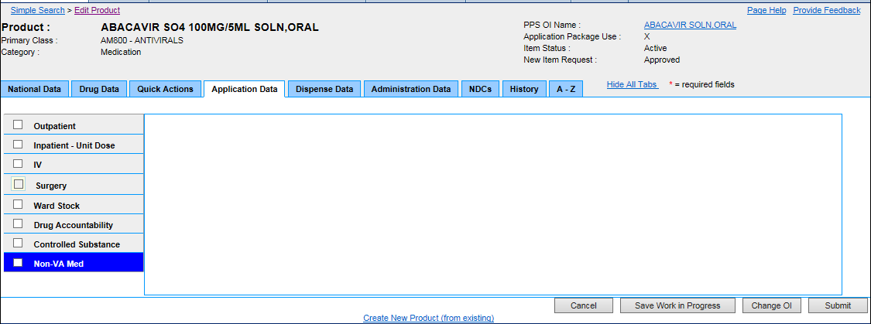

Figure 133: Product Application Data Tab-Non-VA Med

**Field List Header**

**See Product Header.**

**Field List Non-VA Med**

For future development, and not in use at the moment.

**Buttons and Links**

**Cancel**

Click this button discard changes and return to the previous page.

**Save Work in Progress**

Click this button to save your work. See Saved Work in Progress tab for more information.

**Change OI**

Click this button to open an Orderable Item Search page, which you can use to search criteria for product, dosage form, item status, and new item request to search for an orderable item. You are selecting a parent for the product.

**Submit**

Click this button to submit the additions or changes you have made.

**Create New Product (from existing)**

Click this link to open the Add Product page, and create a product from an existing product.

### Product Dispense Data Tab

This tab appears when you edit a product and select the Dispense Data tab. Use this tab to edit product-related dispensing data.

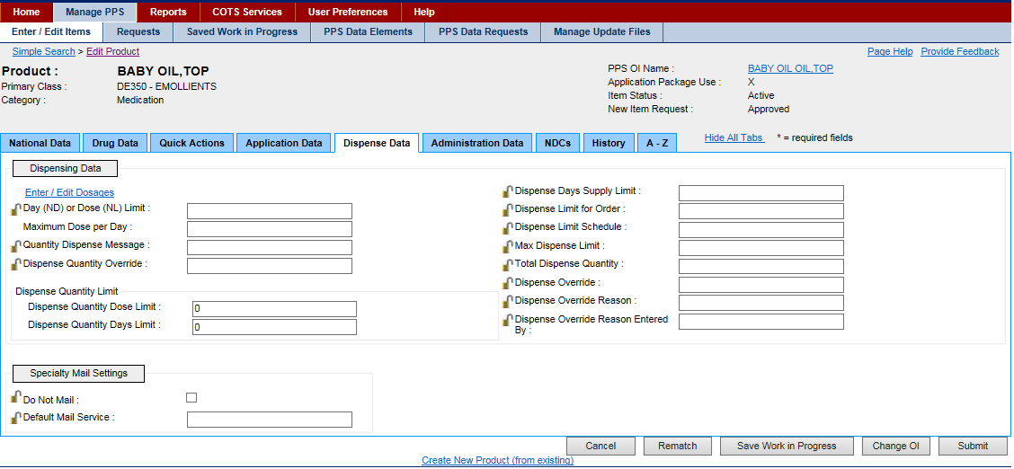

Figure 134: Product Dispense Data Tab

**Field List Header**

**See Product Header.**

**Field List Dispense Data Tab**

**Dispensing Data**

**Enter/Edit Dosages**

Click this link to open a pop-up that allows you to enter or edit dosages. See Edit Dosage Form Name for more information.

**Day (ND) or Dose (NL) Limit**

Enter the day or dose limit for the product.

Click the lock icon Graphic Open Lock to lock the field so that it cannot be changed. The system changes the icon Graphic Closed Lock. The lock is a toggle, which can be clicked to lock or unlock the field.

**Maximum Dose per Day**

Enter the maximum dose limit per day from 0 to 999.

**Quantity Dispense Message**

Enter Quantity Dispense Message for the product.

Click the lock icon Graphic Open Lock to lock the field so that it cannot be changed. The system changes the icon Graphic Closed Lock. The lock is a toggle, which can be clicked to lock or unlock the field.

**Dispense Quantity Override**

Enter the Dispense Quantity Override for the product.

Click the lock icon Graphic Open Lock to lock the field so that it cannot be changed. The system changes the icon Graphic Closed Lock. The lock is a toggle, which can be clicked to lock or unlock the field.

**Dispense Quantity Limit**

**Dispense Quantity Dose Limit**

Enter a limit for the dispense quantity dose for the product.

Click the lock icon Graphic Open Lock to lock the field so that it cannot be changed. The system changes the icon Graphic Closed Lock. The lock is a toggle, which can be clicked to lock or unlock the field.

**Dispense Quantity Days Limit**

Enter a limit for the dispense quantity days for the product.

Click the lock icon Graphic Open Lock to lock the field so that it cannot be changed. The system changes the icon Graphic Closed Lock. The lock is a toggle, which can be clicked to lock or unlock the field.

**Dispense Days Supply Limit**

Enter a limit for the dispense days supply for the product.

Click the lock icon Graphic Open Lock to lock the field so that it cannot be changed. The system changes the icon Graphic Closed Lock. The lock is a toggle, which can be clicked to lock or unlock the field.

**Dispense Limit for Order**

Enter a limit for the Dispense for Order for the product.

Click the lock icon Graphic Open Lock to lock the field so that it cannot be changed. The system changes the icon Graphic Closed Lock. The lock is a toggle, which can be clicked to lock or unlock the field.

**Dispense Limit Schedule**

Enter a limit for the dispense schedule for the product.

Click the lock icon Graphic Open Lock to lock the field so that it cannot be changed. The system changes the icon Graphic Closed Lock. The lock is a toggle, which can be clicked to lock or unlock the field.

**Max Dispense Limit**

Enter a limit for the maximum dispense limit for the product.

Click the lock icon Graphic Open Lock to lock the field so that it cannot be changed. The system changes the icon Graphic Closed Lock. The lock is a toggle, which can be clicked to lock or unlock the field.

**Total Dispense Quantity**

Enter a total for the dispense quantity for the product.

Click the lock icon Graphic Open Lock to lock the field so that it cannot be changed. The system changes the icon Graphic Closed Lock. The lock is a toggle, which can be clicked to lock or unlock the field.

**Dispense Override**

Enter the Dispense Override for the product.

Click the lock icon Graphic Open Lock to lock the field so that it cannot be changed. The system changes the icon Graphic Closed Lock. The lock is a toggle, which can be clicked to lock or unlock the field.

**Dispense Override Reason**

Enter the Dispense Override Reason for the product.

Click the lock icon Graphic Open Lock to lock the field so that it cannot be changed. The system changes the icon Graphic Closed Lock. The lock is a toggle, which can be clicked to lock or unlock the field.

**Dispense Override Reason Entered By**

Enter the name of the user who entered the dispense override reason.

Click the lock icon Graphic Open Lock to lock the field so that it cannot be changed. The system changes the icon Graphic Closed Lock. The lock is a toggle, which can be clicked to lock or unlock the field.

**Specialty Mail Settings**

Do Not Mail

Click the check box to indicate no mail notifications.

Click the lock icon Graphic Open Lock to lock the field so that it cannot be changed. The system changes the icon Graphic Closed Lock. The lock is a toggle, which can be clicked to lock or unlock the field.

**Default Mail Service**

Enter a Default Mail Service.

Click the lock icon Graphic Open Lock to lock the field so that it cannot be changed. The system changes the icon Graphic Closed Lock. The lock is a toggle, which can be clicked to lock or unlock the field.

**Buttons and Links**

**Cancel**

Click this button discard changes and return to the previous page.

**Save Work in Progress**

Click this button to save your work. See Saved Work in Progress tab for more information.

**Change OI**

Click this button to open an Orderable Item Search page, which you can use to search criteria for product, dosage form, item status, and new item request to search for an orderable item. You are selecting a parent for the product.

**Submit**

Click this button to submit the additions or changes you have made.

**Create New Product (from existing)**

Click this link to open the Add Product page, and create a product from an existing product.

### Product Administration Data Tab

This tab appears when you edit a product and select the Administration Data tab. Use this tab to edit product-related administration data.

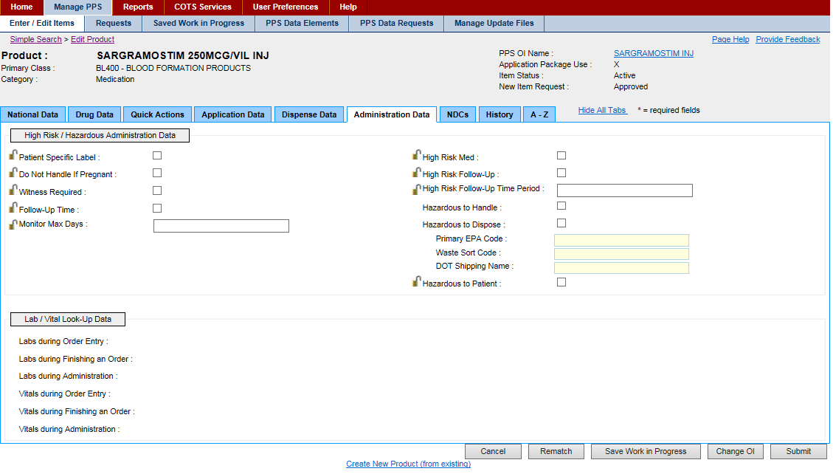

Figure 135: Product Administration Data Tab

**Field List Header**

**See Product Header**.

**Field List Administration Data Tab**

**High Risk / Hazardous Administration Data**

**Patient Specific Label**

Click this check box to indicate the need for a Patient Specific Label.

Click the lock icon Graphic Open Lock to lock the field so that it cannot be changed. The system changes the icon Graphic Closed Lock. The lock is a toggle, which can be clicked to lock or unlock the field.

**Do Not Handle If Pregnant**

Click this check box to indicate that the product should not be handled by a pregnant woman.

Click the lock icon Graphic Open Lock to lock the field so that it cannot be changed. The system changes the icon Graphic Closed Lock. The lock is a toggle, which can be clicked to lock or unlock the field.

**Witness Required**

Click this check box to indicate that a witness is required when the product is administered to a patient.

Click the lock icon Graphic Open Lock to lock the field so that it cannot be changed. The system changes the icon Graphic Closed Lock. The lock is a toggle, which can be clicked to lock or unlock the field.

**Follow-Up Time**

Click this check box to indicate that patient follow-up monitoring is required after the administration of the product.

Click the lock icon Graphic Open Lock to lock the field so that it cannot be changed. The system changes the icon Graphic Closed Lock. The lock is a toggle, which can be clicked to lock or unlock the field.

**Monitor Max Days**

Enter the number of days to monitor the patient after the administration of the product from 0 to 999.

Click the lock icon Graphic Open Lock to lock the field so that it cannot be changed. The system changes the icon Graphic Closed Lock. The lock is a toggle, which can be clicked to lock or unlock the field.

**High Risk Med**

Click this check box to indicate that the mediation is high risk.

Click the lock icon Graphic Open Lock to lock the field so that it cannot be changed. The system changes the icon Graphic Closed Lock. The lock is a toggle, which can be clicked to lock or unlock the field.

**High Risk Follow-Up**

Click this check box to indicate that patient follow-up monitoring is required after the administration of the product.

Click the lock icon Graphic Open Lock to lock the field so that it cannot be changed. The system changes the icon Graphic Closed Lock. The lock is a toggle, which can be clicked to lock or unlock the field.

**High Risk Follow-Up Time Period**

Enter the number of days to monitor the patient after the administration of the product from 0 to 120.

Click the lock icon Graphic Open Lock to lock the field so that it cannot be changed. The system changes the icon Graphic Closed Lock. The lock is a toggle, which can be clicked to lock or unlock the field.

**Hazardous to Handle**

Click this check box to indicate that this product is hazardous to handle. Precautions should be taken.

**Hazardous to Dispose**

Click this check box to indicate that the product is Hazardous to Dispose. The system enables the following additional fields:

* In Primary EPA Code, enter the Primary Environmental Protection Agency (EPA) Code.
* In Waste Sort Code, enter the Waste Sort Code.
* In DOT Shipping Name, enter Department of Transportation (DOT) shipping code.

You must be logged in with the role of Manager, Second Approver, or Supervisor to use these fields. See Identity Management for more information.

**Hazardous to Patient**

Click this check box to indicate that the product is hazardous to the patient.

Click the lock icon Graphic Open Lock to lock the field so that it cannot be changed. The system changes the icon Graphic Closed Lock. The lock is a toggle, which can be clicked to lock or unlock the field.

**Lab/Vital Look-Up Data**

See the Labs & Vitals Tab for the source for entries in the field set.

**Labs during Order Entry**

The view-only laboratory tests required during order entry for the orderable item

**Labs during Finishing an Order**

The view-only laboratory tests required during order entry finishing for the orderable item

**Labs during Administration**

The view-only laboratory tests required during administration for the orderable item

**Vitals during Order Entry**

The view-only vitals monitoring required during order entry for the orderable item

**Vitals during Finishing an Order**

The view-only vitals monitoring required during order entry finishing for the orderable item

**Vitals during Administration**

The view-only vitals monitoring required during administration for the orderable item

**Buttons and Links**

**Cancel**

Click this button discard changes and return to the previous page.

**Save Work in Progress**

Click this button to save your work. See Saved Work in Progress tab for more information.

**Change OI**

Click this button to open an Orderable Item Search page, which you can use to search criteria for product, dosage form, item status, and new item request to search for an orderable item. You are selecting a parent for the product.

**Submit**

Click this button to submit the additions or changes you have made.

**Create New Product (from existing)**

Click this link to open the Add Product page, and create a product from an existing product.

### Product NDCs Tab

This tab appears when you edit a product and select the NDCs tab. Use this tab to edit product-related NDC data.

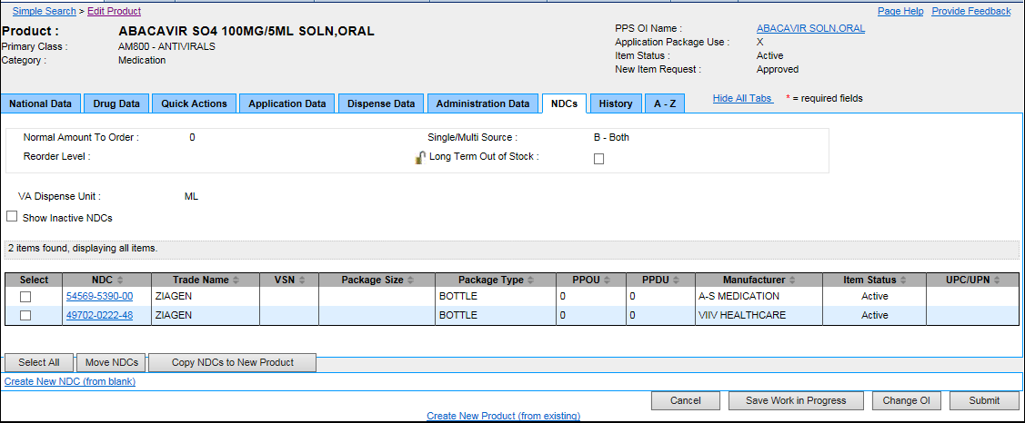

Figure 136: Product NDCs Tab

**Field List Header**

See Product Header.

**Field List NDCs Tab**

**Normal Amount to Order**

The view-only Normal Amount to Order for selected product

**Reorder Level**

The view-only product Reorder Level

**Single/Multi Source**

The view-only source status: M - Multi Source; S - Single Source; B - Both; N - Neither

**Long Term Out of Stock**

Click this check box to indicate the product is out of stock for the long term.

Click the lock icon Graphic Open Lock to lock the field so that it cannot be changed. The system changes the icon Graphic Closed Lock. The lock is a toggle, which can be clicked to lock or unlock the field.

**VA Dispense Unit**

The view-only product VA Dispense Unit

**Show Inactive NDCs**

Click this check box to display inactive national drug code(s) (NDCs) in the list below.

**Field List NDCs List**

**Select**

Click the check box to view additional details of product.

**NDC**

Click this link to open the NDC Main Tab where you can edit the National Drug Code (NDC) for the selected product.

**Trade Name**

The view-only product Trade Name

**VSN**

The view-only Vendor Stock Number (VSN) for the product. See Application Data Tab: Drug Accountability for the original entry.

**Package Size**

The view-only Package Size for the product

**Package Type**

The view-only Package Type for the product

**PPOU**

The view-only Product Price per Order Unit (PPOU) for the product. See Application Data Tab: Drug Accountability for the original entry.

**PPDU**

The view-only Product Price per Dispense Unit (PPDU) for the product. See Application Data Tab: Drug Accountability for the original entry.

**Manufacturer**

The view-only name of the Manufacturer for the product

**Item Status**

The view-only the Item Status for the product: Active or Inactive

**UPC/UPN**

The view-only Universal Product Code (UPC) or Universal Product Number (UPN) for the product

**Buttons and Links**

**Select All**

Click this button to select all entries in the Select column of the table for further handling.

**Move NDCs**

Use this button to remove NDCs from the product. See Remove NDCs from Product for more information.

**Copy NDCs to New Product**

Use this button to copy the NDCs for the displayed product to a new product. See Copy NDCs to New Product for more information.

**Create New NDC (from existing) Link**

Click this link to open the Add New NDC page. See Add NDC for more information.

**Cancel**

Click this button discard changes and return to the previous page.

**Save Work in Progress**

Click this button to save your work. See Saved Work in Progress tab for more information.

**Change OI**

Click this button to open an Orderable Item Search page, which you can use to search criteria for product, dosage form, item status, and new item request to search for an orderable item. You are selecting a parent for the product.

**Submit**

Click this button to submit the additions or changes you have made.

**Create New Product (from existing)**

Click this link to open the Add Product page, and create a product from an existing product.

## Product Change Request Tab

After you submit product changes, this tab appears. Select the Change Request tab and use the tab to request changes.

To complete requests tasks, you must have the appropriate role assigned. See Identity Management for more information.

This page also appears when you approve, reject, or place a request in an under review or a pending state.

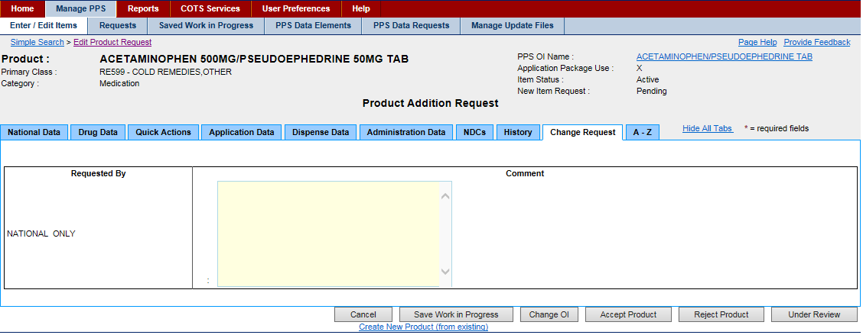

Figure 137: Product Change Request Tab

**Field List Header**

See Product Header.

**Field List Change Request Tab**

**Requested By**

The view-only name of the user requesting the change to the product

**Comment**

Enter Comments to request changes to the product.

**Buttons and Links**

**Cancel Button**

Click this button discard changes and return to the previous page.

**Save Work in Progress**

Click this button to save your work. See Saved Work in Progress tab for more information.

**Change OI**

Click this button to open an Orderable Item Search page, which you can use to search criteria for product, dosage form, item status, and new item request to search for an orderable item. You are selecting a parent for the product.

**Create New Product (from existing)**

Click this link to open the Add Product page, and create a product from an existing product.

## Product Pending Modification Tab

After you submit product changes, this tab appears. Select the Pending Modification tab and use the tab to approve, reject, or place the change in a pending state.

To complete requests tasks, you must have the appropriate role assigned. See Identity Management for more information.

This page also appears when you approve, reject, or place a request in an under review or a pending state.

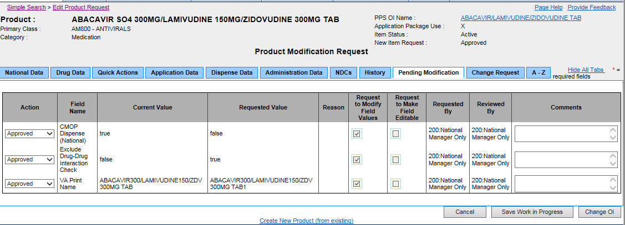

Figure 138: Product Pending Modification Tab

**Field List Header**

**See Product Header**

**Field List Pending Modification Table**

**Action**

Select a state from the drop-down list: Approved, Rejected, Pending.

**Field Name**

The view-only name of the field where the change was made.

**Current Value**

The view-only original value of the field

**Requested Value**

The view-only modified value of the field

**Reason**

The view-only reason that the change is being submitted

**Request to Modify Field Values**

If the box is checked, the field can be edited.

If the box is unchecked, the field is view-only.

This field is completed by a local manager and it will not be useful until PPS-L is released.

**Request to Make Field Editable**

If the box is checked, the request is to enable the field so that it can be edited.

If the box is unchecked, the request is to disable the field so that it cannot be edited.

This field is completed by a local manager and it will not be useful until PPS-L is released.

**Requested By**

The view-only role name of the user who made the request

**Reviewed By**

The view-only role name of the user who reviewed the request

**Comments**

Enter any comments about the change.

**Buttons and Links**

**Cancel Button**

Click this button discard changes and return to the previous page.

**Save Work in Progress**

Click this button to save your work. See Saved Work in Progress tab for more information.

**Change OI Button**

Click this button to change the orderable item.

**Create New Product (from existing)**

Click this link to open the Add Product page, and create a product from an existing product.

## Rematch

When the user navigates to the Enter/Edit Items tab on the Manage PPS page, selects a one or product for editing, and is looking at the National Data tab, the user is able to inactivate a product or propose a future inactivation date. When the user edits a product in PPS-N it causes a potential un-match at the local level due to an Inactivation, Proposed Inactivation or “Other” modification. The PPS system then provides the user the ability to select products as suggestions or automatic rematches to replace the edited product.

The Data NDF update Report will display to the user the products whose edits cause the potential un-match along with products that are suggested for rematch, products that will be automatically rematched, or an indicator that there are no alternatives.

From the edit product page the user can select the **Rematch** button to navigate to the Rematch page. See image below.

**To Access Rematch Page:**

1. Navigate to the **Manage PPS page.**
2. Under **Enter/Edit Items tab** search for an active product, and select that product for editing.
3. Change the Item Status by selecting an option from the drop-down list: Active, Inactive.
4. Once the item status is set to Inactive, click the **Submit** button**.**
5. The Rematch page displays with possible matches, the user can either mark possible matches as suggested or automatic.
6. The user can then either click **Cancel, Skip, or Submit** the changes.

If I click Skip, the current Modification Summary for Product page displays.

If I click Submit, the Modification Summary for Product page that includes the product(s) I selected for rematch displays.

If I click Cancel, I am able to edit the product again.

If I click Accept Changes, the confirmation page displays.

**To Define an Automatic Rematch:**

1. In Automatic, click the radio button beside a VA product name that matches the unmatched product.
2. Click the Submit button. The system re-displays the Unmatched Products list and updates the Rematch Type to Automatic.

**To Define One or More Suggested Rematch:**

1. In Suggestion, click the radio button beside a VA product(s) name that is a possible match to the unmatched product.
2. Click the Submit button. The system re-displays the Unmatched Products list and updates the Rematch Type to Suggest.

**To Search for Product:**

1. If none of the suggestions is a good match, click the Product Search button. They system opens the Associate Product search page.
2. In Search for, enter text.
3. In Search Field, select a field from the drop-down list.
4. In Strength, enter strength.
5. Click the Search button. The system displays a list of possible matches.
6. In VA Product Name, click the link of a possible match. The system closes the search page and re-displays the Possible Matches with the product you selected added to the list.
7. To add more products, click the Internet Explorer Back button and click the link of another possible match in the VA Product Name.
8. Complete the match process by selecting Automatic or Suggestion radio button.

**Field List Rematch**

**VA Product Name**

The name of the VA product. Click the link to open the Possible Rematches page.

**VA Product ID**

The view-only VA Product Identification

**Rematched VA Product Name**

The view-only name of the Rematched VA product

**Rematched Status**

The view-only Rematched Status: Active or Inactive

**Rematched VA Product ID**

**Rematch Type**

The view-only Rematch Type for the product: Suggest or Automatic.

Rematch Button

Screenshot of Rematch  button



Figure 139: Rematch Page with Possible Matches



Figure 140: Rematch Modification Screen



Figure 141: Proposed Inactivation for Product for Rematch

# Product National Data Tab

This tab appears when you edit a product and select the National Data tab. Use this tab to edit product-related national data.



Figure 142: Product National Data Tab

**Field List Header**

See Product Header.

**Field List National Data Tab**

Fields with a red asterisk are required fields that you must complete.

**VA Product Name**

The view-only name of the VA product. The name is derived based on the following criteria.

If the product has more than one Ingredient Name in Ingredients multiple, the system sorts Ingredient Names in alphabetical order. Each Ingredient Name is followed by Ingredient Strength and Ingredient Unit.

If the product has more than one Ingredient Name in Ingredients multiple, the system inserts a slash ( / ) after each Ingredient Unit with the exception of the last Ingredient Unit. Further, the system inserts Dosage Form after the last Ingredient Unit. The system truncates the value if it exceeds the max limit of 64 characters.

If Not for Human Use is marked and Category does not equal Investigational, then the system starts the VA Product Name with the prefix AML. For example, a VA Product Name of Tylenol 325 mg Tab, SA becomes AML Tylenol 325 mg SA Tab.

**Generic Name** \*

Select a Generic Name for the product from the drop-down list.

Click the Graphic Plus Buttonto add a new generic name. The system opens the Add Generic Name page, which you can use to add a new generic name for the product.

**Product Strength**

Enter the strength of the product.

**Product Unit**

Select a unit for the product from the drop-down list.

Click the Graphic Plus Buttonto add a new unit for the product. The system opens the Add Dose Unit Name page, which you can use to add a new unit for the product.

**VA Dispense Unit** \*

Select a VA Dispense Unit for the product from the drop-down list.

Click the Graphic Plus Buttonto add a new dispense unit for the product. The system opens the Add Dispense Unit Name page, which you can use to add a new dispense unit for the product.

**VA Print Name** \*

Enter the VA Print Name for the product. The name is derived based on the following criteria.

If the product has more than one Ingredient Name in Ingredients multiple, the system sorts Ingredient Names in alphabetical order. Each Ingredient Name is followed by Ingredient Strength and Ingredient Unit.

If the product has more than one Ingredient Name in Ingredients multiple, the system inserts a slash ( / ) after each Ingredient Unit with the exception of the last Ingredient Unit. Further, the system inserts Dosage Form after the last Ingredient Unit. In addition, if the Dosage for value is composed of two parts separated by a comma, the system reverses the two parts and removes the comma. The system truncates the value if it exceeds the max limit of 40 characters.

If Not for Human Use is marked and Category does not equal Investigational, then the system starts the VA Product Name with the prefix AML. For example, a VA Product Name of Tylenol 325 mg Tab, SA becomes AML Tylenol 325 mg SA Tab.

If the product item has more than one Ingredient Name in Ingredients multiple, Ingredient Names must be in alphabetical order.

When edited, this field requires a second review. See PPS Data Requests Tab for more information.

**VA Product ID**

The view-only Consolidated Mail Outpatient Pharmacy (CMOP) identification. This field is required after the product has been approved or after the VA Print Name of an existing product has been edited and approved.

When edited, this field requires a second review. See PPS Data Requests Tab for more information.

**CMOP Dispense (National)**

Click this check box to indicate that the product is to be dispensed via the national Consolidated Mail Outpatient Pharmacy (CMOP).

When edited, this field requires a second review. See Section 3.4 for more information.

**Exclude DDI Check**

Click this check box to indicate that the product is to be excluded from the system Drug-Drug Interaction (DDI) check.

**Override DF Check Exclusion**

Click this check box to indicate that the product is included in the national Drug File (DF) check.

**Auto-Create Possible Dosage**

Click this check box to indicate that the system should suggest a possible dosage automatically.

**Possible Dosages to Create**

This field is required when Auto-Create Possible Dosage is selected.

Select a possible dosage from the drop-down list to auto-create for the dispense drugs: N - No Possible Dosages; O - Only 1x Possible Dosage; B - Both 1x and 2x Possible Dosages.

**Product Package**

This field is required when Auto-Create Possible Dosage is selected.

Select a possible package description for the product from the drop-down list.

**Product Text**

This field is to enter any text for notes relating to the product.

 Note the Text field displays only the first 36 characters of the OI Text. The user can navigate into that field, which will expand to show the full text.

**FDA Med Guide**

The view-only name of the Federal Drug Administration (FDA) medical guide in which the product is detailed.

Click the PDF icon Graphic PDF Buttonto open the FDA Medical Guide.

**GCNSEQNO**

Enter the Generic Sequence Number (GCNSEQNO) for the product.

When edited, this field requires a second review. See PPS Data Requests Tab for more information.

**VUID**

The view-only VA Unique Identifier.

**CS Federal Schedule** \*

Select a federal controlled substance schedule from the drop-down list: 0 - Unscheduled; 1 - Schedule 1; 2 - Schedule II; 2n - Schedule II Non-Narcotic; 3 - Schedule 3; 3n - Schedule III Non-Narcotics; 4 - Schedule IV; 5 - Schedule 5.

**National Formulary Indicator**

Click this check box to indicate that the product is part of the national formulary.

When edited, this field requires a second review. See PPS Data Requests Tab for more information.

**National Formulary Name**

The view-only name of the product in the national formulary

**Formulary Designator**

This field shows the formulary designator being added to an existing product.

**Item Status** \*

Select a status for the product: Active or Inactive.

**Proposed Inactivation Date**

Enter a Proposed Inactivation Date using the format DD-Mon-YYYY.

Click the lock icon Graphic Open Lock to lock the field so that it cannot be changed. The system changes the icon Graphic Closed Lock. The lock is a toggle, which can be clicked to lock or unlock the field.

**Copay Tier**

Click the Add New Row button to add a row to the Copay Tier.

* Select the Copay Tier from the drop-down menu.
* Effective Date will auto-populate with today's date, the user can also a start date for the start of the copay period.
* For the End Date, the user can enter an end date for the end of the copay period, or if the user adds another row and sets a new copay tier the end date will auto-populate with a day before the new row's effect date.
* Click the Remove button beside an entry to remove the copay range.

**Sub-Category Box**

Click one or more of the check boxes to indicate a Sub-Category for the product: Chemotherapy; Herbal; OTC; Veterinary.

**VA Drug Class** \*

Click the Add New Row button to add a row to the VA Drug Class table.

* In VA Drug Class, enter the name of the class for the VA drug. Click the add_button.pngto add a new drug class for the product. The system opens the Add Drug Class page, which you can use to add a new drug class for the product.
* In Primary, click the check box to indicate that this drug class is primary. When the product includes more than one VA Drug Class, you must select one as primary. If the product includes only one VA Drug Class, the system automatically selects it as primary.

When edited, this field requires a second review. See PPS Data Requests Tab for more information.

Click the Remove button beside an entry to remove the drug class.

**Active Ingredient**

Click the Add New Row button to add a row to the Ingredient Name table.

* In Ingredient Name, enter the name of the active ingredient. Click the add_button.pngto add a new active ingredient for the product. The system opens the Add Ingredient Name page, which you can use to add a new active ingredient for the product.
* In Strength, enter a strength for the active ingredient.
* In Drug Unit, enter a drug unit for the active ingredient. Click the add_button.pngto add a new drug unit for the active ingredient. The system opens the Add Drug Unit Name page, which you can use to add a new drug unit name for the active ingredient.
* Click the Remove button beside an entry to remove it.

**Synonyms**

Click the Add New Row button to add a row to the Synonyms table.

* In Synonym, enter a synonym for the product.
* In Use, enter medication use: 0 - Trade Name; 1 - Quick Code; D - Drug Accountability; C - Controlled Substance.
* In NDC Code, enter a National Drug Code (NDC) for the product synonym.
* In VSN, enter the Vendor Stock Number (VSN) for the product synonym.
* In Order Unit, enter order unit type for the product synonym. Click the add_button.pngto add a new order unit for the synonym. The system opens the Add Order Unit Abbreviation page, which you can use to add a new order unit abbreviation for the synonym.
* In PPOU, enter a Product Price per Order Unit (PPOU) for the product synonym.
* In DUOU, enter a Drug Units per Order Unit (DUOU) for product synonym.
* In PPDU, enter a Product Price per Dispense Unit (PPDU) for the product synonym.
* In Vendor, enter a vendor name for the product synonym.
* --Click the Remove button beside an entry to remove the synonym.

When edited, this field requires a second review. See PPS Data Requests Tab for more information.

**Buttons and Links**

**Cancel**

Click this button discard changes and return to the previous page.

**Save Work in Progress**

Click this button to save your work. See Saved Work in Progress tab for more information.

**Change OI**

Click this button to open an Orderable Item Search page, which you can use to search criteria for product, dosage form, item status, and new item request to search for an orderable item. You are selecting a parent for the product.

**Submit**

Click this button to submit the additions or changes you have made.

**Create New Product (from existing)**

Click this link to open the Add Product page, and create a product from an existing product.

### Ingredients List Report

This report provides a complete list of the Active products in PPS-N EPL with each of their ingredients.

**Buttons**

* Click the Get Status button to open the current status of the report and enable buttons.
* Click the Download Current button to download the current report. To continue, see Open or Save a Report.
* Click the Generate New button. The system opens a pop-up window with a message indicating how long the process will take. Click the OK button to start the process. The system generates a new report. After generation is complete, click the Download Current button. To continue, see Open or Save a Report.



Figure 143: Access Page for Ingredients List Report

**Navigation Bar**

The main navigation bar includes primary tabs: Home, Manage PPS, Rematch, Reports, COTS Services, User Preferences, and Help. Click a tab to open secondary tabs or pages. Additional tabs can display based on permissions: Manage Application, Migration Tab.



Figure 144: Navigation Bar

* Image First Row: This row is the primary menu. Click a tab to open a secondary menu or a page.
* Image Second Row: This row is the secondary menu. In this example, it's the secondary menu for Manage PPS. Click a secondary tab to open a page.
* Image Third Row: This row contains bread crumbs, which shows selections you've made to arrive at the current page. After you have several links displaying, you can click a link in the bread crumbs to return to an earlier page.

### Edit Product Request

Use this page to manage a request that another user has entered. This same page is used to manage Addition Requests as well as Modification Requests and the screen is altered a little differently depending on which type of request is being handled.

Complete the steps to Search for Requests.

After you have search results, complete any of these tasks:

* Approve Request
* Reject Modification Request
* Place Request Under Review
* Place Request in Pending State

To complete requests tasks, you must have the appropriate role assigned. See Identity Management for more information.

### Edit Orderable Item Request

Use this page to manage a request that another user has entered. This same page is used to manage Addition Requests as well as Modification Requests and the screen is altered a little differently depending on which type of request is being handled.

Complete the steps to Search for Requests.

After you have search results, complete any of these tasks:

* Approve Request
* Reject Modification Request
* Place Request Under Review
* Place Request in Pending State

To complete requests tasks, you must have the appropriate role assigned. See Identity Management for more information.

### Request Summary

This page is used for all item types within the PPS System. The page shows a summary of the changes and the modifications that have occurred to the item and lists the changes so the user can see a concise view of the changes the user is approving.

Complete the steps to Search for Requests.

After you have search results, complete any of these tasks:

* Approve Request
* Reject Modification Request
* Place Request Under Review
* Place Request in Pending State

To complete requests tasks, you must have the appropriate role assigned. See Identity Management for more information.

### Comment

Use this page to save the current state of the item as a work in progress. No changes will be made to the item in the database and no request is generated.

To Save Work:

1. On a page with a **Save Work in Progress** button, click the button. The system opens a comments page.
2. In the comment field, enter a comment to reference your work in progress. Be descriptive.
3. Click the Submit button. The system adds an entry to the Saved Work in Progress table. No changes are made to the item in the database and no request is generated.

****

Figure 145: Saved Work in Progress Comment Page

## Associate a Product from Rematch

Rematch allows you to rematch VA products to products that are not currently matched because their potential match(es) are inactivated, have a future activation date, or for another reason.

To Rematch:

1. To Access Rematch Page:
2. Navigate to the **Manage PPS page.**
3. Under **Enter/Edit Items tab** search for an active product, and select that product for editing.
4. Change the Item Status by selecting an option from the drop-down list: Active, Inactive.
5. Once the item status is set to Inactive, click the **Submit** button**.**

To Automatically Match:

1. In Automatic, click the radio button beside a VA product name that matches the unmatched product.
2. Click the Add to Product button. The system re-displays the Unmatched Products list and updates the Rematch Type to Automatic.

To Add Suggestion:

1. In Suggestion, click the radio button beside a VA product name that is a possible match to the unmatched product.
2. Click the Add to Product button. The system re-displays the Unmatched Products list and updates the Rematch Type to Suggest.

 To Search for a Rematch:

1. From the possible Rematch Page (see Rematch) select the Search button.
2. Using the Search Field drop down menu select the search field.
3. Click the Search button to display a list of product.
4. Select the product.
5. Click the Add to Product button. The system re-displays the Unmatched Products list and updates the Rematch Type to Suggest.

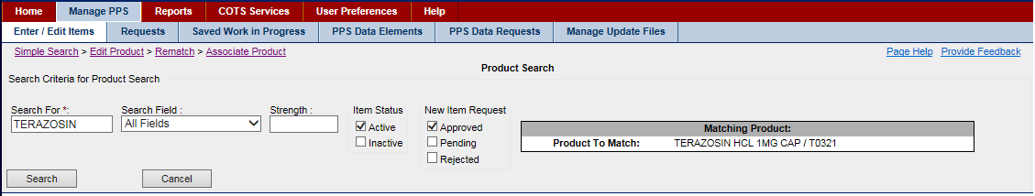

Figure 146: Associate Product Search Field

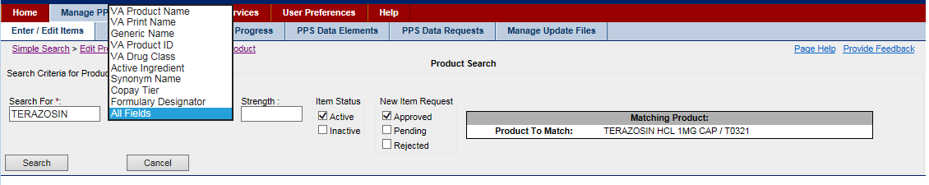

Figure 147: Associate Product Search Results

### Edit

Edit pages allow you to view, modify, approve, or reject existing or newly created items.

See the following pages for more information.

* Edit Product
* Edit Orderable Item
* Edit NDC

# Glossary

1

10F: VHA Office of Logistics

A

A&MM: Acquisition and Materiel Management

AAA: Authentication, Authorization, and Access

AAC: Austin Automation Center

AAIP: Authorization and Authentication Infrastructure Program

ABC Inventory Analysis: A method used to categorize inventory into groups based on certain characteristics in order to develop inventory planning policies, plan orders, set inventory control schedules, and manage inventory quantity levels and costs. The three categories may be based on certain activity characteristics. Items compose 10% of the products but are 70% of the cost. B items compose 20% of the items but are 20 % of the cost. C items compose 70% of products but are 10% of the cost. Other ABC characteristics could be developed based on such things as consumption rates or drug characteristics such as risk or effectiveness.

Accept Order: An authorized user indicating to the system after entering an order that the order is complete and ready for signature. The acceptance of the order changes the order status to Pending (refer to Pending definition) and triggers a notification to the provider for a co-signature or second signature (if needed).

Accessor: A Java method that examines the state of an object, does not change it, and typically returns a result. Accessors are often called getters and their names often start with get.

ACD: Automatic Call Distribution

ACID: Atomicity, Consistency, Isolation, and Durability

ACK (HL7): Acknowledgement

Acquisition and Materiel Management (A&MM): The service organization that reviews all requests for supplies and equipment, and maintains systems, procedures, controls, and reports for: stock control, equipment planning and acquisition, property accounting and control, procurement from VA sources and other agencies, excess and exchange/sale property disposal, and supply fund management programs. The service organization also initiates and coordinates all equipment and supply action involving new and replacement facility construction, and audits invoices and all receiving reports and resolves discrepancies with Fiscal Service.

ACR: American College of Radiology

Activator: A person given the authority to review and finish a pending electronic product order so that it can be filled in accordance with Provider instructions.

Actor: A person who will use the system. Actors are used in Use Cases to document and model the envisioned System/User interaction.

Actor Generalization: An approach used in Use Case development to show that actors are specializations of one another. For example, the PEPS Manager actor is a generalization of a PEPS Local Manager and a PEPS National Manager.

ADA: American Disability Act

Additive: A drug (e.g., an electrolyte, vitamin, nutrient, antibiotic) that is added to an IV solution for the purpose of parenteral administration (giving a drug intravenously).

ADDS: Automated Drug Dispensing System

ADE: Adverse Drug Event

Administration Discrepancy Limit: A VA Data Field in the PEPS system denoting the amount of a drug that can be missing before a criminal reporting process is started.

Administrative Schedule Domain: Contains the sets of standard times over which medications are to be administered.

Admission/Discharge: A module of the Patient Information Management System (PIMS) that provides a comprehensive range of software supporting the administrative functions of Patient registration, admission, discharge, and transfer.

Admixture: A type of intravenously administered medication comprised of any number of additives (including zero) in at least one solution. It is given at a specified flow rate.

ADPAC: Automated Data Processing Application Coordinator

ADR: Adverse Drug Reaction

ADR (Architecture): Administrative Data Repository

ADT: Admission/Discharge/Transfer

Adverse Drug: The unwanted or unintended effects of an adverse drug event that occur during the drug’s proper use.

Adverse Drug Event (ADE): The unwanted or unintended events caused by medical management rather than by the underlying disease or the condition of the Patient. May not always cause an injury.

Adverse Reaction Tracking (ART): The VHA software package that stores and reports the Patient allergy or adverse reaction data.

AHFS (Framework): American Hospital Formulary Service Framework

AICC: Aviation Industry CBT Committee

AID: Architecture and Interface Design Strategy Document

Alerts: A software object typically generated by an application in response to some particular event. Alerts are messages that require acknowledgement from their recipients.

Allocated Inventory: The quantity of physical inventory on-hand (i.e., in storage at that particular location) that is committed for use in filling activated Patient orders.

Alternative Flow: A term used when developing Use Cases. An Alternate Flow is one segment of a complete path through a Use Case.

Ambulatory Care Reporting Project: The process of collecting and storing encounter-based clinical, diagnostic, and administrative Outpatient data for daily transmission to the Austin Automation Center.

AMIS: Automated Management Information System

AMS: Addiction Management System

Ancillary Support: Auxiliary or secondary services provided to a patient in addition to his or her main healthcare services. For example, lab tests are typically considered ancillary support.

Another Neat: A Java-based software application building tool that provides full portability for pure Java code.

ANSI: American National Standards Institute

ANT: Another Neat Tool

API: Application Programming Interface

Application: A software product that provides a specified functionality.

Application Package Use: Indicates which VistA package uses the item (e.g., Inpatient, Outpatient).

Application Programming Interface (API): Enables applications to communicate with each other. An API is the set of programming language constructs or statements that can be coded in an application program to obtain the specific functions and services provided by an underlying operating system or service program.

Application Services: A single logical authoritative source of data. Its purpose is to encapsulate the business rules associated with its data and to abstract the data source(s) from the applications and/or services that interact with it (i.e., Billing, Clinical Reminders, Person Demographics, Terminology, and Appointment Management).

APRD: Audible Prescription Reading Devices

AR: Accounts Receivable

AR/WS: Inpatient Pharmacy Automatic Replenishment/Ward Stock

Architecture: The organizational structure of a system Hardware Configuration Item (HWCI), or Computer Software Configuration Item (CSCI), identifying its components, their interfaces, and a concept of execution among them.

Area of Use: Any location where inventory is maintained, including pharmacies, Controlled Substances (CS) vaults, wards, clinics, etc.

ART: Adverse Reaction Tracking

Artifact: A physical piece of information used or produced by a software development process. Examples of artifacts include documents, models, source files, scripts, and binary executable files. It is a work product or a deliverable.

ASC: Accredited Standards Committees

ASIS: Application Structure and Integration Services

ASP: Active Server Page

Assumption: An external factor that may be true in the future and that may have an impact on how an application is built.

ASTM: American Society for Testing and Materials

Asynchronous: Events that are not synchronized by a shared signal such as clock or semaphore, proceeding independently.

ATC Canister: The brand name for the automatic dispensing unit that is used to package specific medications into unit dose packages.

ATP: Acceptance Test Plan

Attribute: A name property of the class or its objects.

Audit Record (Inventory): A record stored in the system to allow tracking, accountability, reporting, and process metrics of specific actions. One example is the required accountability throughout the CS handling processes.

Authentication, Authorization, and Access (AAA) Security: The AAIP initiative has been replaced by KAAJEE.

Authoritative Source: A single, unambiguous, reliable, and official representation within a system.

Authorized User: A person given the appropriate system access and privileges to perform some task.

Automated Management Information System (AMIS): A generalized system established to provide and meet the reporting requirements for the VHA and to provide statistical data for management use at all levels.

Automatic Refill: A valid refill request forwarded directly to dispensing. These types of refills do not require any form of intervention prior to dispensing.

Average Wholesale Price (AWP): A list price, which few customers actually pay. There is no standard method for calculating the AWP.

AWP: Average Wholesale Price

AWT: Abstract Window Toolkit

B

Back Count: A process followed by Nursing that consists of counting a CS inventory location after medication is removed from it. An example would be a locked cabinet drawer in which morphine tablets are stored. Each time a tablet is removed, the nurse should do a “Back-Count” on the drawer by entering the remaining number of tablets into the system.

Baseline: A complete copy of a project that is captured to act as a “snapshot” of the project’s plans and status at a particular point in time. This frozen perspective is used to measure change from the original snapshot or picture of that original element.

Basic Flow: The main success scenario from trigger to completion.

BCMA: Bar Code Medication Administration

BEA: BEA Systems, Inc.

BID: Twice a Day

Black-box Testing: A testing technique that takes an external perspective of the system and does not explicitly use knowledge of the internal structure of the system. Testing without knowledge of the internal workings of the item being tested.

BO: Business Object

Borrow Order (Inventory): Allows the local pharmacy to obtain inventory without placing a Vendor purchase order. This order does not involve billing, but will support “horse trading” for specific items with the lending institution. See glossary term Lend Order (Inventory).

BPR: Business Process Re-engineering

BSAD: Baseline System Architecture Document

Business Analysis Model: An object model describing the realization of business Use Cases.

Business Delegate: Used to hide the underlying implementation details of the business service, such as lookup and access details of the Enterprise JavaBeans (EJB) architecture. The software intermediary used to decouple business components from the code that uses them.

Business Delegate Pattern: A façade used to encapsulate calls to your business model.

Business Engineering: A set of techniques a company uses to design its business according to specific goals.

Business Logic: The logic relating to processing, workflow, business rules, data, etc.

Business Logic Layer: The code that resides in this layer executes the work that needs to be done; it is responsible for carrying out the individual steps of a process. This layer is typically designed using business entities. The business entities implement the business rules. They do not store the business data; instead, they may hold references to data entities that store the data.

Business Model: A visual representation of business processes and entities. Comprises two models (physical or logical representation of a system or its subsystems): (1) a business Use Case model to describe the business actors and the business processes, and (2) a business object model to describe business entities used by the business Use Cases.

Business Object: An object that represents tangible entities within an application that a user can create, access, and manipulate while performing a Use Case. Business Objects are typically stateful, persistent, and long-lived. Business Objects contain business data and model the business behavior.

Business Process: A group of activities that takes input, transforms it, and provides an output to an internal/external customer (see glossary term Process). An example of a business process for a hospital would be “order fulfillment,” involving the input of several cross-functional activities resulting in a prescription in the hands of the Patient customer.

Business Process Model: A model that outlines the workflow of an organization. It uses text, diagrams, and/or graphical shapes to model the various steps of a process. Models can be detailed in nature (representing very specific tasks) or they can be high-level (representing interaction between major business units).

Business Process Re-engineering (BPR): The fundamental analysis and redesign of business processes and management systems, job definitions, organizational structures and beliefs, and behaviors to achieve dramatic performance improvements to meet contemporary requirements. Information Technology (IT) is a key enabler in this process.

Business Rules: The basic business vocabulary and criteria that control or guide business behavior; indicate what is required and not required in running the business. A statement expressing a policy or condition that governs business actions and establishes data integrity guidelines.

Business Service: The software object that a client asks to do asynchronous processing; a service in the business tier that can process a client’s software request.

C

C2: Represents a Schedule 2 Narcotic

Cache: A fast memory used to hold commonly used variables, which are automatically fetched by hardware from the slower and larger main computer memory.

Cache Rational Database: The post-relational database management system that has been identified by the VHA for data storage needs at the local level.

CAIP: Cross-Application Integration Protocol

Cancel: An undo action in a GUI (Cancel is not an action on an order).

Candidate Architecture: The proposed design of a system structure.

Capability: A software element addressing a specific, well-defined functional responsibility of the containing service.

Capacity Management: The process of planning, analyzing, sizing, and optimizing automated capabilities to satisfy demand in a timely manner and at a reasonable cost. This process should be proactive and responsive to business needs because the business cannot add resources after a capacity problem has happened without impacting performance.

Caregiver: A person who administers medication to the Patient. May pick up or receive medications for the Patient. May also communicate for the Patient in cases where the Patient is unable (e.g., Nurse, Resident, Physician, Spouse).

CBOC: Community Based Outpatient Clinic

CBPM: Current Business Process Model

CBT: Computer-Based Training

CCB: Change Control Board

CCM: Change and Configuration Management

CCOW: Clinical Context Management (formally Clinical Context Object Workgroup)

CDATA: Character Data

CDC: Centers for Disease Control and Prevention

CDER: Center for Drug Evaluation and Research

CDS: Clinical Data Services

CDW: Clinical Data Warehouse

CE: Clinical Evaluator

CEN: Committee European de Normalization

Centers for Disease Control and Prevention (CDC): The lead Federal Agency for protecting the health and safety of people at home and abroad, providing credible information to enhance health decisions, and promoting health through strong partnerships. Serves as the national focus for developing and applying disease prevention and control, environmental health, and health promotion and education activities designed to improve the health of the people of the United States.

CHAMPUS: Civilian Health and Medical Program of the Uniformed Services

Change Management: The formal process of recording, analyzing, estimating, tracking, and reporting of modifications to the project baseline artifacts, such as business functional requirements.

Change Request (CR): The mechanism by which a change to a project deliverable or artifact is requested.

Change Set: A list of related versions associated with a change management activity.

Character Data (CDATA): An XML section tag used to denote character data that will be ignored by the XML parser. The tag begins with the string “<![CDATA[” and ends with “]]>”.

CHCS: Composite Health Care System

CHDR: Clinical Data Repository/Health Data Repository

Check: A visual inspection by a pharmacist to ensure that the medication dispensed matches the labeled container

Chemotherapy: The treatment of a disease using chemical agents that are intended to eliminate the causative organisms without harming the Patient.

Child Orders: One or more Inpatient medication orders that are linked together using the conjunctions AND, OR, THEN, or EXCEPT to create combinations of dosages, medication routes, administration schedules, and order durations.

CHIPS: Consolidated Health Information Program System

CHISS: Common Health Information Security Services

CI: Configuration Items

CID: Criteria Identification

CIF: Continuous Improvement Framework

CIO: Chief Information Officer

CIP: Capital Investment Proposal

Client: The person or organizational entity that pays for the development of a product.

Client Application: A piece of software that accesses remote services offered by another piece of software, usually over a network connection. In the user interface context, a client is a software application with which a user interacts to perform some function.

Client/Server: The model of interaction in distributed data processing in which a program at one location sends a request to a program at another location and awaits a response. The requesting program is called a client, and the answering program is called a server.

Clinical Context Management: Formerly Clinical Context Object Workgroup (CCOW). A vendor independent standard developed by the Health Level Seven (HL7) organization to allow clinical applications to share information at the point of care. Using a technique called “context management,” allows information in separate healthcare applications to be unified so that each individual application is referring to the same Patient, encounter, or user. Works for both client-server and Web-based applications.

Clinical Data Repository/Health data Repository (CHDR): A system extending the capabilities of interacting with Department of Defense (DoD) data sources. It will increase the accessibility of Veteran health information. It is currently planned to be used where VHA and DoD share facilities for healthcare. The current plan is to merge the two capabilities into a set of services.

Clinical Data Service: The HealtheVet service responsible for providing read and write access to the Health Data Repository (HDR).

Clinical Decision Support: The informational or actionable tool that provides support during order processing. For example, a dosing calculator provides the logic to determine the appropriate dose for a medication. Also, a drug guideline is an informational resource for data relating to a medication.

Clinical Evaluator: A person who evaluates the clinical status of a Patient (e.g., Licensed Physician or Licensed Pharmacist).

Clinical Guidelines or Drug Treatment Guidelines: The systematically developed statements to assist Practitioner and Patient decisions about appropriate healthcare for specific clinical circumstances.

CLO: Chief Logistics Officer

CM: Configuration Management

CMON: Clinical Monitoring

CMOP: Consolidated Mail Outpatient Pharmacy

CMOP Transmission: The act of transmitting a prescription to a CMOP for dispensing.

CMP: Configuration Management Plan

CMT: Container Managed Transaction

Co-Signer: A person who reviews and signs prescriptions or medical documents based on designated authority. A second signature is usually required when a document is initiated by a Provider that is undergoing training or in cases where the margin of error of the medication being prescribed is so small that a second signature is advised to ensure the safety of the Patient.

COAS: Content Access Service (formally Clinical Observation Access Service)

Commercial off-the-Shelf (COTS) Software: The commercially available applications sold by vendors through public catalogue listings. COTS software is not intended to be customized or enhanced.

Complete Order: An order that has been recorded, activated, filled, checked, and is ready for delivery to the Patient.

Complex Order: An order that consists of one or more linked medication orders, known as “child” orders.

Component: A physical, replaceable part of a system that packages implementation and conforms to and provides the realization of a set of interfaces. A component represents a physical piece of implementation of a system, including software code (source, binary, or executable) or equivalents such as scripts or command files.

Component (Architecture): A software term for an independent unit of deployment composed of one or more modules within a package.

Component-based Development: The creation and deployment of software-intensive systems assembled from components as well as the development and harvesting of such components.

Compound Medication/Compound Order: A medication produced or manufactured by combining two or more ingredients.

Computerized Patient Record System (CPRS): Stored information in VistA, or other automated systems using electronic storage. CPRS supports entry of notes and orders, rules-based order checking, and results reporting (Medical Records Management Handbook). CPRS provides an integrated Patient record system for clinicians, managers, quality assurance staff, researchers, and others. It may be referred to as Electronic Medical Record (EMR) in the private sector.

Consolidated Mail Outpatient Pharmacy (CMOP): The VA mail-order pharmacy system.

Constant Dosage: A constant administration dose of a drug for a specific duration of therapy. For example, the dosage of a drug might be “4mg” two times a day for 7 days.

Constant Schedule: The schedule of a drug remains constant for a specific duration of therapy. For example, a drug may have been scheduled for two times a day for 7 days.

Constraint: A global requirement that restricts how a product or application may be produced.

Consult Tracking: A VistA product that is used to request and track consultations or procedures from one clinician to another clinician or service.

Context: The subject matter, people, or organizations that might have an impact on the requirements of a product or application.

Context Diagram: A visual representation of the application and the external applications, systems, or organizations with which it must interact.

Contingency Plan: A management plan that identifies alternative strategies to be used to ensure product success if specified risk events occur.

Continuous: A medication order that is given continuously to a Patient for the life of the medication order, as defined by the Start/Stop Date/Time. This is also a schedule type.

Control Factors: These refer to the definition and use of different numbers for each inventory location to manage the quantity of inventory in that location. They include factors such as average rate of use by the functional area, delivery lead time, Par Level, the maximum quantity; Reorder Point, the quantity level at which a reorder signal is sent; and Safety Stock, a safety level quantity.

Controlled Substance (CS): All drugs listed in the Code of Federal Regulations (CFR) 21, Part 1300, to include the following:

Controlled Substance Tote: A sealed package (e.g., brown bag, box, or envelope) containing one or more CS.

COOP: Continuity of Operations

Copay Tier: A Copay Tier is a fixed copayment amounts depending on the class of the medication

CORBA: Common Object Request Broker Architecture

Core-FLS: Core-Financial and Logistics System

COTR: Contracting Officer’s Technical Representative

COTS: Commercial Off-The-Shelf (software)

Counseling (Patient Education): A discussion aimed at educating a Patient about a drug therapy regimen. The Omnibus Budget Reconciliation Act of 1990 (OBRA ’90) requires that all Patients be offered counseling for new medications. In particular, a Pharmacist must offer to discuss drug therapy regimens to each Patient when filling prescriptions for them. During counseling, the Pharmacist discusses any information about the drug therapy, which in the professional judgment of the Pharmacist is necessary for the proper use of the medication. The outcome of the counseling session is documented in the Patient’s electronic prescription order, indicating if a Patient accepted counseling and if the counseling was understood. Any extensive counseling and its documentation is recorded in a Text Integrated Utility (TIU) Progress Note.

CPMP: Clozapine Patient Management Protocol

CPOE: Computerized Physician Order Entry

CPRS: Computerized Patient Record System

CPRS-R: Computerized Patient Record System-Re-engineering Computerized Patient Record System-Rehosting

CPU: Central Processing Unit

CR: Change Request

Credentialing: The recognition of professional or technical competence through registration, certification, licensure, etc.

Critical Path: The series of activities that determines the duration of the project. In a deterministic model, the critical path is usually defined as those activities with float-less-than or equal to a specific value, often zero. It is the longest path through the project.

Cross-Application Integration Protocol (CAIP): A consistent set of interfaces for the common services in use within the Enterprise is required in order to promote interoperability within and across the VHA. The goal is to formalize these interfaces, providing style guidance to projects that will be building and using VHA’s service architecture. The principal objective is to provide clear guidance to project teams detailing the approach that is to be taken when building interfaces that require communication/collaboration with service components within the VHA.

CRUD: Create-Read-Update-Delete

CS: Controlled Substances

CS Counter: A person who performs a back-count on a Controlled Substances (CS) inventory location after removing stock.

CS Destroyer: A person who records the destruction of a CS at a central destruction site or the transfer of a CS to a third-party destruction agency.

CS Discoverer: A person who discovers a discrepancy between a system balance and a physical amount of CS, whether for an inventory location or for an invoice.

CS Disposer: A person who disposes of a CS at a location other than a central destruction site (e.g., a nurse who cleans up a broken vial).

CS Inspector: A person who audits CS inventory to ensure that the inventory balances are accurate and that all CS are accounted for.

CS Manager: A person who handles processes involving escalated problems with CS (e.g., the criminal reporting process for missing CS).

CS Packager: A person who packages CS for transport within the facility (e.g., vault technician, licensed pharmacist).

CS Receiver: A person who receives CS after they have been transported within the facility (e.g., vault technician, nurse, or licensed pharmacist).

CS Shipper: A person who ships packages containing CS.

CS Shipping Order Approver: A person who approves, edits, and cancels CS Shipping Orders.

CS Shipping Order Census: A person who creates Shipping Orders for CS when the CS needs to be shipped back to the vendor or to locations with other Drug Enforcement Administration (DEA) numbers.

CS Signer: A person who signs for an action involving CS that requires a signature.

CS Waster: A person who records the wasting of CS.

CSC: Computer Software Component

CSCI: Computer Software Configuration Items

CSRI: Core Specification for Re-hosting Initiatives

CSV: Comma Separated Value

CTS: Centralized Terminology Service

Current Business Process Model (CBPM): Captures and documents the business processes “as is.” Also known as the Current Business Model (CBM).

Current Stock: The amount of medications, supplies, etc., on-hand and available for dispensing.

Custodian: Anyone who has custody of CS in the system.

Customer: The requestor, end-user, individual, or organization that specifies (or may assist with specification) and typically accepts the project deliverables. There may be multiple customers on a given project.

CWAD: Crisis, Warnings, Allergies, Directives

D

Days Supply Limit: A VA Data Field used to specify the default days’ supply (e.g., 90 days) that a medication can be dispensed.

DEA: Drug Enforcement Agency

DIF: Drug Information Framework

Dispense Quantity Limit: A VA Data Field that specifies the limit as a Quantity-per-Time period. Quantity is the number of dispense units. Time period is specified by a number of days

Dispense Unit: A unit of measure for dispensing (e.g., GM, EA).

Domain: Refers to data elements used by PEPS items; for example: Manufacturer, Standard Med Route. Usually domain in this context refers to a domain entry, not necessarily the entire domain.

Dosage Form: The medium used to administer the active ingredient(s) in health products. Dosage forms include, but are not limited to capsules, tablets, injectables, oral solutions, drops, creams, ointments, and patches.

Dose: A specified quantity of a therapeutic agent, such as a drug, prescribed to be taken at one time or at stated intervals.

DPP: Detailed Project Plan

Draft Order: A dispense order entered into the system by a user, but not completed or not submitted to pharmacy for dispensing.

Drug Class: The grouping of drug products based on various criteria, which may include similarity of chemical structure, clinical indications, pharmacology, and therapeutic activity.

Drug Class Domain: Contains the list of VA Drug Classifications that can be used for Product Items.

Drug Data Vendor: The company that supplies medical information products (e.g., MicroMedex or First Databank).

Drug Enforcement Administration (DEA) Number: A numbering system that was implemented as a way to successfully track CS from the time they are manufactured until the time they are dispensed to the Patient or destroyed according to DEA regulations.

Drug Indication Dosing: Allows for different dosages for different disease states as well as for different Patient conditions. For example, the dose for Megestrol used for anorexia is 800mg daily, whereas the dose for Megestrol used for breast cancer is 40mg four times daily. Additionally, doses for Patients with impaired renal or hepatic clearances may have to be adjusted.

Drug Unit Domain: Provides the list of available units of measure that can be used for a medication.

Drug/Disease Interaction: An event that occurs when a drug’s action or effect are altered by a disease or clinical condition. May result in worsening of the disease by the drug.

Drug/Drug Interaction: The pharmacological or clinical response to the administration of a drug combination different from that anticipated from the known effects of the two agents when given alone.

DSD: Delivery Service Delegate

DSS: Decision Support System

DTAC: Development Technology Advisory Committee

Duration: The amount of time that the Patient should use the specified dose. This can be calculated from the time between the Start Date/Time and Stop Date/Time for an Inpatient medication order.

DUZ: A value that identifies a specific end-user signed into the VistA system. The DUZ is being replaced by the VPID but is still in use.

DVA: Department of Veterans Affairs

E

E/R: Entity/Relationship

E3R: Electronic, Error, and Enhancement Report

EBAC: Entity-Based Access Control

ebXML: Electronic Business eXtensible Markup Language

ECMB: Executive Change Management Board

ECME: Electronic Claims Management Engine

ECR: Engineering Change Request

ECSS: Electronic Claims Submission System

EDI: Electronic Data Interchange

EDS: Electronic Data Systems

EE: External Environment

eInvoice: An invoice received electronically into the pharmacy system from the prime vendor for medications.

EJB: Enterprise Java Bean

Electrolyte: An additive that disassociates into ions (charged particles) when placed in solution.

Electronic Error and Enhancement Request (E3R): A software application located on Forum. It is used VHA-wide to submit suggestions for changes to Office of Information Field Office (OIFO) software products.

Electronic Pharmacy Claims/Billing: Electronic billing for outpatient prescriptions at point of care service.

Electronic Signature: A computer data compilation of any symbol or series of symbols executed, adopted, and/or authorized by an individual to be the legally binding equivalent of the individual’s handwritten signature. See glossary term Digital Signature for expansion of this concept within the VA.

Element: An object that encompasses a set of versions, organized into a version tree. They can be either files or directories.

Email Group: A group of individuals who receive email and alerts about a topic pertaining to the group.

Emergency Cache: A bulk supply of drugs stored in central pharmacy specifically for use in large scale emergencies or catastrophic events. The supply is not available for use in filling Patient orders unless released to the pharmacy prior to replacement or expiration.

Encapsulation: The hiding of a software object’s internal representation. The object provides an interface that queries and manipulates the data without exposing its underlying structure.

Encounter: A professional contact between a Patient and a Practitioner. A Patient may have multiple encounters for one appointment or during a single visit to a Department of Veterans Affairs Medical Center (VAMC) facility.

Enhanced Requests: A type of stakeholder request that specifies a new feature or functionality of the system.

Enterprise Architecture: The architecture that incorporates an entire business or major portion thereof.

Enterprise Product List (EPL): A compendium of medications, supplies, and prosthetics available for ordering.

Enterprise Reference Terminology (ERT): A standardized set of medical vocabulary used within VHA systems, provides for the sets that accommodate local variations in terminology, and supports automated translation among terminology sets.

Enterprise Terminology Service (ETS): The inclusive name for both the ERT and VETS projects. ETS determines terminology for clinical content (i.e., Pharmacy, Labs, Orders, and Vitals). ETS has been renamed to Standardized Terminology Service (STS).

Entity Bean: A reusable software component used to implement business logic; multiple clients can access it simultaneously; it represents persistent items that could be stored in a database.

Entity By: The name of the user who entered the order into the computer.

ePharmacy: VA electronic pharmacy claims. Used to transmit claims between the VHA and insurance providers.

EPL: Enterprise Product List

EPL-L: EPL Local

EPL-M: EPL Master

EPL-N: EPL National

ER: Emergency Room

ER (Architecture): Entity-Relationship

ERT: Enterprise Reference Terminology

ES: Enterprise Strategy

Essential Use Case: A Use Case containing a basic course of action. It is referred to as the “typical-path;” the main start-to-finish path that the actor and the system will follow under normal circumstances. Any activity that deviates from the “typical-path” is referred to as an alternate course of action. See the glossary term Use Case.

ETC: Enhanced Therapeutic Classification

Event: An occurrence that may be synchronous or asynchronous and to which an application must respond in some manner.

Expiration Date (Drug): The date a drug is no longer allowed to be used to fill a Patient order based on a time period established by the manufacturer after which the drug effectiveness is likely to have deteriorated. Maintaining control of this constraint is a high priority Patient safety issue for VHA.

Extend Relationship: A relationship that continues the functionality of a “parent” Use Case but is subject to a specific condition. It is used to indicate a relationship between a “parent” Use Case and a Use Case containing an alternate course of action. It is conditional and may or may not be used by the “parent” Use Case.

eXtensible Markup Language (XML): A simple, very flexible text format derived from Standard Generalized Markup Language (SGML).

Extension Point(s) (XPn): A simple, very flexible text format derived from Standard Generalized Markup Language (SGML).

External Data Fields: A named marker that references a location or set of locations within the behavioral sequence for a Use Case, at which point additional behavior can be added.

F

FDA: Food and Drug Administration

FDA Schedule: A classification of medications with regards to the Controlled Substances Act of 1970 which dictates special procedures or handling for prescriptions and administration of medication.

FDB: First Databank

FDR: Financial Data Repository

Federal:

Federal Health Information Exchange (FHIE): Formerly known as the Government Computer-Based Patient Record (GCPR). Addresses a Presidential Directive to create a comprehensive, life-long medical record for America’s military service members. Its current implementation allows the retrieval of Veteran health information from the DoD data source.

Federal Stock Number (FSN): (DOD) The Federal Stock Number of an item of supply consists of the applicable 4-digit class code number from the Federal Supply Classification plus a sequentially assigned 7-digit Federal Item Identification Number. The number shall be arranged as follows: 4210-196-5439. Note that Federal Stock Numbers were replaced by National Stock Numbers effective 30 September, 1974.

FHIE: Federal Health Information Exchange (formerly GCPR)

FileMan (FM): A software application that creates and maintains a database management system that includes features such as a report writer, data dictionary manager, scroll and screen-oriented data entry, text editors, programming utilities, tools for sending data to other systems, and file archiving.

Fill: The process whereby a pharmacy will prepare a medication order for dispensing to the Patient.

Fill Station: The area in which orders are filled or dispensed manually (i.e., by a Pharmacist or a Pharmacy Technician) or automatically (i.e., by automation equipment).

Final Check: A final look at the dispensed prescription before delivery to the Patient to ensure that the prescription has been dispensed accurately as prescribed.

FIPER: Federal Intelligent Product Environment

First Fill: See glossary term Original Fill.

Fiscal Year (FY): The period from October First of one year to September Thirtieth of the next year.

FM: FileMan

FMS: Financial Management System

Form 222: A special order form used to distribute CS (Schedule I and II drugs). The keeping of records is required for distribution of a CS from one manufacturer to another, from manufacturer to distributor, and from distributor to dispenser.

Formulary: A collection of pharmaceutical substances along with their formulas, uses, and methods of preparation. Additionally, this can be a list of products that are approved for use with Patients (for the appropriate indications).

Formulary Decision Makers: A group of individuals who decide on adding, deleting, or changing a product to/from/on the National Enterprise Product List (EPL) or National Formulary. See glossary term Enterprise Product List (EPL).

Forum: A National On-line network. In addition to network mail, Forum hosts several National databases that include: Physician Data Query (PDQ) Cancer Information Database; Performance Excellence Database for sharing quality assurance success stories; VA/DoD Health Care Sharing Agreements; National On-Line Information System for tracking problems (NOIS) reported to OI Field Office specialists; Interlibrary Loan System; Facility ADP Plans; Decentralized Hospital Computer Program (DHCP) Site Implementation System; and E3R System designed for entering requests for software enhancements.

Fractional Dose: A situation in which the dose administered to the Patient is less than the amount that was dispensed.

Framework: A set of assumptions, concepts, values, and practices that constitute a way of describing a real situation.

FSS: Federal Supply Schedule

FTEE: Full-time Employee Equivalent

Function: An activity that spans the entire duration of a project (e.g., status reporting, quality assurance, verification, and validation).

Functional Testing: Testing that ignores the internal mechanism of a system or component and focuses solely on the outputs generated in response to selected inputs and execution conditions.

FY: Fiscal Year

G

GAL: Glossary and Acronym List

GCN: Generic Code Number

GCN Sequence Number: A number that represents a generic formulation, specific non generic ingredient(s), drug strength, dose form, and route of administration.

GCPR: Government Computer-based Patient Record (now FHIE)

GDD: GUI Design Document

Generic Drug: A nonproprietary drug approved by the FDA that is tested against a standard of bioavailability and bioequivalence.

Generic Name: A non-proprietary name assigned to an item (e.g., drug, supply).

Generic Substitution: Contains the same active, chemically identical ingredient(s) and is identical in strength, concentration, dosage form, and route of administration to the drug product prescribed.

GIP: Generic Inventory Package

Goal: A statement of the desired outcome of a product that shows it to be reasonable, measurable, and feasible.

GOTS: Government Off-the-Shelf (software)

Graphical User Interface (GUI): A type of interface that enables users to communicate with a program by manipulating graphical features, rather than by entering commands. Typically, a GUI includes a combination of graphics, pointing devices, menu bars and other menus, overlapping windows, and icons.

Green Sheet (GS): A special form used to account for the use of CS in the absence of automated equipment that can perform the accounting function. Currently, VA FORM 10 ‑2638 is being used.

Grey-box Testing: Test designed based on the knowledge of algorithm, internal states, architectures, or other high-level descriptions of the program behavior.

GS: Green Sheet

GUI: Graphical User Interface

GWD: GUI Workshop I Document

H

HA: High Availability

Happy Path: The main start-to-finish path that the actor and the system will follow under normal circumstances.

HDD: High Level Design Document

HDR: Health Data Repository

HDR-Hx: Health Data Repository – Historical

HDR-IMS: Health Data Repository – Interim Messaging Solution

HDR-L: Health Data Repository – Local

HDR-N: Health Data Repository – National

HDS: Health Data Systems

Health Data Repository (HDR): A true longitudinal healthcare record including data from VA and non-VA sources. The health data system supports research and population analyses; facilitates Patient access to data; sharing of information across VHA; and improves data quality and data security.

Health Data Repository II (HDR II): The clinical data repository for HealtheVet-VistA. HDR II will store all nationalized, viewable, patient-centric clinical data for the VHA in support of longitudinal, patient-centric care.

Health Data Repository-Historical (HDR-Hx): The HDR Hx collects legacy VistA data from 128 VistA systems in at least four clinical domains. HDR Hx stores the data in a text “read only” format to accessible by the local VistA systems.

Health Data Repository-Interim Messaging Solution (HDR-IMS): The pre-HDR II interim solution for nationalizing viewable, patient-centric clinical data. The HDR IMS will collect data from 128 VistA systems in at least four clinical domains from the point at which the data is standardized in the VistA system going forward. HDR IMS will ultimately be replaced by HDR II. Prior to the deployment of HDR II, HDR IMS will be a data provider to CDS.

Health Level Seven (HL7) Messaging: A standardized messaging protocol that is common to medical applications.

HealtheVet-VistA: The next generation of VistA provides enhanced flexibility for future healthcare and compliance with the One VA Enterprise Architecture. It enables seamless data sharing between all parts of VA to benefit Veterans and their families.

HIA: Health Information Architecture

Hibernate: A powerful, ultra-high performance object/relational persistence and query service for Java. It allows for the development of persistent classes following common Java idiom–including association, inheritance, polymorphism, composition, and the Java collections framework. The Query Language, designed as a “minimal” object-oriented extension to SQL, provides a bridge between the object and relational worlds. Also allows for the expression of queries using native SQL or Java-based Criteria and Example queries.

High Risk: A VA Data Field used to indicate whether an item is considered “high-risk” to a patient and therefore requires follow-up or double-checks during administration.

HINQ: Hospital Inquiry

HIPAA: Health Insurance Portability & Accountability Act of 1996

HIS: Indian Health Service

Historical Medication Profile (Long): A list of all active, recently discontinued, and expired prescriptions for a Patient.

HL7: Health Level Seven

Hold Order: An instruction not to dispense an “Active Order” until a specified date/time. The Hold is removed once the date/time is met. For doses, a user specifies how many doses to “Hold” and the system automatically calculates the date/time associated with the doses. A Patient’s “Active Orders” can also be automatically placed on “Hold” when there is a Patient movement event (i.e., admission, discharge, transfer, pass). In this case, the “Hold” is manually removed by an authorized user.

HP: Hewlett-Packard Development Company, L.P.

HTML: Hypertext Markup Language

HW: HealtheVet-VistA

Hyperal: A protein-carbohydrate solution. Electrolytes, fats, trace elements, and vitamins can be added. Since this solution generally provides all necessary nutrients, it is commonly referred to as Total Parenteral Nutrition (TPN). This solution provides all necessary nutrients parenterally.

Hyperalimentation: A process of long-term feeding of a hyperal.

Hypertext Markup Language (HTML): The basic language that is used to build hypertext documents on the World Wide Web. It is used in basic, plain ASCII-text documents, but when those documents are interpreted (or rendered) by a Web browser, the document can display formatted text, color, a variety of fonts, graphic images, special effects, hypertext jumps to other Internet locations, and information forms.

I

ID: Identification

IEN: Internal Entry Number

IFCAP: Integrated Funds Distribution, Control Point Activity, Accounting, and Procurement

Item: A generic type representing one conceptual entity consisting of a collection of data fields. For example, a medication may contain the following collection of data fields: Product Name, Generic Name, Trade Name, Dosage Form, NDC, etc. Conceptual entities include Medications, Supplies, and Investigationals.

Iteration: The smallest segment of activity in an Iterative Development Process (IDP). Iterations reside within a phase and have a distinct plan, objective, and evaluation criteria. A distinct sequence of activities with a base-lined plan and valuation criteria resulting in a release (internal or external). An iteration usually lasts two or three weeks and starts with a planning meeting.

Iterative Development Lifecycle (IDL): A process that confronts issues early on, driven by architecture, technology, risk, and customer priorities. It assumes requirements are not fully known at project start and supports showing early prototypes to customers. It uses component-based development, forcing early elaboration of infrastructure; common mechanisms control structures and Configuration Management principles to manage sharing.

Iterative Development Process (IDP): A partitioning of the development of the system modules into iterations. In successive iterations, grows the system by developing more and more modules, while making necessary changes along the way as more is learned about the system.

IV: Intravenous

IV&V: Independent Verification and Validation

IVR: Interactive Voice Response

J

J2CA: J2EE Connector Architecture

J2EE: Java 2 Enterprise Edition

J2SE: Java 2 Standard Edition

JAAS: Java Authentication and Authorization Service

JAR: Java Archive

Java: A programming language developed by Sun Microsystems that is specifically designed for writing programs that can be safely downloaded to your computer through the Internet and immediately run without fear of viruses or other harm to your computer or files. Java is a simple, robust, object-oriented, platform-independent multi-threaded, dynamic general-purpose programming environment. It is best for creating applets and applications for the Internet, Intranets, and any other complex, distributed networks.

Java API for XML-Based Remote Procedure Call (JAX-RPC): It is used to build Web applications and Web services, incorporating XML-based RPC functionality according to the SOAP 1.1 specification.

Java Architecture for XML Binding (JAXB): A method that provides a convenient way to bind an XML schema to a representation in Java code. This makes it easy to incorporate XML data and processing functions in applications based on Java technology without having to possess extensive XML knowledge.

JavaBeans: A platform-independent software component technology for building reusable Java components called “beans.” Once built, these beans can be made available for use by other software engineers or can be used in Java applications. Using JavaBeans, software engineers can manipulate and assemble beans in a graphical drag-and-drop development environment.

Javascript: A scripting language for Web pages, JavaScript can be written and embedded into HTML documents. JavaScript was designed to resemble Java, which in turn looks a lot like C and C++. The difference is that Java was built as a general purpose object language, while JavaScript is intended to provide a quicker and simpler language for enhancing Web pages and servers.

JAX-RPC: Java API for XML-Based RPC

JAXB: Java Architecture for XML Binding

JAXP: Java API for XML Processing

JCA: J2EE Connector Architecture

JCAHO: Joint Commission on Accreditation of Healthcare Organizations

JDBC: Java Database Connectivity

JDOM: Java Document Object Module (Java-based document object module for XML)

JIT: Just-In-Time

JMS: Java Messaging Service

JNDI: Java Naming and Directory Interface

JProbe Profiler: The leading Java profiling tool that helps developers to quickly diagnose performance bottlenecks in Java code. With highly accurate diagnostics, including line-by-line results, developers can dramatically improve application performance.

JTA: Java Transaction API

JUnit: A unit testing tool for the Java programming language. This tool provides methods of testing the correctness of a particular module of source code independently.

Just-In-Time (JIT): A term that describes an inventory management objective of the right inventory in the right quantity arriving just at the time of need. JIT is actually a process for optimizing the pharmacy processes for inventory use by eliminating all process waste including wasted steps, wasted movement, wasted material, excess inventory, etc. In theory, some stock rooms in pharmacy could be eliminated or reduced in size if a vendor could deliver directly to the area of use JIT. A real world example is the bread shelves in your grocery store. These are stocked by the bread vendor JIT, and using visual orders. The grocery store does not have a bread stock room in the back.

JVM: Java Virtual Machine

K

KAAJEE: Kernel Authentication and Authorization for J2EE

Kernel: A vendor-independent application development environment, as well as a run-time environment, providing standard vendor independent services to applications software. It is not an operating system, but a set of utilities and associated files that are executed in an M environment. It is central to VA Decentralized Hospital Computer Program (DHCP) software strategy, in that it permits any DHCP software application to run without modification on any hardware/software platform that supports American National Standards Institute (ANSI) Standard M. All operating system-specific, M implementation-specific, or hardware-specific code is isolated to this environment.

Kernel Authentication and Authorization for J2EE (KAAJEE): A part of the VA Single Sign-On/User Context (SSO/UC) project, which addresses the authentication and authorization needs of J2EE-based Web applications, currently hosted on Oracle 9iAS. The limited aim of the first phase is to provide “single credential” authentication and “single repository” authorization for J2EE Web applications, using the user’s existing, familiar Kernel access and verify code for authentication, and using the Kernel system as the authorization repository as well.

KIDS: Kernel Installation and Distribution System

Kiosk: A terminal that allows users (e.g., Patients) to order refills and obtain information about their medical histories (i.e., medication, medication profiles). May also be a machine with dispensing capabilities that interfaces with the VistA Pharmacy system.

L

Lab Display: A VA Data Field used to specify what Labs need to be displayed for a drug within VistA.

Large Volume Parental (LVP): A solution intended for continuous parenteral infusion, administered as a vehicle for additive(s) or for the pharmacological effect of the solution itself. It is comprised of any number of additives, including zero, in one solution. It runs continuously, with another bag administered when one bottle or bag is empty. This is an admixture.

Layer: A logical grouping of the components within the system that are separated by common functionality.

LE: Local Environment

Legacy System: An existing system that is deployed in an organization with plans to be replaced by a newer system and newer technology.

Lend Order (Inventory): This functionality allows the local pharmacy to supply (lend) inventory to a borrowing institution. This order does not involve billing but will support “horse trading” for specific items with the borrowing institution. See glossary term Borrow Orders (Inventory).

Licensed Pharmacist: An individual who has graduated from an accredited school of pharmacy, passed a state board examination, and served an internship under a licensed pharmacist in a community or hospital pharmacy.

Licensed Practitioner: An individual who is licensed or otherwise authorized to provide healthcare services.

Loading Dose: A dose of drug sufficient to produce a plasma concentration of drug that would fall within the therapeutic window after only one or very few doses over a very short interval. It is larger than the dose rate needed to maintain the concentration within the window and would produce toxic concentrations if given in repeated doses.

Local Order Processing Decision Rule (LOPDR): The rules specific to the local order processing that assist with the selection of products based on Patient data.

Local Reporting Fields: The fields configured and appended to an item in the Local EPL for use only by the Local EPL Management System. Local Reporting Fields are designed to capture data specific to local activities, but they will not be usable for program functionality. The fields will only be useful for reporting and searching.

Location Group: A group of hospital locations that can include: wards, rooms, and clinics. A location group is created and stored so that it can be used when running a Unit Dose Pick List or a Sterile Product Work List to define the area of the hospital that is serviced.

Log 4J: An open source logging tool that allows developers to write log statements in their software and configure them externally, using properties files.

LOPDR: Local Order Processing Decision Rule

Lot Number: The tracking number assigned by the manufacturer to manufacturing batches in order to track a product recall in the event of a problem with the drug in terms of Patient safety. Maintaining control of this constraint is a high-priority Patient safety issue for the VHA.

LRU: Least Recently Used

LVN: Licensed Vocational Nurse

LVP: Large Volume Parenteral

M

M: MUMPS – Massachusetts General Hospital Utility Multi-Programming System

M&IS: Messaging and Interface Services

Mail Order Pharmacy: The remotely located pharmacies that are high-volume processors for medications that are to be mailed to Patients.

Maintenance Dose: The dose needed to maintain the concentration within the therapeutic window when given repeatedly at a constant interval.

Manufacturer: Specifies the vendor or company that produces the product.

Manufacturer Domain: Holds the list of manufacturers specific to NDC Items.

MAP: Medical Advisory Panel

MAR: Medical Administration Record

MARS: MUMPS Automated Reporting System

MAS: Medical Administration Service (now Health Administration Service)

Master Vault: A location designated to store controlled substances and which is set up as the main dispensing site for controlled substances.

MD: Doctor of Medicine

Medical Advisory Panel (MAP): A committee that is part of the management and medical decision-making structure of the VA Pharmacy Business Management. The committee consists of eleven Physicians in practice at VA medical centers and one DoD Physician.

Medication Checker: An authorized person who performs the validation check on filled medication prior to dispensing (e.g., Licensed Pharmacist or Pharmacy Technician).

Medication Deliverer: An authorized person or device that delivers medication(s) to a Patient or Caregiver at point-of-care (e.g., a pneumatic tool, mail carrier, Pharmacy Technician, Nurse).

Medication Filler: An authorized person that dispenses medications, mixes IVs, etc. Note that the filler may be a Pharmacist, Pharmacy Technician, or an automated filling device.

Medication Instruction Domain: Holds the abbreviations that are often used when entering the prescription sig. Each entry in this domain holds an expansion of the abbreviation which is used to complete the sig as it is printed on the prescription label.

Medication Receiver: A person who receives medication(s) from a Patient upon admission (e.g., Nurse).

Medication Returner: A person who returns a Patient’s medications to the Patient when the Patient is discharged from the hospital.

Medication Route: The method in which the product is to be administered (e.g., oral, injection).

Medication Use Evaluation (MUE): An order entry process that is similar to a templated order entry that incorporates a series of screens whereby the Orderer proceeds to answer some system-generated questions. The uniqueness of this process is that the system provides a series of pop-up boxes relating to the importance of the questions and why it is important for the Providers to answer the questions. Of even greater importance, the system will actually provide references and a synopsis of referred article(s). In this manner, the Provider is treated as an interested professional with a high level of interest for providing the best care for his or her Patient.

Message: A collection of data in a standardized format that can be sent to or received at a given destination.

Message Beans: A reusable software component that is designed to handle incoming messages based on Java Message Service technology.

Milestone: A significant event that occurs at a single specific point in time, usually denoting initiation or completion. Milestones are also used to communicate decisions made or received.

Missed Dose: A dose scheduled to be administered to a patient, but not administered to the patient at the scheduled time.

Missed Medication: A scheduled medication that is not administered to the Patient, usually because the Patient is unavailable or the Patient refuses the medication.

Missing Dose: A scheduled medication (e.g., unit dose) that is unavailable at the time of the scheduled administration.

Mitigation: A method or procedures which may: (1) avoid an impact altogether by not taking a certain action or parts of an action; (2) minimize impacts by limiting the degree or magnitude of the action and its implementation.

Model-View-Controller: A software architecture that separates an application’s data model (the model), user interface (the view), and control logic (the controller) into three distinct components so that modifications to one component can be made with minimal impact to the others.

Modification Request: A request generated from PEPS when a PEPS Local Manager makes a request to change a non-editable data field on a PEPS item. The PEPS National Manager reviews the Modification Request and either approves or rejects the request.

Module: A software term for a specialized unit within a component that carries out a specific function that may depend upon other modules within the same component.

MOM: Message Oriented Middleware

MOP: Mail Order Pharmacy

MPD: Minimal Patient Dataset

MPI: Master Patient Index (or Master Person Index)

MS: Microsoft

MSH: Message Header

MTF: Medical Treatment Facilities

MUE: Medication Use Evaluation

Multicast: A message that is sent out by a host to several devices on the network. They are generally sent at specified intervals to avoid cluttering the network and, in the case of Local Area Transports (LAT), contain the name of the host sending them as well as information about which LAT services that host provides.

Multidimensional Data Model: A visual representation that uses data from multiple dimensions (examples are Products, and Time) to display information.

MUMPS: Massachusetts General Hospital Utility Multi-Programming System

MUMPS Language (M Code): The American National Standards Institute (ANSI) computer language used by VA FileMan and throughout VistA.

Mutator: A Java method that changes the state of an object. Mutators typically do not return a result, but mutators can both change the state of an object and return a result. Mutators are often called “setters,” and their names often start with “set.”

MVC: Model-View-Controller

MyHealtheVet: A Web-based application where Veterans, family, and clinicians may come together to optimize Veterans’ healthcare. Web technology combines essential health record information enhanced by online health resources to enable and encourage Patient/Clinician collaboration. Clinicians can communicate and collaborate with Veterans much more easily. The online environment will map closely to existing clinical business practices, while extending the way in which care is delivered and managed.

N

National Drug Code (NDC): A universal product identifier for human drugs. It is assigned a unique 10-digit or 11-digit, 3-segment number: the first segment is a labeler code that identifies the manufacturer; the second segment is a product code that identifies the medication; the third segment is a code that identifies the packaging. The code can be any one of the following configurations: 4-4-2, 5-3-2, or 5-4-1.

National Drug File (NDF): A VistA package that provides standardization of the local drug files in all VA medical facilities. Standardization includes the adoption of new drug nomenclature and drug classification, as well as linking the local drug file entries to data in the National Drug Files.

National Drug Text Domain: Provides information on drug restrictions, guidelines, and protocols to help assure medications are being used according to formulary specifications.

National Management Team: The group responsible for decisions made at a national level regarding settings in PEPS. This would currently be characterized as the PBM team, but it may include other representatives in the future.

National Patient Care Database (NPCDB): A database maintained in the Austin Automation Center (Austin, Texas). The database receives selected demographic data, encounter-based clinical data, and diagnostic data from VAMCs and enables a detailed analysis of the VHA Outpatient Health Care activity.

NCA: National Cemetery Administration

NCPDP: National Council for Prescription Drug Programs

NCPS: National Center for Patient Safety

NDC: National Drug Code

NDDF: National Drug Data File

NDF: National Drug File

NDF-RT: NDF Reference Terminology

NDS: Naming/Directory Service

NE: National Environment

Needs Summary List: Specifies the amount and types of a medication needed to complete the items in a Unit Dose Pick List, or specifies the amount and types of additives and solutions needed to complete the items in a Sterile Product Work List.

NEMA: National Electrical Manufacturers Association

New Item: A unique item generated at a local facility or from COTS to be entered into PEPS.

New Molecular Entity (NME): An FDA designation for a drug that is under investigation for use or is new to the market. It is not the molecular equivalent for any drug that is currently under investigation or on the market. A new dosage form or strength of an existing product is not an NME.

NF: Non-formulary

NME: New Molecular Entity

Non-Formulary Drug: The medications that are defined as commercially available drug products not included in the VA National Formulary.

Non-VA Medication: The Joint Commission on Accreditation of Healthcare Organizations (JCAHO) has indicated that all medications, including herbal supplements, over-the-counter (OTC) non-prescription medications, and medications prescribed by providers outside the VA (collectively known as “Non-VA medications”), should be entered in the medical record. The user will be able to enter this information into the medical record so that Providers have a better picture of the medications the Patient is taking and that order checks against these medications can occur. Entering Non-VA medications is not the same as placing orders. Users simply enter information to provide a more complete view of what the Patient is taking.

Now Dose: A medication dose that is required for administration as soon as possible and is normally outside of the standard dosing schedules.

NPCDB: National Patient Care Database Project

NSC: Non-Service Connected

O

O/R: Object/Relational

OCIS: Office of Cyber and Information Security

OE: Order Entry

OED: Office of Enterprise Development

OERR: Order Entry/Results Reporting

OI: Office of Information

OIT: Office of Information and Technology

OITP: Office of Information Testing Process

OLAP: Online Analytical Processing

OLTP: Online Transaction Processing

OMG: Object Management Group

On-Call: A specific medication order or action that is dependent upon another medication order or action taking place before it is carried out. For example, “Cefazolin 1 gm IVPB On‑Call to Operating Room.” Since it may be unknown when the Patient will be taken to the operating room, the administration of the On-Call Cefazolin is dependent on that event. This is also a schedule type. See glossary term Schedule Type.

One-Time: A medication order given only one time to a Patient. This medication order type is usually given to the patient within a fixed length of time (e.g., 24 hours). One-time is also considered as a schedule type. See glossary term Schedule Type.

One-VA Architecture: The architecture standard designed to accommodate all applications within the VA. The architecture should foster the sharing of information about Veterans within and between VA facilities located across the U.S.

OO: Object-Oriented

OOAD: Object-Oriented Analysis and Design

OP: Outpatient

OPAI: Outpatient Automated Interface

OpenEHR: Open Electronic Health Record Foundation

Operational Data Store: The database-of-record, which contain data that continually changes as updates are made and that reflect the current value of the last transactions. It is a source of data for the data warehouse.

OPP: Operating Policies and Procedures

OR: Operating Room

OR (Architecture): Logical OR

Oracle Rational Database: The relational database management system that has been identified by the VHA to be used for data storage needs at the national level.

Orange Book Code: The abbreviated name for Therapeutic Equivalence Evaluations Codes. This coding system for therapeutic equivalence evaluations is constructed to allow users to determine quickly whether the FDA has evaluated a particular approved product as therapeutically equivalent to other pharmaceutically equivalent products (first letter) and to provide additional information on the basis of FDA’s evaluations (second letter).

Order: A request for a product that will be used in the support of a single Patient care. Usually initiated by a Physician or an authorized person.

Order Check: A review of the Patient’s current and proposed drug therapy for the purpose of promoting therapeutic appropriateness. This includes evaluation of the medication order and information from the Patient record for known allergies, contraindications, reasonable dose, and route of administration, reasonable directions for use, duplication of therapy, drug-drug, drug-food, and drug-disease interactions, and adverse drug reactions.

Order Check Request: A request from VistA to PEPS to retrieve data from the COTS data source. This data will then be forwarded from PEPS back to VistA for use.

Order Set: A logical group of items ordered together for one Patient that can be acted on as one (i.e., signed, discontinued). It serves as a mechanism to allow order entry operations on related orders to occur as a single operation. An “order set” can be created manually and can be saved, stored, and retrieved as needed for common therapy treatments. It also includes functionality currently associated with complex orders, templates, and quick orders.

Order Unit Domain: Holds the list of packaging units that are valid when describing a drug entry.

Orderable Item (OI): A product the provider can select to order through CPRS. For pharmacy Orderable Items the provider will see “drug name and dose form” as the Orderable Item.

Orderer: An authorized person who initiates the prescription order (e.g., Physician, Physician’s Assistant, Pharmacist, Nurse, or Nurse Practitioner).

Original Fill: The first dispensing of an Outpatient order. Also known as a First Fill.

OSS: Open Source Software

OTC: Over-the-Counter

OTP: Overall Test Plan

Outpatient Automation: A VHA project in which all of the requests for automatic medication dispensing will be sent to this system. The system will then send the request to the most appropriate auto-filling machine containing the desired medication.

Outpatient Fill Priority: The indicator that determines the order in which Dispense Requests are filled for Outpatient orders. By default, Dispense Requests for Discharge orders are the highest priority. The second highest priority is Dispense Requests with a delivery method of Window. The third highest priority is Dispense Requests with a delivery method of Mail.

Outpatient Visit: The physical presence of a person who has obtained Outpatient services during a single 24-hour period.

Over-the-Counter (OTC) Drugs: Drugs that are available from retail stores without a prescription.

Overall Architecture: A high-level depiction of the design of a software application that is part of a larger system.

P

P&T: Pharmacy and Therapeutics

Package: A set of routines, files, options, templates, security keys, screens, bulletins, functions, help frames, forms, blocks, objects, protocols, dialogues, list templates, windows, and namespaces according to DBA requirements that function as a unit.

Package Type Domain: Provides the list of available package types for an NDC Item.

PACS: Picture Archiving Communication Systems

PAE: Pharmacy Application Environment

Par Level: The calculated desired quantity of product to have on hand based on historical use or an administrative decision.

Parenteral: Medications introduced by means other than by way of the digestive tract.

Partial Fill: A prescription that has been filled for a quantity smaller than requested. A possible reason for a partial fill is that a Patient is to return to the clinic in ten days but the prescription calls for a thirty-day supply.

Patient: An authorized person who is allowed to receive care or is identified as needing care and receives medications as an Inpatient in a ward or as an Outpatient in a specialty clinic. Also, receives medications as an Outpatient at the pharmacy (window pick-up or mail). Note that a Patient may also include active military personnel and family members of Veterans. A person who requires medical treatment, typically the Veteran or one of their relatives.

Patient Care Management Module (PCMM): The VistA module developed to assist VHA facilities in implementing primary care and managing the assignment of resources that was designed to assess capacity in Outpatient clinics. Users can set up and define a treatment team, assign positions to the team, assign Patients to the team, and assign Patients to a primary care provider.

Patient Care Team: A group of diverse clinicians who communicate with each other regularly about the care of a defined group of Patients and participate in that care.

Patient Educator: An authorized person who provides counseling and information to the Patient regarding medication being administered.

Patient Medication Profile (PMP): Used by pharmacy to view the appropriate pharmacy-related information about a VA Patient. It displays demographics and certain clinical information about a Patient. It also displays a list of pending and active orders (to include recently expired and recently discontinued orders). It can be used for informational purposes as a view-only version. However, authorized personnel can also use it to process and take actions on a Patient’s prescription orders.

Patient Specific Label: A VA Data Field used to specify whether a medication requires a patient specific label.

PATS: Patient Advocate Tracking System

PBM: Pharmacy Benefits Management

PCA: Patient Controlled Administration

PCE: Patient Care Encounter

PCM: Project Configuration Manager

PCMM: Primary Care Management Module

PCP: Primary Care Provider

PDA: Personal Digital Assistant

PDM: Pharmacy Data Management

PDR: Pharmacy Data Repository Physician’s Desk Reference

PDS: Pharmacy Data Store

PDSP: Project Defined Software Process

PDTS: Pharmacy Data Transaction System

PDX: Patient Data Exchange

Pending Order: The status of an order entered by a Provider through CPRS and that has been electronically signed without Pharmacy or Nursing finishing the order. Once Pharmacy or Nursing finishes and verifies the order, the order status changes to an Active order.

PEPS Local Administrator (PLA): A PLM who has the additional permission to create, update, or delete search templates or partial saved items at a local instance.

PEPS Local Manager (PLM): An authorized user who updates editable fields and rules at a Local facility. Receives/sends update requests from/to the PEPS National Manager.

PEPS Manager (PM): A parent role for PEPS National Manager and PEPS Local Manager. This role is able to make changes to PEPS and is used when the distinction between PEPS Local and PEPS National is not needed.

PEPS National Administrator (PNA): A PNM who has the additional permissions to create, update, or delete national-level templates.

PEPS National Manager (PNM): The authorized user who receives and reviews update requests from drug Vendors and PEPS Local Managers. Sends requests to appropriate decision makers. Creates updates for the National PEPS. Sends update to the PEPS Local Manager and to interested parties.

PEPS Second Reviewer (PSR): A person who performs Quality Assurance checks for PEPS items being processed nationally. A PSR may also perform the Second Reviewer role of a PNM when so designated by the PNM.

PEPS Viewer: An authorized user who uses PEPS in a read-only fashion, such as searching and viewing item data. This user is unable to make changes to PEPS data. Formerly referred to as PEPS User.

PEPS-L: PEPS Local

PEPS-L Mgmt App: PEPS Local Management Application

PEPS-M: PEPS Master

PEPS-M Mgmt App: PEPS Master Management Application

PEPS-N: PEPS National

Persisted Data: Any data that a system records in a state (or form) that is retrievable by the system or some other system later after some span of time.

Person Services: A person-oriented business component and interface used for person lookup within a system. This is required to produce person -oriented business components and user interfaces for person lookup. This is required to support the implementation of service oriented n-tier application architecture, centralized/distributed deployment architecture, and application modernization as specified by VHA Enterprise Architecture and the HealtheVet Logical Model.

PFSS: Patient Financial Services System

Pharmacy and Therapeutics (P&T) Committee: An advisory committee of the medical staff that represents the official, organizational line of communication and liaison between the medical staff and the pharmacy department; its recommendations are subject to medical staff approval.

Pharmacy Benefits Management (PBM): The office responsible for oversight of the VHA pharmacy process as well as National reporting.

Pharmacy Data Management (PDM): A VistA package that provides tools for managing site configurable data in pharmacy files.

Pharmacy Data Repository (PDR): A data source of Pharmacy medication order data that is not a part of the HDR. The examples of the types of data that may reside in PDR are “who reviewed a medication order,” “who filled a medication order,” drug lot number and expiration date, “what equipment was used to fill the medication order,” and other information that needs to be persistently stored.

Pharmacy Enterprise Product System (PEPS): A component of the overall PRE system whose purpose is to manage medications and supplies in support of pharmacy operations. It uses the Enterprise Product List (EPL) to store information about medications and supplies. See glossary term Enterprise Product List.

Pharmacy System Domain: Contains data that pertains to the entire Pharmacy system of a medical center, and not to any one site or division.

Pharmacy Technician: An authorized person who provides support within the pharmacy organization. This person may have a license or specific authorization to perform specific tasks within the pharmacy. Typical tasks include dispensing an order, labeling items, etc.

Pick List: Items that need to be gathered, or picked, while filling a Patient’s order. See glossary term Pull List.

Piggyback: The small volume parenteral solution for intermittent infusion. A piggyback is comprised of any number of additives, including zero, and one solution: the mixture is made in a small bag. The piggyback is given on a schedule (e.g., Q6H). Once the medication flows in, the piggyback is removed; another is not hung until the administration schedule calls for it.

PIMS: Patient Information Management System

PKI: Public Key Infrastructure

PLM: PEPS Local Manager

PM: PEPS Manager

PMD: Program Mistake Detector (Java source code analyzer)

PMI: Patient Medication Information

PMIS: Patient Medication Information Sheet

PMO: Program Management Office (as used by PRE)

PMP: Patient Medication Profile

PMP (Management): Project Management Plan

PNM: PEPS National Manager

PO: Purchase Order

POC: Point of Contact

POI: Poor Obfuscation Implementation (Java API to access Microsoft format files)

Point-of-Use (POU) Equipment: The automatic dispensing system of secured supplies.

POJO: Plain Old Java Object

Polypharmacy: The practice of administering many different medicines concurrently for the treatment of the same disease.

Postconditions: An assertion that must hold following the successful execution of the associated function (e.g., use case path, class method, and/or test case).

POU: Point-of-Use

PPP: Pharmacy Prescription Practices

PPS: Pharmacy Product System

PRE: Pharmacy Re-engineering

PRE CCB: PRE Configuration Control Board

Pre-exchange Order: Any Inpatient order that must be delivered to the ward before the scheduled delivery of products (e.g., NOW orders, STAT orders, missing dose request). An Inpatient order that is not included in a Unit Dose Pick List or Sterile Product Work List.

Preconditions: A condition that must always be true before the start of a use case or test case.

Preferred Products: The products stocked in the pharmacy that have a high turnover rate or comprise a large percentage of the dispensed items.

Preparation List (Prep List): Contains detailed information about active and future Unit Dose medication orders that are “due” for administering to Patients in a particular location (e.g., ward) during a specified timeframe. The Prep List can be printed to facilitate routine medication rounds by displaying medications to be administered during the specified timeframe for the Caregiver’s assigned Patients, which facilitates in the gathering of medications.

Prescription: An Outpatient medication order written on a standard blank issued by a regulatory body. An Outpatient order can be in a written format also on VAF 10-1158 Doctor’s Order sheet. Currently, DEA requires controlled substances to be submitted to Pharmacy in a written format with a “wet signature.”

Presentation Layer: A logical grouping of user interaction and display components.

Primary Care Provider (PCP): A Patient’s main healthcare provider in non-emergency situations either chosen by or assigned to a Patient.

Primavera IT Project Office TM: A software application used to uniquely identify work units and status of the work.

PRN: Pro re nata (As needed)

Pro re nata: A Latin term, basically meaning “take as needed.” It is normally abbreviated as PRN.

Process: A process is a collection of activities that takes one or more kinds of input and creates an output that is of value to the customer. It is cross-functional and results oriented, defying rather than respecting organizational boundaries. It is focused on goals and ends rather than actions and means. Thinking about the process is a prerequisite to re-engineering; only processes can be re-engineered.

Process (Architecture): An operating system term for a unit of work that contains one or more threads.

Procurer: Any authorized person who plans and orders supplies (e.g., Procurement Specialist).

Product Item: A specific type of medication, supply, or prosthetic.

Product Name: A unique name assigned to each drug product in the National Drug files.

Product Number: The number used by the product manufacturer to identify a product.

Product Type: An indicator that defines whether an item is categorized as a medication, supply, or prosthetic.

Progress Note: The communication among disciplines concerning the Patient’s care. Members of the Patient care team must document observations, progress, response to and changes in treatment, subsequent assessments of the Patient’s response to care, other intervention, planned follow-up care, instructions, and diagnosis and pertinent findings from ancillary tests. Progress notes must give a pertinent chronological report of the Patient’s course. Progress notes may include, but are not limited to: a change in diagnosis(es), a change in condition, and/or a Patient’s leave of absence. They may also include any justification for Patient limitations. Clinical care must be documented in a progress note by the respective clinical staff as defined by their scope of practice. Documentation in the progress notes is required when there is a history of allergies, adverse reactions, or other conditions. The appropriate progress title must be used to trigger Patient postings.

Project Management Office (PMO): An entity formed to coordinate across the enterprise all efforts toward making a project successful. The mission of the PMO is to monitor project activities and work elements, to coordinate efforts among all stakeholders, and ultimately, to ensure the success of a project.

Project Management Plan (PMP): A strategic document for describing and executing a project. It defines the technical and managerial approach, project functions, and deliverables necessary to satisfy the requirements of a project, such as agreement on scope and priorities.

Project Plan: See glossary term Project Management Plan (PMP).

Project Sponsor: The person who promotes and/or authorizes the initiation of a project, provides ongoing support, and has a vested interest in the success of the project.

Protect from Light: A VA Data Field used to specify whether an item must be protected from light.

Prototype: A mock-up, model, or actual working version of a technological device or process used to generate engineering information that will help design or perfect the final product/process. Engineering prototypes, test-of-principle models, bench models, breadboard models, and pre-production prototypes are used in the new product stages of development.

Provider: An authorized person who delivers some form of healthcare to a Patient. Additionally, these individuals may be considered as an Orderer with the authority to sign orders if given the authorization within the system. Some providers may not be given the authority to sign orders (e.g., nursing staff).

PS: Person Service

PSL: Person Service Lookup

PSR: PEPS Second Reviewer

PUI: Project Unique Identifier

Pull: A style of data management in which an application actively gathers data from an external application or system.

Pull List (Inventory): An inventory requirements list of items to be “pulled” from supply inventory locations for the purpose of replenishment to the user areas. It is generated from a combination of consumption rates, replacement lead times, and inventory control factors. See glossary term Pick List.

Push: A style of data management in which an application actively sends data to an external application or system.

Q

Q6H: Every six hours

QA: Quality Assurance

QD: Every Day

QID: Four Times a Day

QO: Query Object

Quality Assurance (QA): A set of activities that defines and implements quality into the software development process. Conducting work product reviews, testing, analyzing metrics, and surveying users are typical quality assurance activities.

Quick Order: A pre-written order of any number of items (a single medication or an order set). Quick Orders are used to expedite order entry for commonly used orders.

R

R.Ph: Registered Pharmacist

RAR: Resource Adapter Archive

Rational ClearCase: A tool developed by IBM to control and manage versions of elements such as source files for software and documentation, directories, reports, etc.

Rational ClearQuest: A tool developed by IBM to submit and track change requests, gather project matrices, and generate defect summary reports.

Rational RequisitePro: A tool developed by IBM to organize, prioritize, track, and control changing requirements of a system or application.

Rational Software Architect: A tool developed by IBM to model the system components and their interactions.

RBAC: Role-Based Access Control

RDBMS: Relational Database Management System

RDV: Remote Data View

Re-engineering: The fundamental rethinking and radical redesign of business processes to bring about dramatic improvements in performance (Re-engineering The Corporation, Michael Hammer, James Champy, 1993). It is concerned with the redesign of work so that it can be performed in a more superior way. The application of re-engineering principles has since been extended to processes outside and between organizations to address total enterprise relationships (X-engineering The Corporation, James Champy, 2002).

Read-back: This is a JCAHO requirement for verbal orders (i.e., orders communicated by face-to-face contact). A verbal order must be read back to the ordering medical staff member by the Pharmacist to verify the verbal order was correctly heard and understood. A licensed Practitioner will be required to sign the verbal order within 24 hours from the time the verbal order was given.

Recall Class: Three different levels of pharmacy action depending on the severity of the problem causing the recall. A Class 1 recall is the most severe, requiring notification of Patients who have received the medication.

Receiver: An authorized person who receives supplies from Vendor(s) and places them into the pharmacy’s inventory system (e.g., Procurement Specialist).

REE: Registration/Enrollment/Eligibility

Refill: To fill a prescription a second or subsequent time.

Refrigeration: A VA Data Field used to specify whether an item requires refrigeration.

Renew: Continuation of an existing order by an authorized user (e.g., provider). For Outpatient orders, the renew action creates a new order with a new prescription number and a new expiration date. For Inpatient orders, renew action does not create a new order. In Inpatient renew, a new Default Stop Date/Time is calculated for the existing order.

Renewal: A new order that was generated by the renew process. See glossary term Renew.

Reorder Amount: The quantity of an item to be ordered from the replenishment source when a Reorder signal is sent. It is triggered by the status of the inventory control factors, usually when the quantity remaining reaches the reorder point.

Reorder Point: The quantity level at which the reorder signal is sent.

Reorder Signal: A notification within the system that there is an inventory quantity that has fallen below the Reorder Point. This is used by the system to generate an internal replenishment order and in formulating Vendor supply orders.

Replenisher: Any authorized person who identifies the need for, and replenishes, internal inventory stock (e.g., Pharmacy Technician).

Replenishment: The inventory items used to restock user area locations (e.g., ward stock, automated dispensing devices) without being tied to a Patient order. These tend to be commonly used items stored for easy access at quantity levels required for Patient safety and work process flow. Quantities are debited from pharmacy supply locations but are still carried in inventory as unallocated. The item location changes from pharmacy supply to user area. Usage from the user area debits inventory from that area. See related glossary term Dispensed Inventory.

Request: A user action that a PEPS Item (OI, Product Item, or NDC Item) addition or modification be considered by the PNM for updates within the PEPS enterprise database.

Requirement: A criterion that a system or software must meet. It can include things the system must do, characteristics it must have, and levels of performance it must attain. Systems engineers develop them before a system is created. As it is developed, the system is evaluated according to how well it meets its criterion. Requirements may be business, functional, and/or system needs. They are documented in detail in the System Requirements Specification document.

Requirements Management Plan (RMP): A document that describes the requirements artifacts, requirement types, and their respective requirement attributes. This artifact contains information to be collected and control mechanisms to be used for measuring, reporting, and managing changes to the product requirements.

Residual Effect of a Drug: The remains of a medication or its active metabolites in the Patient’s system after the medication is taken or administered. The length of activity will depend on various factors (e.g., the drug, the Patient’s ability to eliminate the medication).

Restricted Medication: The medications that are only allowed to be prescribed based on a set of criteria, such as only being allowed if the Patient is diagnosed with a particular problem, or has lab values of a certain type and level. Medications become restricted due to a number of reasons, the primary ones being abuse potential, cost, or risk to the Patient.

Restricted Refill: A refill that is tied to certain policies established by the pharmacy and will require certain actions by the Orderer (e.g., review updated lab values) prior to sending the restricted refill to be dispensed.

Return on Investment (ROI): The rate of return which is used to evaluate the efficiency of an investment; typically expressed as a percentage.

RFID: Radio Frequency Identification

RIM: Reference Information Model

Risks: The events or circumstances that may happen that could jeopardize the outcome of the project, such as cost overruns, schedule delays or project cancellation. Risks can also be events that may happen that could allow the project to complete ahead of schedule or run more efficiently.

RMI: Remote Method Invocation

RMP: Requirements Management Plan

ROI: Return on Investment

Route of Administration: Specifies the method by which the drug is to be administered.

RPC: Remote Procedure Call

RSA: Replacement Scheduling Application

Rx: Prescription

Rx Consult Domain: Holds the expansion of the number codes that represent the additional warnings/consultations that may be needed for a particular drug.

Rx Norm: A clinical drug nomenclature produced by the National Library of Medicine (NLM), in consultation with the Food and Drug Administration (FDA), the VA, and the HL7 standards development organization. It provides standard names for clinical drugs (active ingredient + strength + dose form) and for dose forms as administered. It provides links from clinical drugs to their active ingredients, drug components (active ingredient + strength), and some related brand names. To the extent available from the Food and Drug Administration, NDCs (National Drug Codes) for specific drug products that deliver the clinical drug are stored as attributes of the clinical drug in RxNorm.

S

SACC: Standards and Convention Committee

Safety Stock: The quantity of an inventory item that is kept in an inventory location for Patient safety purposes in order to allow for deviations in demand or supply that might stem from variability in internal processes, unforeseen Patient demand, supplier availability, or transportation.

SAML: Security Assertion Markup Language

SC: Steering Committee

SCCB: SwRI Configuration Control Board

Schedule: The frequency by which the doses are to be administered (i.e., Q8H, BID, NOW). Often referred to as Administration Schedule.

Schedule Type: The indicator that identifies the type of schedule (i.e., Continuous, PRN, On-Call, and One-Time) for the medication being administered to a Patient.

Scheduled Order: An Inpatient order that is scheduled to be delivered to a ward at a specific time. Scheduled orders appear in a Unit Dose Pick List or Sterile Product Work List for filling.

SCM: Software Configuration Management

Scored: Indicates that the medication has been marked by the manufacturer so that the medication can be divided (e.g., split) in two.

SDD: Software Design Document

SDF: Software Development Folder

SDK: Software Development Kit

SDLC: Software Development Life Cycle

SDS: Standard Data Service

Secondary Inventories: The stock that is maintained in user areas.

Section 508: The section of the Rehabilitation Act that requires any electronic information developed, procured, maintained, or used by the federal government be accessible to people with disabilities. As a result of new requirements added to the Rehabilitation Act in 1998, guidelines for electronic information including Web sites have been developed and were adopted on December 21, 2000. All electronic information created or acquired by any federal agency or department, on or after June 21, 2001, must comply with these accessibility standards.

SEO: Software Engineering Organization

Sequence Diagram: A visual representation that shows interaction between objects with an emphasis on the order in which the objects pass information or actions between themselves. The objects could be (i.e., people, computer systems, locations, etc.).

Service: A logical grouping of capabilities that support a common business process. Thus a “drug information service” might provide capabilities that allow for the searching of different types of drug information and different types of searches for the same information (i.e., searching for a drug by Generic Name, NDC, Therapeutic category). This is loosely analogous to the class-method relationship, in which a class is composed of multiple methods that support the usage of the class.

Service (Architecture): A logical grouping of related software capabilities that share common business goals in a functional process and communicate through a well-defined interface mechanism.

Service-Oriented Architecture (SOA): A system architecture that encourages the development, collection and use of software services. These services communicate with each other. The communication can involve either simple data passing or it could involve two or more services coordinating to complete an activity. Services require a standardized communication protocol.

Session Bean: A reusable software component that is used to implement business logic; it can be of stateless or stateful variety; its existence is short-lived; and its purpose is to execute on behalf of a single client.

Session Facade: Decouples the user of the service from the multiple entity beans that may reside behind a service method by providing a common session bean for that particular service. For example, most service method calls will require two distinct events to complete: one to authenticate that the user is authorized to use the service and the second is to invoke the capability of the service method. It hides these event invocations from the client, providing them with one session bean that handles all subsequent method invocations required to complete the service method request.

SGML: Standard Generalized Markup Language

SHG: Strategic Health Group

Shortage: A deficit between inventory available and inventory required.

SIG: The Latin word, Signatura, abbreviated as “SIG.” (also called SIG, or transcription), which gives instructions to the Patient on how, how much, when, and how long the drug is to be taken. These written instructions are preceded by the symbol “S” or “SIG.” from the Latin, meaning “mark.” The signature should always be written in English; however, Physicians continue to insert Latin abbreviations, e.g., “1 cap t.i.d. pc,” which the Pharmacist translates into English when he or she prints the label, such as “take one capsule three times daily after meals.” The purpose of the prescription, special instructions, and warnings, followed by the signature of the prescriber, may also be included.

Sign Order: The action taken by a user to provide a signature on an order that is legally binding. In the system, the signature is an electronic signature. See glossary term Electronic Signature.

SIL: Security Integration Laboratory

Simple Object Access Protocol (SOAP): A lightweight protocol for exchange of information in a decentralized, distributed environment. It is an XML-based protocol that consists of three parts: an envelope that defines a framework for describing what is in a message and how to process it, a set of encoding rules for expressing instances of application-defined data types, and a convention for representing remote procedure calls and responses.

Single Sign-On: A set of software components, usually distributed over a network, which allow a user to log into his workstation once, and thereafter start applications without having further authentication required.

Smart Card: In the VA/DEA PKI Pilot, the clinician uses a smart card to digitally sign Outpatient medication orders for Schedule 2 and Schedule 2n CS after using the current electronic signature process within CPRS. The technologies used in PKI add security for these substances. Smart cards have the clinician’s photo and an integrated circuit (a computer chip) that stores other information such as demographics, access and verity codes, a personal identification number (PIN), and a digital certificate.

SME: Stakeholder/Subject Matter Expert

SOA: Service Oriented Architecture

SOAP: Simple Object Access Protocol

Software Configuration Management (SCM): A process or methodology comprised of tools and techniques that are used to manage change to software assets.

Software Development Kit (SDK): A set of tools, APIs, and/or documentation to assist with the development of software in a specific computer language or for a particular operating environment.

Software Development Life Cycle (SDLC): A structured methodology used in the development of software products and packages. This methodology is used from the conception phase through to the delivery and end of life of a final software product.

Software Development Plan (SDP): A comprehensive, composite artifact that gathers all information required to manage the project. It encompasses a number of artifacts developed during the Initiation phase and is maintained throughout the project.

Software Package: A software term for a high-level, common grouping of one or more components within a system.

Software Quality Assurance (SQA): The set of activities that defines and implements software quality into the process and encompasses systematic activities that provide evidence that the product meets the customer’s expectations, in terms of use and the associated quality factors. This includes monitoring the methods and standards used, and then verifying that they have been properly applied. Also tracks that the required procedures have taken place during the SDLC. It does this by auditing the quality actions of the products in development and alerting management to any deviations.

Software Quality Assurance Team: Oversees all aspects of quality assurance in each OED project.

Software Requirements Specifications (SRS): A document that outlines and records the requirements for a project. The document formally states the requirements for the project.

Solution: A vehicle for additive(s) or for the pharmacological effect of the solution itself. Infusion is generally continuous. A LVP or piggyback has only one solution (primary solution). A hyperal can have one or more solutions.

SOP: Standard Operating Procedure

SOW: Statement of Work

Special Handling: The Drug Enforcement Agency (DEA) special handling codes used to designate drug products as over-the-counter, narcotics, bulk compounds, and supply items. Requirements exist for each code that determines how a drug product is to be handled and/or stored.

Specialty: The particular subject area or branch of medical science to which one devotes professional attention.

SPF: Single Point of Failure

Splittable: A VA Data Field used to specify whether an item can be split for dispense or be prescribed as a splittable dose.

SPM: Software Project Manager

SPML: Service Provisioning Markup Language

SQA: Software Quality Assurance

SQAP: Software Quality Assurance Plan

SQL: Structured Query Language

SRS: Software Requirements Specification

SS: System Specification

SSO: Single Sign-On

Staging Area: A specific inventory location where items slated for disposal are placed prior to shipping or destruction. This is for control and tracking of items removed from active inventories for reasons such as product quality, spoilage, expirations, or recalls.

Stakeholders: The people or groups who have a stake in the outcome of the project. Normally stakeholders are from within the company (e.g., internal clients, management, employees, and administrators). A project may also have external stakeholders, including suppliers, investors, community groups, and government organizations.

Standard Data Service (SDS): Consists of architecture service components to support the migration of applications from M-based VistA to new HealtheVet-VistA architecture. The major purpose of SDS is to provide a centralized repository of standard (non-clinical) administrative data together with a data maintenance mechanism and a distribution capability for transporting the data to HealtheVet-VistA applications.

Standardized Domain: Domains are standard or standardized. Standardized domains will have a VUID from VETS, using the specified field(s) for that item or domain to determine the uniqueness of the VUID.

STAT: Statim (Latin: Immediately [medical])

Steering Committee (SC): The key body within the governing structure that is responsible for the business issues associated with the project that are essential to ensuring the delivery of the project outputs and the attainment of project outcomes. This includes approving the budgetary strategy, defining and realizing benefits, monitoring risks, quality and timelines, making policy and resourcing decisions, and assessing requests for changes to the scope of the project.

Sterile Product: An item that is completely clean and free from bacteria (e.g., IVs and gauzes).

Sterile Product Work List: A list of sterile product Dispense Requests that are scheduled to be administered to the Patients in a ward group within a specified window of time. The Sterile Product Work List replaces the ward list and manufacturing list from VistA.

Stock Level: The current inventory quantity of an item. It may be a calculated or physical count quantity depending on the use in the system. It may also be displayed and used at multiple organizational levels such as a quantity in a specific inventory location, the quantity in a ward, the quantity in central pharmacy supply, or a total rolled up quantity for the entire facility.

Storage Location: Where the contents of a Dispense Request are stored. Once a Dispense Request product is filled and checked, it is stored in a designated Storage Location to be later retrieved by the Medication Deliverer at the window or in the mail room. The Storage Location could be a particular refrigeration unit if the medication needs to be kept cool, a locked cage in the case of CS, or a tote for those medications that need to be packaged and mailed.

Structural Testing: Testing that takes into account the internal mechanism of a system or component.

STS: Standards and Terminology Services

Stub: A piece of code used during development to simulate the activity of a missing service, component, or interface that is not yet developed.

Subject Matter Expert: A person thought of as dictionaries or references that provide the final authority on what something means or how it is to be performed, while developers and trainers are the readers who turn that authority into information that can be understood and used by others. They are experts on the content of information.

Subsystem: A subsystem is a logical grouping of related software packages and services that combine to form an independent system within an enterprise.

Supply Area: The pharmacy inventory locations from which Patient orders are filled or user area requirements are replenished. It also is the area where incoming inventory is stocked following the receiving process from outside sources (e.g., vendors, loans, gifts).

Support Staff: A person who identifies Patients (or panel of Patients) who need to be seen or have requested to be seen.

SwRIa: Southwest Research Institute

Syringe: A device used to inject fluids into or withdraw them from something (e.g., the body or its cavities, IV set).

System Administrator: An authorized person who manages the components of the Pharmacy System to which access is restricted for most Pharmacy users. For example, a System Administrator might create user profiles, define local user roles, configure local parameters, or run reports.

T

Tall Man: A technique of lettering that helps medical professionals detect drugs that could be confused because of similarly spelled names. It uses alternating upper- and lower-case spelling of drug names to visually distinguish look-alike, sound-alike medication names. The confusion of drug names accounts for approximately 15% of all reported medication errors (e.g., hydrALAZINE/hydrOXYzine, and glipiZIDE/glyBURIDE).

Tapered Order: An order for which a drug dose is increased or decreased over a period of time until the desired end dose is achieved. For example, a drug might have been ordered in the following sequence: 0.5mg for 5 days, then 1mg for 5 days, then 2mg for 5 days, then 4mg after that for the remainder of therapy.

Task: A functional term for a piece of work performed to achieve an end-user goal.

TBD: To Be Determined

TCO: Total Cost of Ownership

TCP/IP: Transmission Control Protocol/Internet Protocol

TeamPlay TM: The software application used to uniquely identify work units and status of the work.

Technical Services Project Repository (TSPR): The official Web site to store and display information about projects within Office of Enterprise Development.

Telemedicine: The use of telecommunications technology as a medium to provide medical services to sites that are at a distance from the Provider. Telemedicine telecommunications link Providers and Patients together from diverse geographic locations, and they transmit text and images for medical consultation and treatment.

Template: An object with a pre-set format. The pre-set format can be used as a starting point for a particular application (e.g., a template for entering chemo orders, a template for requesting to add drugs to EPL). The pre-set format can be used to enforce a specific process for completing an action (for quality purposes and/or for policy purposes.)

Terminology Mediation: A method of mapping local terms to an enterprise-wide terminology reference. This is provided by ERT for the PRE system.

Test Case: A defined set of conditions used by a tester to exercise a system under development to determine if a requirement or use case is satisfied.

Test Environment: Equipment (e.g., servers, hardware) dedicated to test a system under development.

Test Input: Information (e.g., data) that must be in place to execute a test case.

Test Plan: A document that describes the scope, approach, resources, and schedule of intended test activities.

TFI: Tricare Fiscal Intermediary

Therapeutic Alternatives: The drug products differing in composition or in their basic drug entity, but of the same pharmacological and/or therapeutic class, which are considered to have very similar pharmacological and therapeutic activities and adverse reactions when administered to Patients in therapeutically equivalent doses.

Therapeutic Class: The general classification of medication in which a product is categorized. Compounds are classified into classes, chemical or functional (Therapeutic), according to their structure and function. A particular compound may belong to one or more classes and are categorized both structurally and functionally. To date, some compounds have not been classified.

Therapeutic Equivalence: The drug products that, when administered to the same person in the same dosage regimen, provide essentially the same therapeutic effect or toxicity. Bioequivalent products are expected to be therapeutically equivalent.

Therapeutic Interchange: The authorized exchange of various therapeutic alternates by Pharmacists under arrangement between Pharmacists and Orderers who have previously established written guidelines or protocols within a formulary system and jointly agreed on conditions for interchange or who give permission individually at the time of exchange.

Thick Client: A software product that does as much processing as possible at the client side and passes only the data required for communication and archival storage to the server entities.

Thin Client: A software product that does most of its processing on a central server with as little hardware and software as possible at the user’s site. Ideally the user will have only a screen, keyboard, a pointing device (if needed), and enough computing power to handle display and communications.

Third-Party Pharmacy: Those pharmacies that are not directly affiliated with the VA. They are the Walgreens, CVS, and other commercial and governmental pharmacies not directly under the control of the VA.

Thread: An operating system term for an instance of concurrent execution within a process.

TID: Three Times a Day

Tier: A hardware term for a physical grouping of the components within the system that are separated by physical locality.

TIU: Text Integration Utility

TOAD: Tool for Oracle Application Development

Total Cost of Ownership (TCO): A process that helps a company determine whether it wins or loses from specific technology implementations. It is used to look at the overall impact of the implementation. Cost is the numerator. The denominator might be service, customer satisfaction, quality levels, or productivity. Although cost-of-ownership factors vary according to technology and environment, costs are typically broken out into categories such as capital costs, technical support, administration, and end-user operations.

Total Parenteral Nutrition (TPN): The intravenous administration of the total nutrient requirements of the Patient. The term TPN is also used to mean the solution compounded to provide those requirements. See glossary term Hyperalimentation.

Total Stock: The total amount of on-hand inventory (e.g., medications, supplies).

TPB: Transitional Pharmacy Benefit

TPN: Total Parenteral Nutrition

TQS: Terminology Query Service

TR-LV&HW: Testing Requirements for Legacy-VistA and HealtheVet-VistA

Trade Name: A name (i.e., brand name) assigned to a generic product to distinguish it as one produced and sold by a specific manufacturer.

Transfer Order (Inventory): An internal order to allow the transfer of inventory items within the local organization from one inventory location to another. It allows the pharmacy to manage inventory such as moving items from one ward to another.

Transport CS: The process of moving of a CS inside the facility.

Transport Invoice: A list of CS items that are being moved from one location to another within the same facility. It can be a single sealed package containing one or more CS items or multiple sealed packages. The Transport Invoice exists in the system as a list of CS items that has a custodian, origin, and destination.

Treatment: The provision, coordination, or management of healthcare or related services by one or more healthcare Providers. This includes the coordination of healthcare by a healthcare Provider with a third party, consultation between Providers relating to a Patient, and the referral of a Patient for healthcare from one healthcare Provider to another.

TRM/SP: Technical Reference Model and Standards Profile

TSEC: Trade Study Evaluation Criteria

TSPR: Technical Services Project Repository

TSS: Trade Study Scenarios

TUID: Temporary Unique Identifier

U

UAT: User Acceptance Test

UCI: User Class Identifier

UD: Unit Dose

UI: User Interface

UML: Unified Modeling Language

UN/EDIFACT: United Nations/Electronic Data Interchange for Administration, Commerce and Transport

Unallocated Inventory: Physical inventory that has not been reserved for filling of dispense requests.

Unified Change Management (UCM): A layer built on Rational ClearCase to provide additional configuration management features for software development.

Unified Modeling Language (UML): A standardized language used for object-oriented modeling.

Unit Dose Indicator: An indicator to differentiate products produced in blister packs verses product produced in bulk bottles.

Unit Dose Pick List: A list of unit dose Dispense Requests that are scheduled to be administered to the Patients in a ward group within a specified window of time. The Unit Dose Pick List replaced the Pick List from VistA.

Units per Dose: The number of Units (i.e., tablets, capsules) to be dispensed at one time for a dose. Fractional numbers will be accepted.

Universal Product Code (UPC): A 12-digit code assigned to an item to identify the product and the vendor that sells the product.

URL: Uniform Resource Locator

Usage: The removal of an inventory item from the inventory location is assumed to be used or consumed by the user in the managed area in which the inventory location is defined. It does not track actual consumption by the Patient through administration or dispense. See glossary terms Replenishment and Dispensed Inventory.

Use Case: A narrative describing a sequence of actions and responses between an actor and a system. The narrative is technology-free and implementation independent. It is the description of a well-defined task or goal – from the point-of-view of the actor that achieves the Use Case’s goal. A Use Case describes what the system needs to do without specifying how the system will do it. A Use Case that “calls” on other Use Cases – for additional functionality – via an extend or include relationship is referred to as a “parent” Use Case.

Use Case Diagram: A diagrammatic representation of the boundaries of a product or Application showing the actors outside the boundary and the Use Case or work units inside the boundary.

Use Case Specifications: A document that defines a sequence of actions performed by a system that yields an observable result of value to an actor.

Use Rule: A criterion-based rule for a product, group of products, or class of products that aids decision support.

User: The requestor, individual, or organization that specifies, or may assist with specification, and typically accepts the project deliverables. There may be multiple users on a given project.

User (Inventory): A term used in the inventory system to refer to the area personnel that handle or administer the drugs. They are the pharmacy customer to whom inventory items are supplied.

User Acceptance Test (UAT): The process that confirms the system functionality meets all user requirements as stated in the requirements document(s). The UAT is usually conducted by the stakeholders.

User Area (Inventory): A term used in the inventory system to refer to the pharmacy customer areas such as wards or clinics. These are areas out of which drugs are administered as opposed to the pharmacy that dispenses them.

User Area Manager: An authorized person who monitors, oversees, and manages supplies for a specific area (e.g., person who would interact with the Replenisher in maintaining appropriate levels of inventory).

USPS: United States Postal Service

V

VA: Department of Veterans Affairs

VA Data Fields: A set of rules governing the use of a product in the VHA system. Examples include: “Witness required for Administration,” “Useable for Outpatient Only,” “Must be Refrigerated,” etc. These fields are defined in the requirements process and cannot be modified or added after the system has been deployed. The VA Data Fields are fields that must be set by a VA entity (i.e., cannot be obtained from a COTS product or other data source). When values are defined for the fields at National, they may be marked as “non-editable” preventing Local VHA facilities from changing the setting. Any field left editable can be changed by a local facility.

VA Generic Name: The name assigned to an item (e.g., medication, supply) in Pharmacy VistA files.

VA Product Name: The name assigned to a medication item in Pharmacy VistA files. The name includes the Strength, Unit, and Dosage Form of the medication.

VA-wide Person Identifier (VPID): A unique identification number assigned to all persons associated with the VA, including Veterans, Patients, and employees. According to http://vista.med.va.gov/iss/acronyms/index (To access the link, VA VPN access is needed).

VACO: VA Central Office

VAEA: VA Enterprise Architecture

Value Object: A software element that exposes property mutators and accessors. A Data Transfer Object from Sun’s Design Pattern Catalog is a synonymous term.

VAMC: Department of Veterans Affairs Medical Center

Variable Dosage: A medication treatment whereby the administration doses vary for the duration of treatment. For example, a drug may be taken/administered in the following order: 4mg a.m., 2mg noon, 4mg HS (at bedtime) for 7 days.

Variable Schedule: The schedule of a drug whereby it may vary during the therapy. For example, a drug may be given twice a day on Monday and Tuesday and three times a day on the remaining days of week for 7 days.

VAX MUMPS Standard: An advanced operating system, originally designed by Digital Equipment Corporation (DEC), that operates on the VAX and Alpha architectures. The correct way to refer to the operating system is OpenVMS for VAX or OpenVMS for Alpha. VMS is one of the most secure operating systems on the market.

VBA: Veterans Benefits Administration

VDD: Version Description Document

VDEF: VistA Data Extraction Framework

VDL: Virtual Due List

VDSI: VistA Data Systems and Integration

VeHU: VHA eHealth University

Vendor: The organization that provides supplies to the pharmacy. Note that this may include prime, non-prime, and loaning organizations (any outside supplier; e.g., external supplier).

Vendor Purchase Order: An order that details the items the pharmacy wishes to procure from a prime or non-prime supplier (Vendor). It is often called a procurement order, supply order, or sales order.

Verify: To assure that an order placed for a Patient is accurate as recorded and ready for dispensing.

Version: A variant of some artifact; later versions of an artifact typically expand on earlier versions. Major revisions will mean the version number is incremented by one or more. Minor revisions will be signified by the addition of a decimal number in tenths or hundredths.

Veterans Health Information Systems and Technology Architecture (VistA): The automated information systems used in VAMCs. The Department of Veterans Affairs (VA) has had automated information systems in its medical facilities since 1985, beginning with the Decentralized Hospital Computer Program information system, including administrative and extensive clinical administration capabilities.

Veterans Integrated Service Network (VISN): A set of healthcare facilities within a geographical area. Each VHA healthcare facility is located in one of many VISNs (Veterans Integrated Service Networks) spanning the U.S. and its territories.

VETS: VHA Enterprise Terminology Service

VHA: Veterans Health Administration

VHA Health Information Model (VHIM): A model that provides standard definitions, semantics, and constraints so that data can be represented consistently across all components of the HealtheVet Architecture.

VHA OI: VHA Office of Information

VHA Unique Identifier (VUID): These are non-business, unique numbers that are automatically assigned to concepts, properties, and relationships in a terminology to facilitate their access and manipulation by computers.

VHIM: VHA Health Information Model

VIE: VistA Interface Engine

Virtual Due List (VDL): A list of medications that need to be administered to a Patient within a specified time parameter. These include active Continuous, PRN, On-Call, and One-Time medication orders.

Virtual Private Network (VPN): A scheme where a portion of a network is connected via Internet, but information sent across the Internet is encrypted. The result is a “virtual network,” which is also part of a larger network entity. This enables users to privately share private information over a public infrastructure.

Vision Document: The stakeholder’s view of the product to be developed specified in terms of the stakeholders key needs and features. It provides the contractual basis for the more detailed technical requirements.

Visit: A Patient event that begins when the Patient arrives at a clinic for medical evaluation or treatment and concludes when the Patient departs.

VISN: Veterans Integrated Service Network

VistA: Veterans Health Information Systems and Technology Architecture

VistA Data Systems and Integration Service (VDSI): The service group that manages VistA system changes to ensure compliance with standards and regulating bodies; ensures resource impacts are assessed to allow sufficient time for equipment or software procurements as needed; manages and maintains the VistA data architecture working in close association with OED Program Directors and manages technical/application integration oversight, support, and tools to ensure products inter-operate effectively and make maximal use of existing software tools. VDSI performs five required reviews of VistA products to support these goals, which are typically performed at specific points in the software development lifecycle.

VistA Interface Engine (VIE): A Delivery Service routing component that receives messages from the Delivery Service inbound queue and provides message handling based on Delivery Service functionality.

VistA Update Message: A message from PEPS to VistA that contains an update (e.g., update may include a New Item in PEPS, a change to an existing item in PEPS).

VistALink: A standardized, portable, and secure mechanism for establishing connections between Java (J2SE and J2EE) and VistA/M servers. It is a transport layer that provides HealtheVet-VistA application developers APIs for establishing synchronous, real-time communication between Java applications and VistA/M systems.

Visual Flow Management: This term is referring to visual systems or the establishment of a visual workplace in which the ultimate outcome is visual information sharing. The bingo board is just a simple example. It provides immediate visual information to the observer. There are numerous visual tools that could be put in place in the pharmacy that would supplement the use of the new PRE system as well as improve Pharmacy work processes. For example, the bin described in “visual order” could include a visual display of the expiration date of items in the bin.

Visual Order: In the context of inventory management, refers to the use of a physical visual signal or indication that an item needs to be replenished. This might be an empty bin in which its physical condition (empty) generates an automatic refilling action. That single visual signal could trigger real time replenishment from a supply cart. No computer transaction is required at that time. Appropriate use of this process tool would multiply a pharmacy’s capability when combined with the PRE system. The size of the bin determines the Par Level, the fact that is empty defines the Usage, and the Reorder Point, the filling action defines Replenishment. A single computer transaction recording the filling event would generate the tracking and ordering requirements that normally require multiple and time wasting separate transactions including scanning use, generating a pick list, withdrawing from supply, scanning replenishment, and generating a procurement order. See glossary term Visual Flow Management.

Vitria: A Business Process Integration platform orchestrating interactions between existing and future applications, data, people, and partners to provide real-time visibility and control over strategic business processes.

VMS: VAX Mumps Standard

VO: Value Object

VOB: Versioned Object Bases

VPFS: Veterans Personal Finance System

VPID: VA-wide Person Identifier

VPN: Virtual Private Network

VUID: VHA Unique Identifier

W

WAN: Wide Area Network

Waste Log: A record of all instances when a CS was wasted (i.e., never made it to a patient for any reason: dropped, broken, etc.) including: Date/Time, Location, User ID, VUID, Amount Wasted, Reason for Waste, Investigated (Yes/No).

WBS: Work Breakdown Structure

WDDE: Ward Drug Dispensing Equipment

Web Service: A collection of functions that are packaged as a single entity and published to the network for use by other programs. They are building blocks for creating open distributed systems, and allow companies and individuals to quickly and cheaply make their digital assets available worldwide.

Web Services Interoperability (WS-I): A consortium of a large number of companies, representing a wide range of industries including automotive, consumer packaged goods, finance, government, insurance, media, telecommunications, travel, and the computer industry. WS-I is focused on promoting the interoperability of Web services applications across different computing environments and programming languages. It does so by providing advice, best practices, and other resources intended to assist developers of Web services applications.

White-box Testing: A testing technique that derives test cases from the structure of a system or software program.

Wide Area Network (WAN): A physical or logical network that provides capabilities for a number of independent devices to communicate with each other over a common transmission-interconnected topology in geographic areas larger than those served by local area networks.

Witness: An authorized person who co-signs an action taken by another Caregiver to attest to the correctness of the action as documented (e.g., witness of CS waste, witness of chemotherapy drug administration).

Witness for Administration: A VA Data Field used to specify whether an item needs to have a witness in order to be administered to a patient.

WLES: WebLogic Enterprise Security

Work Product: An item produced by an individual or Project Team. The OED Quality Policy specifies mandatory work products for review: Project Management Plan (PMP), Software Requirements Specification (SRS), Software Design Document (SDD), Function Point Workbook, Use Cases and Use Case scenarios, Supplemental Specifications (if Use Cases were created), Test Plan, Test Scripts, Code, Documentation (Release Notes, User Manual, Technical Manual, Installation Guide, Security Guide), Patch Components (if released through the National Patch Module). When object-oriented methodology is used for development during highly critical projects, class diagrams, entity relationship diagrams, and data flow diagrams must undergo the Work Product Review Process.

Work Product Review (WPR): The formal examination or analysis of a work product by project or possibly non-project personnel.

Workload Instance Credit: Credit given to a user by the system for the number of occurrences related to a specific activity. For example, a user might select Profile Review as the activity, and the user may indicate a number of occurrences for that activity. The system will then credit the user with the number of occurrences indicated for the activity.

WPR: Work Product Review

WS: Ward Stock

WS-I: Web Services Interoperability

X

X12N: ANSI X12 Subcommittee N

XA: eXtensible Architecture

XACML: eXtensible Access Control Markup Language

XDE: Extended Development Experience (IBM, Corp. Rational)

Xdoclet: An open source code generation engine that enables Attribute-Oriented Programming for Java. It allows for integration of meta data (attributes) into software code to increase its significance. Special JavaDoc tags are used to implement this functionality. Xdoclet parses source files and generates many artifacts such as XML descriptors and/or source code. These files are generated from templates that use the information provided in the source code and its JavaDoc tags.

XMI: XML Metadata Interchange

XML: eXtensible Markup Language

XOR: Logical eXclusive OR

XPn: Extension Points

XSD: XML Schema Definition

XUI: eXtensible User InterfaceSource: Starfield B. Primary care: concept, evaluation, and policy. New York: Oxford University Press, 1992

Template Revision History

| Date | Version | Description | Author |
| --- | --- | --- | --- |
| March 2016 | 1.7 | Updated to align with new VIP policies and processes | VIP Business Office |
| December 2015 | 1.6 | Updated to align with current OI&T Documentation Standards, edited to conform with latest Section 508 guidelines, and remediated with Common Look Office tool | Process Management |
| June 2015 | 1.5 | Edited to conform with Section 508 guidelines and remediated with Common Look Office tool | Process Management |
| May 2015 | 1.4 | Reviewed and approved by PMAS Process Improvement Lockdown. Updated instructional test | Process Management |
| November 2014 | 1.3 | Updated to conform with latest Section 508 guidelines and remediated with Common Look Office tool | Process Management |
| April 2014 | 1.2 | Changed title page to clarify that version number refers to software version | Process Management |
| April 2011 | 1.1 | Formatted to current ProPath documentation standards and edited to conform with latest Alternative Text (Section 508) guidelines | Process Management |
| June 2009 | 1.0 | Initial Version | PMAS Business Office |